**Pseudo code**

string rev_text(string revText)

{

int txtLen = revText.length();

string retString = "";

for (int i = 1; txtLen - i; i++)

{

retString = revText[i];

}

return retString;

}

int rev_file()

{

string fullText[TXT_LINES];

open myFile;

if (myFile.is_open())

{

string tmpStr = "";

int index = 0;

while (getline(myFile, tmpStr))

{

index++;

fullText[index] = tmpStr;

}

myFile.close();

}

else

{

cout << "Unable to open " << MY_FILE << endl;

}

fstream revFile(REV_FILE, ios::out | ios::trunc);

if (revFile.is_open())

{

for (int i; i < TXT_LINES; i++)

{

revFile << rev_text(fullText[i]);

}

revFile.close();

}

else

{

cout << "Unable to open " << REV_FILE << endl;

}

return 0;

}

int main()

{

string appendMe = "";

cout << "Enter a string to append to the end of " << MY_FILE << endl;

getline(cin, appendMe);

open myFile

if (myFile.is_open())

{

myFile << endl << appendMe;

myFile.close();

}

else

{

cout << "Unable to open " << MY_FILE << endl;

}

rev_file();

}

**src Code**

/**

* AUTHOR: Alec McDaugale

* DATE: 11-10-2014

*

* DESCRIPTION:

* This program takes a users input and appends it to the end of a file without

* deleting existing text called CSC450_CT5_mod5.txt file. It will then reverse

* all of the characters in the CSC450_CT5_mod5.txt file and store the result

* in a CSC450-mod5-reverse.txt file.

*/

#include <iostream>

#include <fstream>

#define MY_FILE "CSC450_CT5_mod5.txt"

#define REV_FILE "CSC450-mod5-reverse.txt"

#define TXT_LINES 4

using namespace std;

string rev_text(string revText)

{

int txtLen = revText.length();

string retString = "";

for (int i = 1; txtLen - i; i++)

{

retString = revText[i];

}

return retString;

}

int rev_file()

{

string fullText[TXT_LINES];

fstream myFile(MY_FILE, ios::app);

if (myFile.is_open())

{

string tmpStr = "";

int index = 0;

// Store contents of file to string array.

while (getline(myFile, tmpStr))

{

index++;

fullText[index] = tmpStr;

}

myFile.close();

}

else

{

cout << "Unable to open " << MY_FILE << endl;

}

// Open file to truncate.

fstream revFile(REV_FILE, ios::out | ios::trunc);

if (revFile.is_open())

{

for (int i; i < TXT_LINES; i++)

{

revFile << rev_text(fullText[i]);

}

revFile.close();

}

else

{

cout << "Unable to open " << REV_FILE << endl;

}

return 0;

}

int main()

{

string appendMe = "";

// Clollect usr strings.

cout << "Enter a string to append to the end of " << MY_FILE << endl;

getline(cin, appendMe);

// Open file in append mode.

fstream myFile(MY_FILE, ios::app);

if (myFile.is_open())

{

// Append usr string to end of file.

myFile << endl << appendMe;

myFile.close();

}

else

{

cout << "Unable to open " << MY_FILE << endl;

}

rev_file();

return 0;

}

**ScreenShot**

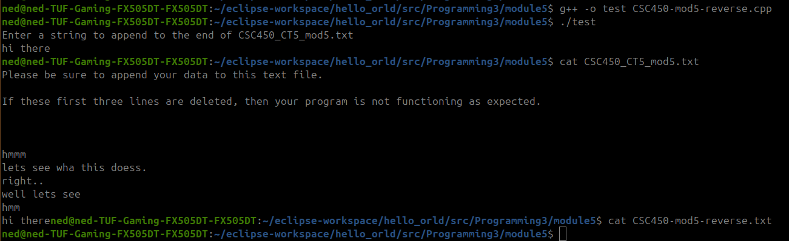

**Github**

https://github.com/amcdaugale/Programming3/blob/main/module5/CSC450-mod5-reverse.cpp

