**Subject:** PWD Green Stormwater Infrastructure Public SMPs GIS Data

_____________________________________________________________________________________

## GIS Data Summary

Public Green Stormwater Infrastructure (GSI) Stormwater Management Practice (SMP) polygon features were exported from DataConv.GISAD.Green_Stormwater_Infrastructure_Feature feature classes representing GSI SMP polygons on 02/03/2015. This is a snapshot of a continuously updated data set, known to contain errors and missing values as described below.

GIS polygon features are drawn based on design and as-built plan sets. In order to fit within the constraints of other GIS features such as buildings and curb lines, GIS polygon features may not match actual SMP geometry. Refer to **SMPFootprint** field, below, for the actual SMP footprint area.

**Table 1. Files Included in this Data Set**

|  |  |  |
| --- | --- | --- |
| File Name | Type | File Description |
| GSI_Public_SMP_Polygons_02_03_2015 | .shp | Public SMP Polygons (multipart features) |
| GSI_Public_SMP_Polygons_join_02_03_2015 | .shp | As above with SMP attributes pre-joined |
| GSI_Public_System_Points_02_03_2015 | .shp | Public GSI System Points |
| GSI_Public_System_Points_join_02_03_2015 | .shp | As above with System attributes pre-joined |
| SMPs_join_02_03_2015 | .xls | SMP attributes (including some System-level attributes); MS Excel |
| SMPs_join_02_03_2015 | .txt | SMP attributes (including some System-level attributes); Tab-delimited |
| Systems_join_02_03_2015 | .xls | SMP attributes; MS Excel |
| Systems_join_02_03_2015 | .txt | System attributes; Tab-delimited |

To create the final Public SMP Polygon layer (GSI_Public_SMP_Polygons_02_03_2015.shp), GSI features were dissolved by SMP_ID, creating multipart polygon features for all SMP polygons with the same SMP_ID. SMP 588-1-1 is a series of rain gardens along the Penn St. Trail. These SMPs will be divided into multiple systems in a later data release.

To create the final Public GSI System point layer (GSI_Public_System_Points_02_03_2015.shp), GSI polygon features were dissolved by SystemID, creating multipart polygon features for all SMP polygons with the same System ID. Centroid point features were then created for the dissolved polygons. Depending on System geometry the centroid may not be within the polygon feature(s) themselves.

## GSI Project Hierarchy

In increasing order of complexity, multiple stormwater management practices (***SMPs***) may be hydraulically connected within a ***System***, multiple *Systems* may be grouped in a ***Project***, and multiple *Projects* may be combined in a single ***Work Number***, or bid package (Figure 1).

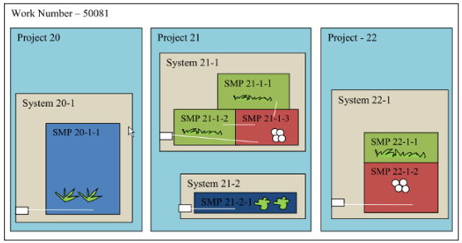

**Figure 1. Conceptual diagram of *SMP*, *System*, *Project* and *Work Number* hierarchy**

## GIS Attributes – GSI Public SMP Polygons and GSI Public System Points

**SMP_ID –** *SMP* ID key used to join tabular data (on SMPNumber). Note that there are multipart polygon features dissolved on SMP_ID. A common reason for this is a break in trench geometry at a utility crossing. Two trench polygons would be drawn to represent the *SMP* footprint, each having the same SMP_ID. See details below for information on joining GIS data with additional tabular data.

**SYSTEM_ID –** *System* ID key used to join tabular data (on SystemNumber). Note that multiple SMP features may have the same System_ID. See details below for information on joining GIS data with additional tabular data.

In addition to SMP polygon and System point shapefiles, PWD also prepared shapefiles with SMP and System attribute information pre-joined. These shapefiles are called GSI_Public_SMP_Polygons_join_02_03_2015.shp and GSI_Public_System_Points_join_02_03_2015.shp. It should be noted that due to the 10 character field name limit in .dbf files, field names have been abbreviated. Abbreviated attribute names are shown below in square brackets **[]**.

## Additional Attributes – GSI Public SMP Polygons

Additional attributes were extracted in tabular form from the *Green City Clean Waters* tracking system (GreenIT). This is a snapshot of a continuously updated data set, known to contain errors and missing values. For sake of convenience, a number of *System*-level attribute fields are included in the *SMP* attributes. All *SMPs* in the same *System* should have same value for these fields.

**SMPNumber –** *SMP* unique ID field for joining on GIS field SMP_ID. SMPNumber is of the form [*Project*]-[*System*]-[*SMP*] where *Project*, *System* and *SMP* are integers, for example SMPNumber 21-2-1 would indicate *Project* 21, *System* 2 and *SMP* 1. This field is not included in the pre-joined shapefile.

**SMPTypeName [SMPTypN] –** *SMP* type (see table 1, below)

**SMPNewVegetatedArea [SMPNwVA] –** The total area of an *SMP* (ft2) newly planted with vegetation, exclusive of tree pits. *SMP* footprint area constructed in a previously vegetated area is not counted toward NewVegetatedArea. Areas that were previously planted with grass are not considered vegetated. Researchers should note that PWD is currently re-evaluating the way that vegetated area is tracked and future data releases may not include the SMPNewVegetatedArea field. PWD may make available a new field that indicates the total vegetated area of an SMP inclusive of formerly pervious area in future data releases.

**SMPFootprint [SMPFtPr] –** area of the *SMP* footprint (ft2) from design or as-built plans.

**InfiltrationTypeName [InfiltTN] –** The primary *System* function, coded as either “infiltration” or “detention/slow release”. All *SMPs* in the same *System* should have the same value. It should be noted that most detention/slow release *Systems* are not lined and may have some infiltration function.

**SystemStorageVolume [SystmSV] –** Storage volume of the GSI *System* (ft3), based on design or as-built plans. Note that if there are multiple *SMPs* in a *System*, the *System* storage volume is the total storage volume for all the *SMPs* in that system. All *SMPs* in the same *System* should have the same value. Soil in tree pits and storage below the orifice of detention/slow release *Systems* are not counted toward *System* storage volume.

**StormSizeManaged [StrmSzM] –** *System* storage volume divided by impervious drainage area, expressed as depth of precipitation in inches. All *SMPs* in the same *System* should have the same value. Actual *System* performance will depend on a number of factors such as precipitation intensity, inlet capture efficiency, infiltration performance, etc.

**SystemContributingImperviousArea [SystCIA] –** Total impervious area (ft2) draining to the GSI *System*. All *SMPs* in the same *System* should have same value.

**ProjectName [PrjctNm] –** Name for the *Project*, which is a grouping of GSI *Systems* (*e.g.*, along a street, around a school, park, etc.).

**ConstructionCompletedDate [CnstrCD] –** Approximate date of construction completion, last updated when PWD project manager marks the *Project* complete in PWD's Capital Project management system (CAPIT). NULL or NA values indicate that a *Project* is in the design or construction phase.

**CAPITStatus [CAPITSt] -** *Project* status in PWD's Capital Project management system (CAPIT). SMPs should be considered functional and SMP designed metrics final only when CAPIT Status is marked as “Closed” or “Construction Complete”. SMP metrics may change as a project moves through the phases of design (Table 2). Researchers are encouraged to review all SMP data for updates and corrections to SMP metrics in each data release. Researchers should also note that PWD will be adding as-built metrics to track changes in designed values resulting from modifications during construction; this data is not yet available. The designed metrics provided typically reflect designed conditions. However, for two GreenIT projects (IDs 8 and 18), designed metrics have been updated to reflect as-built conditions for changes that occurred during construction

**Table 2. CAPIT Status and Sequence of Design and Construction Phases for PWD Capital Projects**

|  |  |
| --- | --- |
| CAPIT Status | CAPIT Sequence |
| Initiated | 1 |
| Design Started | 2 |
| Design 30 percent Complete | 3 |
| Design 70 percent Complete | 4 |
| In Projects Control | 5 |
| Bid Open | 6 |
| Bid Awarded | 7 |
| Contract Conformed | 8 |
| NTP | 9 |
| Construction Complete | 10 |
| Closed | 11 |
| Cancelled | NA |
| On Hold In Design | NA |
| On Hold In PC | NA |
| Returned to Design | NA |

**Table 3. SMP Type Name Definitions**

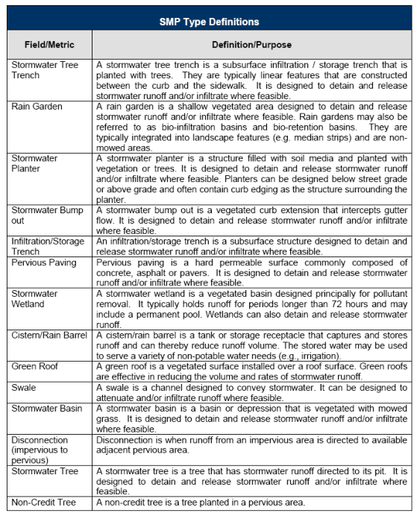

## Additional Attributes – GSI Public System Points

Additional attributes were extracted in tabular form from the *Green City Clean Waters* tracking system (GreenIT). This is a snapshot of a continuously updated data set, known to contain errors and missing values.

**SystemNumber –** *SMP* unique ID field for joining on GIS field SMP_ID. SystemNumber is of the form [*Project*]-[*System*] where *Project* and *System* are integers, for example SystemNumber 21-2 would indicate *Project* 21, *System* 2. This field is not included in the pre-joined shapefile.

**InfiltrationTypeName [InflTN] –** The primary *System* function, coded as either “infiltration” or “detention/slow release”. It should be noted that most detention/slow release *Systems* are not lined and may have some infiltration function.

**SystemStorageVolume [SystmSV] –** Storage volume of the GSI *System* (ft3), based on design or as-built plans. Note that if there are multiple *SMPs* in a *System*, the *System* storage volume is the total storage volume for all the *SMPs* in that system. Soil in tree pits and storage below the orifice of detention/slow release *Systems* are not counted toward *System* storage volume.

**StormSizeManaged [StrmSzM] –** *System* storage volume divided by impervious drainage area, expressed as depth of precipitation in inches. Actual *System* performance will depend on a number of factors such as precipitation intensity, inlet capture efficiency, infiltration performance, etc.

**SystemContributingImperviousArea [SystCIA] –** Total impervious area (ft2) draining to the GSI *System*.

**ProjectName [ProjectNam] –** Name for the *Project*, which is a grouping of GSI *Systems* (*e.g.*, along a street, around a school, park, etc.).

**ConstructionCompletedDate [CnstrCD] –** Approximate date of construction completion, last updated when PWD project manager marks the *Project* complete in PWD's Capital Project management system (CAPIT). NULL or NA values indicate that a *Project* is in the design or construction phase.