## Problem Statement

Kickstarter is the world's largest funding platform for creative projects. Since the site launch on April 28, 2009, 13 million people have backed a project, $3.3 billion has been pledged, and 369,069 projects have been posted. The purpose of this exercise will be to build a predictive model that can accurately classify whether or not a Kickstarter project will be successful.

## Assumptions & Success Metrics

Using a data set found online of Kickstarter projects launched between April 2009 and August 2017, we can see the outcome of projects is broken out as followed:

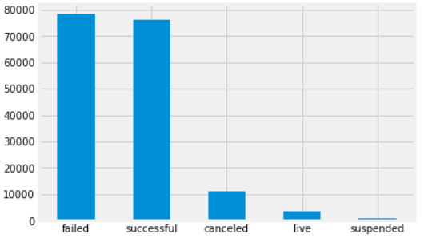

**45% of Projects Succeed!**

For our project, we will classify “canceled” projects as failures, and suspended projects and live projects will be removed from our data set. We will also remove projects that are greater than 1,000,000, since these projects are rare and could skew our predictions. Given these assumptions, it’s been identified that 55% of Kickstarter projects in the data set successfully met their target goal. 55% will serve as the baseline metric for evaluating the predictive model.

## Data Set

The dataset was available online by a team who leveraged Kickstarters’ API to consolidate more than 160,000 projects into a single location. The data set is split out across 42 .csv files, all packaged in a compressed folder. The data contains a number of fields that are either completed by the user, Kickstarter employees, or automatically tracked by the website. The data set contains project details including location, links to photos, whether it was a staffed picked project, and the goal amount, the pledge amount, and more. A more complete list of variables is listed below, along with the target.

### Available Variables:

|  |  |  |
| --- | --- | --- |
| ID | Disable Communication | Launched At |
| Photo | Country | Staff Pick |
| Name | Currency | Is Starrable |
| Blurb | Currency Symbol | Backers |
| Goal | Currency Trailing Code | USD Pledged |
| Pledged | Deadline | Creator |
| State [Target Variable] | State Changed | Source URL |
| Slug | Created At | Location |