Aubrie McIntyre 10/14/2024

**User Guide to Budget Calculator**

*Introduction*

Budget Calculator is a tool that can be used to help visualize your budget, alongside your bills and income for a specific time frame. Budget Calculator is great for keeping records of your income, monthly expenses, as well as extra spending. Many users find great use in visualizing their spending for the month, as it can help them recognize what they need to work on in order to stay within their budget.

*Getting Started*

Upon opening Budget Calculator, the user will be greeted with a screen that asks for their name. After the user enters their name, they should click “OK” or the enter key on their keyboard.

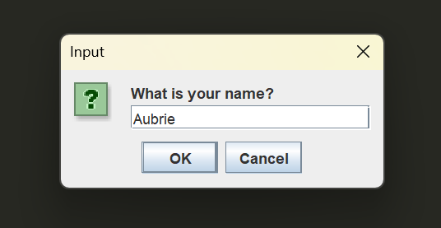

After moving forward, the program will greet the user with a personalized message that includes their name and a greeting. After the user clicks “OK” or the enter key, the screen should change.

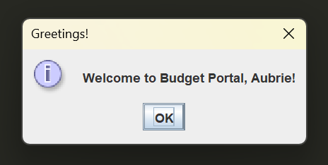

*Gathering Information*

Budget Calculator will need some user-provided information in order to generate a personalized report for the user. Following the personalized greeting, an informational box should appear that depicts this information.

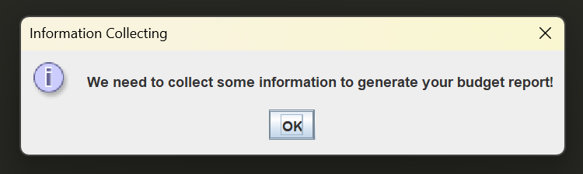

The first category of information that Budget Calculator will ask for relates to the user’s income. The first question that Budget Calculator will ask is in regards to how often the user got paid in a month’s time. It is noted that the user should enter the amount in a numerical format, such as 2 or 4, not “two” or “four”.

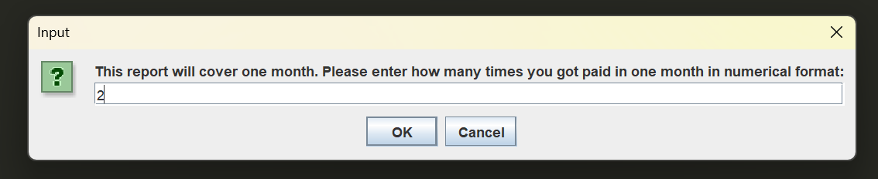

After the user clicks “OK” or hits the enter key on their keyboard, Budget Calculator will confirm the number that was entered in a pop-up. If the user were to enter the wrong number, they would need to close out the application and start over, so it is important to confirm what you are typing before hitting “OK” or the enter key.

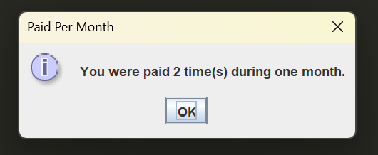

After the user clicks “OK” or hits the enter key, Budget Calculator will let the user know that it is time to provide the numbers for the Income Category. The user should then click “OK” or hit the enter key whenever they are ready.

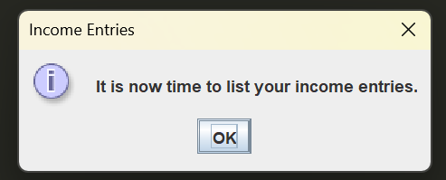

After the user clicks “OK” or hits the enter key, it will be time for the user to enter their entries for the Income Category. For this particular example, we listed 2 income entries, and listed them as 1100.00 and 950.00. Budget Calculator will have the user enter them individually, not at the same time like the pictures may suggest.

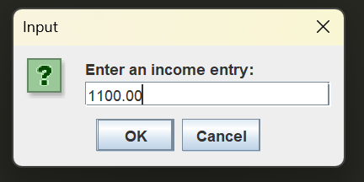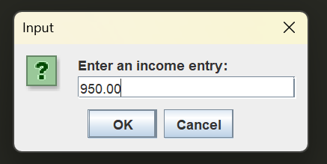

After entering each entry, Budget Calculator will show the user a confirmation message that is personal to how many entries they chose to include.

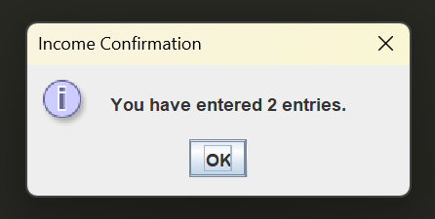

Afterwards, Budget Calculator will begin focusing on the expense category.

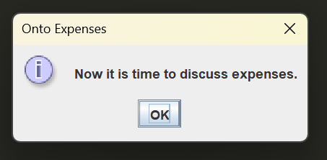

Budget Calculator will provide the user an explanation of what they should include in the expense category.

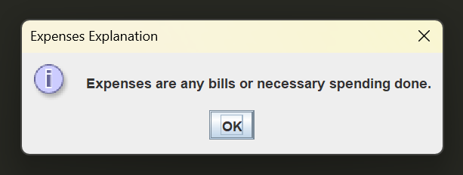

Afterwards, Budget Calculator will request how many entries that the user would like to include for the Expense category.

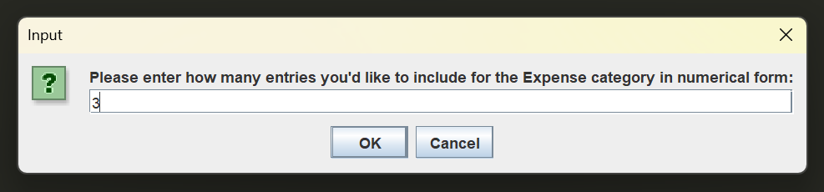

After entering the numerical value, Budget Calculator will provide a confirmation message that repeats the value that the user entered.

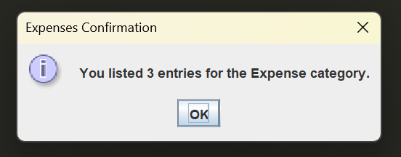

Next, Budget Calculator will prepare the user for their entries into the expense category.

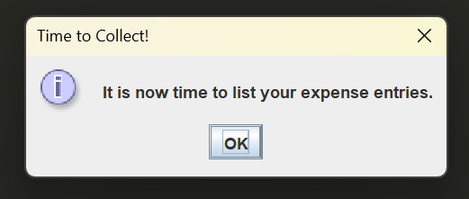

Budget Calculator will ask for expense entries based off of user input for how many they’d like to include. In this example, we chose to list three expenses of 650.00, 120.00, and 80.00.

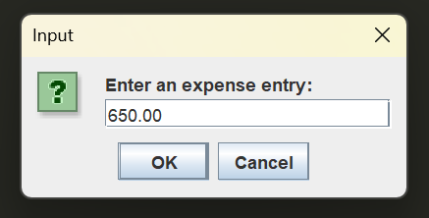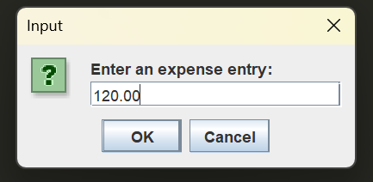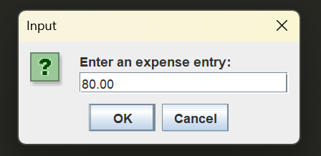

Afterwards, Budget Calculator will show a confirmation to the user to confirm how many entries they’ve entered.

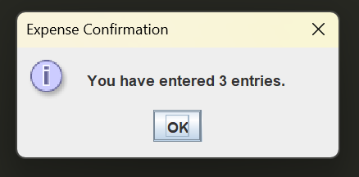

Next, the Budget Calculator will move focus to the budget of the budget report, as well as provide some explanation about the budget, what it will be used for, and defining the spending category.

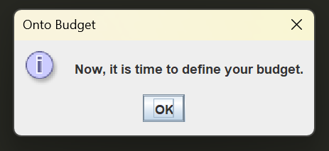

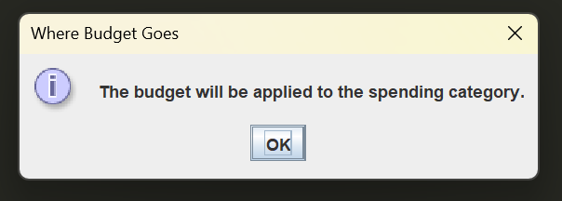

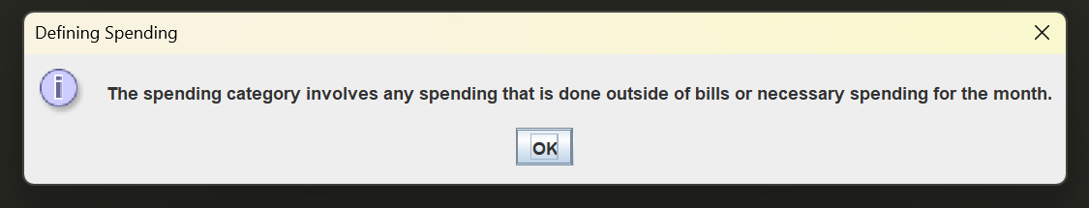

Afterwards, Budget Calculator will have the user input their budget, or spending limit, into the program, as well as provide confirmation of the user’s entry.

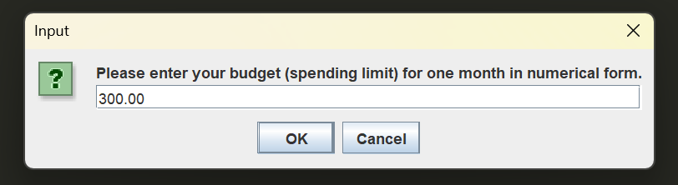

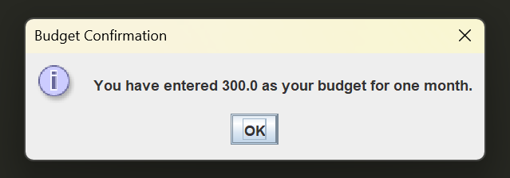

After defining the budget, Budget Calculator turns attention to the final category: the spending category.

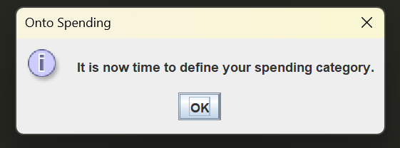

Budget Calculator will ask the user to enter how many entries they’d like to include into the spending category. Afterwards, Budget Calculator will show confirmation of the user entry.

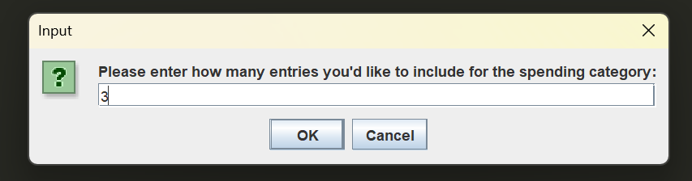

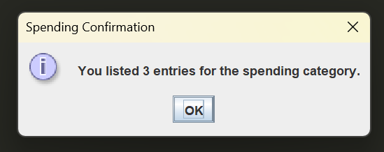

Now, Budget Calculator prepares the user to enter their entries for the spending category.

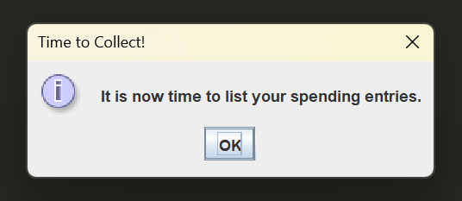

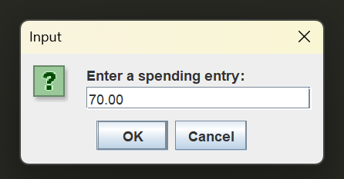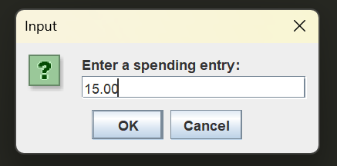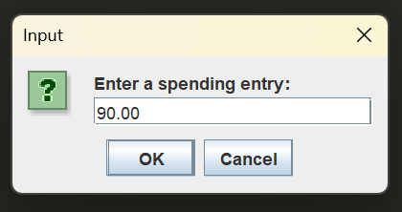

After entering the personalized number of entries, Budget Calculator will provide confirmation of the number of entries.

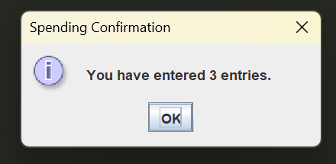

The user has now provided all necessary information! The user should click “OK” or hit the enter key on their keyboard.

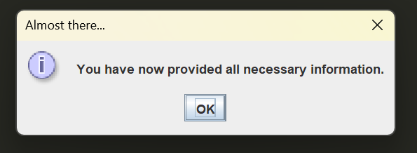

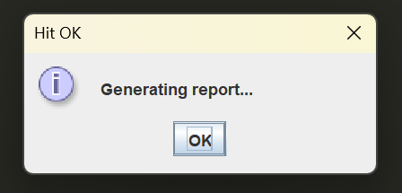

This is an example of the report that would be generated based off of the entries listed in the examples in this guide. The report is very useful to display this information in an easy-to-read and professional-looking manner.

