VEGETATION COVER TYPE EFFECTS ARBUSCULAR MYCORRHIZAL SPORE DENSITY IN NANTUCKET ISLAND, MASSACHUSETTS

Gretchen Addington 1, Dr. Christina Wells 1, Dr. Jennifer Karberg2

1Clemson University, Clemson, South Carolina

2Nantucket Conservation Foundation, Nantucket, Massachusetts

# ABSTRACT

Approximately 90% of terrestrial plants associate with arbuscular mycorrhizal (AM) fungi. AM fungi are responsible for a significant amount of nutrient uptake in host plants. Certain plant communities, such as grasslands and shrublands, may associate with specific groups of arbuscular mycorrhizal fungus. A diverse AM community is a driver of a diverse plant community and understanding of the AM fungal community may prove useful in management of the sandplain grasslands of Nantucket Island, Massachusetts. The goal of the current research on Nantucket was two-fold: to document the density and biodiversity of mycorrhizal communities across the rare sandplain grassland on Nantucket, and to examine the potential mycorrhizal colonization in these same communities. The AM fungal community was measured in two ways: density of spores in the soils, and the colonization potential of the soils. Analysis of spore density differed by high and low cover classes of both shrubs and grasses. However, AM colonization potential, determined through AM fungal root colonization of corn (*Zea mays* L.), is notcorrelated with percent cover of any particular vegetation community type. These mixed results indicate that further study of the specific mycorrhizal communities associated with vegetation cover type might provide more complete understanding of the community assemblage of the sandplain grasslands of Nantucket Island.

Keywords: Sandplain grassland, Arbuscular mycorrhizal fungi, biodiversity, grassland, shrubland

Primary Author Contact

Gretchen Addington

gretchenaddington@gmail.com

740.603.5839

# INTRODUCTION

Arbuscular mycorrhizal (AM) fungi, of the phylum Glomeromycota, are a ubiquitous member of most ecosystems on earth; they are known to associate with 80-90% of terrestrial plants (Simon *et al.* 1993). It has been said that AM fungi played an important role in the success of the early terrestrial plants (Simon *et al.* 1993). According to fossil records, AM fungi-like hyphae and spores were present 600 million years ago, indicating AM fungi was present prior to the development of the first vascular plants (Redecker *et al.* 2000).

AM fungi are important players in the maintenance of ecosystem biodiversity. By essentially increasing the host plants root to soil surface area through extended hyphal growth, AM fungi modify soil nutrient cycling. Additionally, AM fungi have been shown to inhibit the success of plant pathogens (Newsham *et al.* 1995), and to aid in water retention (Lamhamedi *et al.* 1992). The plant provides the fungus with carbon via photosynthates in return for these services.

Plant community composition is determined, at least in part, by the varying responsiveness, or dependency, of the plant species in the community to mycorrhizal colonization (van der Heijden 2002). An increasing number of AM fungi taxa is positively correlated with increased plant biodiversity, indicating that a diverse AM fungal community may be a driver of plant biodiversity (van der Heijden 1998a).

Fungal community shifts from arbuscular mycorrhizal communities to ectomycorrhizal communities have been well documented as the vegetation community moves from early successional herbaceous and graminoid species to woody, later successional woody species (Wu *et al.* 2004, Treseder and Cross 2006, Harner *et al.* 2010, and others) and provides further evidence for a strong link between plant and fungal diversity.

The conservation of Nantucket’s sandplain grasslands is a priority due to the high concentration of rare and endangered species (Nantucket Conservation Foundation, 2004). In the past century, increasing woody encroachment has converted sandplain grasslands and heathlands to shrublands. It is likely that there has been a concurrent change in fungal community. Researchers have examined effective ways to conserve the unique biodiversity of the sandplain grasslands through management but have not yet included the role of mycorrhizal communities in the effectiveness of the techniques.

We examined the presence, density, and diversity of AM fungal communities in sandplain grasslands and adjoining or nearby shrublands across Nantucket Island, MA. If the sandplain grasslands show a strong association with AM fungal communities, then their role should be considered in management techniques aimed at restoring and perpetuating these communities.

The goals of this project were three-fold. First we determined density of AM fungal spores in the top15 cm of soil, the most biologically active area of the soil community, as a metric of AM fungi community activity. Second, the AM fungal community colonization potential was examined using *Zea mays* L. root colonization in collected soil cores taken from the research sites and grown in a controlled greenhouse environment. *Zea mays* L. was selected as a model species because it colonizes with AM fungi readily and is easily obtained. Standard colonization of *Zea mays* L. ranges from 10% to 35 % generally (Stottlemeyer 2011). Finally, the spores collected were morhpotyped to determine the biodiversity of the AM fungal community.

# MATERIALS AND METHODS

Field work was completed on Nantucket Island, Massachusetts in May of 2011. Three field sites were used in three properties across the island: Head of the Plains, property of the Nantucket Land Bank; the Middle Moors, Serengeti, property of the Nantucket Conservation Foundation; and the Eastern Moors, property of the Massachusetts Audubon (Figure 1). These sites are all described as sandplain grasslands and are under management by conservation groups on the island to maintain the grassland plant community. They also range from the eastern portion to the western portion of the island and include coastal and inland properties.

## Soil Collection

A 100 m transect was placed at each of the sampling locations in areas that had variable vegetation cover. Starting at the 10 m point a one square meter quadrat was placed on alternating sides of the transect line; and percent cover of grasses, forbs, and shrubs was recorded, for a total of nine vegetation percent cover measurements per transect, or 27 total measurements. The initial side for quadrat placement was determined by a coin flip. Also, at each 10 meter point, four soil cores were collected to a depth of 15 cm, using a soil auger. The depth of 15 cm was chosen as this is where the majority of belowground biological activity takes place. Three of these cores were placed into one gallon plastic bags to be homogenized later. One soil core was kept intact and placed into a 20 cm tall clear tube that was then sealed on each end. The upper thatch layer, not more than 5 cm in depth, was removed from the soil sample at the time of sampling.

All soil samples were returned to the Nantucket Conservation Foundation’s greenhouse facility. The three soil samples that were stored in bags were homogenized and sieved using a 2 mm pore size sieve to remove rocks and roots. A subsample of the homogenized soil was placed into bags and frozen at -20C. The intact cores, which had been stored in the plastic tubes, were also frozen at -20C. All soil samples were shipped to Clemson University, where they were kept chilled until further processing, approximately one week.

## AM Spore Density Analysis

After thawing the soil samples overnight, three subsamples from each sample bag were taken. These were individually placed into petri plates and weighed to 100 g. In order to determine soil percent moisture, the soil samples were then placed in a 90°C oven for a course of one week, until constant mass was achieved.

One sample of each of the collected soils was further analyzed for spore density. We followed the method set out in Brundett *et al.* 1996. The soil sample was immersed in tap water for 30 minutes to free the spores from the soil particles. A sample of tap water was subjected to the same process to ensure that contamination was not occurring. Each sample was then washed through a series of four sieves of decreasing pore size, 2 mm, 500 μm, 250 μm, and 63 μm or 53 μm. The sieving from the 2 mm sieve was discarded, as this contained only pebbles and no free AM fungal spores.

The sievings from the three remaining sieves were individually washed into test tubes and then centrifuged for two minutes at 2000 rpm. The supernatant was discarded and the pellet was resuspended in 50% sucrose solution, and then centrifuged for three minutes at 3000 rpm to separate spores from the soil. The supernatant was pored over Number 1 Whatman filter paper and vacuum filtered. The sucrose solution was washed away in the process using distilled water. The product of this method was a filter paper with AM fungal spores on it. The paper was placed into a petri plate, allowed to dry, covered, for one week, and then sealed with Parafilm.

The spores were enumerated using a dissecting scope. The area of the viewing circle was determined, and calculated as a percentage of the total area of the petri plate. Enough separate viewing area counts were taken, in an ordered sequence, to cover the entire plate. This count was then calculated into the density of spores per gram of soil.

## *Zea mays* L. Root Colonization Analysis

The intact cores were taken to the Clemson University greenhouse. The temperatures in the greenhouse range from 20C to 38C, and a 14 hour day length was provided. One cap of each tube was removed. Two seeds of Blue Jade Corn (Seed Savers Exchange Product OG1194-721) were placed into each of the tubes. The corn is an organic variety that has not been treated with any antimicrobial coatings. There was 100% successful germination. The plants were watered thrice weekly with 50 ml distilled water. The plants were allowed to grow for one month, a time period long enough for a large amount of root growth, but short enough to disallow root senescence.

Plants were harvested and the roots were washed carefully using distilled water to remove all soil particles, then stored in 100% ethanol. Roots were cleared over the course of several days in 10% KOH in a 75C water bath. After clearing, the roots were washed of any residual KOH with several flushes of deionized water. Next the roots were submerged in a trypan blue staining solution (Sigma product #6146). The solution was prepared by dissolving the trypan blue stain in lactic acid, glycerol, and deionized water, to give a final stain concentration of 0.05% (Koske and Gemma 1989). The roots were flushed of excess staining solution and placed in 50% glycerol solution for destaining and storage. The roots were permanently mounted on microscope slides with polyvinyl-lactic acid-glycerol (Omar *et al.* 1979). The slides were placed in an 82C oven for 36 hours to allow the mounting solution to harden.

Fungal colonization was assessed using the magnified intersections methods with a compound microscope (400 x magnification) and arrow reticule as described by McGonigle *et al.* 1990. These slides were visually scanned in a grid pattern. When the reticule passed a root, it was recorded as an intersection, and that intersection was analyzed for the presence of a fungal body. For each sample, 50 intersections were analyzed. Fungal colonization was calculated as the percentage of root intersections at which fungal bodies were present.

## Statistical Analysis

Spore density results were analyzed using a multivariate analysis of variance (MANOVA). Significance of the MANOVA was determined using Pillai’s Trace, as this is the most robust of the MANOVA tests. Spore density data was log transformed to more completely meet the assumptions of the MANOVA. Significance was determined at a 90% confidence level. The percent cover of forbs was removed from analysis, as it never rose greater than three percent cover. Cover of shrubs and grasses were both analyzed categorically, as high or low. Low denotes a percent vegetation cover of less than 50%; high denotes percent vegetation cover of greater than or equal to 50%. These levels were selected in order to capture the gross plant community type.

Fungal colonization potential was analyzed using univariate analysis of variance. Significance was determined at a 90% confidence level. This data was analyzed without transformations.

# RESULTS

Grass cover ranged from 1% to 100% cover. The mean grass cover was 43.5185% ±7.72762. Grass cover showed a negative trend with shrub cover (Figure 2). Grass cover did not differ by site, (*F*(2, 23)=1.080, *p* = 0.356). Shrub cover differed by site ( *F*(2, 23)=2.725, *p* = 0.087), with the Middle Moors, Serengeti, showing the highest mean shrub cover at 68.33% ± 14.03666. The mean shrub cover of the Head of the Plains and the Eastern Moors did not differ ( *F*(1, 2315)=0.445, *p* = 0.515), and the mean shrub cover of these two sites was 34.6471 ± 7.78287.

The mean spore density of the 500 µm and greater size class was 0.1702 ± 0.02432 spores/g soil. The mean spore density of the 250 µm to 499 µm size class was 0.29667 ± 0.05933 spores/g soil. The mean spore density of the 53 µm to 249 µm size class was 19.43687 ±3.88737 spores/g soil. The mean colonization percentage was 27.1852% ± 2.65866.

We found that mean spore density was significantly higher in areas of high shrub cover when compared to areas dominated by grasses ( Pillai’s Trace = 0.314, *F*(3) = 3.205, *p* = 0.044; Figure 2). Analysis of each of the three size classes of spore density indicated that the largest spore size, greater than or equal to 500 µm, had no significance with the high and low shrub cover categories ( *F*(1, 23)=0.018, *p* = 0.894). The medium size class, 250 µm to 499 µm showed a trend by high and low shrub cover ( *F*(1, 23) = 2.685, *p* = 0.115). The smallest size class, 53 µm to 249 µm, had an even stronger trend ( *F*(1, 23) = 2.822, *p* = 0.107).

Density of all spores, following log transformation, regardless of size class, also differed by grass cover class, *i.e.* greater than or less than 50% ( Pillai’s Trace = 0.278, *F*(3) = 2.701, *p* = 0.072). The largest spore size class, greater than or equal to 500 µm, loosely trended with the high and low grass classes ( *F*(1, 23) = 0.806, *p* = 0.379). The 250 µm to 499 µm size spore class showed no trend with grass cover class ( *F*(1, 23) = 0.016, *p* = 0.901). The 53 µm to 249 µm size spore class density was significantly higher when the grass cover class was greater than or equal to 50% ( *F*(1, 23) = 7.441. *p* = 0.012 Figure 3).

Mycorrhizal colonization potential in corn did not differ by shrub cover class, *F*(1) = 0.073, *p* = 0.790, or by grass cover class ( *F*(1) = 0.612, *p* = 0.442).

# DISCUSSION

The lack of significant difference in the mycorrhizal colonization potential metric, when measured using *Zea mays* L. roots was unexpected. However, this metric would potentially show more significant results had both a monocot and a dicot been used. The potential of a specialized fungal community, specific to vegetation type *i.e.* grasses and shrubs or monocots and dicots, would have been lost by using only a monocot, *Zea mays* L. In the future we suggest that this method be repeated with *Zea mays* L.and *Symphyotrichum novi-belgii* (L.) G. L. Nesom, a forb common to Nantucket Island.

The overall trend of greater AM spore density when shrub cover is less than 50% and grass cover is greater than or equal to 50% indicates that AM fungi may associate more strongly with grasses than shrubs in the sandplain grassland of Nantucket. Management of natural lands on Nantucket may benefit from inoculation of the soil with the AM fungal community associated with grasslands. Step by step instructions for producing soil plugs prepared with the grass associated AM fungal community may be found in Appendix 1. This is a hands-off method that will enhance the grass-specific AM fungal community without the need for fungal species identification.

While inoculation in the field with an unidentified but grass-specific fungal community is sufficient for management purposes, previous studies have shown that there is specialization of mycorrhizal fungal communities to specific plant species (Hartnett and Wilson 1999, Helgason *et al.* 2002, Jakobsen *et al.* 1992, Klironomos 2003, McGonigle and Fitter 1990, Streitwold-Engel *et al.* 2001, Vandenkoornhuyse *et al.* 2002, Vandenkoornhuyse *et al.* 2003, van der Heijden 1998b). Specialization of community should not be ignored, especially considering that the three classes of spore size offered different results. The largest size spore class showed no trend with shrub cover class, but was higher when grass cover was greater than 50%. The medium size spore class density decreased with increased shrub cover, but showed no trend with grass cover. The smallest size spore class density was lower with increased shrub cover, but higher with increased grass cover. This report supports the potential of AM fungal community specialization to grasses and shrubs, and indicates that the community may be, in part, a driver of plant biodiversity.

The biodiversity analysis of the AM fungal community is ongoing. Morphotypes will be recorded through digital photography, and biodiversity metrics are being prepared. However, the strongest tool for complete AM fungal community identification is molecular analysis.

# LITERATURE CITED

Harner M. J., D. L. Mummey, J. A. Stanford, and M. C. Rillig. 2010. Arbuscular mycorrhizal fungi enhance spotted knapweed growth across a riparian chronosequence. Biological Invasions 12:1481-1490.

Hartnett D. C., G. W. T. Wilson. 1999. Mycorrhizae Influence plant community structure and diversity in tallgrass prairie. Ecology 80:1187-1195.

Helgason T., J. W. Merryweather, J. Denison, P. Wilson, J. P. W. Young, and A. H. Fitter. 2002. Selectivity and functional diversity in arbuscular mycorrhizas of co-occurring fungi and plants from a temperate deciduous woodland. The Journal of Ecology 90:371-384.

Jakobsen I., L. K. Abbott, and A. D. Robson. 1992. External hyphae of vesicular arbuscular mycorrhizal fungi associated with *Trifolium-subterraneum* L. 2 Hyphal transport of P-32 over defined distances. The New Phytologist 120:509-516.

Klironomos J. 2003. Variation in plant response to native and exotic arbuscular mycorrhizal fungi. Ecology (Durham) 84:2292-2301.

Koske R. E., J. N. Gemma. 1989. A modified procedure for staining roots to detect VA mycorrhizas. Mycological Research 92:486.

Lamhamedi M., P. Y. Bernier, and J. A. Fortin. 1992. Hydraulic conductance and soil-water potential at the soil root interface of *Pinus pinaster* seedlings inoculated with different dikaryons of *Pisolithus sp*. Tree physiology 10:231-244.

McGonigle T. P., A. H. Fitter. 1990. Ecological specificity of vesicular arbuscular mycorrhizal associations. Mycological Research 94:120-122.

McGonigle T. P., M. H. Miller, D. G. Evans, G. L. Fairchild, and J. A. Swan. 1990. A new method which gives an objective measure of colonization of roots by vesicular-arbuscular mycorrhizal fungi. New Phytologist 115:pp. 495-501.

Omar M. B., L. Bollan, and W. A. Heather. 1979. A permanent mounting medium for fungi. Bulletin of the British Mycological Society 13:31.

Redecker D., R. Kodner, and L. E. Graham. 2000. Glomalean fungi from the Ordovician. Science (New York, N.Y.) 289:1920-1921.

Simon L., J. Bousquet, R. C. Levesque, and M. Lalonde. 1993. Origin and diversification of endomycorrhizal fungi and coincidence with vascular land plants. Nature (London) 363:67-69.

Stottlemyer, A. D. (2011). Effects of prescribed burning and mastication on fuel loading, soil fertility and mycorrhizal inoculum potential, tree regeneration, and understory plant communities in beetle-killed stands in the upper South Carolina Piedmont. (Unpublished doctoral dissertation). Clemson University, Clemson, South Carolina.

Treseder K., A. Cross. 2006. Global distributions of arbuscular mycorrhizal fungi. Ecosystems 9:305-316.

van der Heijden M. G. A. 2002. 10 Arbuscular mycorrhizal fungi as a determinant of plant diversity: in search of underlying mechanisms and general principles. Page 243 *In*I. T. Balwin, M. M. Caldwell, G. Heldmaier, O. L. Lange, H. A. Mooney, E. -. Schulze, and U. Sommer, editors. Ecological Studies, Vol. 157 Mycorrhizal Ecology, Springer, Berlin.

van der Heijden M. G. A., T. Boller, A. Wiemken, and I. R. Sanders. 1998b. Different arbuscular mycorrhizal fungal species are potential determinants of plant community structure. Ecology 79:2082.

van der Heijden M. G. A., J. N. Klironomos, M. Ursic, P. Moutoglis, R. Streitwolf-Engel, T. Boller, A. Wiemken, and I. R. Snaders. 1998a. Mycorrhizal fungal diversity determines plant biodiversity, ecosystem variability and productivity. Nature 396:69.

Vandenkoornhuyse P., K. P. Ridgeway, I. J. Watson, A. H. Fitter, and J. P. W. Young. 2003. Co-existing grass species have distinctive arbuscular mycorrhizal communities. Molecular Ecology 12:3085-3095.

Vandenkoornhuyse P., R. Husband, T. J. Daniell, I. J. Waton, J. M. Duck, A. H. Fitter, and J. P. W. Young. 2002. Arbuscular mycorrhizal community composition associated with two plant species in a grassland ecosystem. Molecular Ecology 11:1555-1564.

Wu B., K. Isobe, and R. Ishii. 2004. Arbuscular mycorrhizal colonization of the dominant plant species in primary successional volcanic deserts on the Southeast slope of Mount Fuji. Mycorrhiza 14:391.

# FIGURES

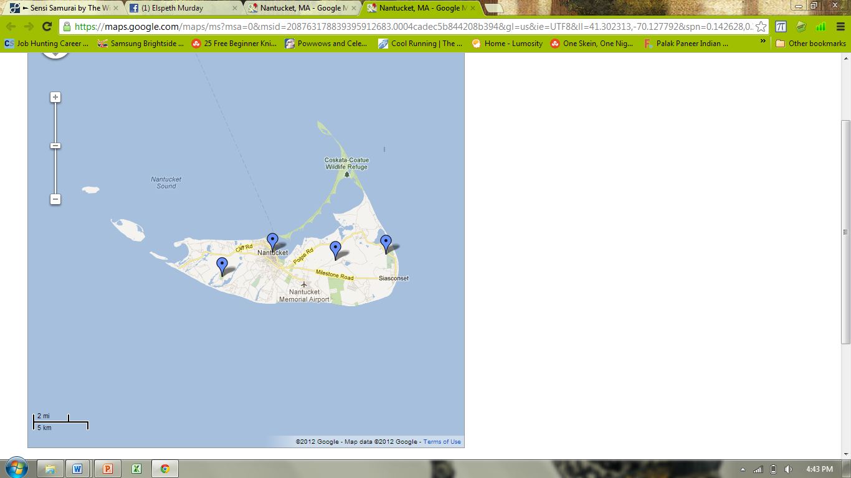

Head of the Plains,

Nantucket Islands Land Bank

5km

Middle Moors, Serengeti

Nantucket Conservation Foundation

Eastern Moors

Massachusetts Audobon

Figure 1: The replicate sampling sites on Nantucket Island, Massachusetts, including the Head of the Plains, Nantucket Islands Land Banks; the Middle Moors, Serengeti, Nantucket Conservation Foundation; and the Eastern Moors, Massachusetts Audubon. 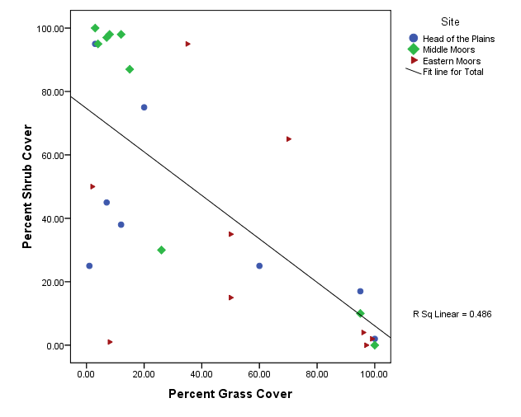Figure 2: Percent grass cover has a negative relationship with percent shrub cover, supporting what is known about succession from grasses to shrubs in the sandplain grassland.

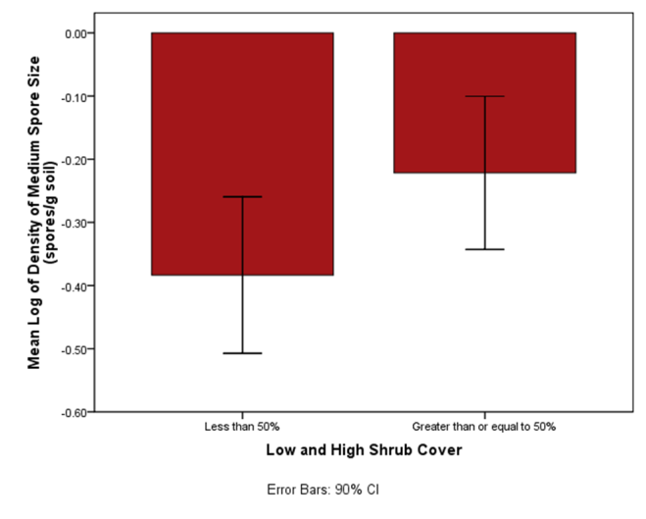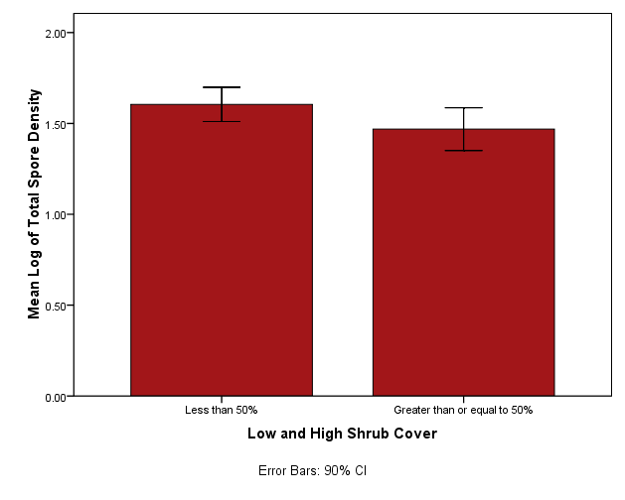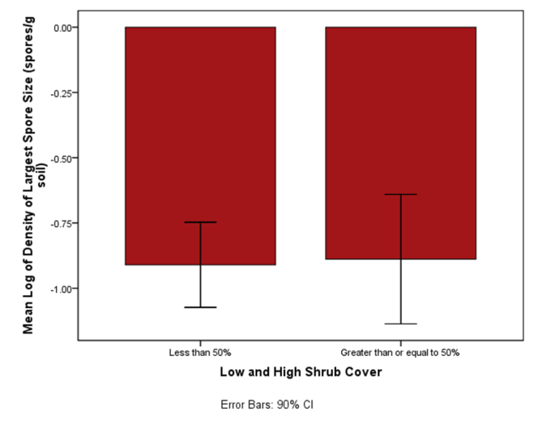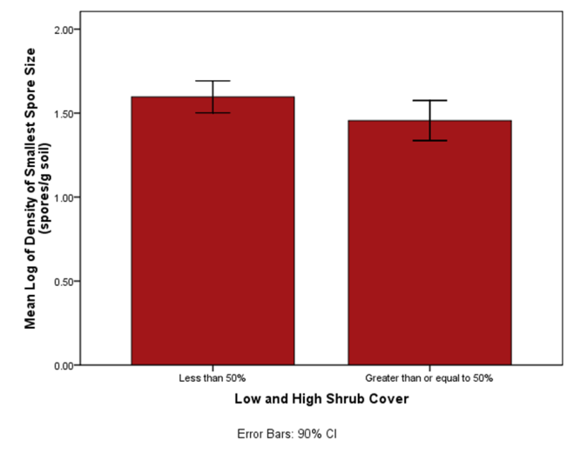

A

B

C

A

D

Figure 3: A. The log of spores density, taken through MANOVA and regardless of spore size, was significantly lower in the greater than 50% shrub cover class ( Pillai’s Trace = 0.314, *F*(3) = 3.205, *p* = 0.044). Significance is noted with a black “X”. B. The mean log of spores 500 µm and larger spores, across high and low percent shrub cover. No significant difference was found in the group ( *F*(1, 23) = 0.018, *p* = 0.894). C. Mean log of 250 µm to 499 µm spore density, across high and low shrub cover. This group showed a trend of increased density under lower shrub percent cover ( *F*(1, 23) = 2.685, *p* = 0.115). Spore density was higher when the shrub percent cover was less than 50%. D. Mean log of 53 µm to 249 µm spore density showed a strong trend when compared with high and low shrub cover ( *F*(1, 23) = 2.822, *p* = 0.107). Spore density was higher when the shrub percent cover was less than 50%.

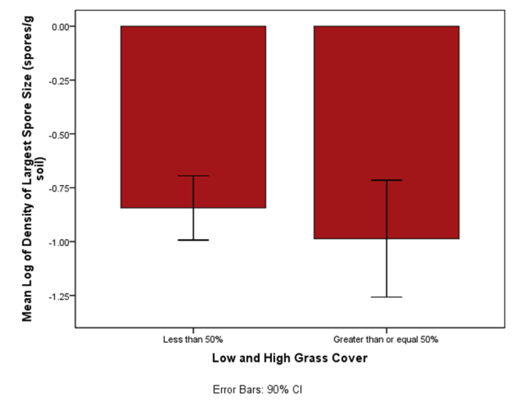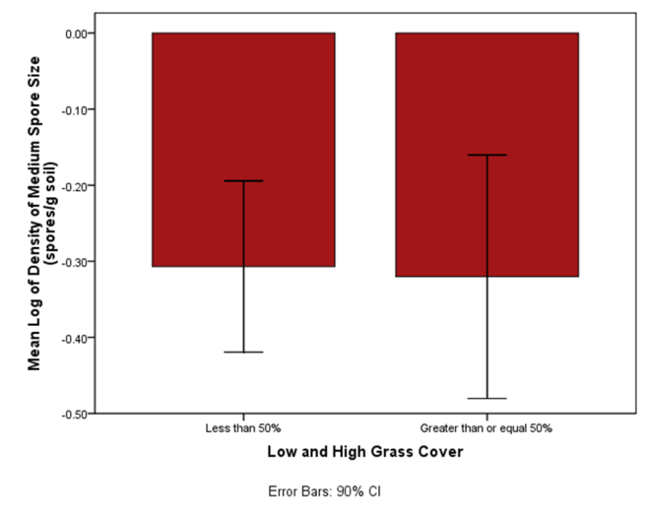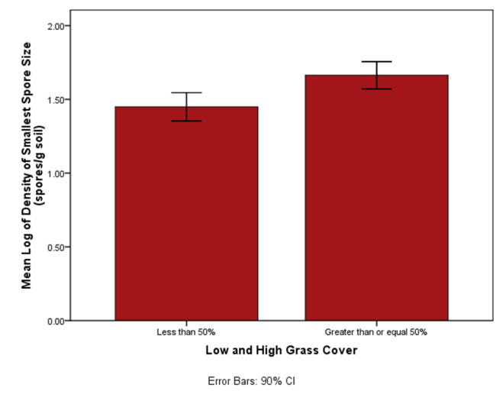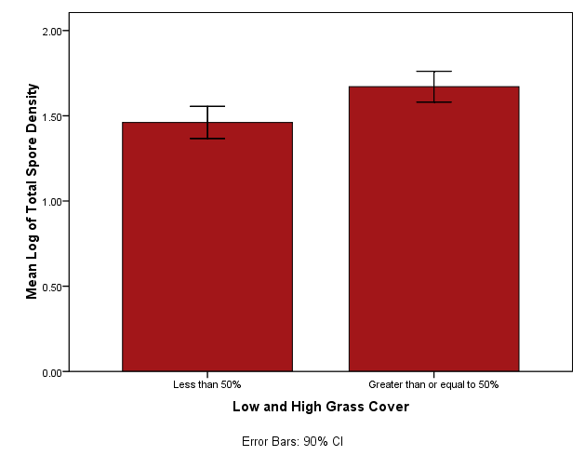

D

A

C

B

Figure 4: A. The log of spore density, taken through MANOVA and regardless of spore size, was significantly lower in the greater than 50% grass cover class ( Pillai’s Trace = 0.278, *F*() = 2.701, *p* = 0.072). Significance is noted with a black “X”. B. A loose trend was found in the 500 µm and greater spore size group ( *F*(1, 23) = 0.806, *p* = 0.379). C.The 250 µm to 499 µm spore size group showed no association with grass cover class ( *F*(1, 23) = 016, *p* = 0.901). D. Mean log of 53 µm to 249 µm spore density was significantly higher in the greater than or equal to 50% grass cover class ( *F*(1, 23) = 7.441, *p* = 0.012). Significance is noted with a black “X”.

# APPENDIX I

**To produce a mycorrhizal treatment in sandplain grasslands**

**Prepared by: Gretchen Addington**

**8Nov11**

Objective: To promote sandplain grassland productivity by installing a native mycorrhizal community.

The information included in this guide will enable to reader to collect soil that embodies the native mycorrhizal community, prepare soil plugs with native nurse plants in a greenhouse, and to install those soil plugs in areas of active management. These steps will lead to a mycorrhizal community in managed sandplain grasslands that supports the rare plants found there. This method is adapted from Brundett et al. 1996, especially pages 165-167. More information on arbuscular mycorrhizal fungi may be found in chapters one and three in Brundett et al. (1996).

## Collection of soil embodying the native mycorrhizal community

Materials required

* Soil corer, bucket auger type
* 5 gallon tub with lid (for homogenization)
* Soil sieve, large mesh size

1. From a model sandplain grassland ecosystem, collect ten soil cores to a depth of 15cm. Remove the thatch layer.
2. Homogenize these cores and pass through the large mesh sieve to remove large detritus.
3. Split the soil sample in half and sterilize one half of the soil.
   1. Autoclave the soil twice at three day intervals for complete sterilization.
4. Return sieved soil to tub, cover with lid, transport back to lab/greenhouse and store in refrigerator until ready to use. Use this soil within one week to avoid mold growth.

## Preparation of soil plugs

Materials required

* Homogenized soil samples (see above)
* 80 conetainers and rack
* Sterilized sand
* 80 Little Bluestem (*Schizachyrium scoparium*) seeds or other similar, native, mycorrhizal plant. Plants should be locally sourced.

1. Cover each conetainer base with aluminum foil to seal drainage holes.
2. Fill each of the conetainers as shown in Diagram 1.
3. Plant one Little Bluestem plant in each container, water to field capacity and allow growing for six weeks, watering as needed.
4. Over the course of the next week, place the plants outside the greenhouse during the day to harden them. The following week, place the plants outside the greenhouse day and night. The plants are now ready to go into the field.

(Repeat these steps using sterilized sand and sterilized soil to create non-mycorrhizal control plugs. Create 40 of these.)

The final product is **40 mycorrhizal soil plugs** and **40 non-mycorrhizal soil plugs.**

It is recommended to perform the sieving method with an extra mycorrhizal soil plug, as found on pg.155 of Brundett et al. (1996) to ensure presence of arbuscular mycorrhizal spores.

## Install the plants in the field

Materials required:

* 40 mycorrhizal soil plugs
* 40 non-mycorrhizal soil plugs
* 100 m transect tape
* 1m by 1m quadrat
* Planting materials (trowels, gloves, etc.)

1. Run the 100m transect tape through the area to be managed.
2. At each 5m point, place the quadrat and determine a percent cover of grass, shrub, and forb.
3. At each even numbered 5m point, plant a total of four mycorrhizal soil plugs, one at each corner. Flag each of these plants.
4. At each odd numbered 5m point, plant a total of four non-mycorrhizal soil plugs, one at each corner. Flag each of these plants.
5. Monitor these plants and 1m by 1m plots for success of sandplain grassland species over at least one growing season.

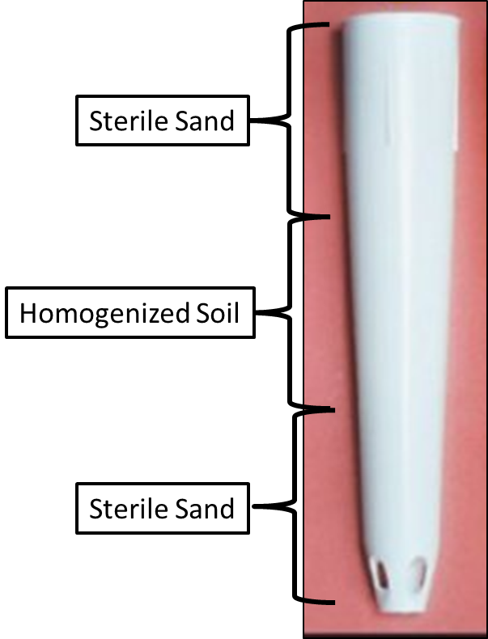

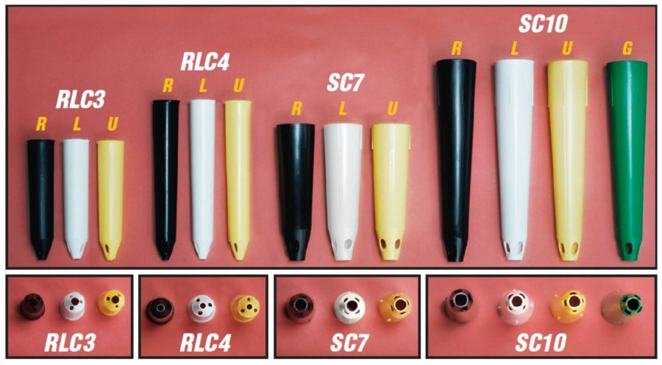

Sterile Sand

Sterile Sand

Homogenized Soil

Diagram 1: Layering of field and sterile sand in conetainers for preparation of soil plugs.

## Materials Suppliers:

Soil corer, bucket type http://www.ascscientific.com/ams.html

Soil Sieve http://www.sifterz.info/?s=Sifter+Dirt

Conetainers and rack http://www.stuewe.com/products/rayleach.php

100 m transect tape http://www.forestry-suppliers.com/product_pages/View_Catalog_Page.asp?mi=5653&title=Keson+Open+Reel+Fiberglass+Tapes

## Reference:

Brundett, M., Bougher, N., Dell, B., Grove, T., & Malajczuk, N. (Eds.). (1996). *Working with mycorrhizas in forestry and agriculture* (1st Ed.). Canberra, Australia: ACIAR Monograph.