Comparative Evaluation of Machine Learning Regression Models Using a Diabetes Dataset
Ashley McKinney | Python Machine Learning Demonstration

Project Purpose
The purpose of this project is to evaluate and compare the predictive performance of three regression-based machine learning approaches: Linear Regression, Random Forest Regression, and Extreme Gradient Boosting (XGBoost). Using a publicly available diabetes dataset, this analysis will examine how effectively each model predicts a continuous measure of diabetes progression based on baseline patient characteristics.
Models will be evaluated using consistent training and testing procedures to determine differences in predictive accuracy and generalization. This analysis is intended to demonstrate practical skills in predictive modeling, model comparison, and interpretation within a healthcare related dataset. Findings will be used to illustrate the strengths and limitations of different regression approaches rather than to support clinical decision-making.
Primary Research Question
How does the predictive performance of Linear Regression, Random Forest Regression, and XGBoost compare when estimating diabetes disease progression using baseline clinical and demographic characteristics?
Supporting Questions
- Which regression model produces the lowest prediction error or unseen data?
- How does model complexity influence predictive performance?
- Which baseline variables contribute most to model predictions?
- What are the advantages and limitations of each modeling approach when applied to a small clinical dataset?
Dataset Selection and Rationale
The Diabetes Regression Dataset available through the scikit-learn Python library was selected for this project. The Diabetes Regression Dataset contains 442 observations and 10 baseline predictor variables. The predictors represent demographic characteristics, body mass index, average blood pressure, and six blood serum measurements.
The outcome variable is a quantitative measure of diabetes disease progression recorded one year after the baseline assessment. The dataset is structured with one observation per participant and is designed for supervised regression analysis. The original dataset is associated with the work of Efron and colleagues (2004) on Least Angle Regression and is commonly used to demonstrate regression and predictive modeling techniques. Limitations to the dataset suggest that although the dataset is relatively small and does not reflect the complexity of longitudinal clinical treatment data, it provides an appropriate starting point for demonstrating model development, evaluation, and comparison.
More information on the dataset can be found at: https://scikitlearn.org/stable/modules/generated/sklearn.datasets.load_diabetes.html.
Predictor Selection Rationale
Table 1 Proposed Five Predictors
Variable | Description | Selection Rationale
Age | Age | Captures demographic variation
Sex | Sex | Accounts for possible demographic differences
BMI | Body mass index | Represents adiposity and metabolic risk
BP | Average blood pressure | Represents cardiovascular and metabolic health
S6 | Blood sugar | Provides a glycemic-related measurement
Five baseline predictor variables were selected for the initial modeling analysis: age, sex, body mass index (BMI), average blood pressure, and blood sugar. The predictors were selected based on their clinical relevance to metabolic health and their representation of demographic, anthropometric, cardiovascular, and glycemic characteristics. A reduced predictor set was chosen to support model interpretability and limit potential redundancy among variables, particularly the six serum measurements included in the original dataset.
Potential multicollinearity among the selected predictors will be evaluated through correlation analysis and variance inflation factors (VIFs). The same five predictors will be used across Linear Regression, Random Forest Regression, and XGBoost to maintain consistency in model comparison.
Phase 1: Model Exploration
Purpose: This phase will cover the Exploratory Data Analysis (EDA) including dataset exploration, data quality assessment, predictor selection, descriptive statistics, correlation analysis, and multicollinearity assessment.
Step 1: Data Import and Initial Inspection Results – The Diabetes Regression Dataset was successfully imported using the scikit-learn Python library. All 442 observations contain non-null values across the 11 variables. All variables have numeric data types, and no missing values were identified during the initial inspection.
Step 2: Create the Five-Predictor Analytical Dataset – the analytical dataset retains all 442 participants while reducing the predictor count from 10 to 5. The five excluded variables represent serum measurements that were not selected for the initial modeling analysis.
Step 3: Duplicate Observation Assessment – The analytical dataset was evaluated for missing values and exact duplicate observations. Initial inspection showed that there were no missing values and the assessment of duplicate records identified zero duplicate observations within the six variable analytical dataset.
Step 4: Descriptive Statistics – descriptive statistics were calculated for all five predictors and the outcome variables across 442 observations. The standardized predictors had approximately equal to zero and standard deviations of 0.0476, while the diabetes progression outcome had a mean of 152.13 (SD = 77.09), with values ranging from 25 to 346.
Step 5: Correlation Analysis – Pearson correlation analysis identified BMI as the strongest correlate of diabetes progression (r = 0.586), followed by blood pressure (r = 0.441) and blood sugar (r = 0.382). Correlations among the five predictors were relatively low, suggesting limited pairwise collinearity.
Step 6: Variance Inflation Factor (VIF) – All five predictors demonstrated low VIF values, ranging from 1.088 (sex) to 1.398 (blood pressure). Since all values are below 5, no multicollinearity concerns supporting retention of all five predictors for model development.
Step 7: Visualize Variable Distributions – Visual inspection of the analytical variables showed generally unimodal distributions, with mild right skewness observed in BMI, blood pressure, and diabetes progression scores. There were extreme observations warranting further assessment before model development.
Step 8: Outlier Assessment – The interquartile range (IQR) method identified three potential outliers in BMI and nine in blood sugar (s6), while no outliers were detected in age, blood pressure, or diabetes progression.
The model exploration suggests retaining all 442 observations since there is no evidence of data-entry errors, and removing extreme observations solely because they fall outside IQR boundaries could introduce bias.
Phase 2: Model Development and Evaluation
The analytical dataset was divided into training (80%) and testing (20%) subsets using a fixed random seed of 42 to ensure reproducibility. The training subset will be used for model development and cross – validation, while the testing subset will be reserved for final evaluation of predictive performance across three regression models.
The analytical dataset was successfully divided into training (n=353; 79.9%) and testing (n=89; 20.1%) subsets using an 80/20 split with a fixed random seed of 42. All five selected predictors were retained in both subsets, ensuring a consistent bias for model development and evaluation.

Phase 3: Linear Regression – Baseline Model
Multiple Linear Regression was selected as the baseline model to predict diabetes progression using five baseline predictors: age, sex, BMI, blood pressure, and blood sugar. The model was fitted using the training dataset (n = 353) and will serve as the benchmark for evaluating predictive performance of Random Forest and XGBoost.
The Multiple Linear Regression model achieved a Mean Absolute Error (MAE) of 49.893, Root Mean Squared Error (RMSE) of 60.074, and R² of 0.319 on the held-out test dataset. These findings indicate modest predictive performance, with approximately 31.9% of the variations in diabetes progression scores accounted for by the model.
Regression coefficient analysis identified BMI as having the largest positive coefficient (β = 768.926), followed by blood pressure (β = 356.535), and blood sugar (β = 203.064), while sex demonstrated a negative coefficient (β = -118.463). These estimates represent adjusted associated within the fitted model and should be interpreted in the context of the dataset’s scaled predictors.
Residual analysis showed prediction errors distributed above and below zero, without a clearly defined nonlinear pattern. There are several large positive and negative residuals observed which indicate variability in predictive accuracy and support further comparison with more flexible regression models.
Phase 4: Random Forest Regression
Random Forest Regression was selected to evaluate whether an ensemble-based, nonlinear modeling approach could improve the prediction of diabetes disease progression compared with Linear Regression. The model will be trained using the same five baseline predictors and training observations (n = 353), with predictive performance evaluated on the held-out testing dataset (n = 89).
Random Forest Regression achieved an MAE of 48.606, RMSE of 62.789, and R² of 0.256 on the held-out testing dataset. Although Random Forest demonstrated a slightly lower MAE than Linear Regression, it produced a higher RMSE and lower R², indicating mixed predictive performance relative to the baseline model.
Random Forest feature importance analysis identified BMI as the most influential predictor (50.98%), followed by blood pressure (18.64%), and blood sugar (15.59%). Age (12.67%) and sex (2.12%) demonstrated lower relative importance, based on impurity reduction across the fitted decision trees.
Random Forest residual analysis identified both positive and negative prediction errors, with several large residuals and a tendency towards underprediction at lower predicted progression scores. The variability in residuals indicates that the model did not fully capture individual differences in diabetes progression.
Phase 5: XGBoost Regression
Extreme Gradient Boosting (XGBoost) Regression was selected to evaluate whether a sequential tree-based ensemble approach could improve the prediction of diabetes disease progression compared with Linear Regression and Random Forest. The model will be trained using the same five baseline predictors and 353 training observations, with predictive performance evaluated on the 89 held-out testing observations.
XGBoost Regression achieved an MAE of 48.886, RMSE of 60.241, and R² of 0.315 on the held-out testing dataset. XGBoost demonstrated comparable predictive performance to Linear Regression, with a slightly lower MAE but higher RMSE and lower R², while outperforming Random Forest on RMSE and R².
XGBoost feature importance analysis identified BMI as the highest-ranked predictor (53.85%), followed by blood pressure (19.79%), and blood sugar (13.92%), while age (7.04%) and sex (5.40%) demonstrated lower relative importance. The predictor ranking was consistent with Random Forest, although the importance values reflect different model-specific calculations.
XGBoost residual analysis demonstrated both positive and negative prediction errors, with several large residuals and no clearly defined nonlinear pattern. Positive residuals were observed among some lower predicted progression scores, suggesting potential underprediction and continued variability in individual-level predictive accuracy.
Phase 6: Model Comparison and Interpretation
Table 2 Model Comparison Evaluation Metrics
Model | MAE | RMSE | R²
Linear Regression | 49.893 | 60.074 | 0.319
Random Forest | 48.606 | 62.789 | 0.256
XGBoost | 48.886 | 60.241 | 0.315
Comparison of the three regression models demonstrated differences in predictive performance across evaluation metrics. Random Forest achieved the lowest MAE (48.606), while Linear Regression produced the lowest RMSE (60.074) and highest R² (0.319). XGBoost performed comparably to Linear Regression, suggesting that increased model complexity did not consistently improve predictive accuracy.

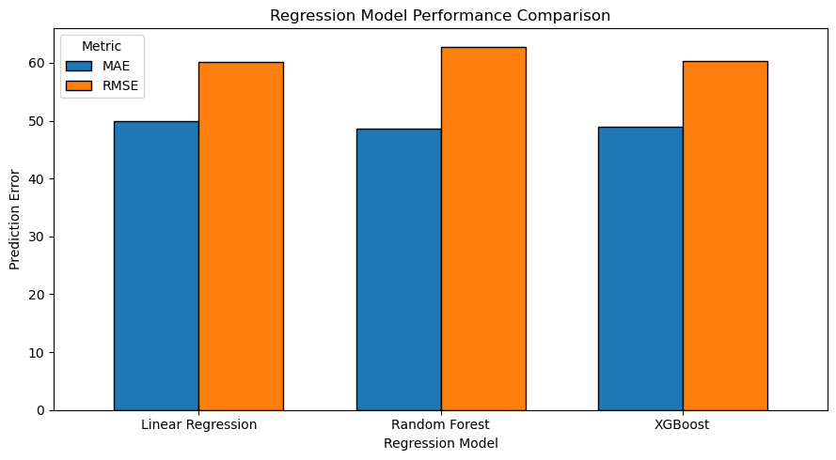
Figure 1 Regression Model Performance Comparison
Visual comparison of model performance demonstrated similar prediction errors across Linear Regression, Random Forest, and XGBoost.
Phase 7: Discussion & Conclusion
Three regression models: Linear Regression, Random Forest, and XGBoost were evaluated to predict diabetes disease progression using five baseline patient characteristics. Linear Regression received the lowest RMSE and highest R², while Random Forest produced the lowest MAE, and XGBoost demonstrated comparable performance to Linear Regression. Although Random Forest and XGBoost can capture nonlinear relationships and interactions, their increased complexity did not consistently improve predictive accuracy compared to the Linear Regression model. Linear Regression was selected as the preferred model based on its lower RMSE, higher R², and greater interpretability compared with Random Forest and XGBoost. Random Forest had lowest MAE, however, Linear Regression provided the strongest overall balance of predictive performance and model simplicity.
BMI was the highest ranked predictor in both tree-based models, followed by blood pressure, and blood sugar. Study limitations included the small sample size, restricted predictor set, and reliance on a single training / testing split without cross – validation or hyperparameter tuning.
Overall, the findings emphasize the importance of comparing multiple modeling approaches and considering predictive accuracy, interpretability, and model complexity when selecting regression methods for healthcare applications.

