Lab 4 : Animating a Character

Lab Overview:
This lab involves setting up an animated character using Unity's Animator system. You will configure an animation state machine, create transitions between animations, and modify the character script to control the animations based on user input.

Step-by-Step Solution:

Task 1: Setup the Animator and Avatar for Both the Character and Animations
- Open the github classroom assignment and download the repo :
https://classroom.github.com/a/kfjdhHaR
2. Once the repo is clone , Open the Sample Scene
  - In the scene folder, Open the sample scene . You should see something like this
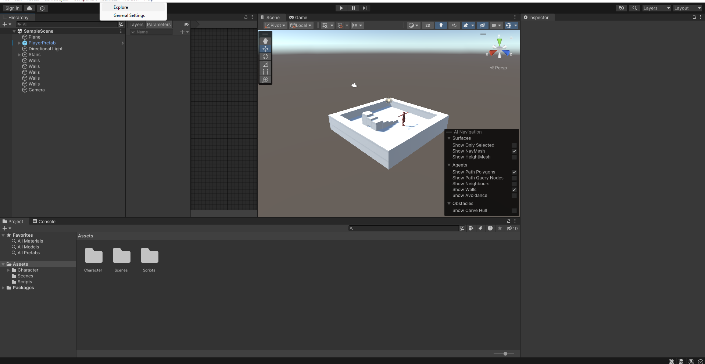
- Select Your Character:
  - In Unity, go to the Hierarchy window and locate your Player prefab.
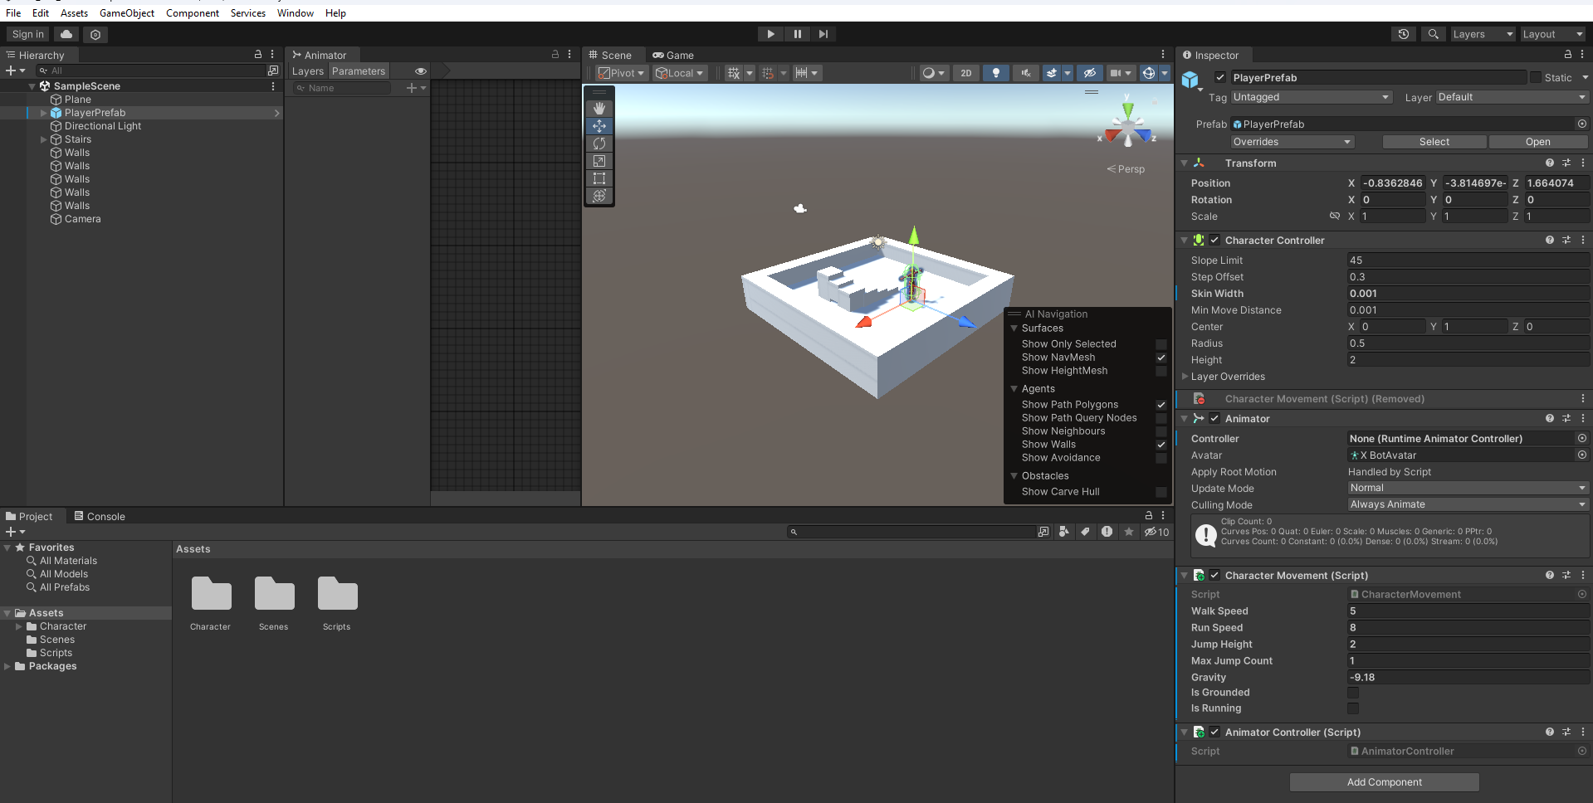
- Create an Animator Controller:
  - In the Assets window (Project tab),open the Character Folder, then the Animation Folder
  - Then right-click and choose Create > Animator Controller.
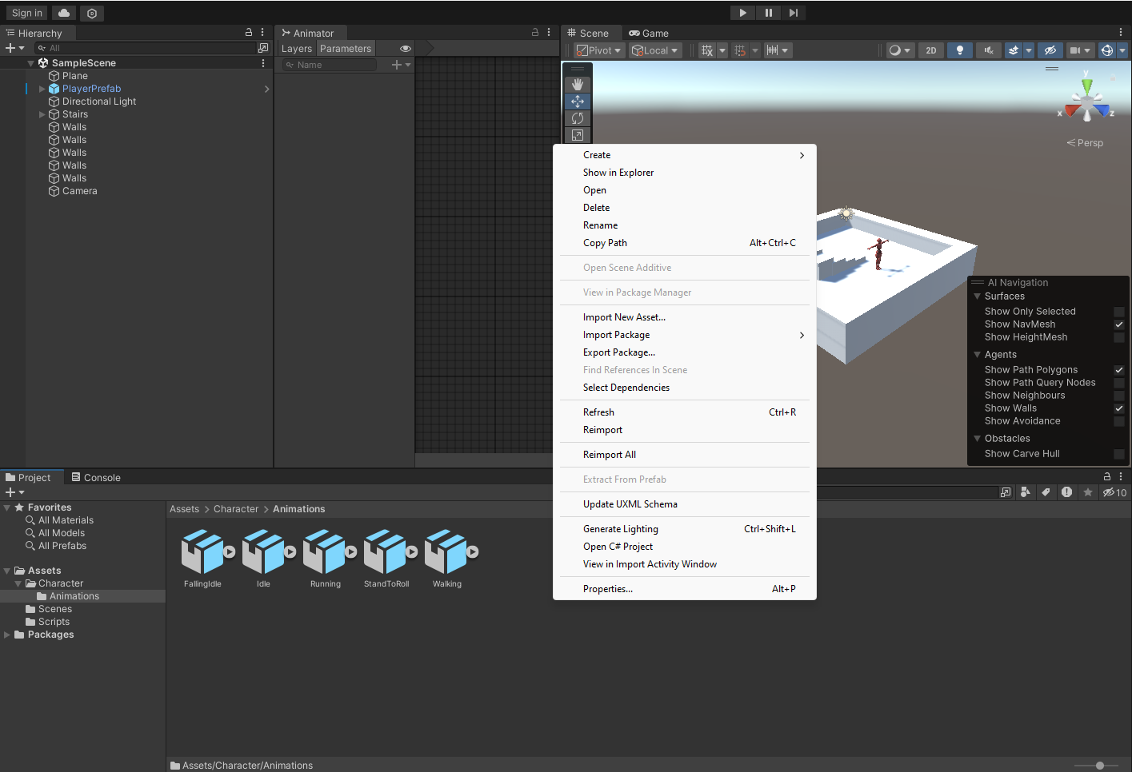
  - Name the new Animator Controller, for example, CharacterAnimator.

  - 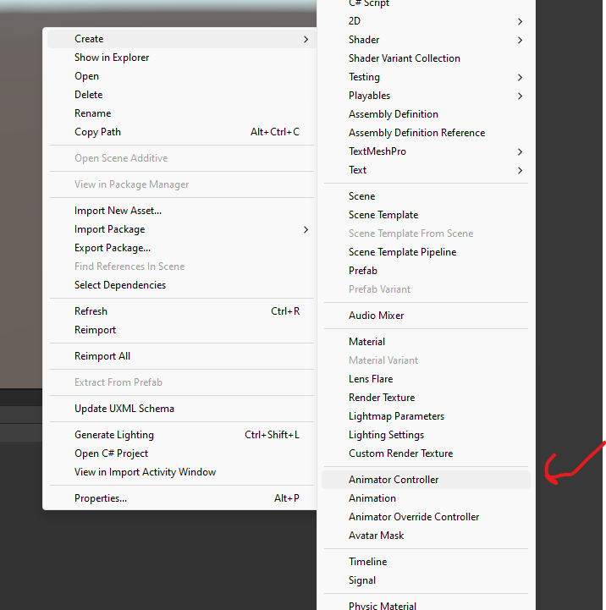
- Assign the Animator Controller to the Character:
  - Select your character in the Hierarchy and look in the Inspector window.
  - Under the Animator component, assign the newly created CharacterAnimator controller by dragging it from the Assets window to the Controller slot in the Animator component.
  - 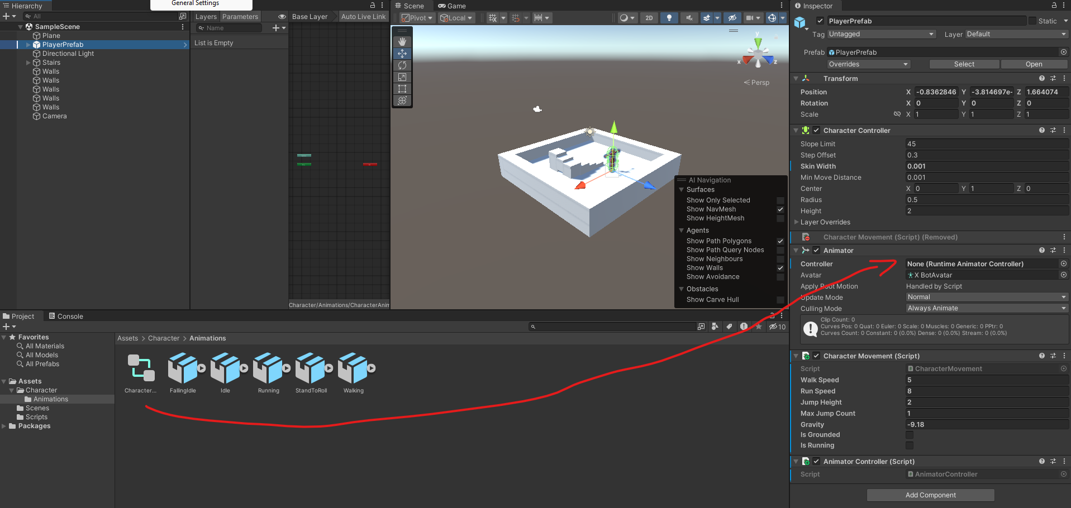
- Ensure the Avatar is Assigned:
  - In the Animator component, there is a field for Avatar. Ensure that the Avatar (skeleton) for your character is properly assigned here. Unity should auto-assign it when importing the character, but if it is missing, you can manually select the Avatar file associated with your character model.
  - 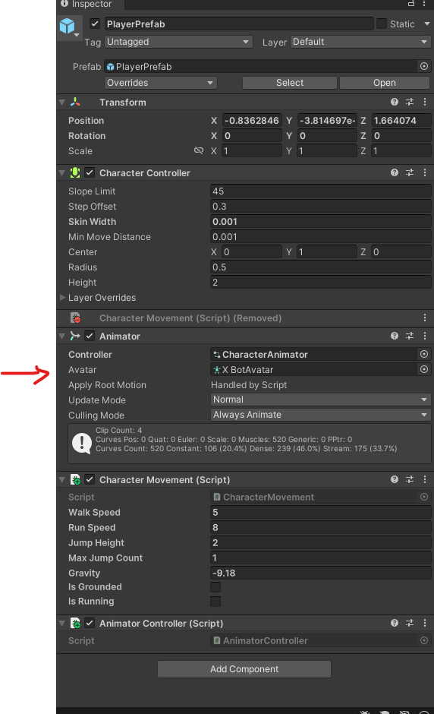
- Open the Animator Controller:
  - You should already have animations (Idle, Walking, Running, Rolling, Falling) in your Animation folder( Assets/Character/Animation).
  - Open the Animator window by going to Window > Animation > Animator or by double clicking on the CharacterAnimator in the assets view .
    - You should see a window like this that pop up
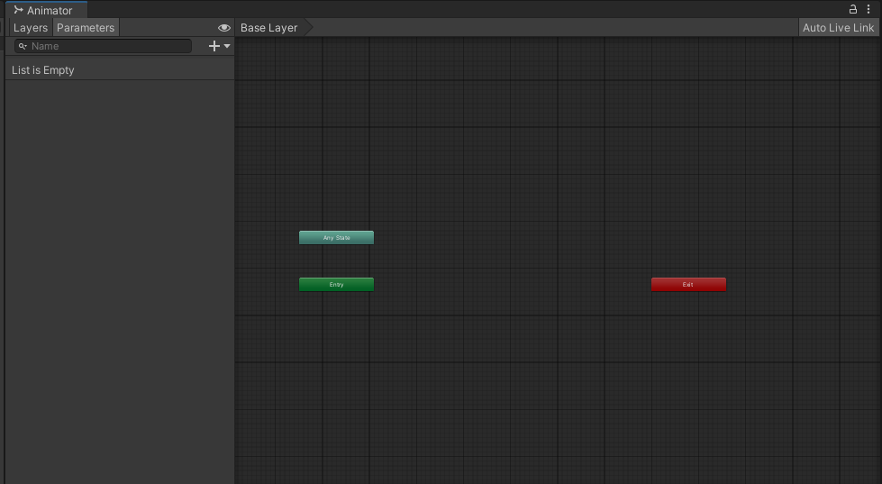

Task 2: Create a Blend Tree for Movement (Idle/Walking/Running)
- Create a Blend Tree State:
  - In the Animator window, right-click in an empty space and choose Create State > From New Blend Tree.
  - 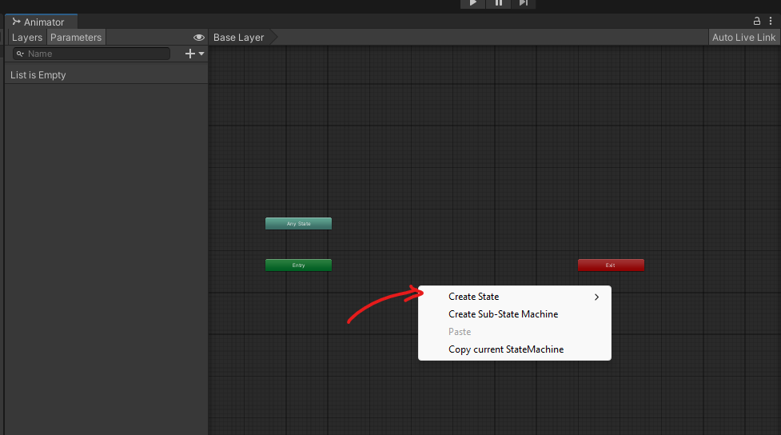
  - 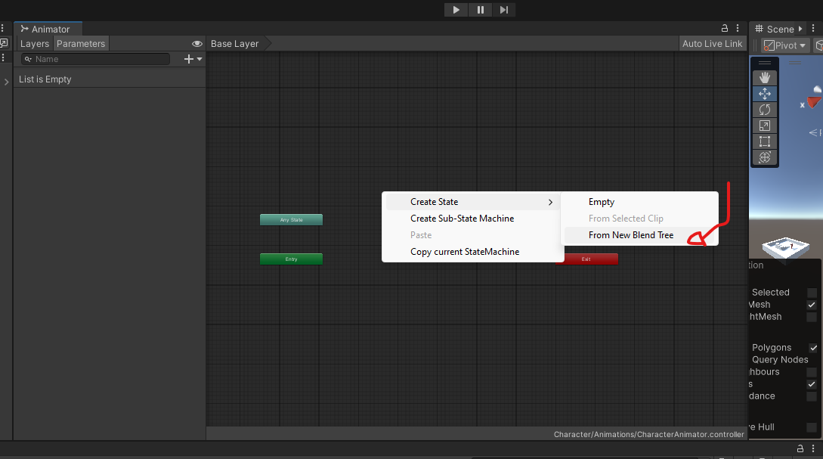

  - 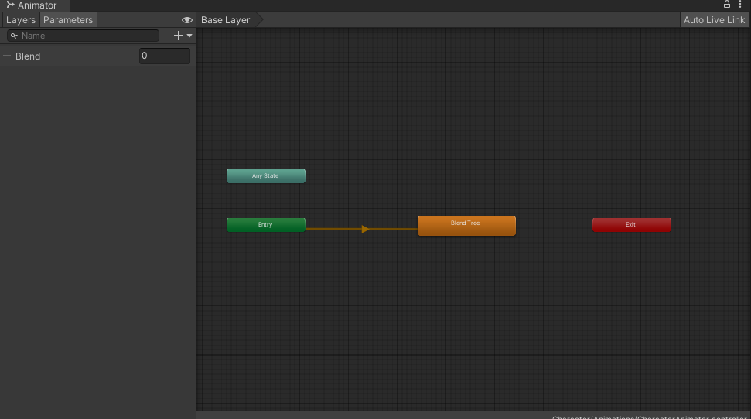
    - In order to rename it. Right click on the Orange box and details of that stat should show up in the inspector

    - 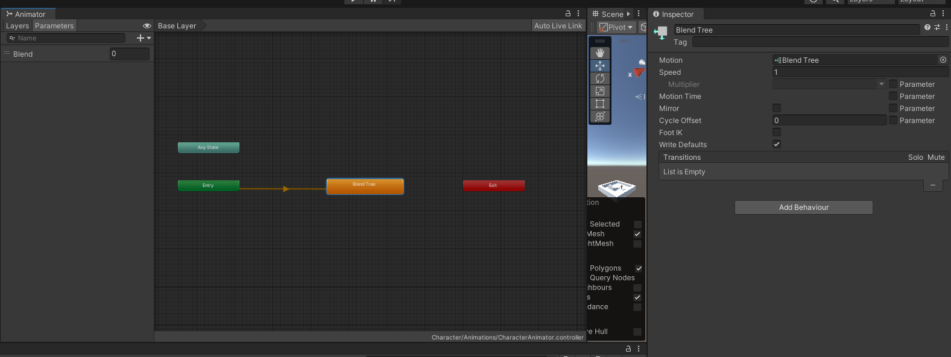
    - You can now rename the State at the top of the Inpsector
    - Rename this blend tree Idle/Walking/Running to represent the different movement states.

  - By default, this state should appear in orange, meaning it is the entry state (the default state when the game starts).

- Open the Blend Tree:
  - Double-click on the Idle/Walking/Running state to open the blend tree editor.
  - 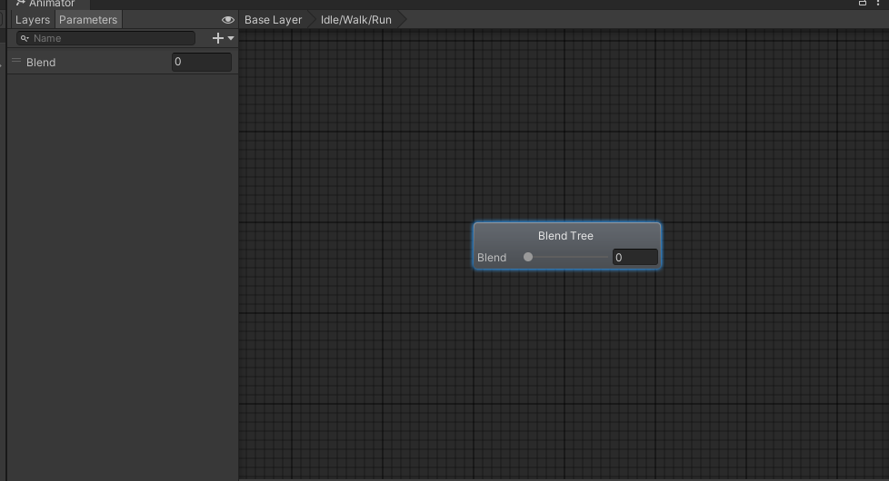
- Set the Blend Parameter:
  - In the Inspector panel (while the blend tree is selected), you will see a Blend section.
  - 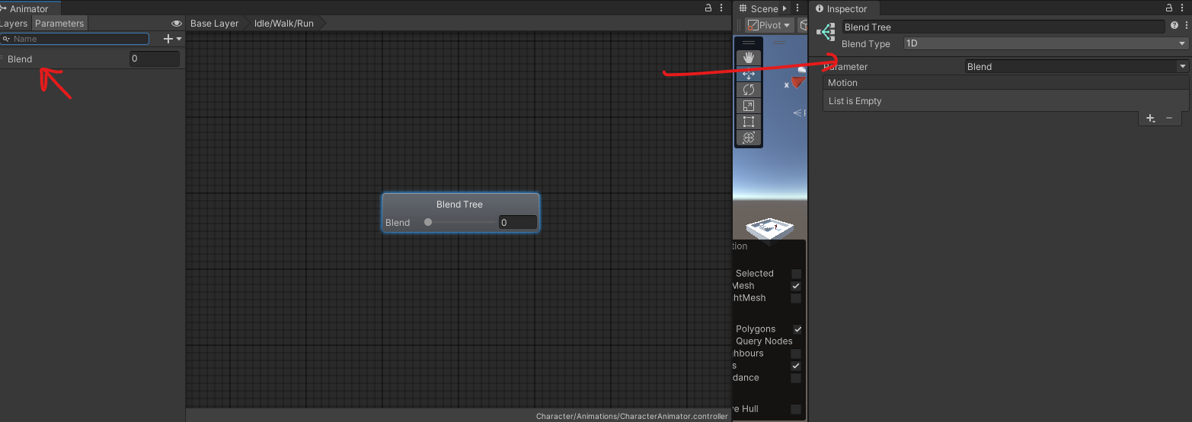
  - Set the Blend Parameter to a new parameter called CharacterSpeed. This parameter will control which animation (Idle, Walking, or Running) plays based on the character’s speed.

- Add Animations to the Blend Tree:
  - In the Inspector panel, click + Add Motion Field to add animation slots to the blend tree.

  - Do that 3 times 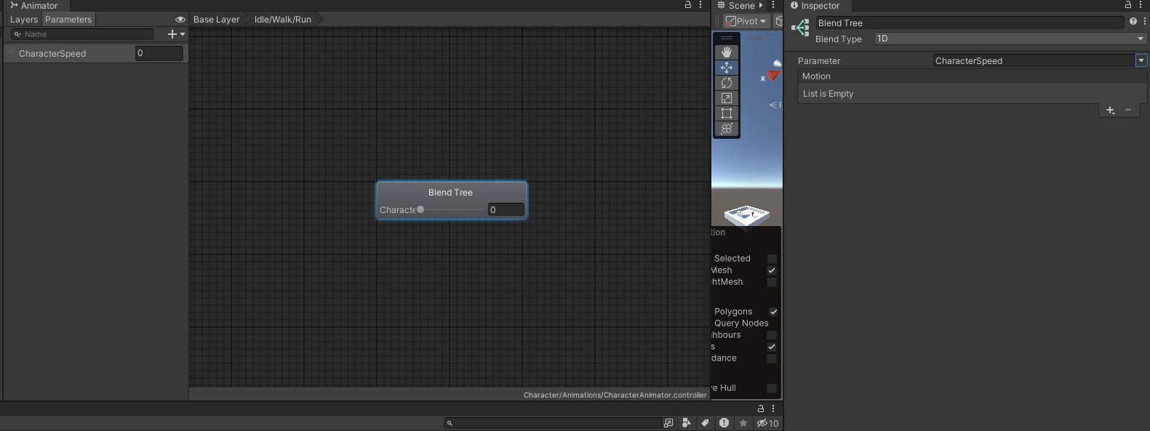
  - 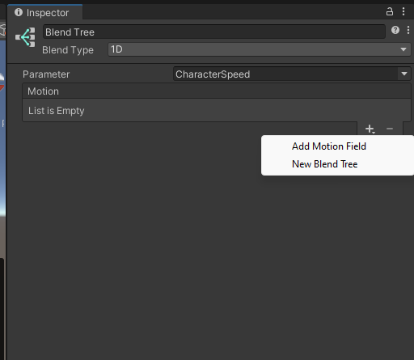

  - 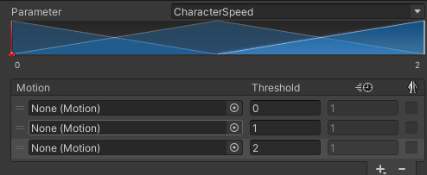
  - Click the little dot in the entry of the List of Motion,then select
  - 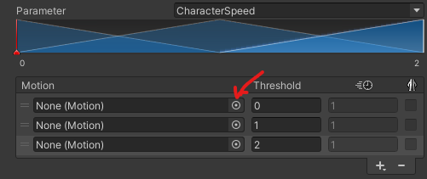
  - 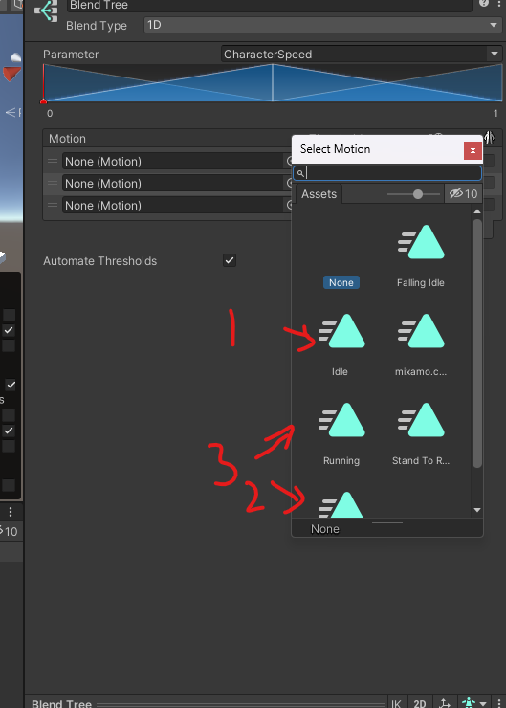
Idle to the first slot , Walking to the second, and Running to the third slot.
  - Uncheck the Compute threshold checkbox.
  - 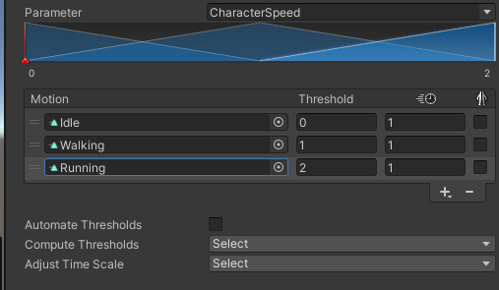
  - Your blend tree all setup should look like the picture above

- Configure Speed Thresholds:
  - Set the speed values for each animation to correspond with different character speeds:
    - Idle: Speed = 0
    - Walking: Speed = 5
    - Running: Speed = 7
  - 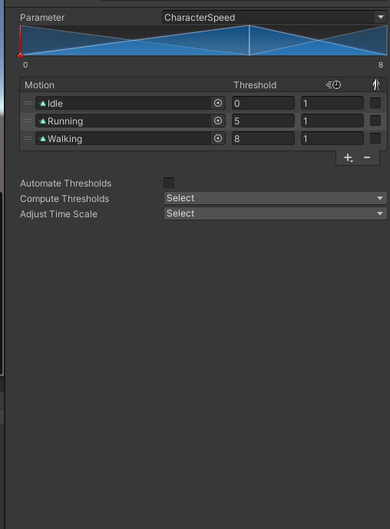
  - As the Character Speed parameter increases from 0 to 2, the blend tree will interpolate between these animations based on the speed of the character.

Go back to the base layer in the Animator by clicking on the Base Layer Button :
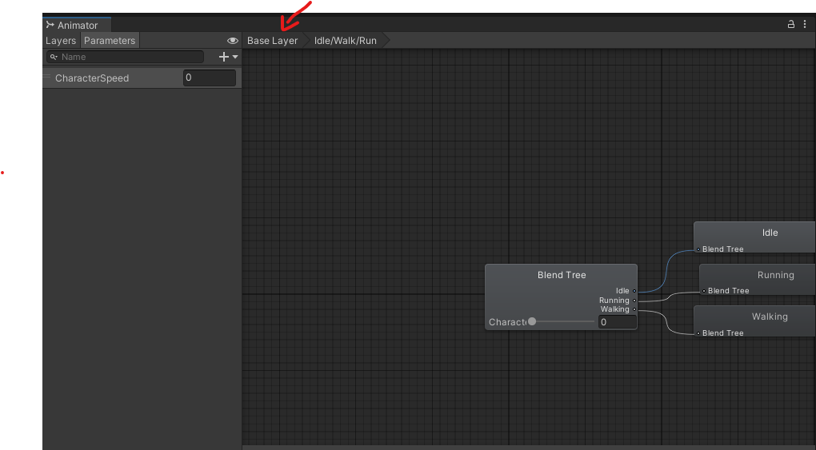

Task 3: Create Transitions for the "Stand to Roll" Animation
- Add the Rolling Animation:
  - Drag the Stand to Roll animation from your Assets folder into the Animator window, creating a new state.

- Create a Transition from Idle/Walking/Running to Rolling:
  - Right-click on the Idle/Walking/Running blend tree and select Make Transition.
  - Drag the arrow to the Stand to Roll state.
  - 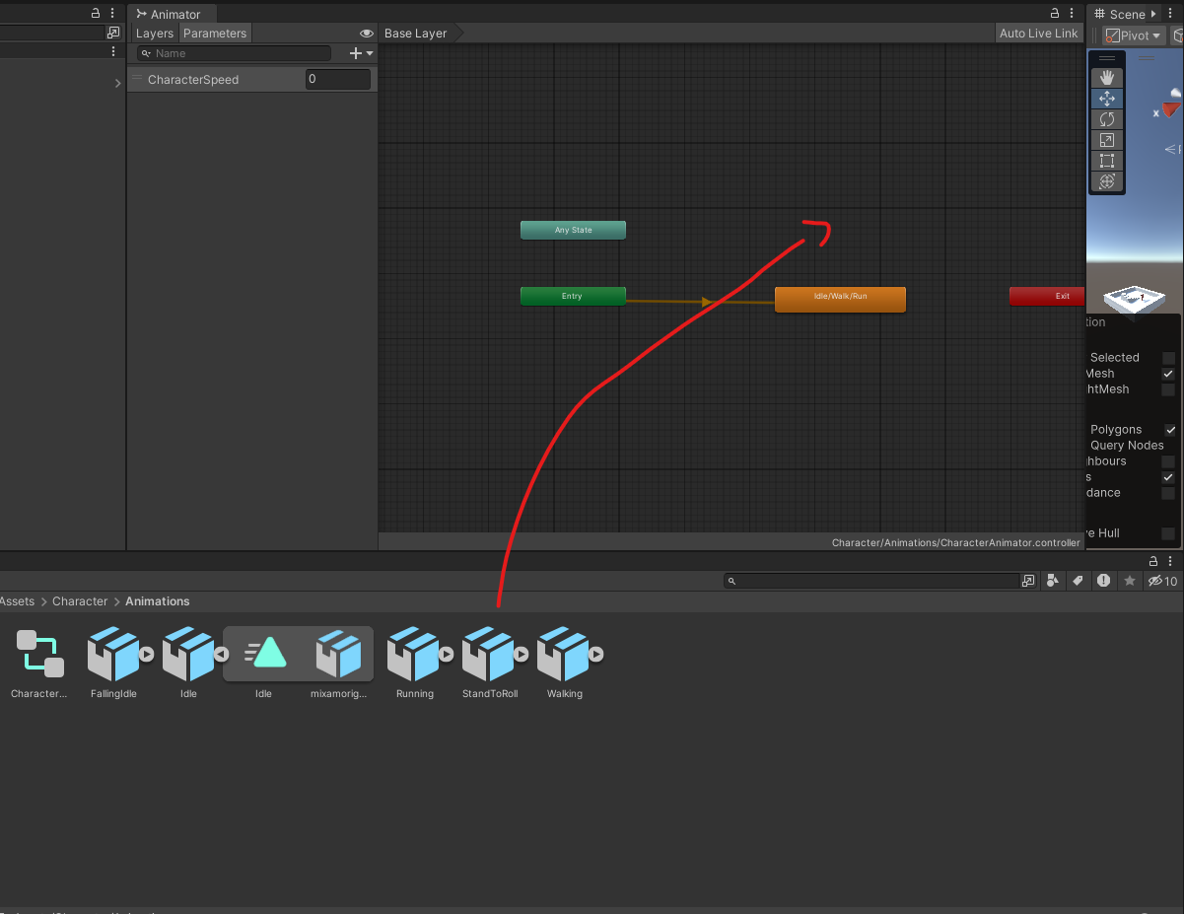

- Create a Transition from Rolling back to Idle/Walking/Running:
  - Right-click on the Stand to Roll state, choose Make Transition, and drag the arrow back to the Idle/Walking/Running blend tree.
  - 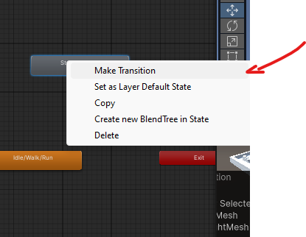
  - 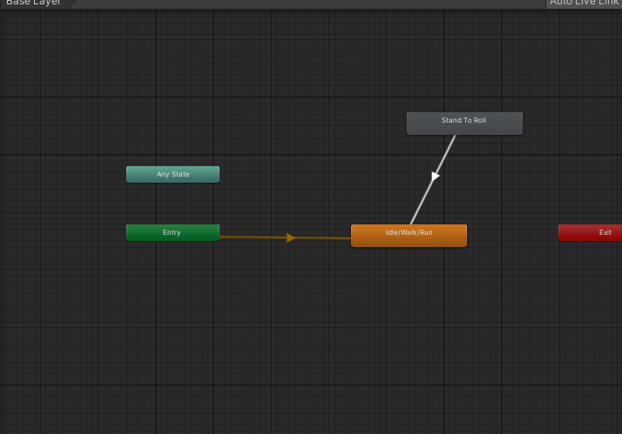
- Setup the "IsRolling" Parameter:
  - In the Animator window, click the Parameters tab (next to Layers).
  - 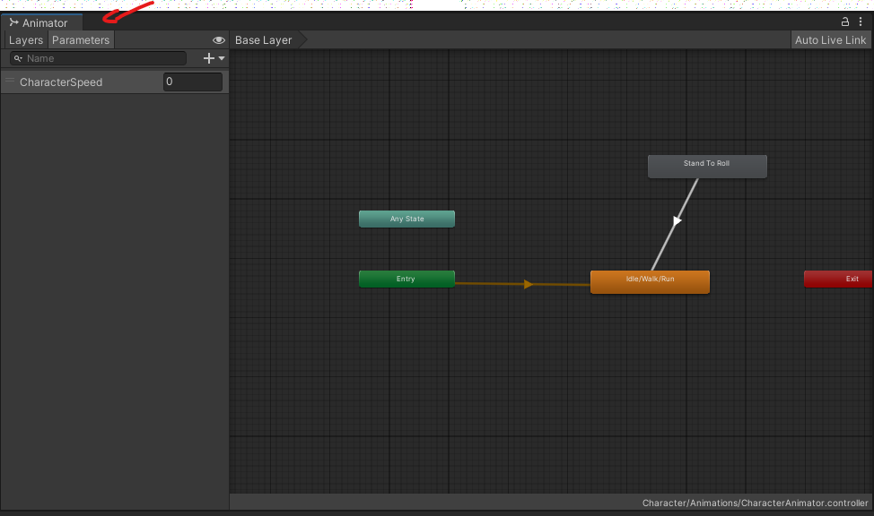
  - Add a new Trigger parameter called doRoll.
  - 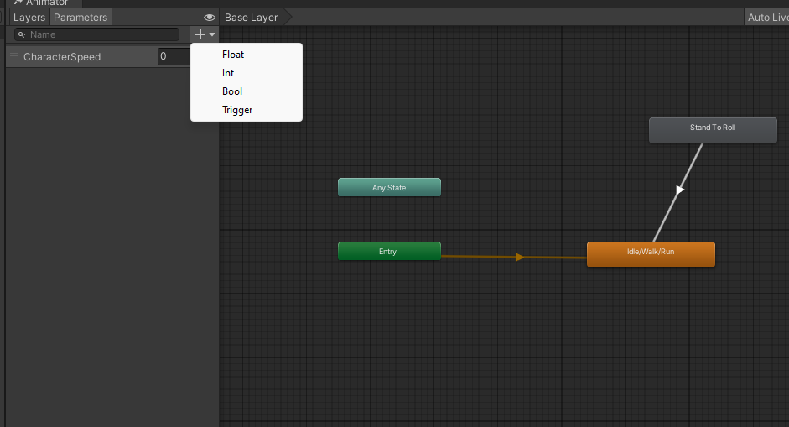
  - 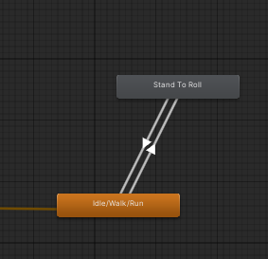
  - By the end your stand to roll should be connected like the previous picture
- Configure Transition Conditions:
  - Select the transition from Idle/Walking/Running to Stand to Roll.
    - Add the parameter doRoll in the condition
    - Uncheck Has Exit time
    - 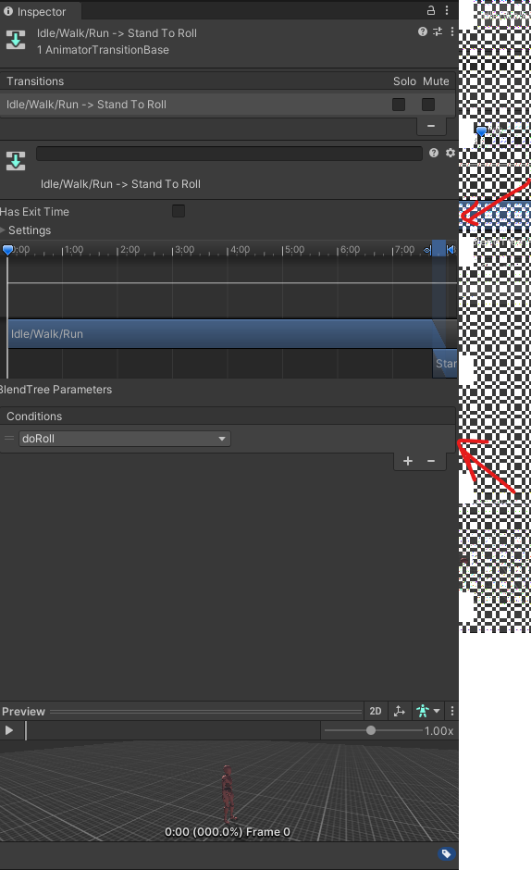
  - Select the transition back to Idle/Walking/Running make sure the HasExitTime is still checked to make sure the roll animation plays fully before going back to the Idle/Walk/Run state
  - 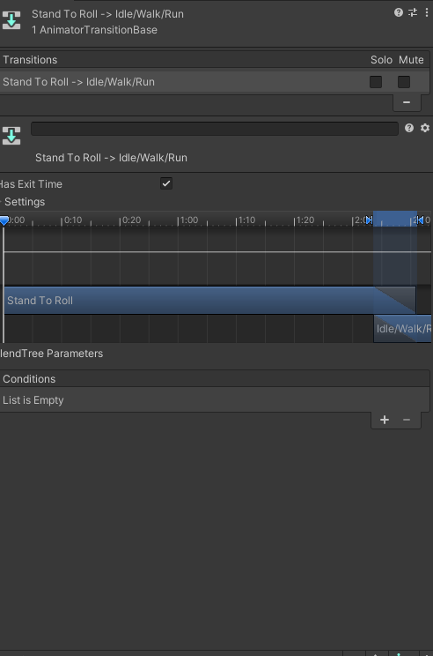

Adding a behaviour to the roll.
Click on the state Stand to roll

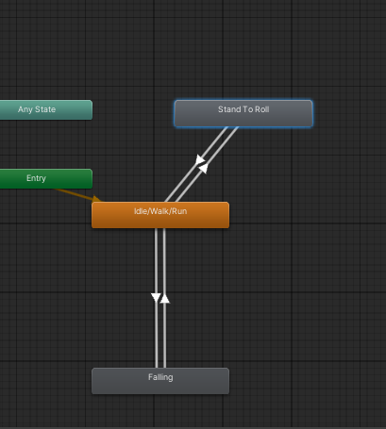

On the left panel you should see this window click on the Add behaviour button.
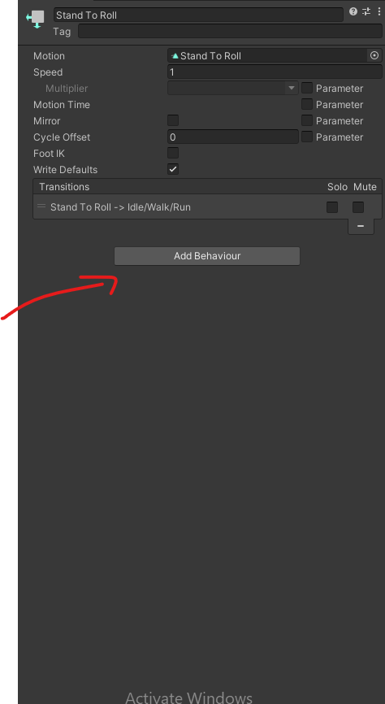
Click new Script
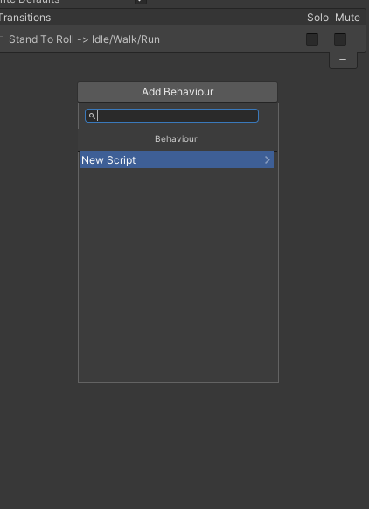
Call it Roll Behaviour
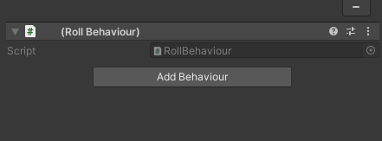

Update the script you just created this script. This will enable and disable rootmotion at the begining and end of the roll animation so that only the roll is affected by root motion.
using System.Collections;
using System.Collections.Generic;
using UnityEngine;

public class RollBehaviour : StateMachineBehaviour
{
// OnStateEnter is called when a transition starts and the state machine starts to evaluate this state
override public void OnStateEnter(Animator animator, AnimatorStateInfo stateInfo, int layerIndex)
{
animator.applyRootMotion = true;
}

// OnStateExit is called when a transition ends and the state machine finishes evaluating this state
override public void OnStateExit(Animator animator, AnimatorStateInfo stateInfo, int layerIndex)
{
animator.applyRootMotion = false;
}
}

Task 4: Create Transitions for Falling Animation
- Add the Falling Idle Animation:
  - Drag the Falling animation from your Assets folder into the Animator window, creating a new state.
  - 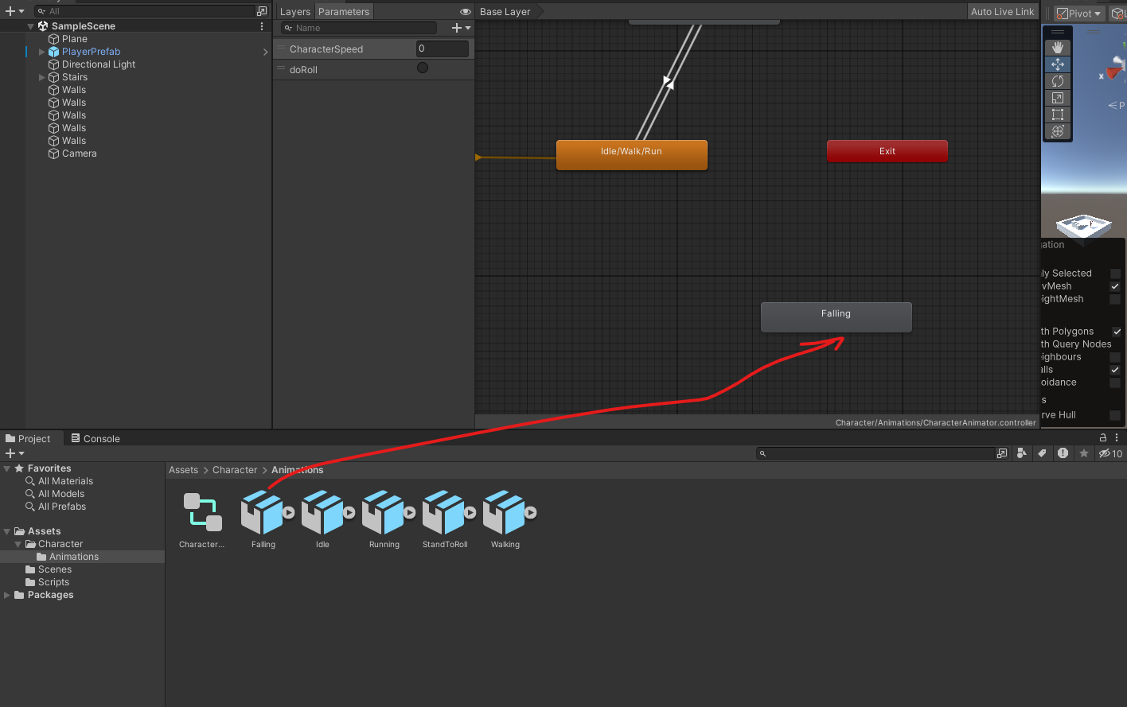
- Create a Transition from Idle/Walking/Running to Falling:
  - Right-click on the Idle/Walking/Running state, select Make Transition, and drag the arrow to the Falling state.
  - 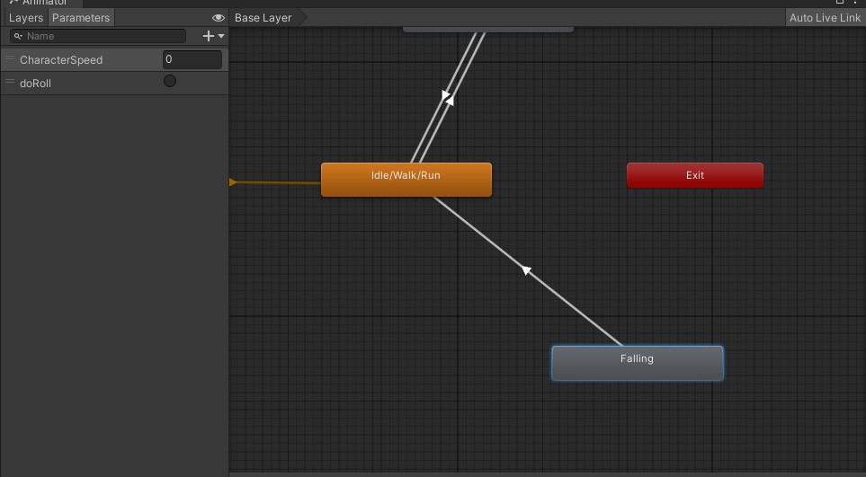
- Create a Transition from Falling back to Idle/Walking/Running:
  - Right-click on the Falling state, select Make Transition, and drag the arrow back to Idle/Walking/Running.
  - 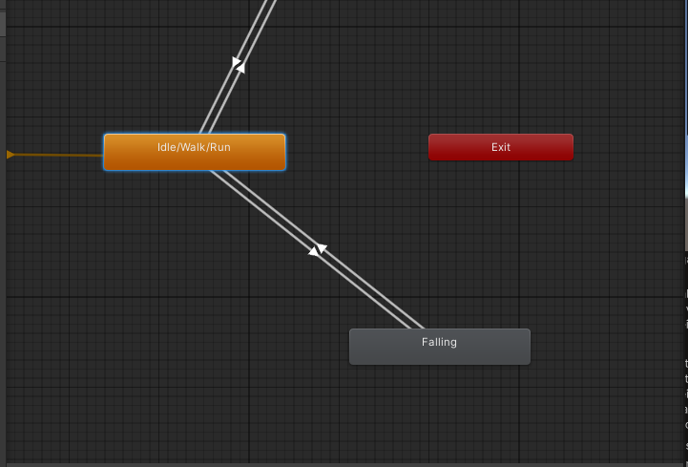
- Setup the "IsGrounded" Parameter:
  - In the Parameters tab, add a new Bool parameter called IsGrounded.
  - 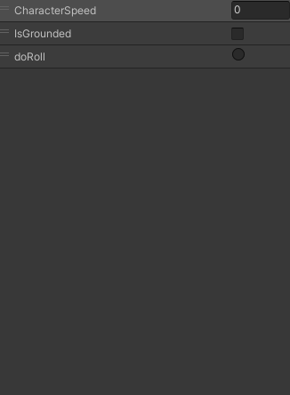
- Configure Transition Conditions:
  - Select the transition from Idle/Walking/Running to Falling.
  - In the Inspector, set the condition to IsGrounded== false and make sure HasExitTime is checked off. ( We want to transition as soon as IsFalling Becomes true
  - 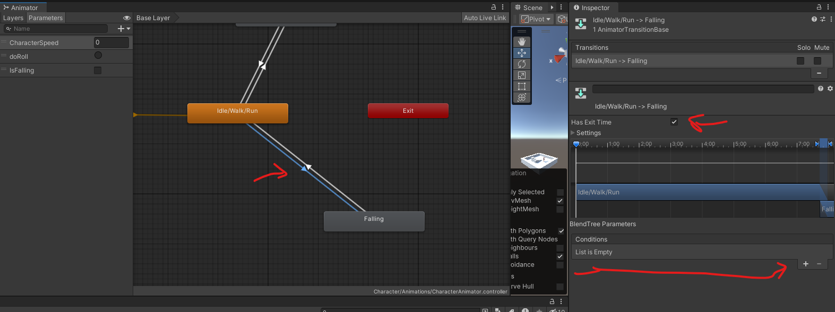
  - 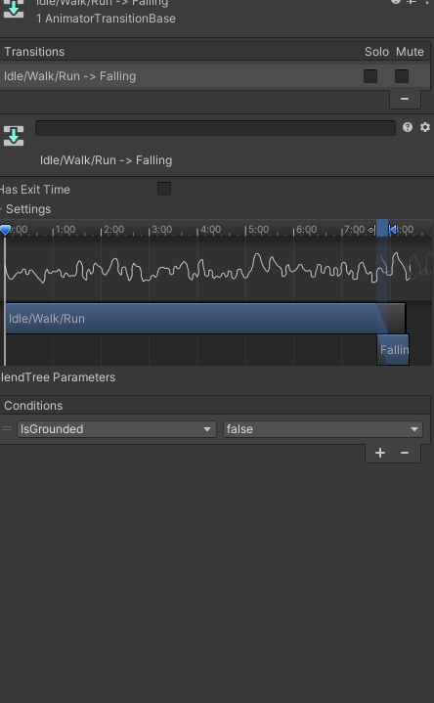
  - Select the transition from Falling Idle back to Idle/Walking/Running and set the condition to IsGrounded== true and we also want to make sure HasExitTime is checked off.
  - 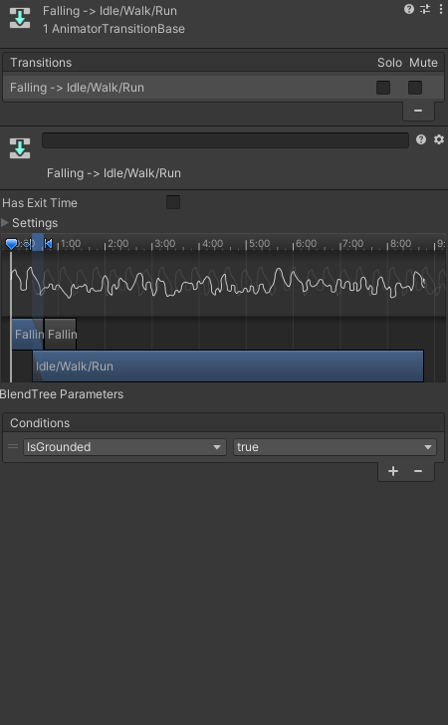
- Make sure the parameter IsGrounded is set to true by default
- 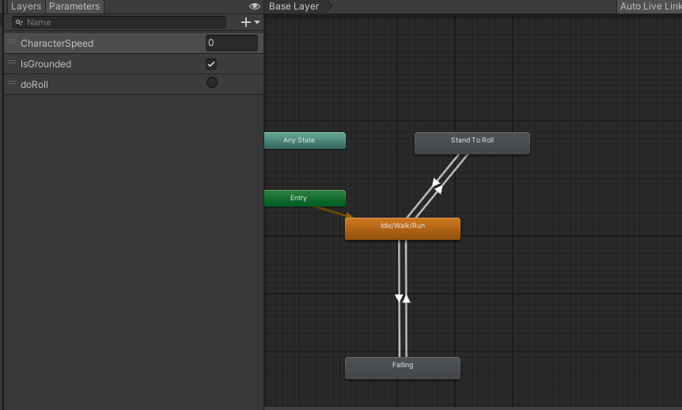

Task 5: Create an PlayerAnimatiorController Script to Control Animation Parameters
Create a script called PlayerAnimatiorController on the Player use this code by click add component and creating a new script on the player game object

using System.Collections;
using System.Collections.Generic;
using UnityEngine;

public class PlayerAnimatorController : MonoBehaviour
{
private Animator animator;
private CharacterMovement movement;
private Rigidbody rb;

public void Start()
{
animator = GetComponent<Animator>();
movement = GetComponent<CharacterMovement>();
rb = GetComponent<Rigidbody>();
}

public void Update()
{
animator.SetFloat("CharacterSpeed", rb.velocity.magnitude);
animator.SetBool("IsGrounded", movement.IsGrounded);

if (Input.GetButtonUp("Fire1"))
{
animator.SetTrigger("doRoll");
}
}
}

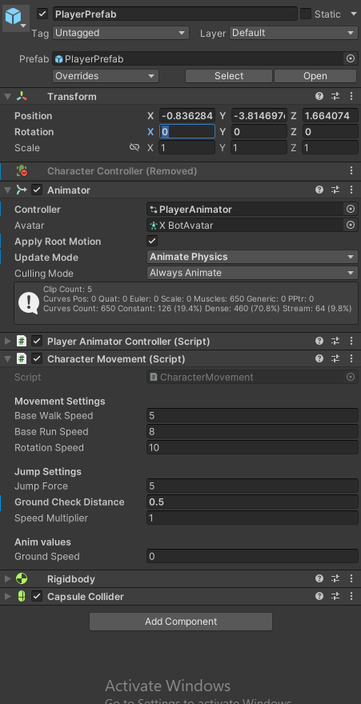

Final Steps:
- Test Your Project:
  - Press Play in Unity to test the character’s animations. Ensure the transitions between Idle, Walking, Running, Rolling, and Falling work as expected based on your inputs.
- Submission:
  - Submit your assignment through github

