# Lab 3: Instantiate, Invoke, and Object Lifetime

#### **Setup:**

1. Clone the repository:
   * Open this link : <https://classroom.github.com/a/UOppABh8>
   * Follow the instruction to clone the repo with Github Desktop
2. Open the sample scene in scene folder   
   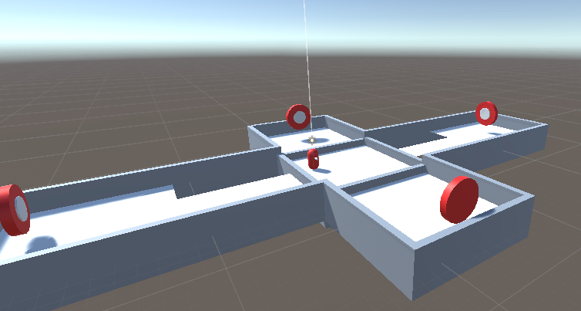

### **Task 1: Create a Bullet/Canonball Prefab**

1. **Create a new GameObject**:
   * Right-click in the *Hierarchy* and select Create > 3D Object > Sphere.
2. **Add Rigidbody Component**:
   * Select the sphere in the *Hierarchy*.
   * In the *Inspector* panel, click Add Component and search for Rigidbody.
   * Make sure the Rigidbody's Use Gravity checkbox is ticked to allow gravity to affect the bullets and make sure it is not a Kinematic object by making sure that the IsKinematic Checkbox is NOT ticked.
   * 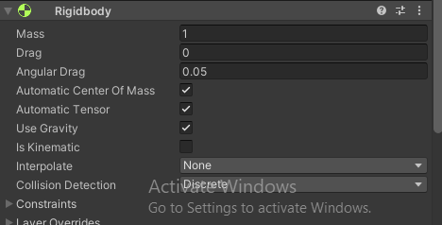
3. **Add Tag**:
   * Click the sphere again, go to the *Inspector*, and click on the Tag dropdown.
   * Select or add a new tag called "Projectile" by clicking Add Tag, then choose Projectile from the list.
   * 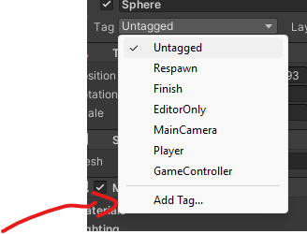
   * 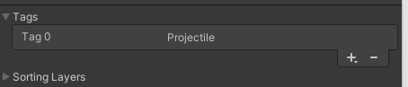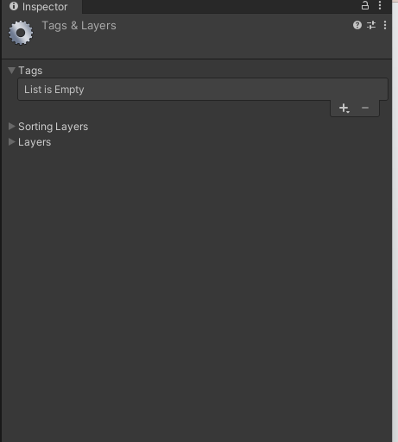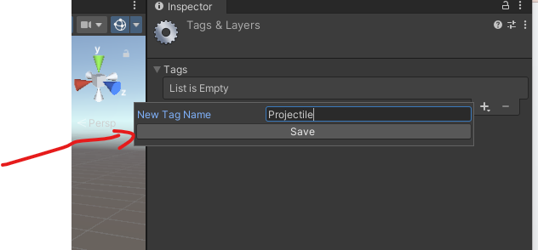
   * Make sure you choose projectile for you bullet after creating the tag.
4. 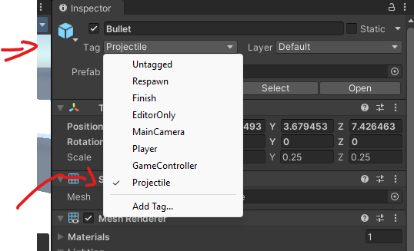
5. Apply the bullet material

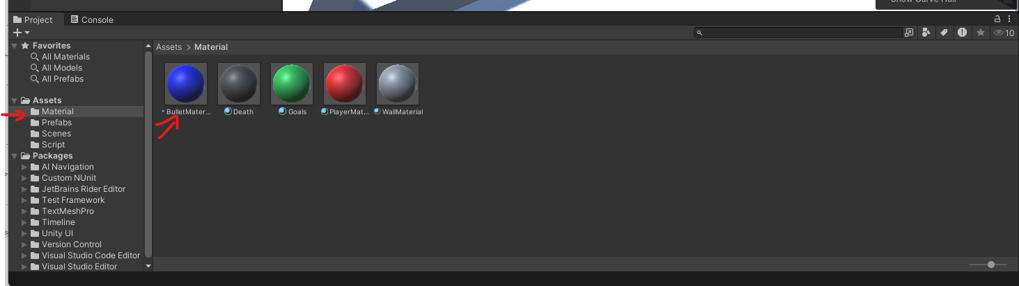

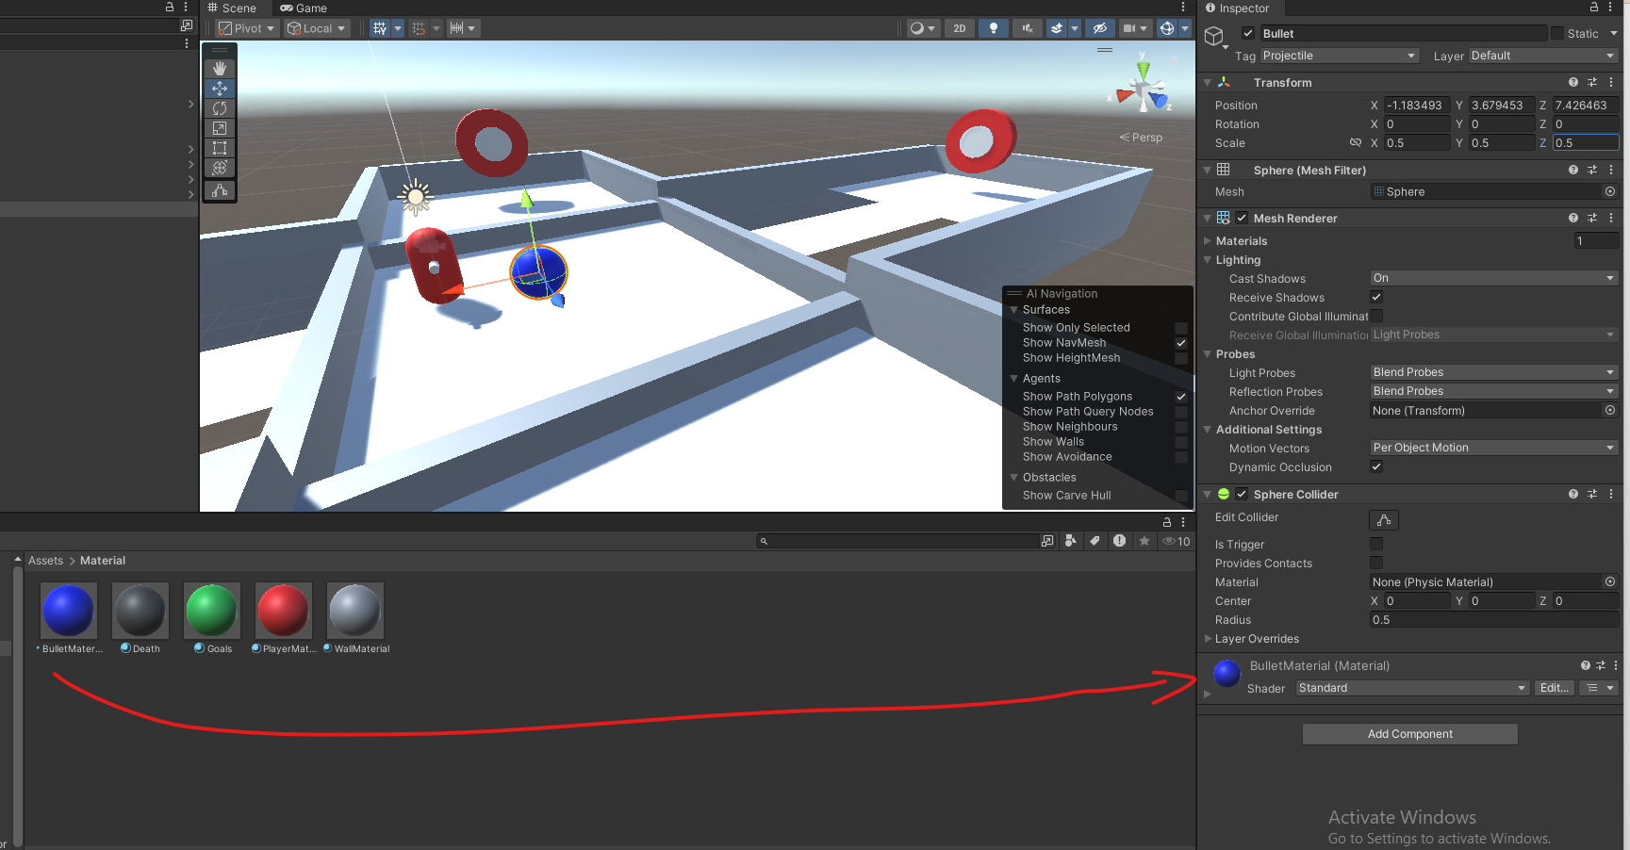

* + Your bullet should look something like this :
  + 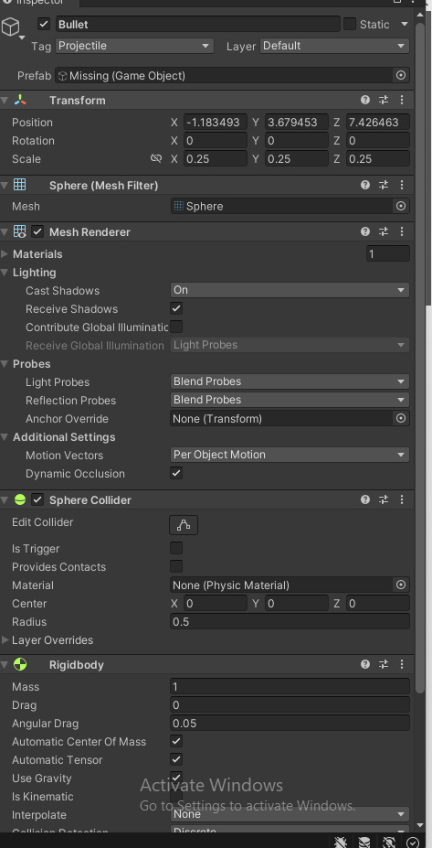

1. **Save it as a Prefab**:
   * Drag the sphere from the *Hierarchy* into the *Project* panel to save it as a prefab.
   * 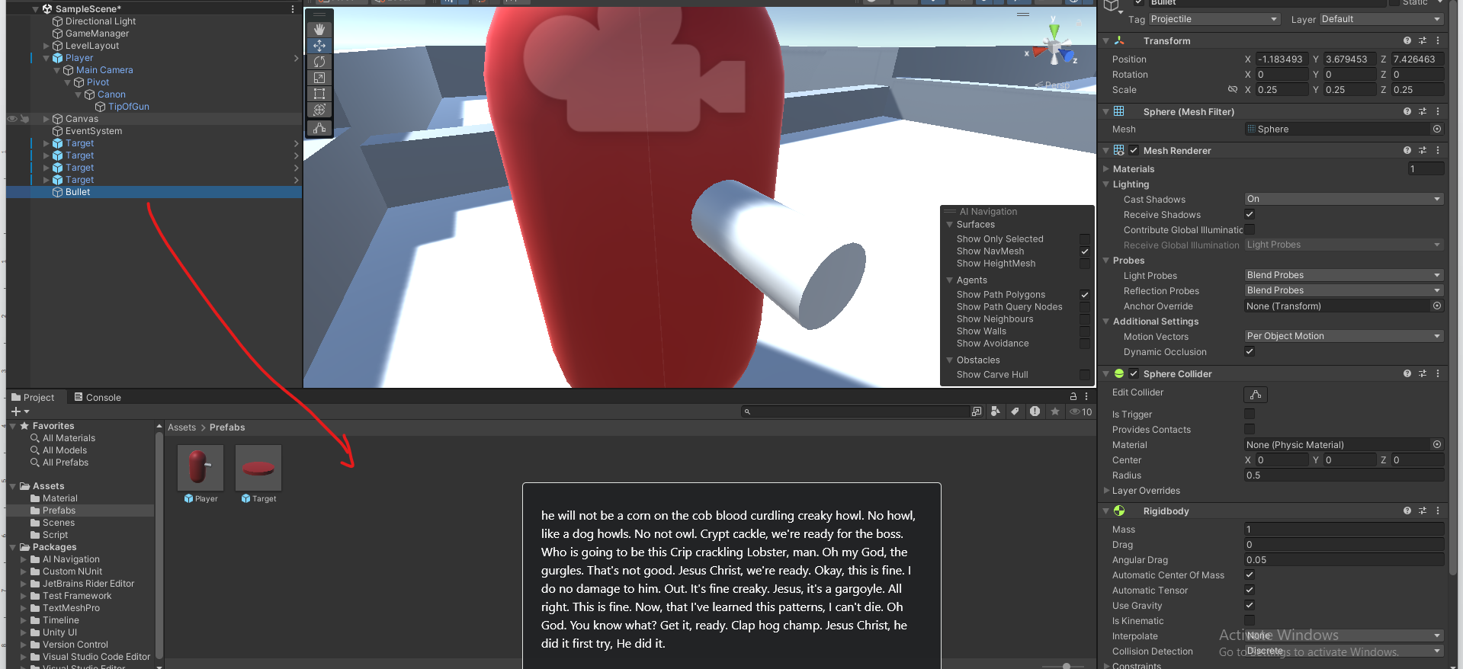

### **Task 2: Create a BulletComponent Script**

1. **Create a Script**:
   * In the *Project* panel, right-click and select Create > C# Script.
   * Name it BulletComponent.
2. **Edit the Script**:
   * Open BulletComponent.cs in the code editor.
   * The bullet component will contain the code for destroying the ball

using System.Collections;

using System.Collections.Generic;

using UnityEngine;

public class BulletComponent : MonoBehaviour

{

void Start()

{

// Destroy object after a few seconds

Destroy(gameObject, 5f);

}

}

1. **Attach the Script**:
   * Attach the BulletComponent script to your bullet prefab by dragging it from the *Project* panel to the prefab's *Inspector*.
   * 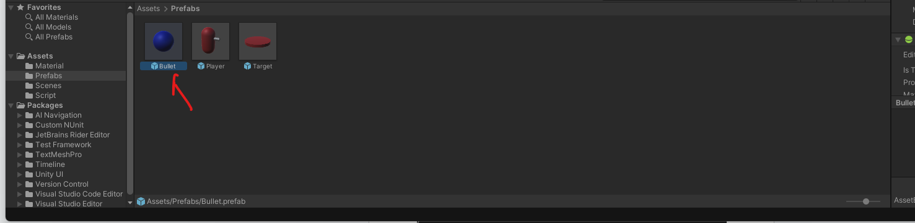

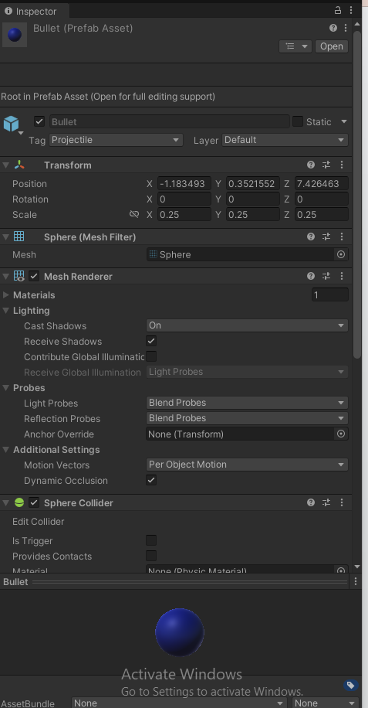

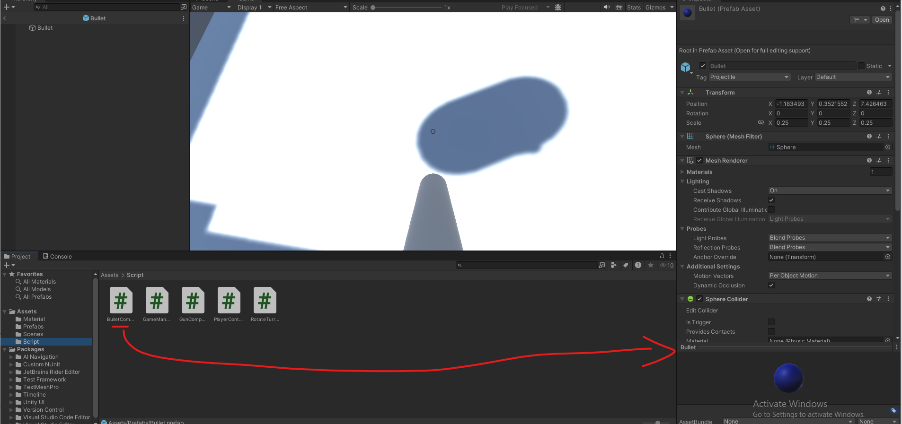

### **Task 3: Modify the Gun component to Spawn the bullets**

1. **Edit the Script**:
   * Open GunComponent.cs and implement the following:

using UnityEngine;

public class GunComponent : MonoBehaviour

{

public GameObject bulletPrefab;

public Transform bulletSpawnPoint;

public float bulletMaxImpulse = 100.0f;

public float maxChargeTime = 3.0f;

private float chargeTime = 0.0f;

private bool isCharging = false;

void Update()

{

// TODO add the logic to track player keeping the input down.

if (Input.GetButtonUp("Fire1"))

{

ShootBullet();

}

}

void ShootBullet()

{

GameObject bullet = Instantiate(bulletPrefab, bulletSpawnPoint.position, bulletSpawnPoint.rotation);

Rigidbody rb = bullet.GetComponent<Rigidbody>();

// TODO change that equation so that it adds an impulse that follows charge time

float bulletImpulse = bulletMaxImpulse;

// An impulse is a force you apply on a object in a single instant.

rb.AddForce(bulletSpawnPoint.forward * bulletImpulse, ForceMode.Impulse);

}

}

1. **Configure the Gun**:
   * The gun component should already be assigned to the Gun gameObject ( A child of the player ) You will need to assign the bullet prefab and the bullet spawn point in the *Inspector*.
   * 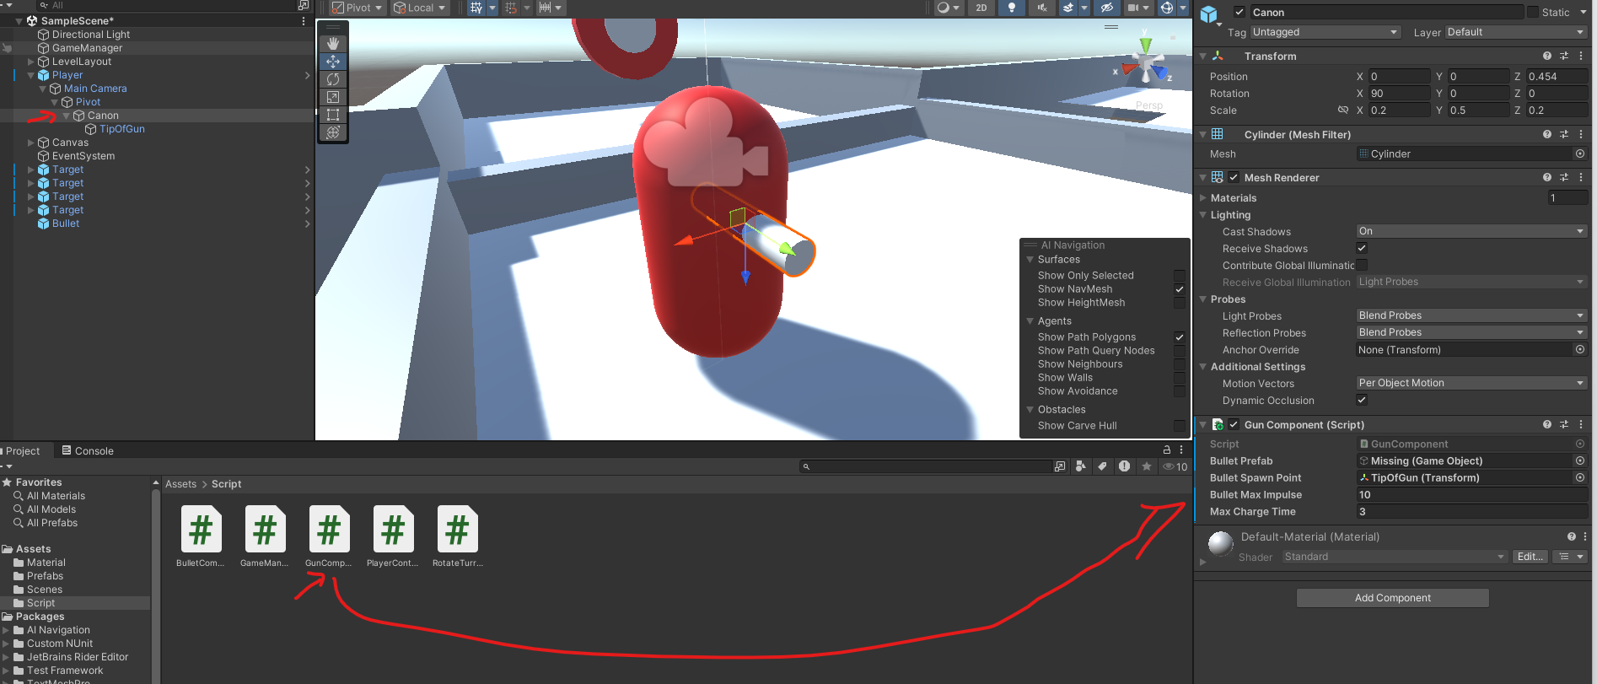

Assign **the tip of gun transform** as the bullet spawn point.

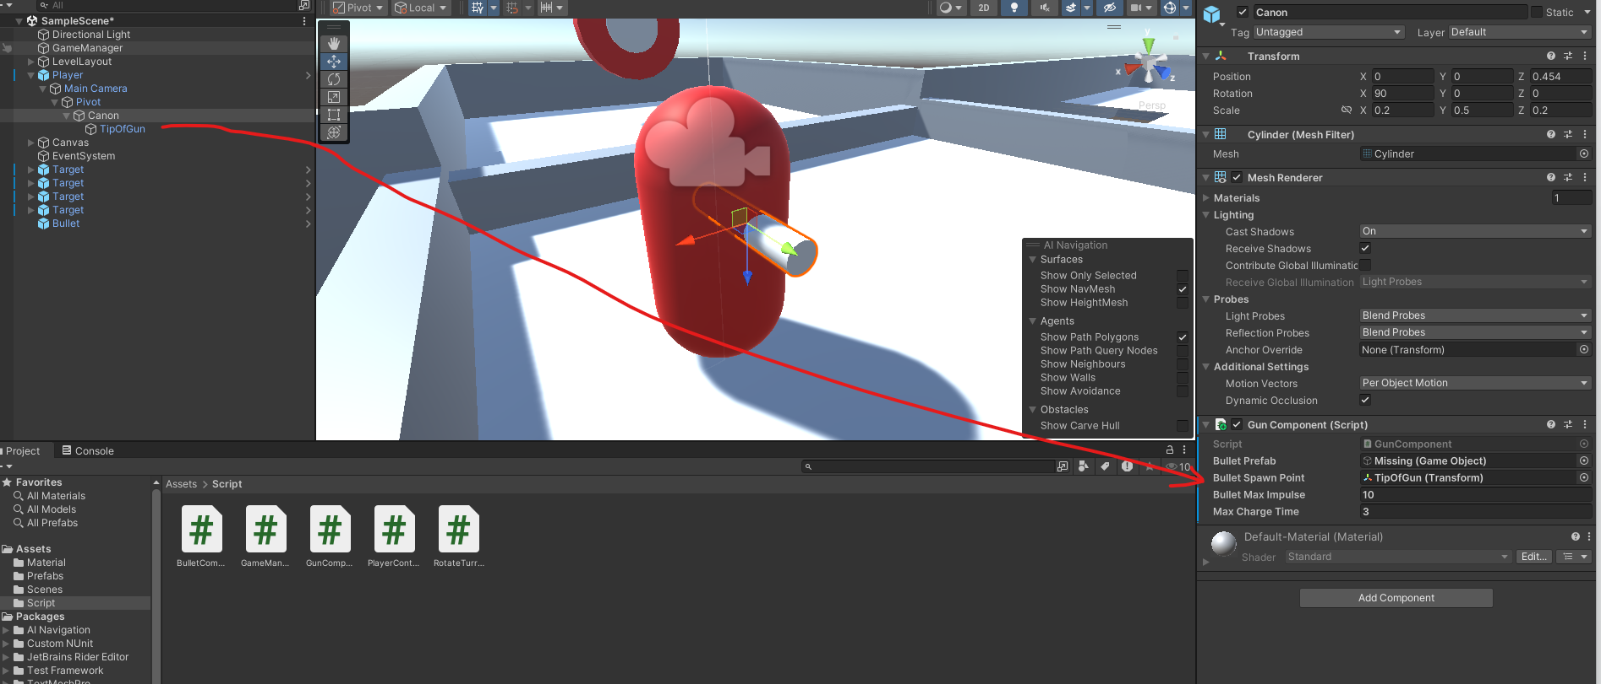

And the bullet prefab as the Bullet Prefab Proprety

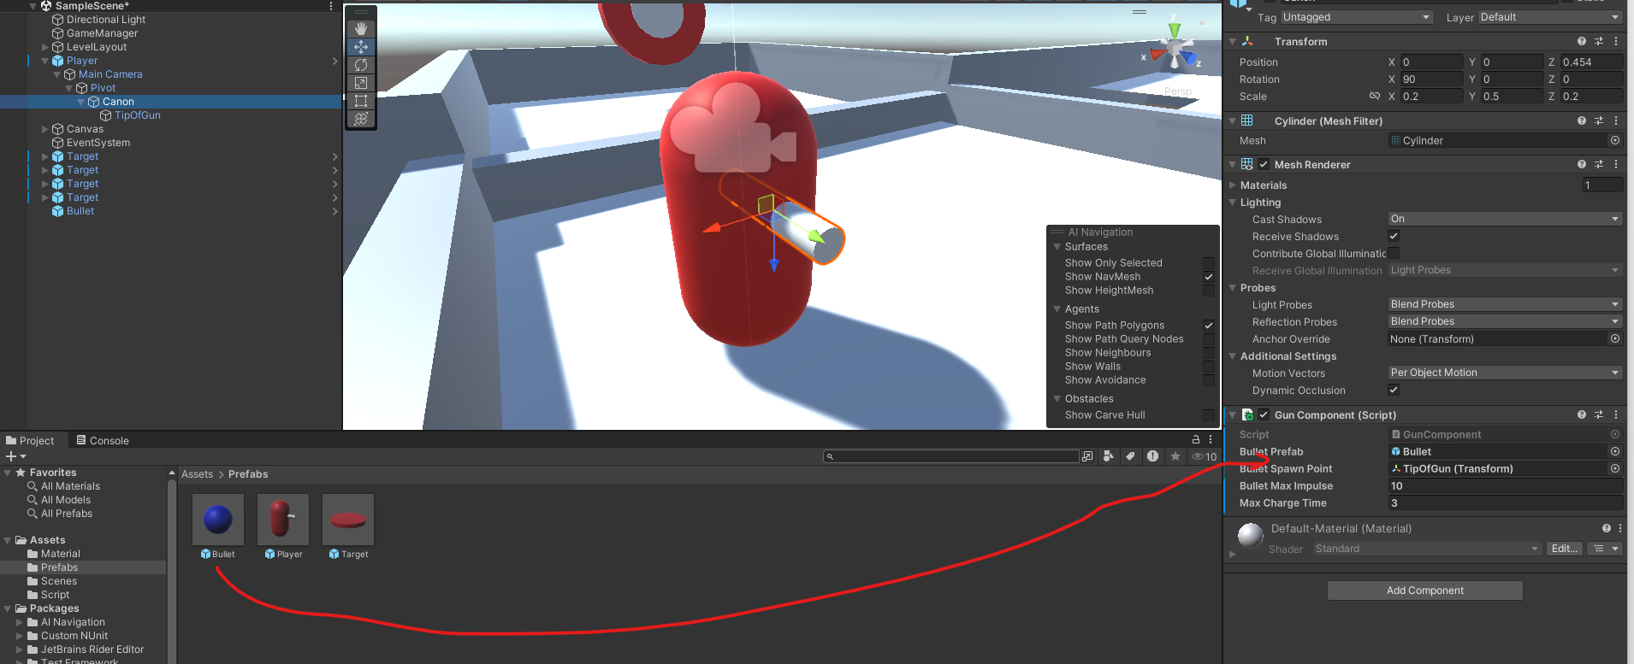

### **Task 5: Modify the Gun Component**

You will need now to modify the gun component Update function to add a charging mechanic for bullet speed. ( IE Charge longer, Bullet goes further )  
**Here are few hints :**

* This will be done within the Update() function.
* You need to detect when the player starts holding the fire button. Use an if condition with the boolean Input.GetButtonDown("Fire1") to detect when the button is initially pressed.
  + When a player first press down the button the chargetime should reset to 0.
* Using the boolean Input.GetButton("Fire1") increments the charge time every frame the button is held down. By adding the Time.deltaTime to the charge time.
  + You should increase the chargeTime value over time using Time.deltaTime, which gives you the time passed between each frame.
* To avoid excessively fast bullets, you can apply a maximum limit to the chargeTime.
  + Use Mathf.Clamp to keep the chargeTime between 0 and a certain max value (like 3 seconds).
    - chargeTime = Mathf.Clamp(chargeTime, 0, maxChargeTime);

**Copy the code you came up with here :   
__________________________________________________________________________________**

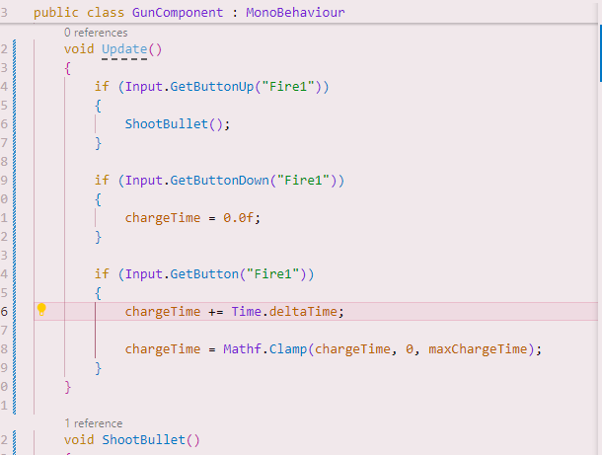

__________________________________________________________________________________

* Now change the ShootBullet function to

void ShootBullet()

{

GameObject bullet = Instantiate(bulletPrefab, bulletSpawnPoint.position, bulletSpawnPoint.rotation);

Rigidbody rb = bullet.GetComponent<Rigidbody>();

// Scale bullet force based on charge time

float bulletImpulse = (chargeTime / maxChargeTime) * bulletMaxImpulse;

rb.AddForce(bulletSpawnPoint.forward * bulletImpulse, ForceMode.Impulse);

}

In the end your GunComponent should look something like this **( NOTE : the next code snippet is a picture)**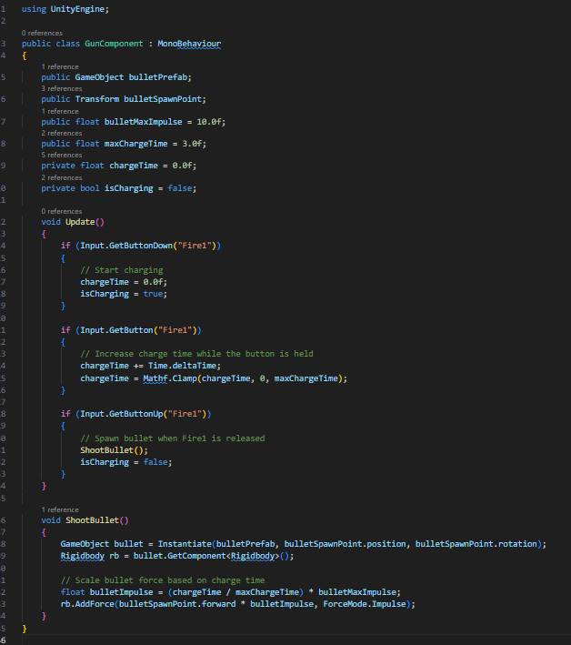

### **Task 4: Target Interaction and Scoring**

1. **Create TargetComponent Script**:
   * In the *Project* panel, create a new C# script called TargetComponent.
2. **Edit the Script**:
   * Open TargetComponent.cs and implement collision handling:

using UnityEngine;

public class TargetComponent : MonoBehaviour

{

private Renderer targetRenderer;

private Color originalColor;

public Color hitColor = Color.green; // Change to any color you want

private void Start()

{

targetRenderer = GetComponent<Renderer>();

if (targetRenderer != null)

{

originalColor = targetRenderer.material.color;

}

}

private void OnCollisionEnter(Collision collision)

{

if (collision.gameObject.CompareTag("Projectile"))

{

GameManager.Instance.IncrementScore();

// Change color

if (targetRenderer != null)

{

targetRenderer.material.color = hitColor;

}

// Restore color and hide target after 5 seconds

Invoke("ResetColor", 5f);

}

}

private void ResetColor()

{

if (targetRenderer != null)

{

targetRenderer.material.color = originalColor;

}

}

}

1. **Attach the Script**:
   * Select the target prefab in your Prefab folder and double click it.  
     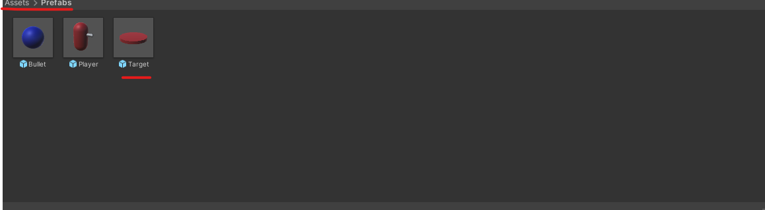
   * It will change the viewport to a blue background with only your prefab where the scene would be
   * 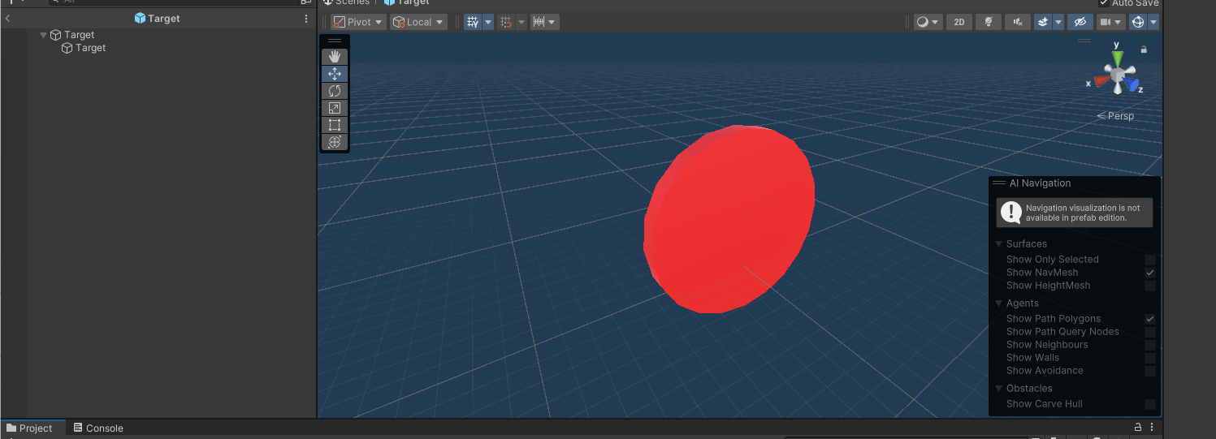
   * Now click on the parent object and add the TargetComponent to it
   * 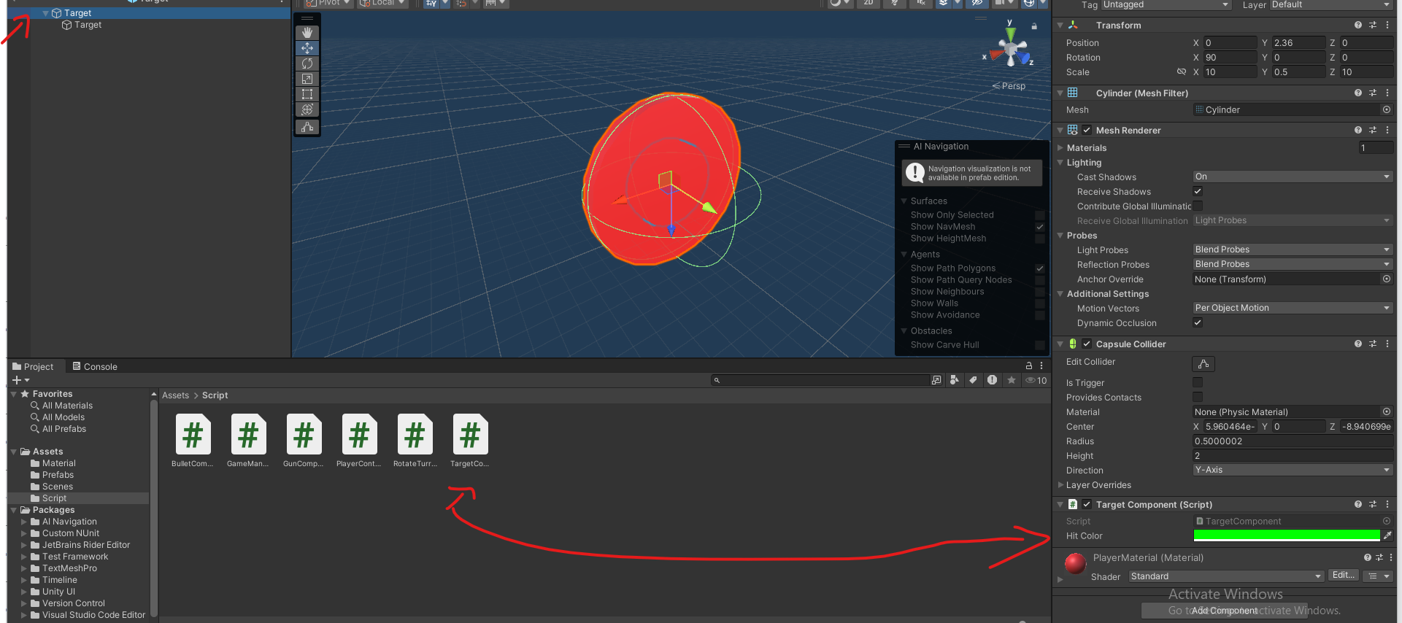
   * This will add the target component on all the Target object in your scene.

You can go back to your scene by pressing the arrow

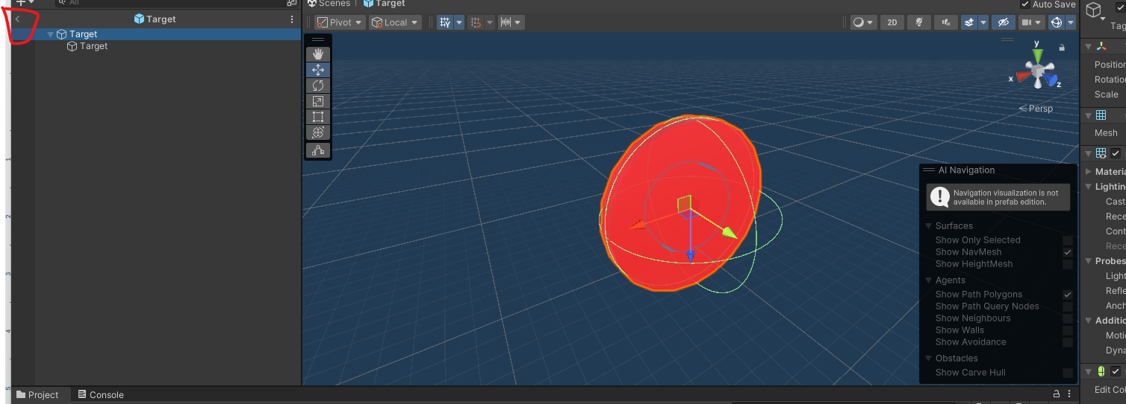

1. **Connect to GameManager**:
   * Ensure your GameManager script has an IncrementScore() method. This will update the score when a bullet hits the target.

Make sure the GameManager IncrementScore Is properly implemented

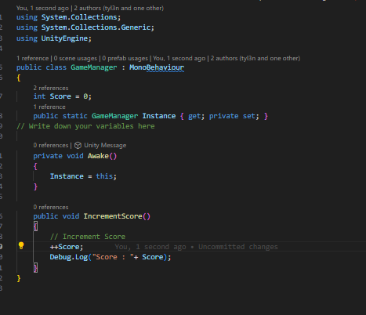

### **Submission**

1. **Add this file to your Asset folder and commit to your repo.**