Lab 3: Instantiate, Invoke, and Object Lifetime
Student: Mariam Salim (6229528)

Setup:
- Clone the repository:
  - Open this link : https://classroom.github.com/a/xsIFwI4x
  - Follow the instruction to clone the repo with Github Desktop
- Open the sample scene in scene folder
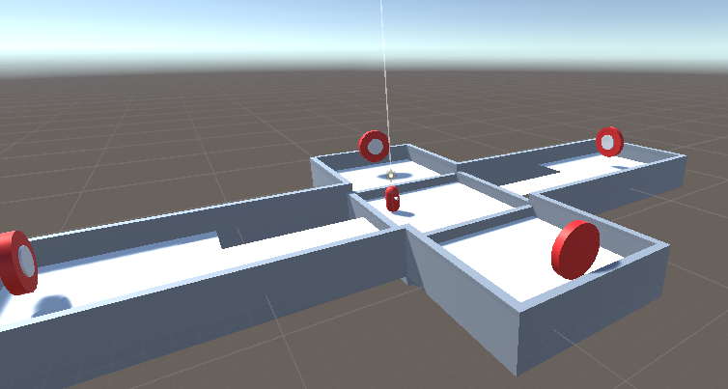

Task 1: Create a Bullet/Cannonball Prefab
- Create a new GameObject:
  - Right-click in the Hierarchy and select Create > 3D Object > Sphere.
- Add Rigidbody Component:
  - Select the sphere in the Hierarchy.
  - In the Inspector panel, click Add Component and search for Rigidbody.
  - Make sure the Rigidbody's Use Gravity checkbox is ticked to allow gravity to affect the bullets and make sure it is not a Kinematic object by making sure that the IsKinematic Checkbox is NOT ticked.
  - 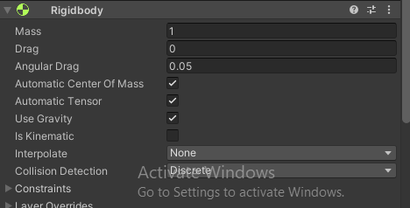

- Add Tag:
  - Click the sphere again, go to the Inspector, and click on the Tag dropdown.
  - Select or add a new tag called "Projectile" by clicking Add Tag, then choose Projectile from the list.
  - 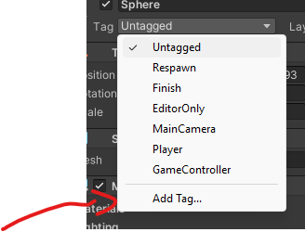
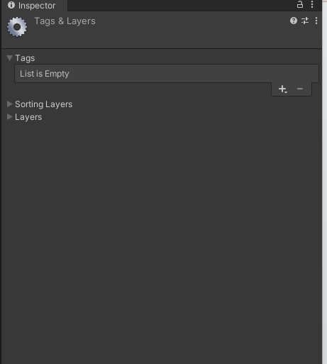
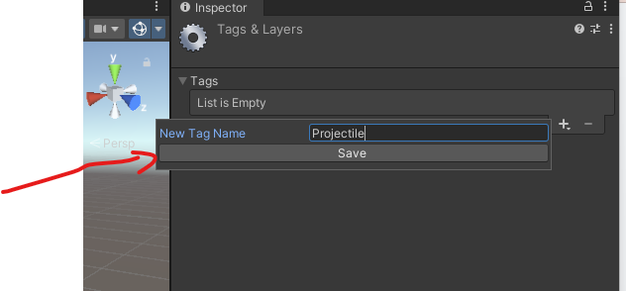
  - 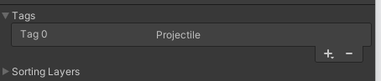

  - Make sure you choose projectile for you bullet after creating the tag.
- 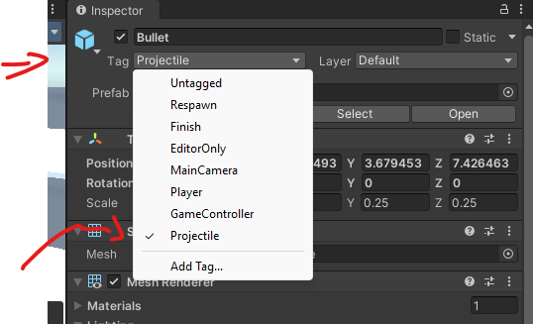
- Apply the bullet material

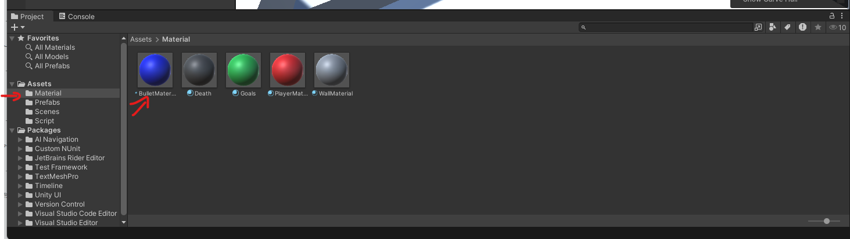
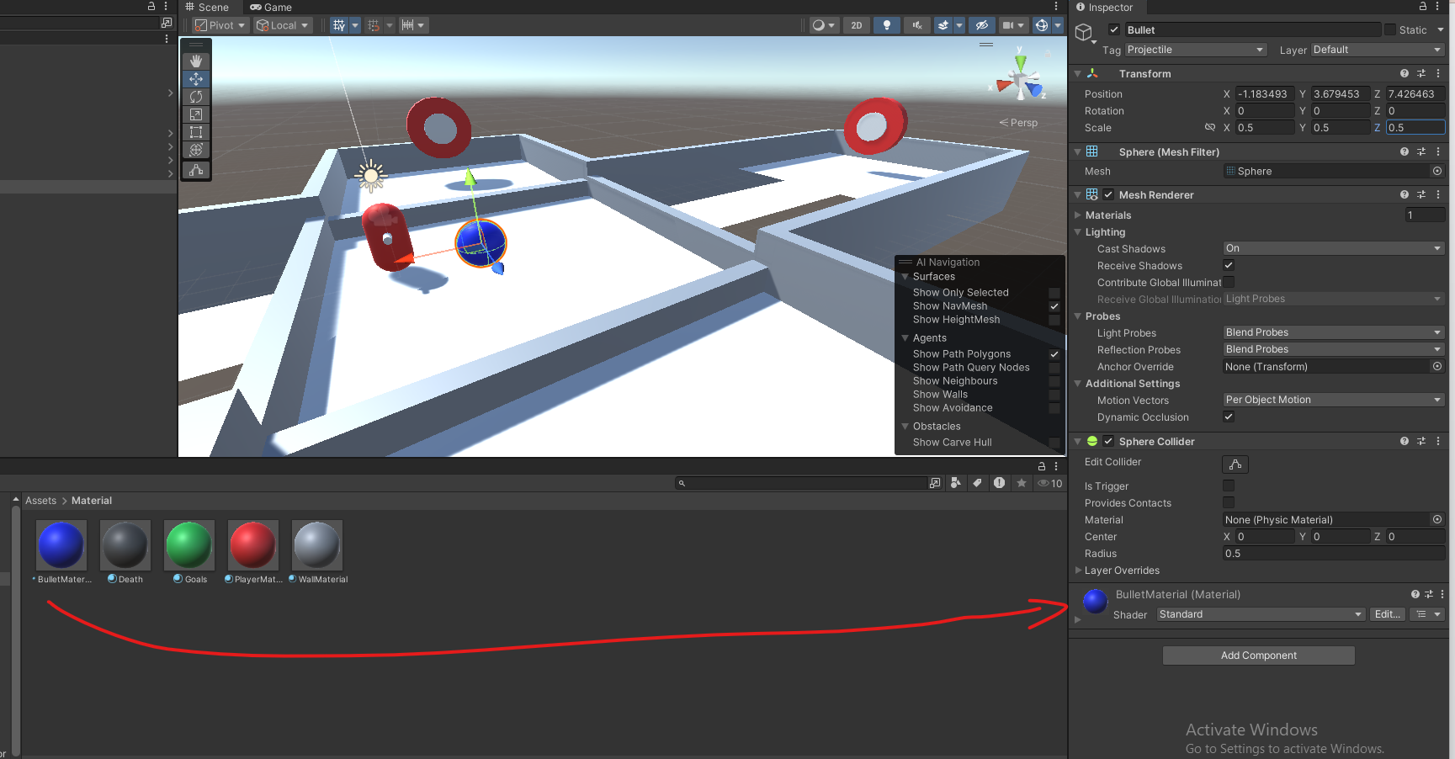

  - Your bullet should look something like this :
  - 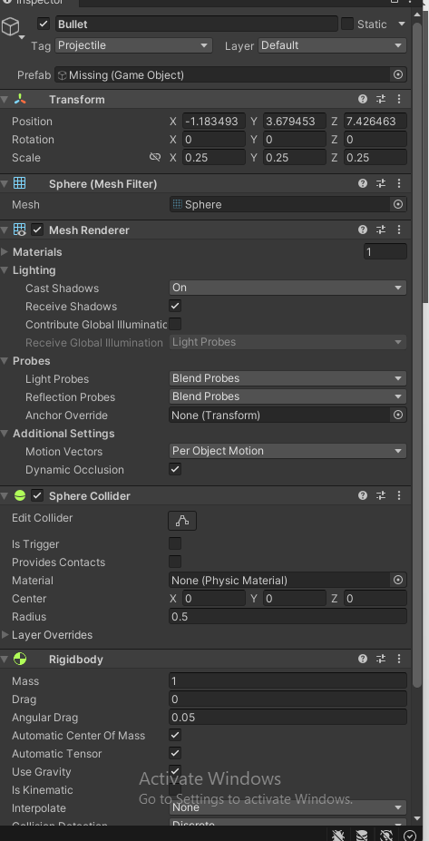

- Save it as a Prefab:
  - Drag the sphere from the Hierarchy into the Project panel to save it as a prefab.
  - 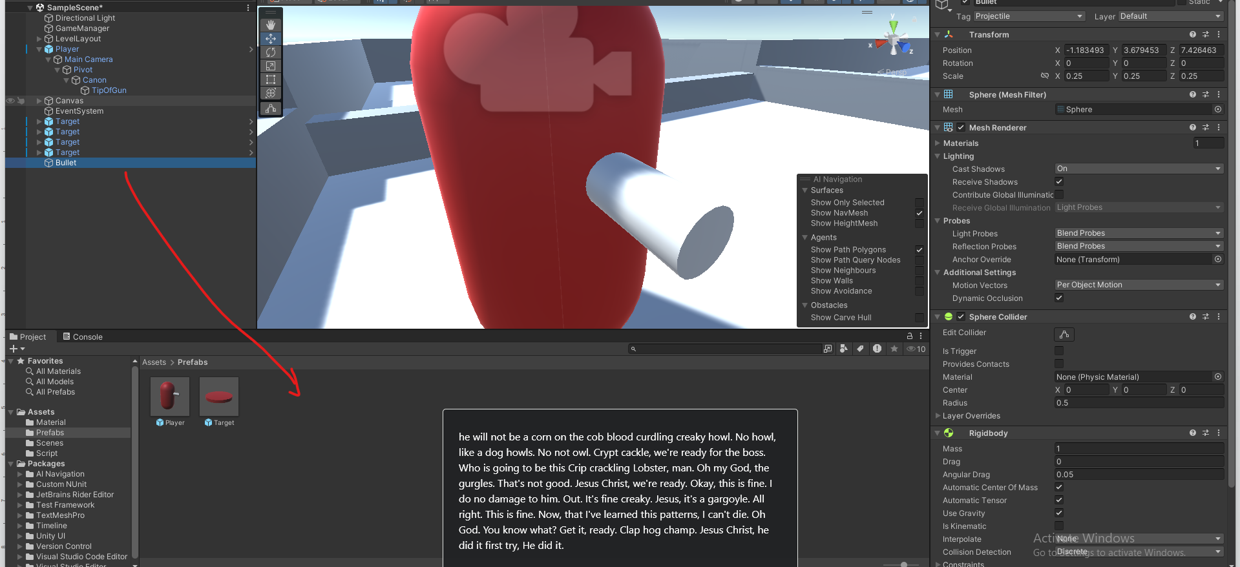

Task 2: Create a BulletComponent Script
- Create a Script:
  - In the Project panel, right-click and select Create > C# Script.
  - Name it BulletComponent.
- Edit the Script:
  - Open BulletComponent.cs in the code editor.
  - The bullet component will contain the code for destroying the ball

using System.Collections;
using System.Collections.Generic;
using UnityEngine;

public class BulletComponent : MonoBehaviour
{

void Start()
{
// Destroy object after a few seconds
Destroy(gameObject, 5f);
}
}

- Attach the Script:
  - Attach the BulletComponent script to your bullet prefab by dragging it from the Project panel to the prefab's Inspector.
  - 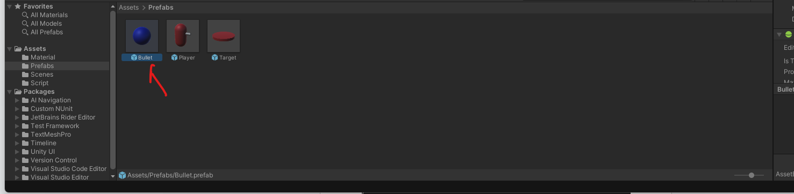
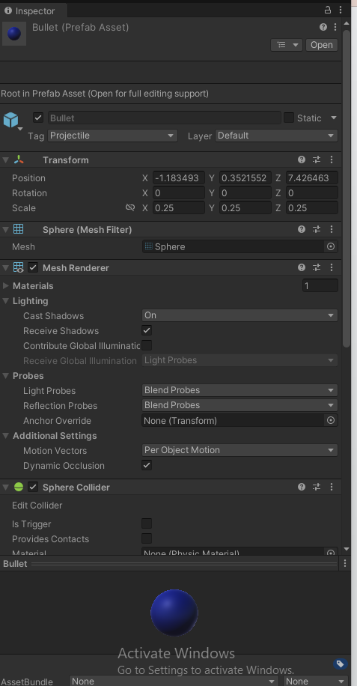
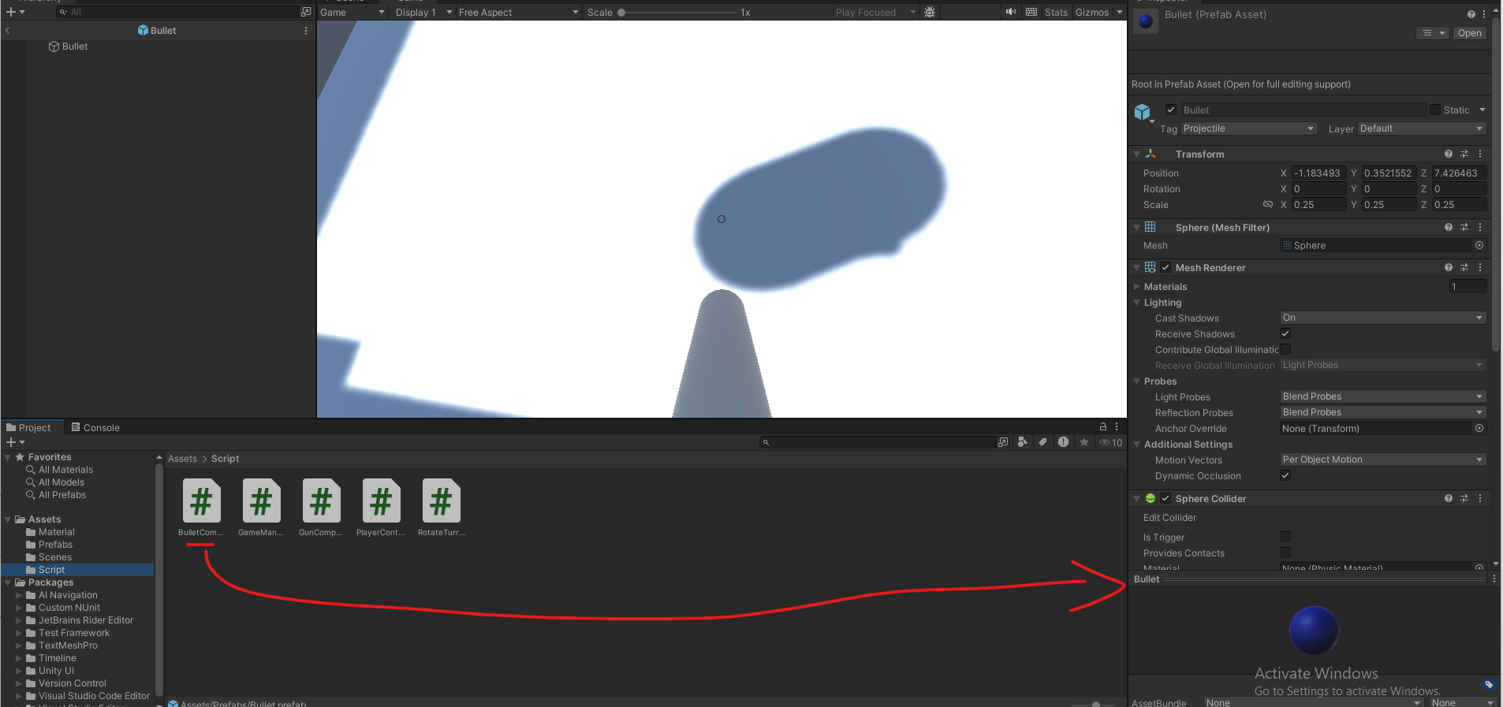

Task 3: Modify the Gun component to Spawn the bullets
- Edit the Script:
  - Open GunComponent.cs and implement the following:

using UnityEngine;

public class GunComponent : MonoBehaviour
{
public GameObject bulletPrefab;
public Transform bulletSpawnPoint;
public float bulletMaxImpulse = 100.0f;
public float maxChargeTime = 3.0f;
private float chargeTime = 0.0f;
private bool isCharging = false;

void Update()
{
// TODO add the logic to track player keeping the input down.
if (Input.GetButtonUp("Fire1"))
{
ShootBullet();
}
}

void ShootBullet()
{
GameObject bullet = Instantiate(bulletPrefab, bulletSpawnPoint.position, bulletSpawnPoint.rotation);
Rigidbody rb = bullet.GetComponent<Rigidbody>();

// TODO change that equation so that it adds an impulse that follows charge time
float bulletImpulse = bulletMaxImpulse;

// An impulse is a force you apply on a object in a single instant.
rb.AddForce(bulletSpawnPoint.forward * bulletImpulse, ForceMode.Impulse);
}
}

- Configure the Gun:
  - The gun component should already be assigned to the Gun gameObject ( A child of the player ) You will need to assign the bullet prefab and the bullet spawn point in the Inspector.
  - 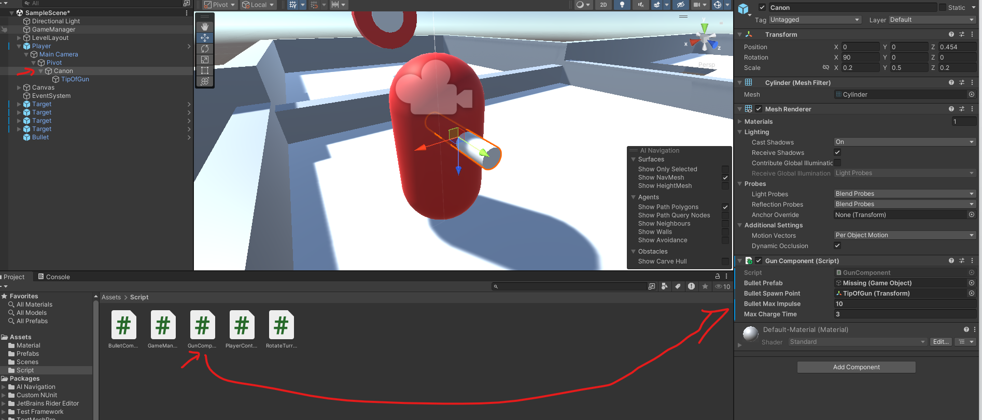

Assign the tip of gun transform as the bullet spawn point.
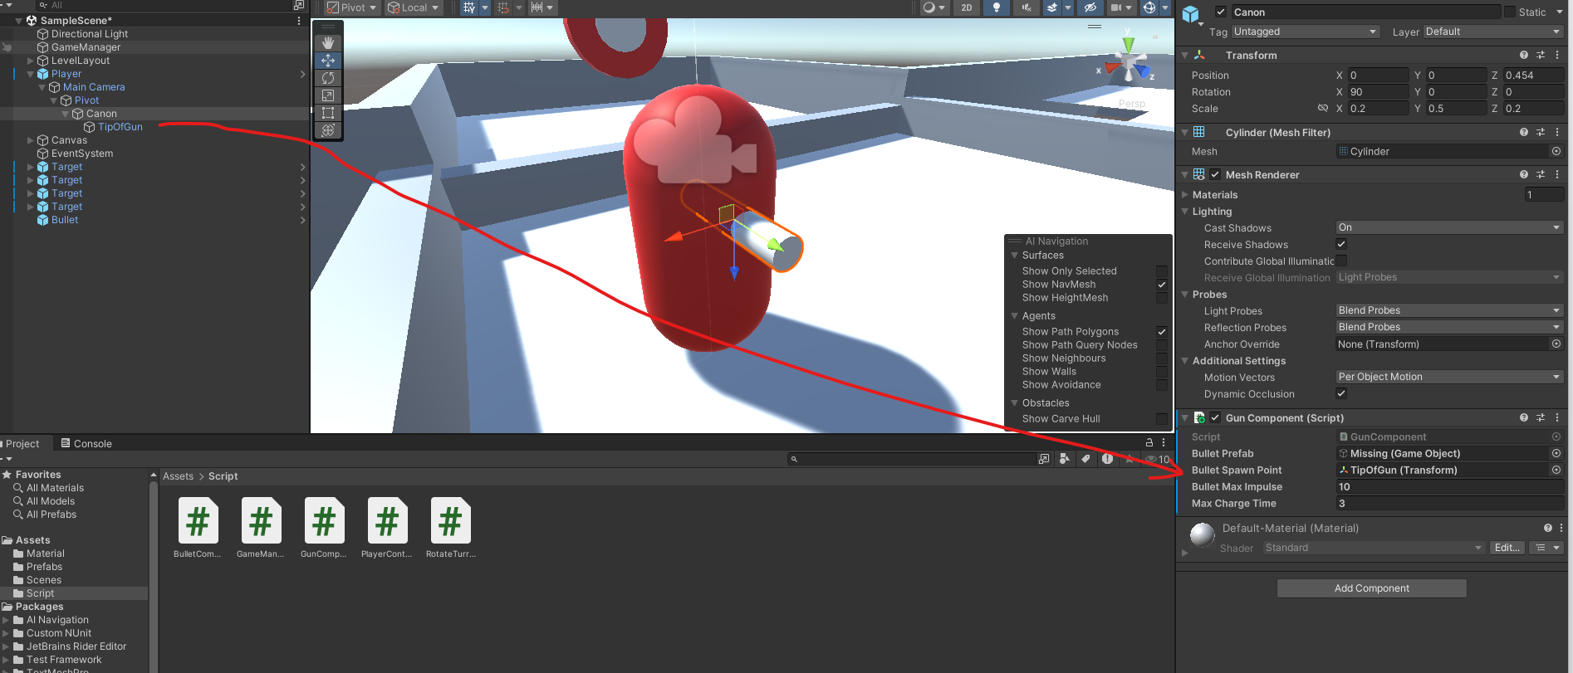
And the bullet prefab as the Bullet Prefab Proprety
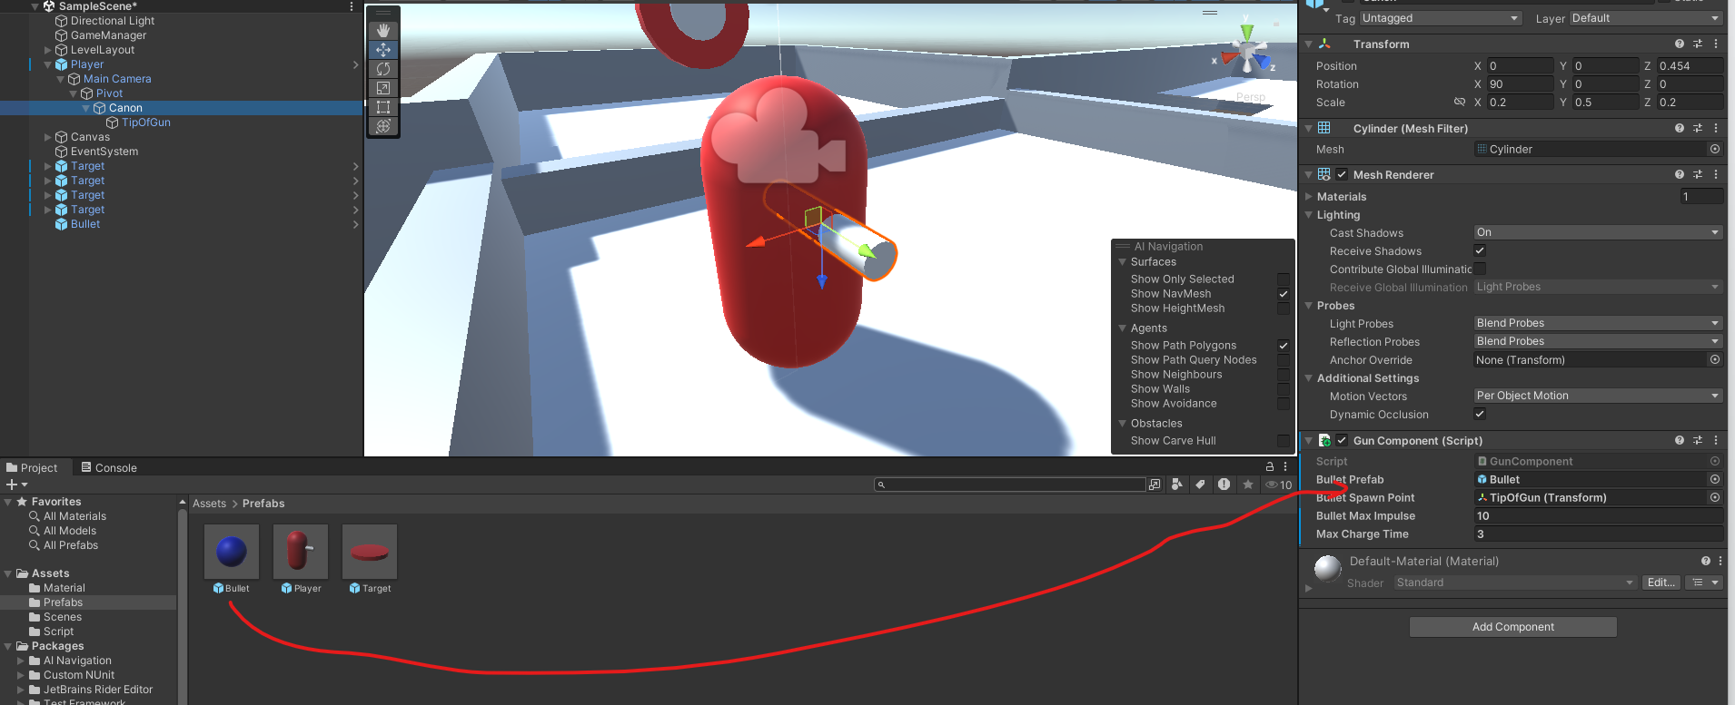

Task 5: Modify the Gun Component
You will need now to modify the gun component Update function to add a charging mechanic for bullet speed. ( IE Charge longer, Bullet goes further )
Here are few hints :
- This will be done within the Update() function.
- You need to detect when the player starts holding the fire button. Use an if condition with the boolean Input.GetButtonDown("Fire1") to detect when the button is initially pressed.
  - When a player first press down the button the chargetime should reset to 0.

- Using the boolean Input.GetButton("Fire1") increments the charge time every frame the button is held down. By adding the Time.deltaTime to the charge time.
  - You should increase the chargeTime value over time using Time.deltaTime, which gives you the time passed between each frame.

- To avoid excessively fast bullets, you can apply a maximum limit to the chargeTime.
  - Use Mathf.Clamp to keep the chargeTime between 0 and a certain max value (like 3 seconds).
    - chargeTime = Mathf.Clamp(chargeTime, 0, maxChargeTime);
Copy the code you came up with here :
__________________________________________________________________________________
using UnityEngine;
public class GunComponent : MonoBehaviour
{
public GameObject bulletPrefab;
public Transform bulletSpawnPoint;
public float bulletMaxImpulse = 100.0f;
public float maxChargeTime = 3.0f;
private float chargeTime = 0.0f;
private bool isCharging = false;

void Update()
{
if (Input.GetButtonDown("Fire1"))
{
chargeTime = 0.0f;
isCharging = true;
}

if (Input.GetButton("Fire1"))
{
chargeTime += Time.deltaTime ;
chargeTime = Mathf.Clamp(chargeTime, 0, maxChargeTime);
}

if (Input.GetButtonUp("Fire1"))
{
ShootBullet();
isCharging = false;
}
}

void ShootBullet()
{
GameObject bullet = Instantiate(bulletPrefab, bulletSpawnPoint.position, bulletSpawnPoint.rotation);
Rigidbody rb = bullet.GetComponent<Rigidbody>();

// TODO change that equation so that it adds an impulse that follows charge time
float bulletImpulse = bulletMaxImpulse;

// An impulse is a force you apply on a object in a single instant.
rb.AddForce(bulletSpawnPoint.forward * bulletImpulse, ForceMode.Impulse);
}
}
__________________________________________________________________________________

- Now change the ShootBullet function to
void ShootBullet()
{
GameObject bullet = Instantiate(bulletPrefab, bulletSpawnPoint.position, bulletSpawnPoint.rotation);
Rigidbody rb = bullet.GetComponent<Rigidbody>();

// Scale bullet force based on charge time
float bulletImpulse = (chargeTime / maxChargeTime) * bulletMaxImpulse;
rb.AddForce(bulletSpawnPoint.forward * bulletImpulse, ForceMode.Impulse);
}

In the end your GunComponent should look something like this ( NOTE : the next code snippet is a picture)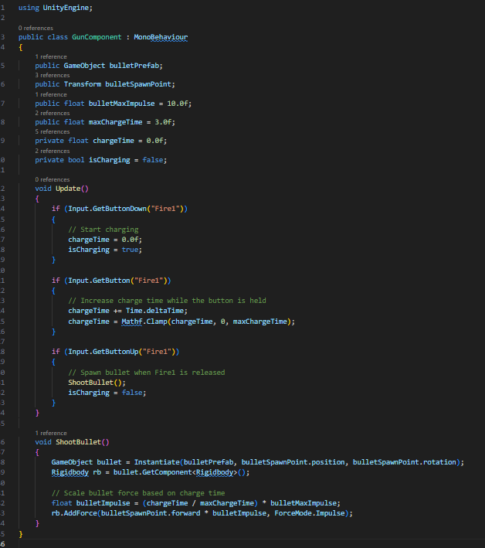

Task 4: Target Interaction and Scoring
- Create TargetComponent Script:
  - In the Project panel, create a new C# script called TargetComponent.
- Edit the Script:
  - Open TargetComponent.cs and implement collision handling:

using UnityEngine;
public class TargetComponent : MonoBehaviour
{
private Renderer targetRenderer;
private Color originalColor;
public Color hitColor = Color.green; // Change to any color you want

private void Start()
{
targetRenderer = GetComponent<Renderer>();
if (targetRenderer != null)
{
originalColor = targetRenderer.material.color;
}
}

private void OnCollisionEnter(Collision collision)
{
if (collision.gameObject.CompareTag("Projectile"))
{
GameManager.Instance.IncrementScore();

// Change color
if (targetRenderer != null)
{
targetRenderer.material.color = hitColor;
}

// Restore color and hide target after 5 seconds
Invoke("ResetColor", 5f);
}
}

private void ResetColor()
{
if (targetRenderer != null)
{
targetRenderer.material.color = originalColor;
}
}
}

- Attach the Script:
  - Select the target prefab in your Prefab folder and double click it.
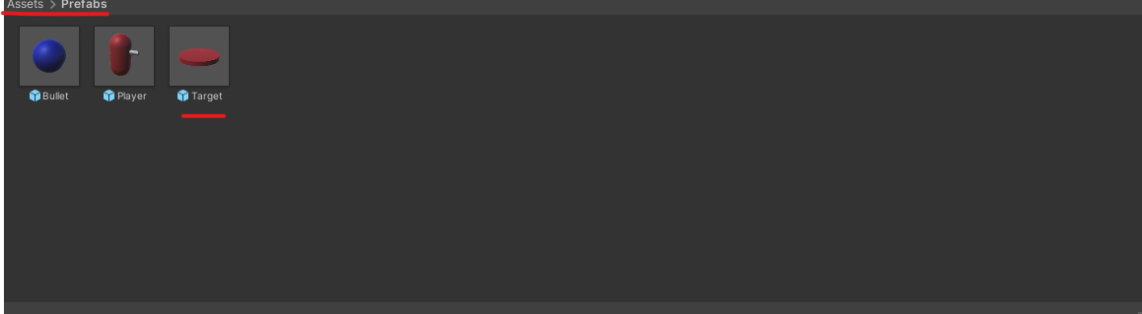
  - It will change the viewport to a blue background with only your prefab where the scene would be
  - 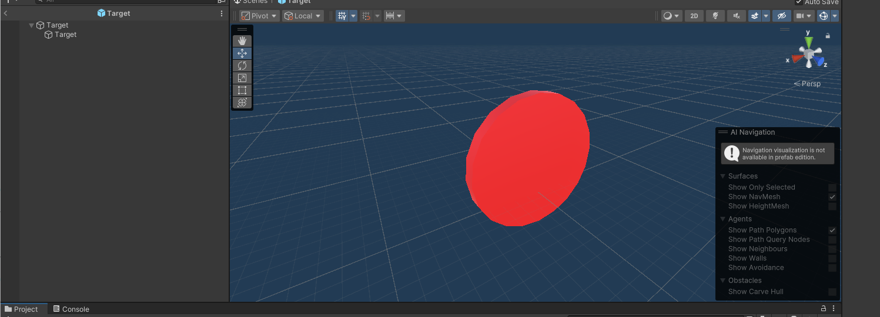
  - Now click on the parent object and add the TargetComponent to it
  - 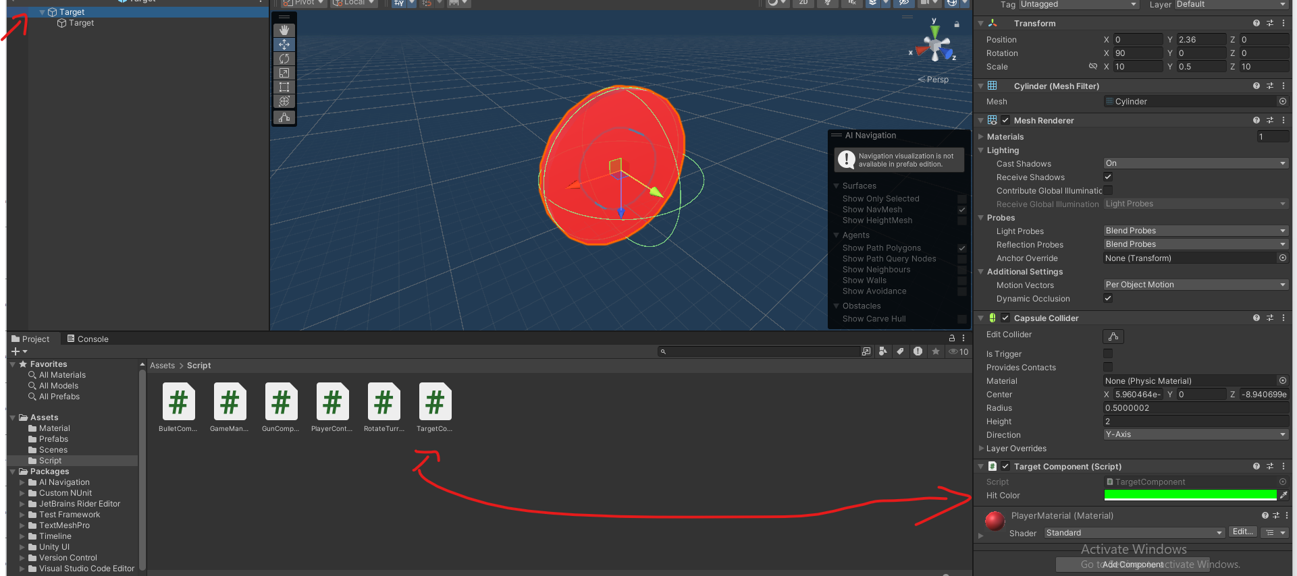
  - This will add the target component on all the Target object in your scene.
You can go back to your scene by pressing the arrow
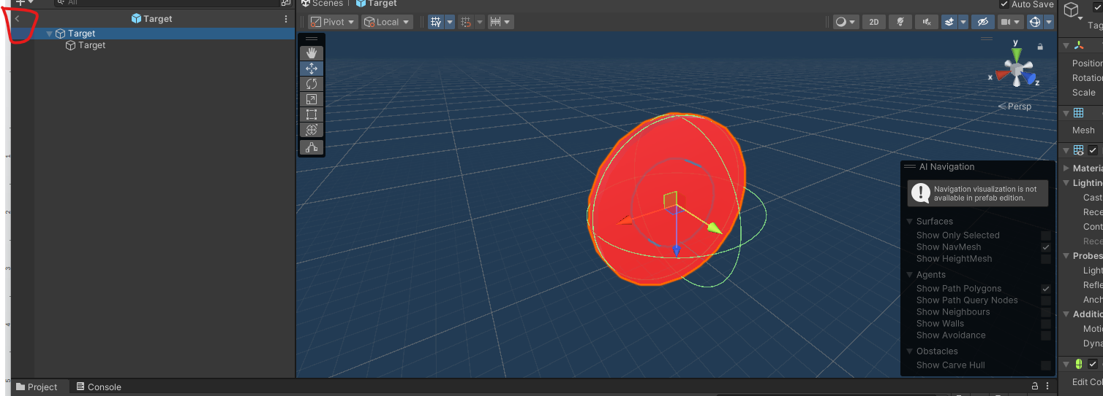
- Connect to GameManager:
  - Ensure your GameManager script has an IncrementScore() method. This will update the score when a bullet hits the target.
Make sure the GameManager IncrementScore Is properly implemented
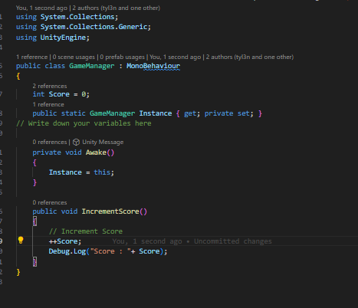

Submission
- Add this file to your Asset folder and commit to your repo.

