Lab 7 Navigation :
Accept the github assignment : https://classroom.github.com/a/D0z8NfHT

Step 1: Setup your scene

- In the inspector add a NavMesh Surface component to the Floor 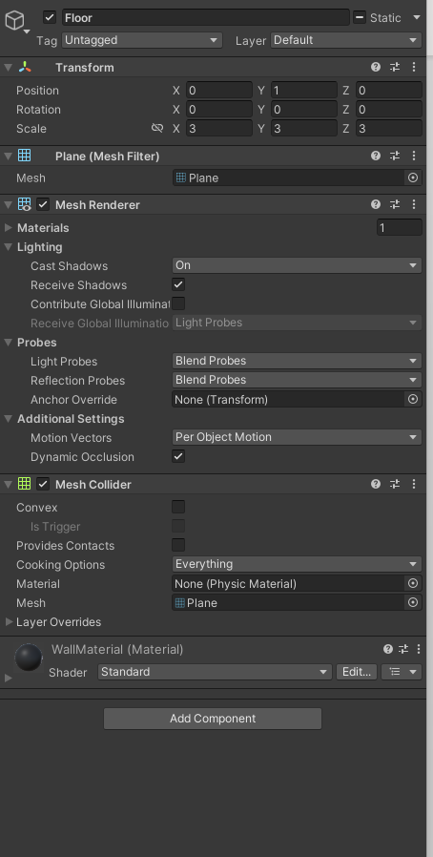
- 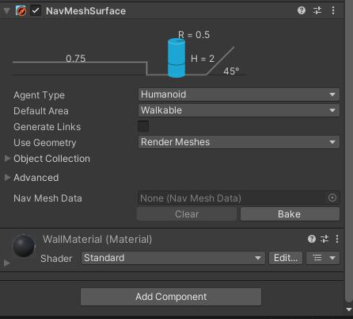
- Make sure that we ignore the player and the enemy
- Then click Bake to bake the navmesh
- 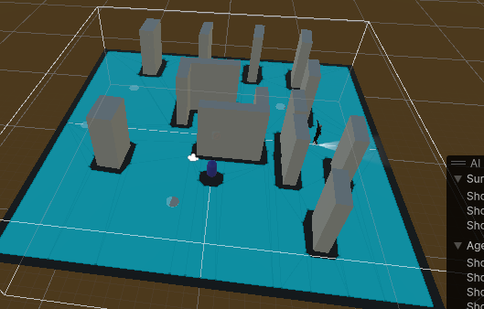

We will now setup the zombie AI Controller it will need to look something like this :
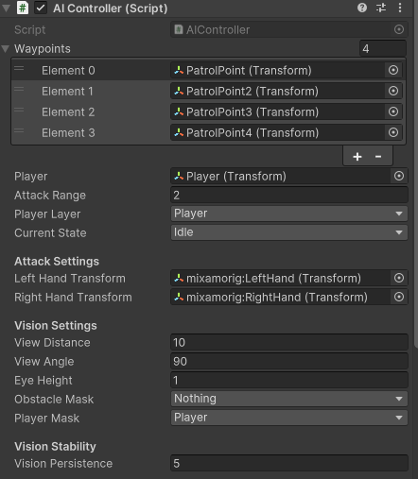

Now lets Create the AI State Machine Classes

3.1 Base State Class
Create an interface called IState:
using System.Collections;
using System.Collections.Generic;
using UnityEngine;

public interface IState
{
StateType Type { get; }
void Enter();
void Execute();
void Exit();
}

3.2 Individual State Classes
For each behavior (Idle, Patrol, Chase, and Attack), create a derived class that inherits from IState:
IdleState:
using System.Collections;
using System.Collections.Generic;
using UnityEngine;

public class IdleState : IState
{
private AIController aiController;
private float idleDuration = 2f;
private float idleTimer;

public StateType Type => StateType.Idle;

public IdleState(AIController aiController)
{
this.aiController = aiController;
}

public void Enter()
{
idleTimer = 0f;
//aiController.Animator.SetBool("isMoving", false);
}

public void Execute()
{
idleTimer += Time.deltaTime;
if (idleTimer >= idleDuration)
{
aiController.StateMachine.TransitionToState(StateType.Patrol);
}
}

public void Exit()
{
// Cleanup if necessary
}
}

PatrolState:
using UnityEngine;
using System.Collections;

public class PatrolState : IState
{
private AIController aiController;
private int currentWaypointIndex = 0;
private bool isWaiting = false;

public StateType Type => StateType.Patrol;

public PatrolState(AIController aiController)
{
this.aiController = aiController;
}

public void Enter()
{

aiController.Agent.isStopped = false;
MoveToNextWaypoint();
}

public void Execute()
{
if (aiController.CanSeePlayer())
{
aiController.StateMachine.TransitionToState(StateType.Chase);
return;
}

if (!isWaiting && !aiController.Agent.pathPending && aiController.Agent.remainingDistance <= aiController.Agent.stoppingDistance)
{
aiController.StartCoroutine(WaitAndAnimate());
}

}

public void Exit()
{
aiController.Agent.isStopped = false;
}

private IEnumerator WaitAndAnimate()
{
isWaiting = true;
aiController.Agent.isStopped = true;

// Play patrol point animation
aiController.aiAnimationController.animator.SetTrigger("doScream");

// Wait for animation duration (1.5 sec here, adjust to your animation length)
yield return new WaitForSeconds(5);

aiController.Agent.isStopped = false;
MoveToNextWaypoint();
isWaiting = false;
}

private void MoveToNextWaypoint()
{
if (aiController.Waypoints.Length == 0)
return;

aiController.Agent.destination = aiController.Waypoints[currentWaypointIndex].position;
currentWaypointIndex = (currentWaypointIndex + 1) % aiController.Waypoints.Length;
}
}

Chase State
public class ChaseState : IState
{
private AIController aiController;

public StateType Type => StateType.Chase;

public ChaseState(AIController aiController)
{
this.aiController = aiController;
}

public void Enter()
{
// No animations, so no need to set any animator parameters
}

public void Execute()
{
if (!aiController.CanSeePlayer())
{
aiController.StateMachine.TransitionToState(StateType.Patrol);
return;
}

if (aiController.IsPlayerInAttackRange())
{
aiController.StateMachine.TransitionToState(StateType.Attack);
return;
}

aiController.Agent.destination = aiController.Player.position;
}

public void Exit()
{
// No cleanup necessary
}
}

AttackState:
using UnityEngine;
using UnityEngine.SceneManagement;

public class AttackState : IState
{
private AIController aiController;
private float attackCooldown = 1.5f; // seconds between attacks
private float lastAttackTime = -999f;

public StateType Type => StateType.Attack;

public AttackState(AIController aiController)
{
this.aiController = aiController;
}

public void Enter()
{
aiController.Agent.isStopped = true;
}

public void Execute()
{
// If player moves out of attack range, go back to chase
if (Vector3.Distance(aiController.transform.position, aiController.Player.position) > aiController.AttackRange)
{
aiController.StateMachine.TransitionToState(StateType.Chase);
return;
}

// Limit how often the AI attacks
if (Time.time - lastAttackTime > attackCooldown)
{
lastAttackTime = Time.time;
aiController.aiAnimationController.animator.SetTrigger("doAttack");
}
}

public void Exit()
{
aiController.Agent.isStopped = false;
}
}

Step 4: Create a class called StateMachine:

Create the State Machine Class
using System.Collections;
using System.Collections.Generic;
using UnityEngine;

public class StateMachine
{
private Dictionary<StateType, IState> states = new Dictionary<StateType, IState>();
private IState currentState;

public StateType GetCurrentStateType()
{
return currentState.Type;
}

public void AddState(IState state)
{
if (!states.ContainsKey(state.Type))
{
states.Add(state.Type, state);
}
}

public void TransitionToState(StateType type)
{
currentState?.Exit();
currentState = states[type];
currentState.Enter();
}

public void Update()
{
currentState?.Execute();
}
}

Now lets modify our AIController to add the StateMachine
Put this variable in the list of variable
public StateMachine StateMachine { get; private set; }

Then add the following functions to the script
void Start()
{
Agent = GetComponent<NavMeshAgent>();
aiAnimationController = GetComponent<AIAnimationController>();
// Animator = GetComponent<Animator>(); // Commented out since we're not using animations

StateMachine = new StateMachine();
StateMachine.AddState(new IdleState(this));
StateMachine.AddState(new PatrolState(this));
StateMachine.AddState(new ChaseState(this));
StateMachine.AddState(new AttackState(this)); // Add the new AttackState

StateMachine.TransitionToState(StateType.Idle);
}

void Update()
{
StateMachine.Update();
currentState = StateMachine.GetCurrentStateType();
}

Now lets create fill in the AIAnimationController. The script responsible for sending animation information to our animator from the navmesh agent.

using UnityEngine;
using UnityEngine.AI;
using UnityEngine.SceneManagement;

[RequireComponent(typeof(Animator))]
public class AIAnimationController : MonoBehaviour
{
public Animator animator { get; private set; }
private AIController aiController;
private NavMeshAgent agent;

void Awake()
{
animator = GetComponent<Animator>();
aiController = GetComponent<AIController>();
agent = GetComponent<NavMeshAgent>();
}

void Update()
{
// Update animation parameters
UpdateAnimations();
}

void UpdateAnimations()
{
float speed = agent != null ? agent.velocity.magnitude : 0f;
animator.SetFloat("CharacterSpeed", speed);
}

void HitPlayer() // Attack Animation Event to check if the player his hit
{
GameObject objectHit;
if (aiController.CheckHandsCollision(out objectHit, "Player"))
{

//SceneManager.LoadScene(0);
}
}

}

Step 8: Assign Components in Unity

- Assign the NavMeshAgent in the inspector.
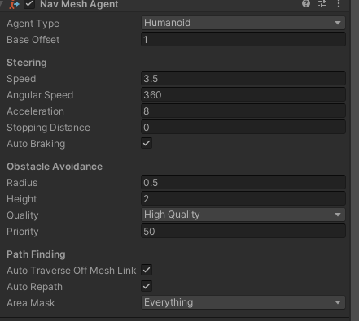

- Make sure the NavMeshAgent base offset is set to 1.
- Assign the AI AnimationController that we just created
- Add an animator that has the EnemyAnimator And the WhiteClownAvatar
- 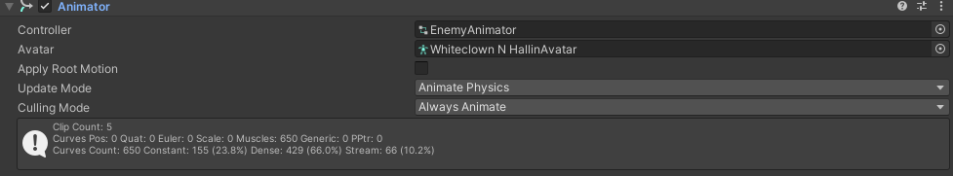
- By the end your zombie game object should look something like this
- 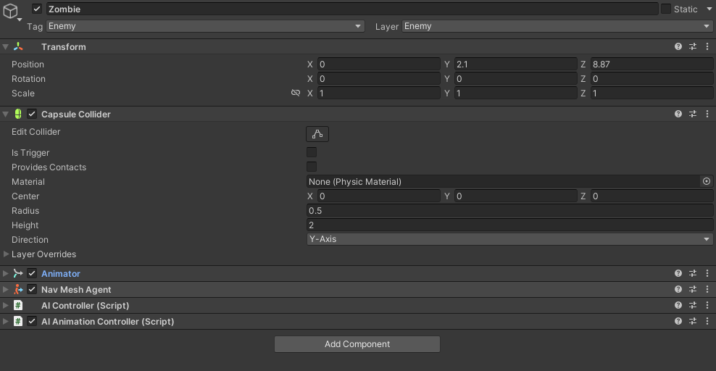
- 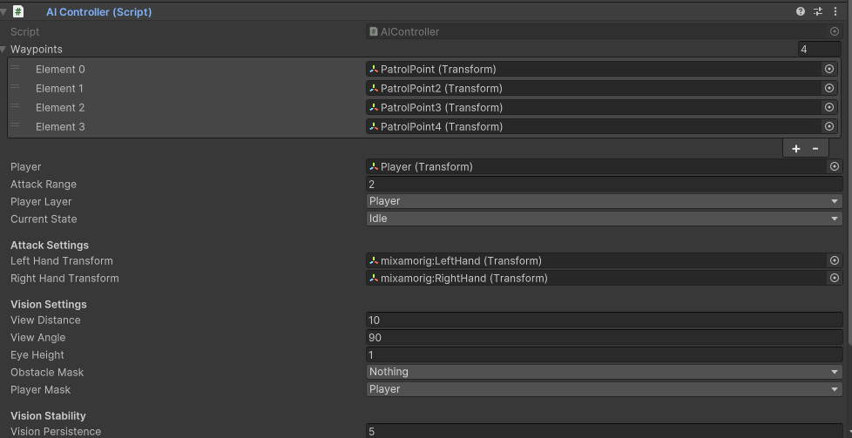
- 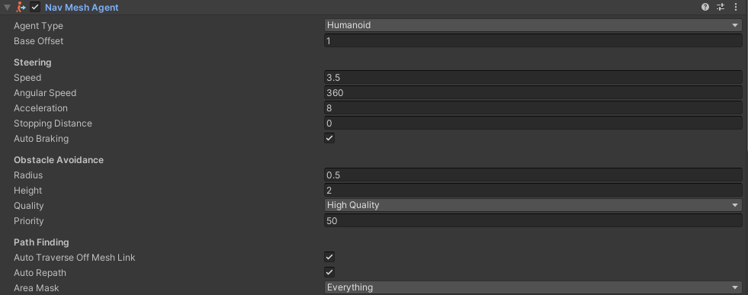
- 
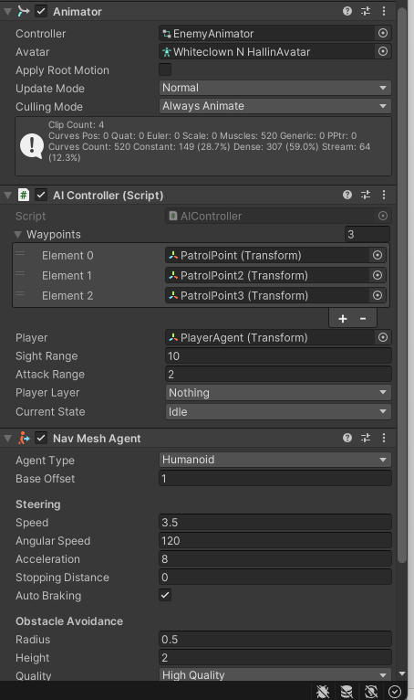
Setup the animator controller

Setup the animator like this

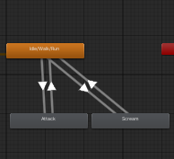
Set up the transition as follows

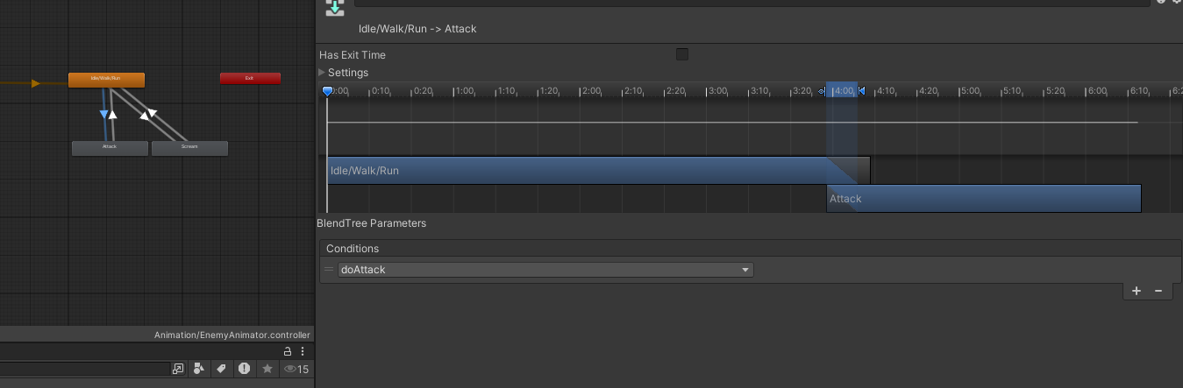
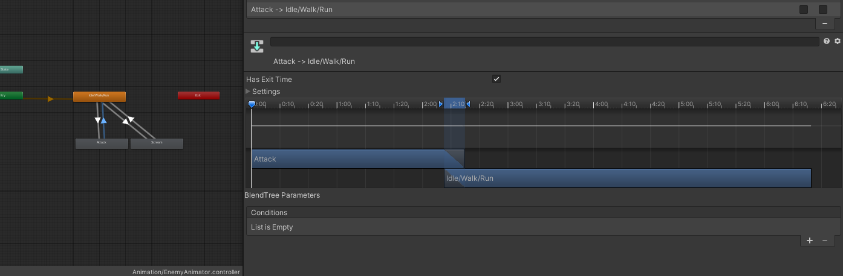
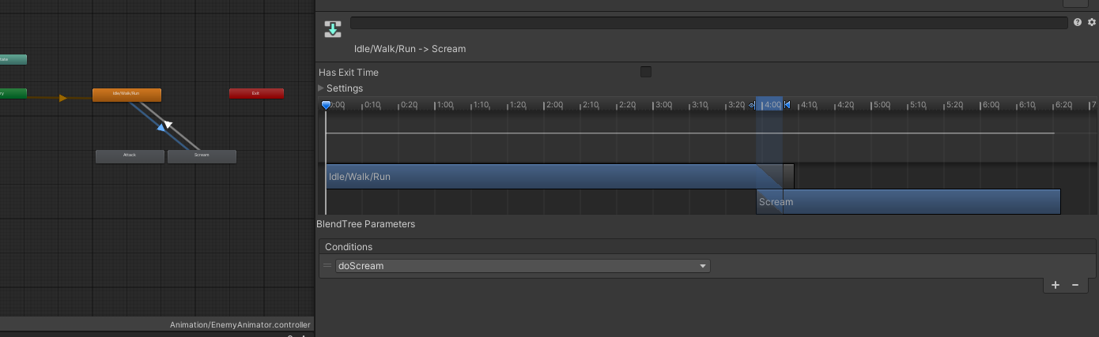
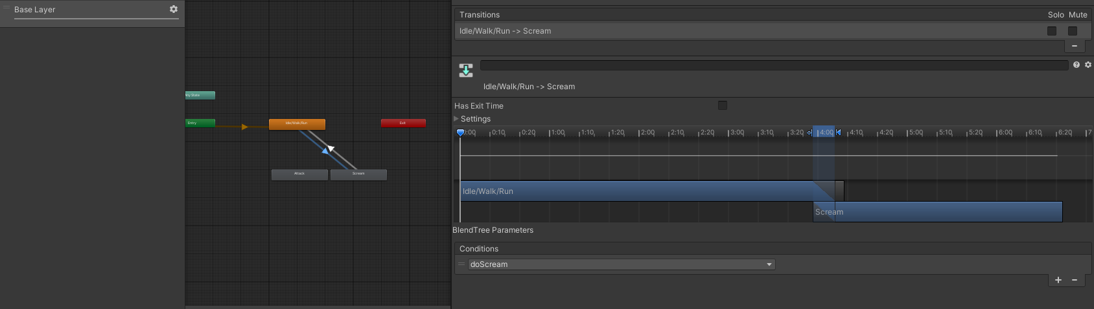
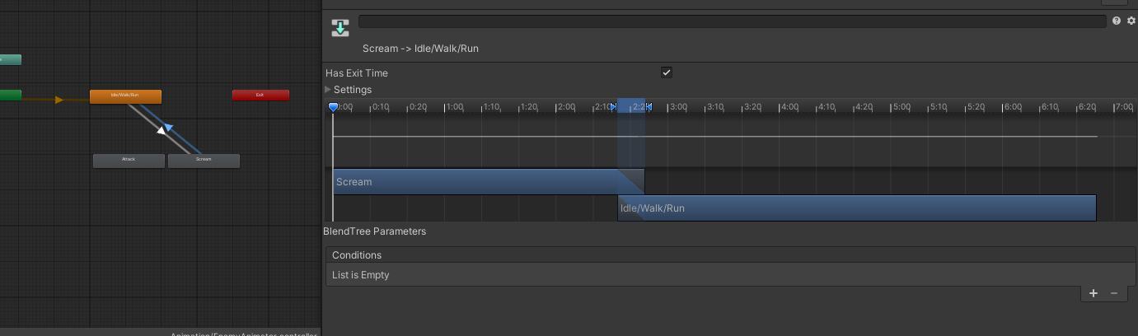

You will notice that when the AI attacks you if you back out he will keep sliding we will fix this by making the attack a layered animation.
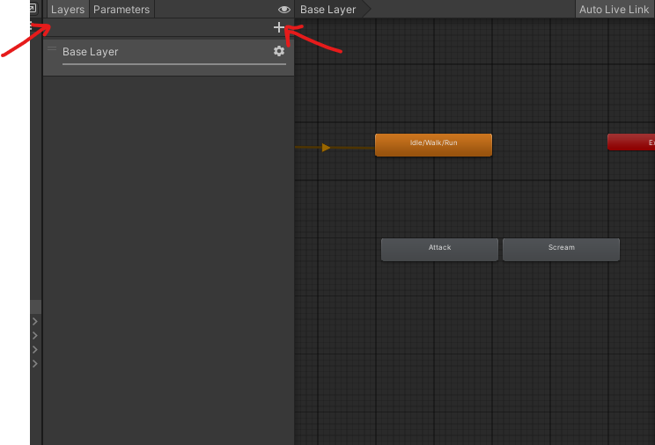

We will create a Layer that we will call UpperBody

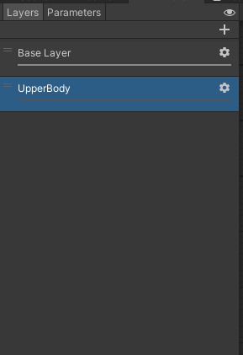
Now we will need to create an avatar Mask In Assets/Animation we will create the avatar mask
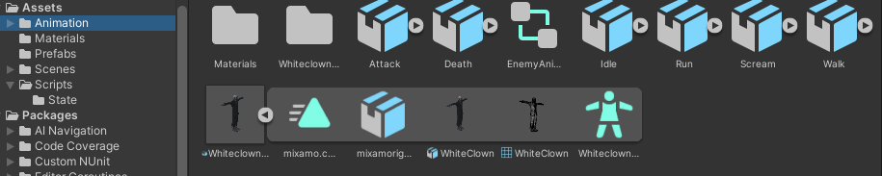
By left clicking and then choosing avatar mask in Create > Avatar mask

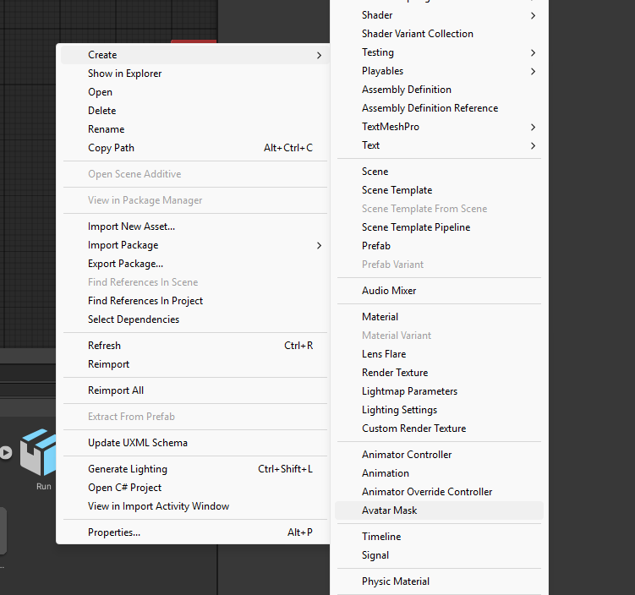

We will call the avatar mask Upper Body

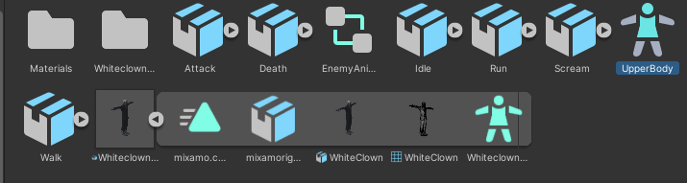
You should see this in the Inspector when you open it

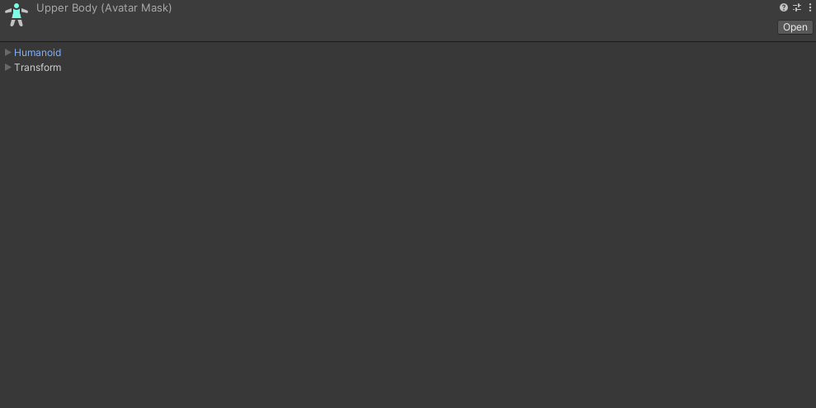
Open the Humanoid Tab

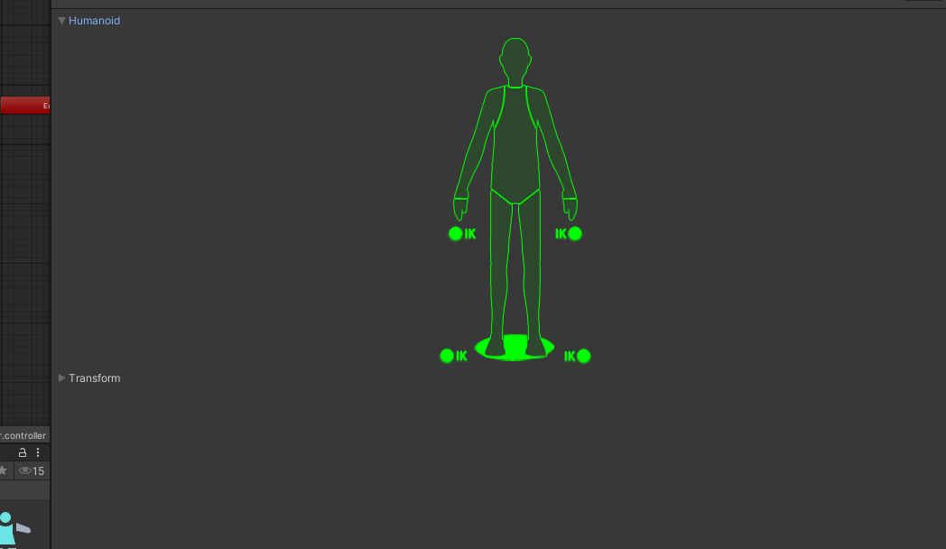
Click on the green areas to make them go red
We want to only have the upper body highlighted green like so :
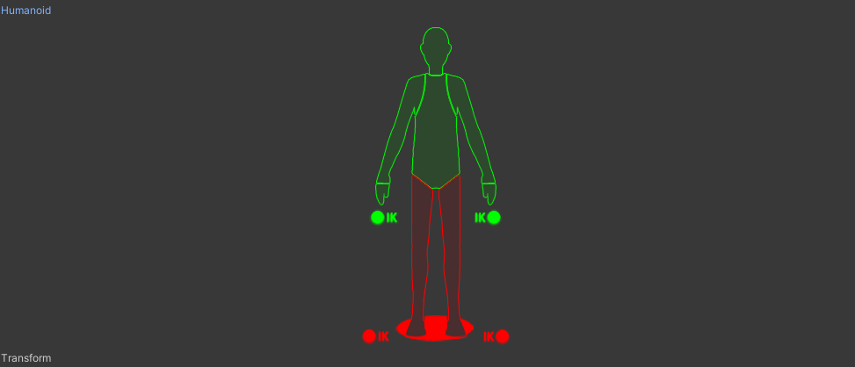
Now we will want to add that mask on our layer. In the Animator open the layers you should see a little gear icon
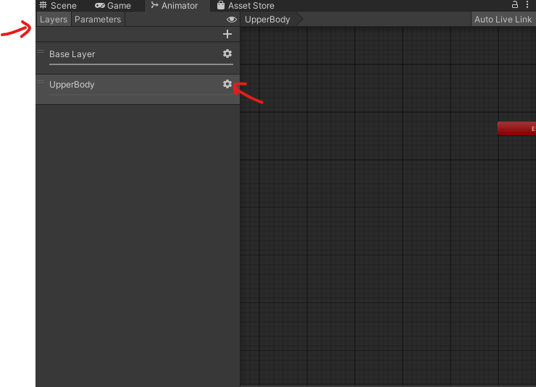

It will open this window. We want to add the mask in the mask section and put the Weight to 1.

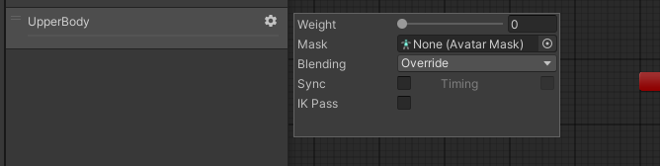
Like so
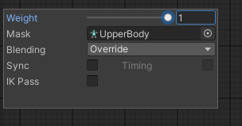
Now if you click on the Upperbody layer there should not be any animation

Copy and paste ones in your Base layer to your Upperbody layer

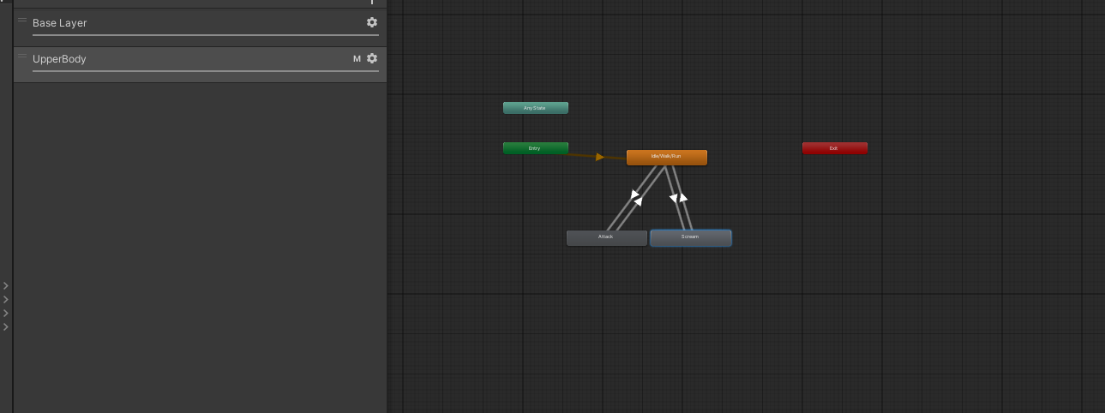
Then remove the scream and attack animation from your base layer

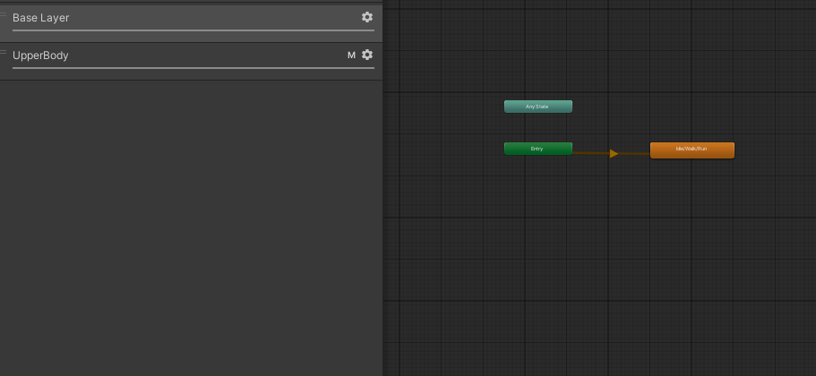

Your scream and attack animation should now only affect the upper body of your character.

You can now uncomment the scenemanager in AIAnimationController in HitPlayer
void HitPlayer() // Attack Animation Event to check if the player his hit
{
GameObject objectHit;
if (aiController.CheckHandsCollision(out objectHit, "Player"))
{

SceneManager.LoadScene(0);
}
}

You should now reload the level when the AI hits you. ( note : you have to be very close to him for the hit detection to work)

