# **Lab 8 : Importing Your Custom FBX (1%)**

**Course:** 420-541-VA Game Programming 2

Welcome to Lab 8! In this lab, you'll learn how to create custom 3D assets using Blender, export them as FBX files, and import them into Unity. Specifically, you'll create a stop sign and import a pre-made house model into your karting mini-game.

## **Prerequisites**

* **Blender** installed on your computer.
* **Unity** (version compatible with the project) installed.
* **Git** installed for cloning the repository (optional but recommended).

## **Task 1: Accept the github classroom assignment.** https://classroom.github.com/a/oVd97y7d

## **Task 2: Create a Stop Sign in Blender**

Now, let's create a simple stop sign using Blender.

### **Steps:**

1. **Open Blender:**
   * Launch Blender from your applications menu.
2. **Delete the Default Cube and :**
   * Click on the default cube to select it.
   * 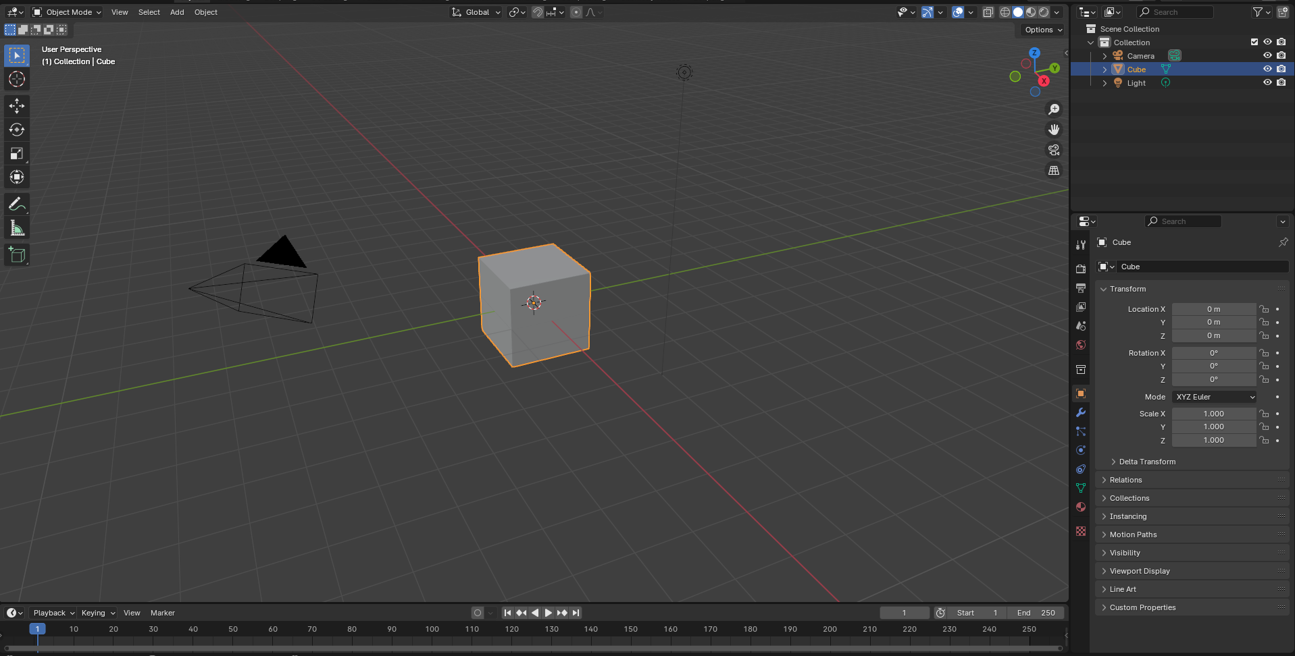
   * Press X on your keyboard and confirm deletion.
   * 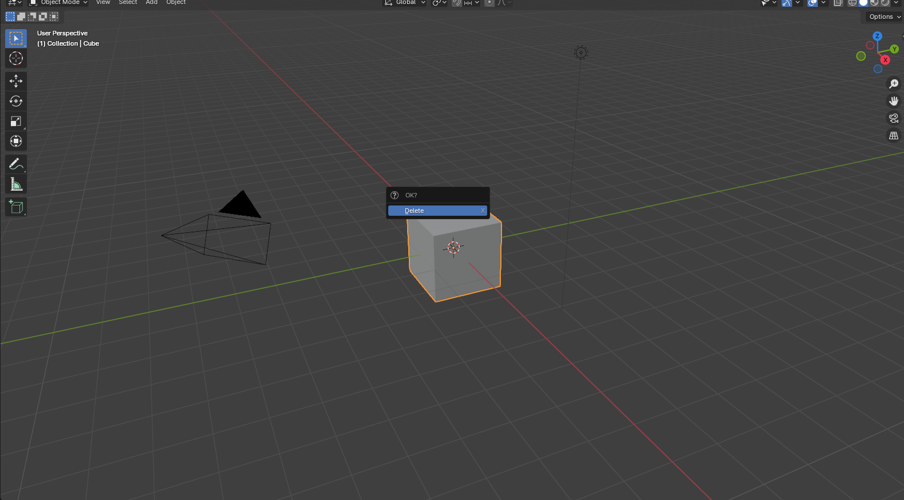

Do the same thing for the light and the camera in the scene view up on the left corner of the screen.

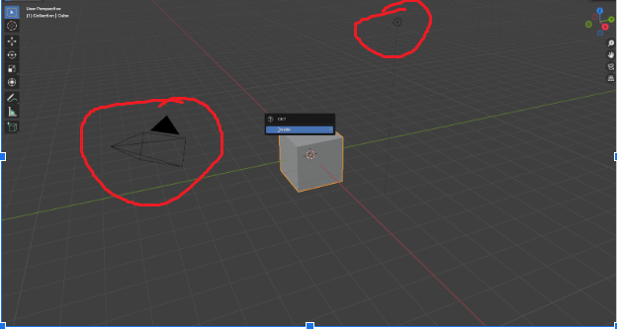

1. **Add a Cylinder for the Sign Post:**
   * Press Shift + A to open the Add menu.
   * Navigate to Mesh > Cylinder.
   * 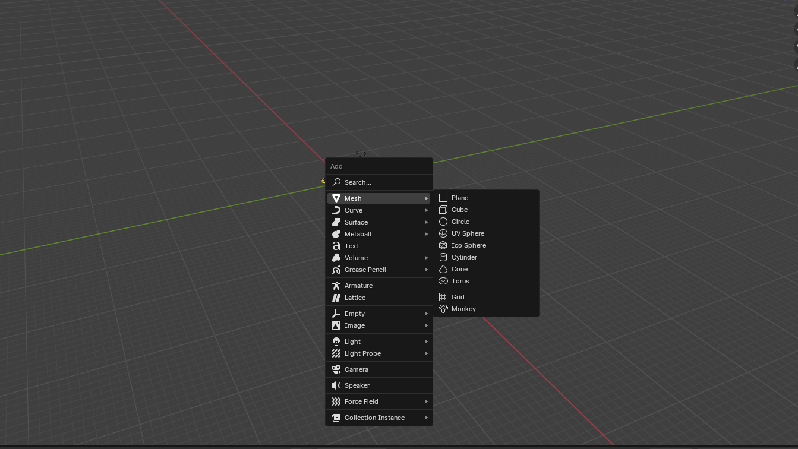
   * 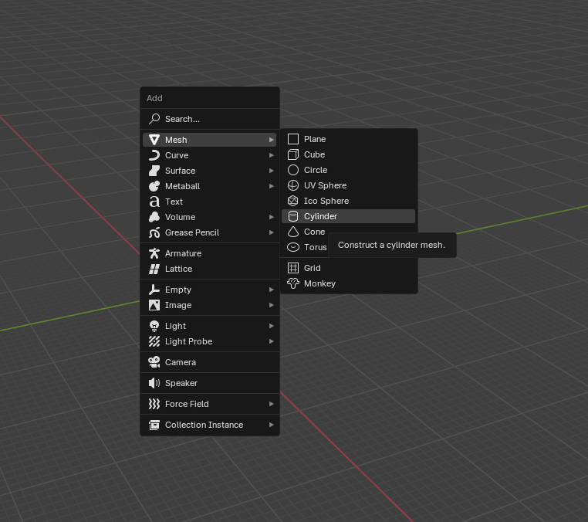
2. **Adjust the Cylinder Dimensions:**
   * With the cylinder selected, go to the Dimensions panel on the right (press N if it's not visible).
   * 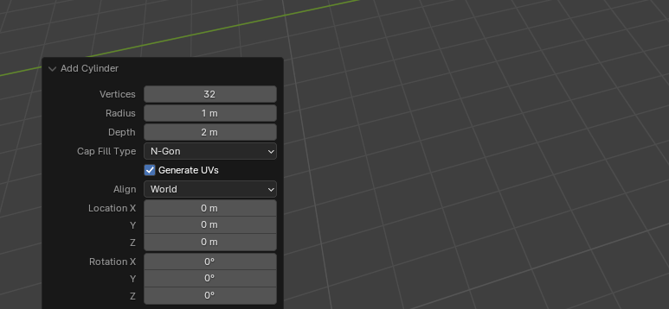
   * Set the dimensions:
     + **Radius (X):** 0.1 units
     + **Depth (Y):** 0.1 units
     + **Cap Fill Type N-Gon**
   * **Press N to change the transform**
   * 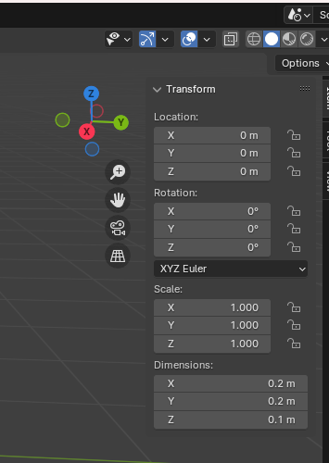
   * **To this**
   * 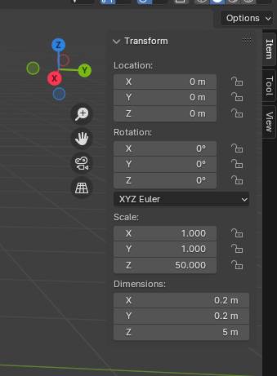
3. **Position the Cylinder:**
   * Set the location:
     + **X:** 0
     + **Y:** 0
     + **Z:** 1.5 (to raise it above the ground plane)
     + 
     + 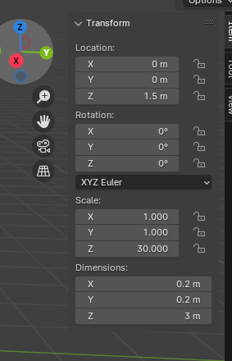
     + 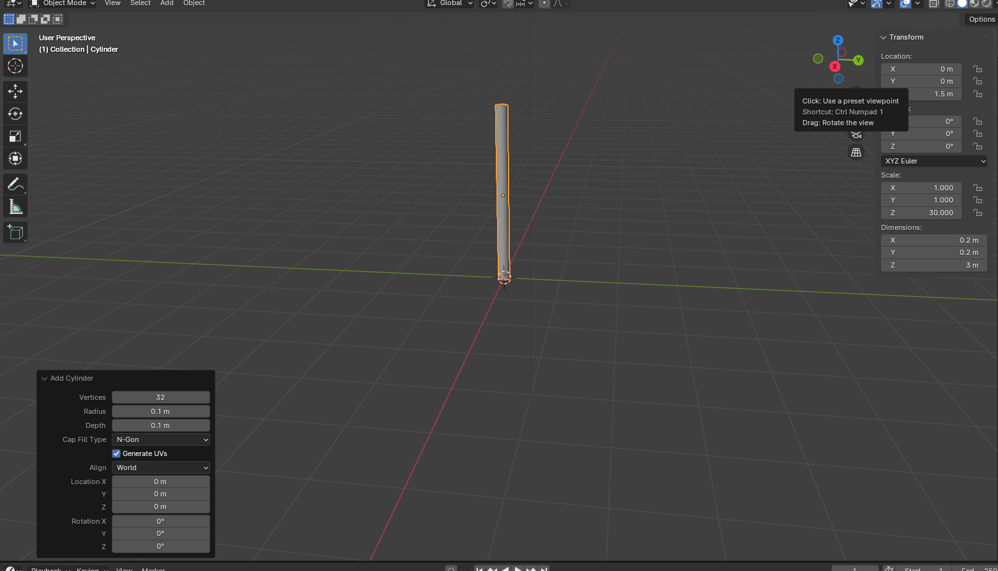
4. **Add an Octagon for the Stop Sign Face:**
   * Press Shift + A and select Mesh > Cylinder.
   * In the bottom-left corner, expand the Add Cylinder panel.
   * Set the Vertices to 8 to create an octagon.
   * Set the Radius to 1
   * 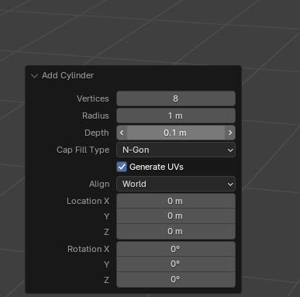
   * 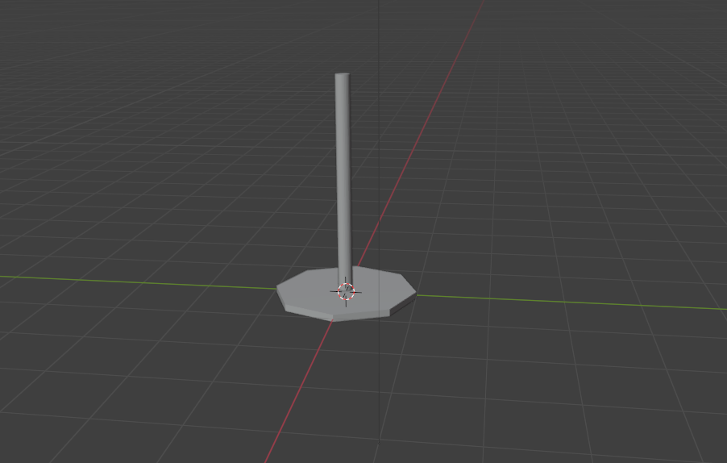
   * Now lets position this octagon
   * Select the octagon and press N
   * 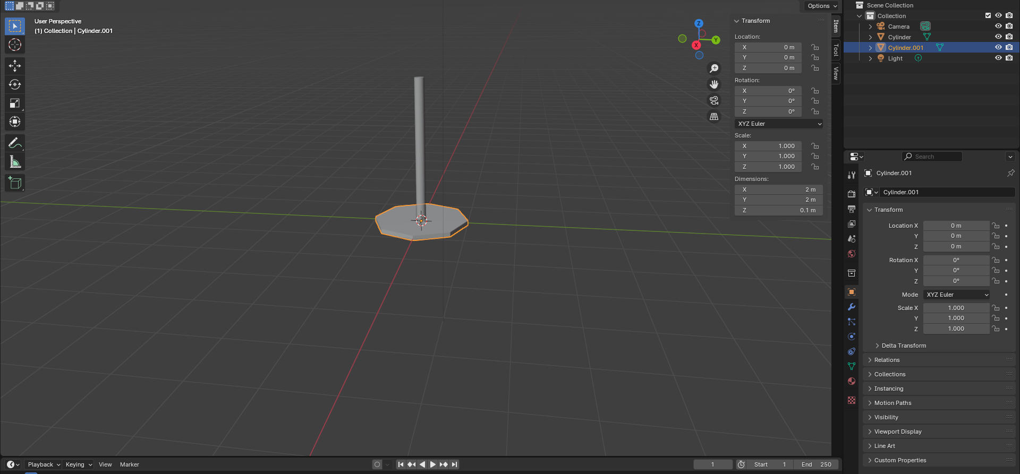
   * Rotate the Octagon 90 degrees in Y
   * And position it at Z = 3
   * 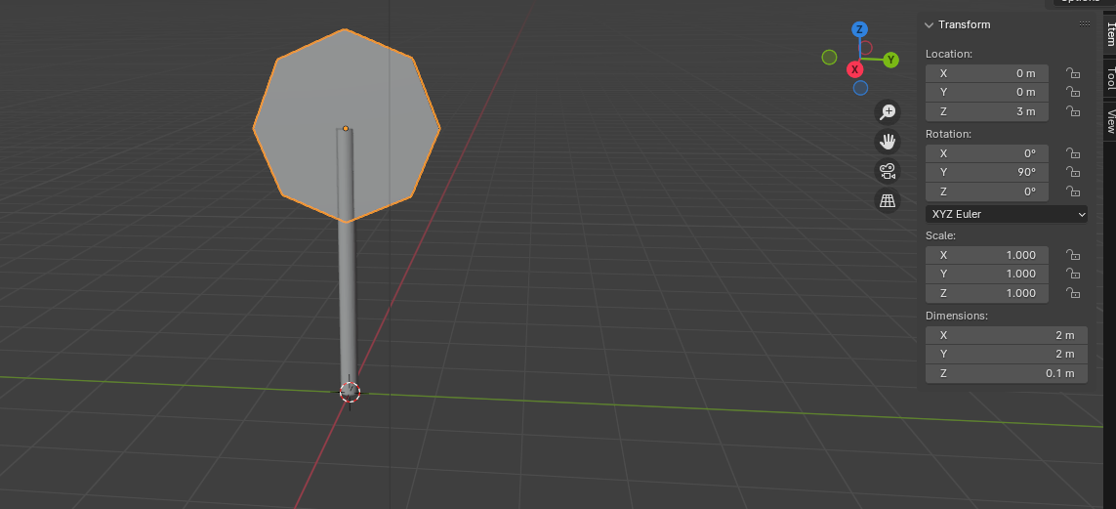
   * Scale it up so we dont see the pole

7. Inset the octagon

* + With the octagon selected, press Tab to enter Edit Mode.
  + Select the face Selector
  + 
  + Select a face of the octagon and inset it by pressing I to open the Inset tool.
  + 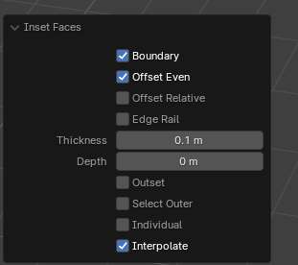
  + Write down 0.1 in the thickness
  + 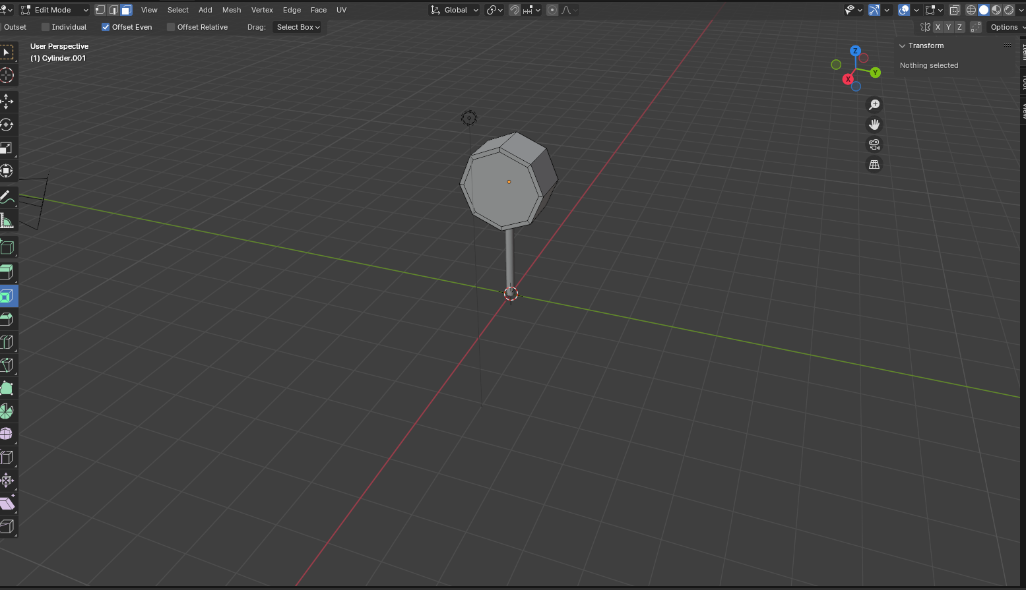
  + Do the same thing on the other side. You can rotate the view by holding down the mouse wheel while moving the mouse.
  + 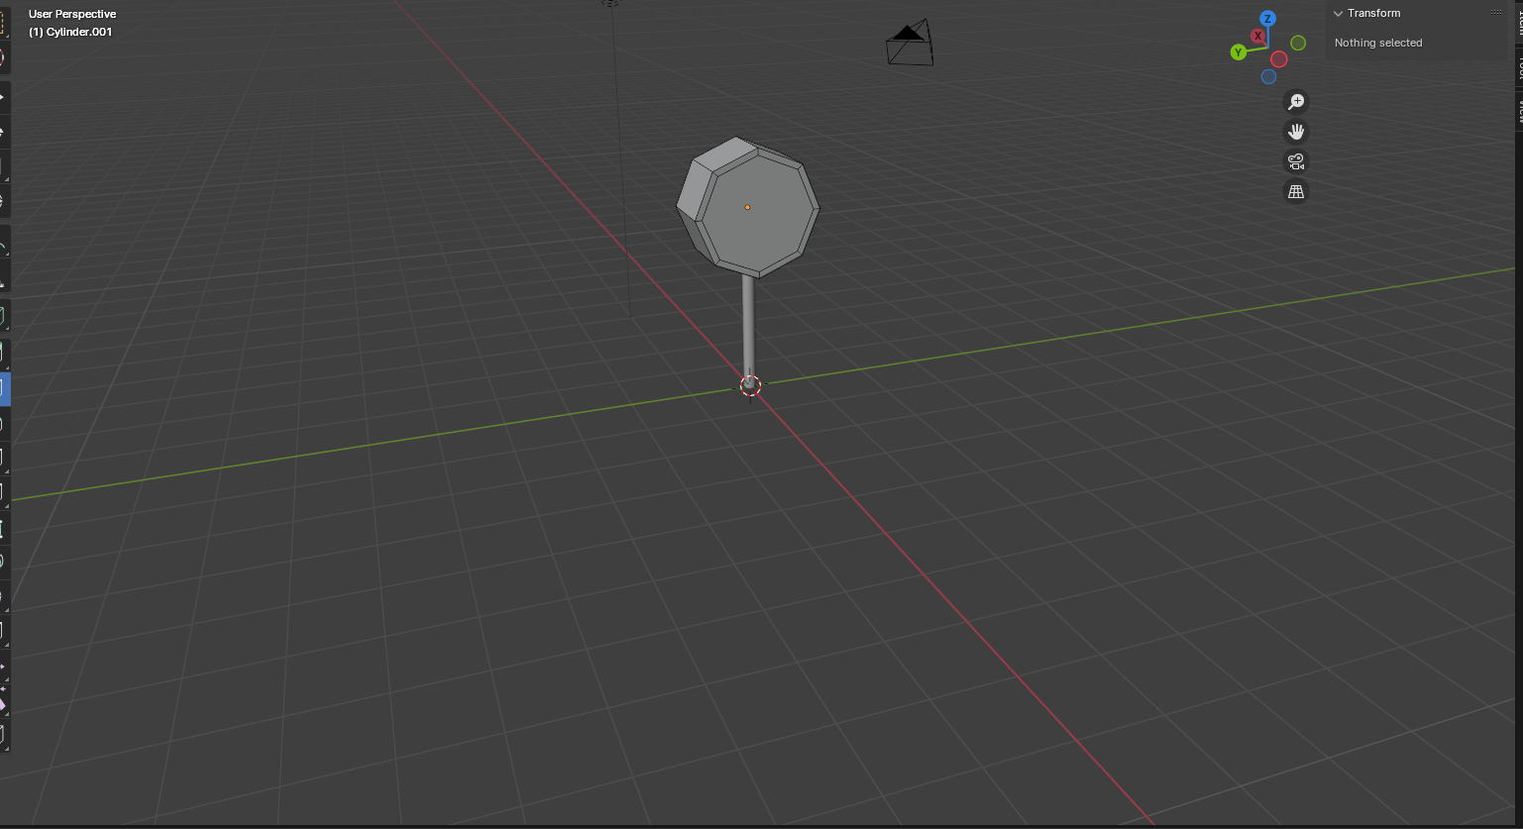

1. **Extrude the Octagon:**
   * Press E to extrude, then X to constrain along the X-axis, and type 0.1 to extrude it by 0.1 units.
   * 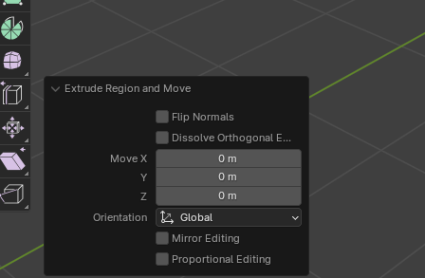
   * 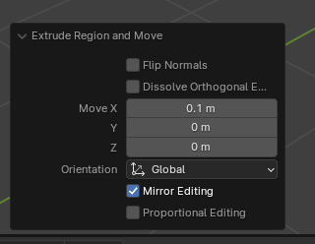
   * Press Tab to exit Edit Mode.
   * To view if your material was properly applied
2. **Add Materials:**
   * **Create Red Material for the Sign Face:**
     + Select the octagon.
     + 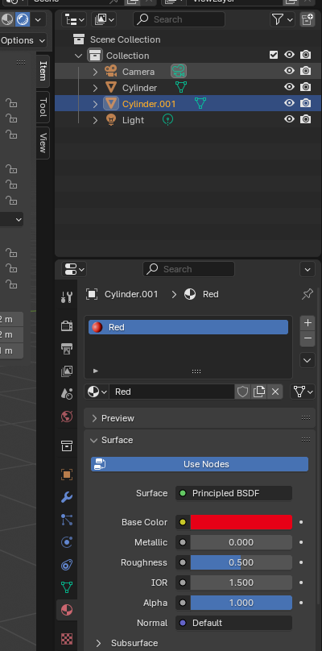
     + Go to the Material Properties tab (sphere icon).
     + 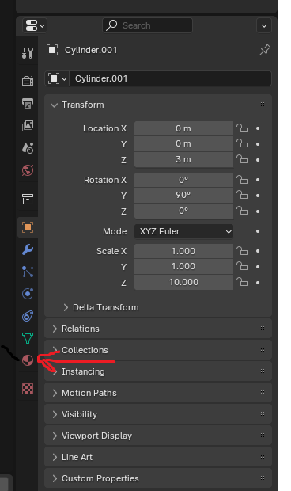
     + Click New to create a new material.
     + 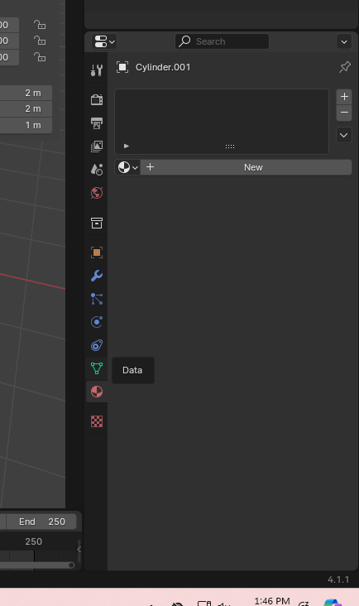
     + Name it Red.
     + 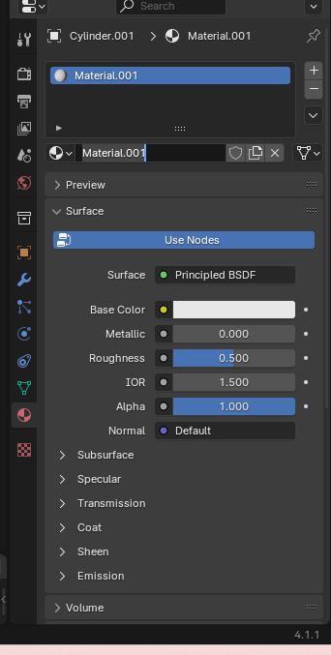
     + 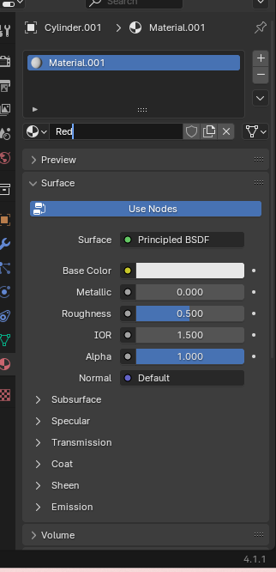
     + 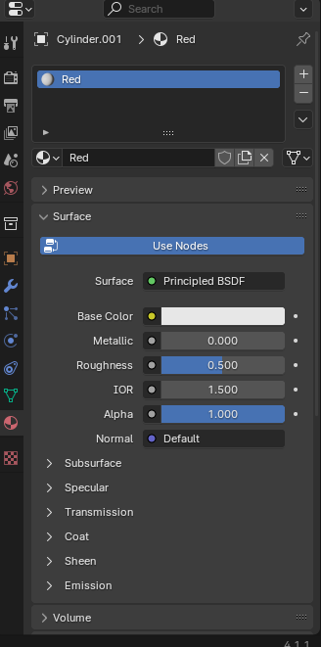
     + Set the Base Color to red.
     + 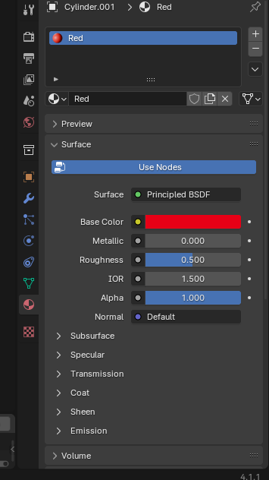
   * **Create Gray Material for the Sign Post:**
     + Select the cylinder.
     + Repeat the steps above but set the Base Color to gray and name it Gray.
3. **Add STOP Text (Optional):**
   * Press Shift + A and select Text.
   * Press R, then X, type 90, and press Enter to rotate the text on the X-axis.
   * Move the text to the front face of the sign:
     + **Location Z:** 2.05
   * Edit the text:
     + Press Tab to enter Edit Mode.
     + Delete the existing text and type STOP.
     + Press Tab to exit Edit Mode.
   * Scale and position the text as needed.

To view if the material were added correctly go to the

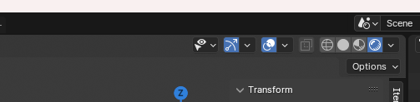

## **Task 3: Export the Stop Sign as an FBX**

Proper scaling and rotation are crucial when exporting models for Unity.

### **Steps:**

1. **Apply Transformations:**
   * Select all objects (A key).
   * Press Ctrl + A and choose All Transforms. This applies location, rotation, and scale transformations.
2. **Set the Origin Point:**
   * With all objects selected, right-click and choose Set Origin > Origin to Geometry.
3. **Join the Objects (Optional):**
   * With all objects selected, press Ctrl + J to join them into a single mesh. This simplifies importing into Unity.
4. **Export as FBX:**
   * Go to File > Export > FBX (.fbx).
   * In the export window, set the following options:
     + **Path Mode:** Copy
     + **Apply Transform:** Check this option.
     + **Scale:** Ensure the scale is set to 0.1.
     + **Forward:** -Z Forward
     + **Up:** Y Up
   * Choose the destination folder inside your Unity project's Assets folder, e.g., Assets/Models/StopSign.
   * Click Export FBX.

## **Task 4: Import the Stop Sign into Unity and Add a Collider**

Now, we'll bring your custom stop sign into Unity and make it interactive.

### **Steps:**

1. **Refresh Unity Assets:**
   * Switch back to Unity.
   * If you saved the FBX in the Assets folder, Unity should automatically import it.
   * If not, drag and drop the FBX file into the Assets panel in Unity.
2. **Adjust Import Settings (Optional):**
   * Select the stop sign FBX in Unity's Project panel.
   * In the Inspector window, check the Scale Factor. It should be 1.
   * Click Apply if you make any changes.
3. **Add the Stop Sign to the Scene:**
   * Drag the stop sign model from the Project panel into the Hierarchy panel.
4. **Position the Stop Sign:**
   * Select the stop sign in the Hierarchy.
   * In the Inspector, set the Position values as desired to place it in your scene.
5. **Add a Collider:**
   * With the stop sign selected, click on Add Component in the Inspector.
   * Search for and add a Mesh Collider or a Box Collider.
     + **Mesh Collider:** Conforms to the shape of your model but is more performance-intensive.
     + **Box Collider:** Simpler shape, better for performance.
   * Adjust the collider's size and position if necessary.
6. **Test the Collider:**
   * Enter Play Mode to test if your player character interacts with the stop sign as expected.

## **Task 5: Import a House Model into Unity**

Next, you'll import a pre-made house model into your Unity project.

### **Steps:**

1. **Download the House Model:**
   * Visit [Low Poly House on OpenGameArt](https://opengameart.org/content/low-poly-house).
   * Click on the download link to get the .blend file.
2. **Place the .blend File into Unity Assets:**
   * Copy or move the .blend file into your Unity project's Assets/Models/House folder (create the folder if it doesn't exist).
3. **Import the Model:**
   * Unity can import .blend files directly.
   * Once the file is in the Assets folder, Unity will automatically import it.
4. **Adjust Import Settings:**
   * Select the house .blend file in the Project panel.
   * In the Inspector, check the Scale Factor.
   * Ensure Apply Transform is checked if available.
   * Click Apply if you make any changes.
5. **Add the House to the Scene:**
   * Drag the house model from the Project panel into the Hierarchy.
6. **Position the House:**
   * With the house selected, set its Position and Rotation in the Inspector to place it appropriately in your scene.
7. **Add Colliders (Optional but Recommended):**
   * To make the house interactable, add colliders:
     + Select the house in the Hierarchy.
     + Click Add Component > Box Collider.
     + Adjust the collider to fit the house shape.
8. **Test in Play Mode:**
   * Enter Play Mode to ensure the house appears correctly and interacts as expected.

## **How to Submit Your Project**

1. Push to github.