**Manual Cleanup (QGIS or ArcGIS)**

1. Add imagery and classified image to view
2. Create new shapefile > Polygon > UTM zone
   1. Save as: City_YYYY_cleanup_class#_yourinitials.shp
   2. Example: Conakry_2013_cleanup_class1_AMCS.shp
3. Toggle Editing on and Draw polygons around areas that should be changed to class1
4. Add field called “CID” and add the class # that it should be changed to for every polygon
5. Toggle editing off and Save Edits
6. Repeat for all classes

Notes:

* Spend about an hour zooming around to find big errors
* Things to keep an eye out for:
  + Airport runways will be misclassified as commercial >> cleanup as Other
  + Highways will be misclassified as commercial >> cleanup as Other
  + Areas of bright Soil may be misclassified as Commercial >> cleanup as Other
  + Coastal sand/waves may be misclassified as commercial >> cleanup as other
  + Other residential/commercial areas may need to be cleaned up as well that the classification may have missed.

Examples:

This area should be changed to Regular residential class (class 1)

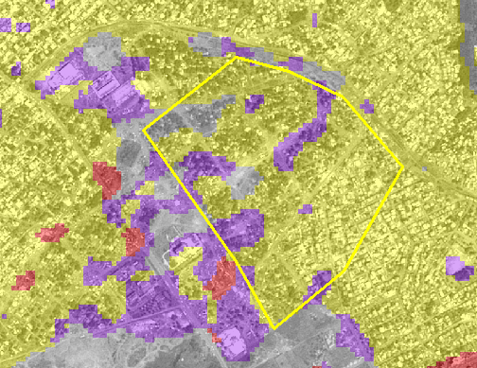

This area should be changed to the Commercial class (class 3)

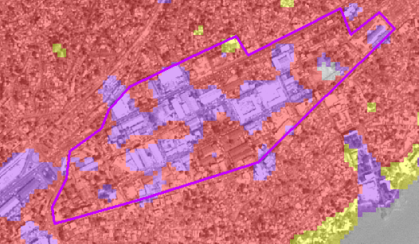

These area should be changed to the Other class (class 4)

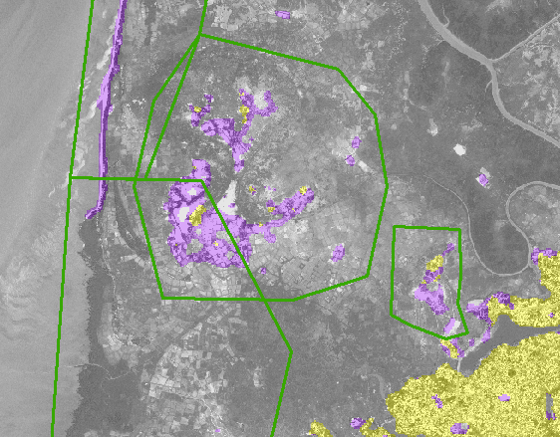

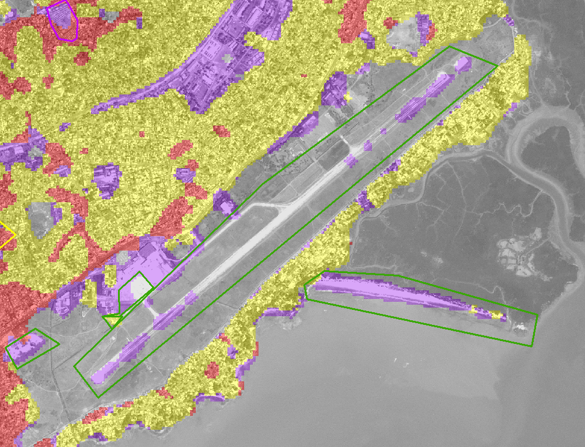

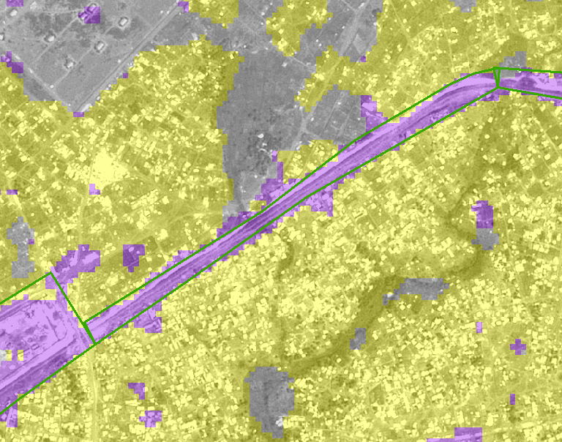

**Reclassifying Raster for Manual Cleanup areas (ArcGIS)**

1. Reclassify Tool
   1. Input Raster: smoothed thematic classification
   2. Reclass Field: Value
   3. Click “Environments…” Tab > Raster Analysis
      1. Cell Size: Same as classification layer (must do this to keep the rasters snapped to each other)
      2. Mask: your Cleanup shapefile (ex: Conakry_2013_cleanup_class1_yourinitials.shp)
   4. Reclassification:
      1. New Values all must be changed to the class of the cleanup polygons (see below)
   5. Output raster: conakry_2013_cleanup_class1_reclassify_yourinitials.img 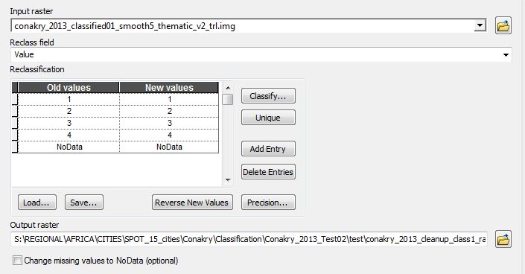
   6. Click Okay
   7. Repeat for all 4 cleanup classes.
2. Mosaic to new Raster
   1. Input Rasters: all four cleanup rasters
   2. Output: Conakry_2013_cleanup_mosaic_all_yourinitials.img
   3. Spatial Reference: UTM zone
   4. Cell size: 20
   5. Number of bands: 1
   6. Click Okay
   7. 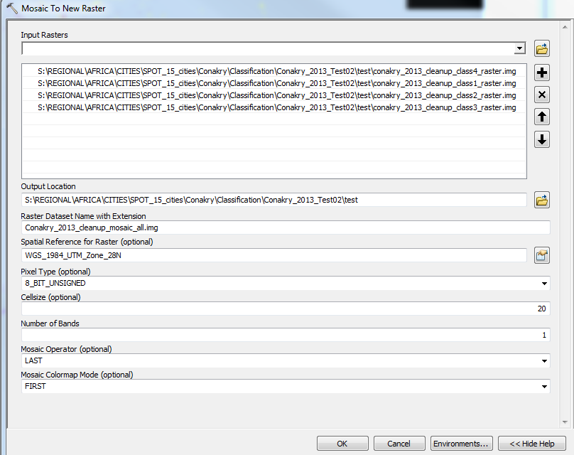
3. Mosaic the classification and the cleanup files together
   1. Input the classification first, then the cleanup mosaic image.
   2. Same parameters as above
   3. 