**Loading and preprocessing the data**

**1. Load the data (i.e. read.csv())**

if(!file.exists('activity.csv')){

unzip('activity.zip')

}

activityData <- read.csv('activity.csv')

**2. Process/transform the data (if necessary) into a format suitable for your analysis**

#activityData$interval <- strptime(gsub("([0-9]{1,2})([0-9]{2})", "\\1:\\2", activityData$interval), format='%H:%M')

**What is mean total number of steps taken per day?**

stepsByDay <- tapply(activityData$steps, activityData$date, sum, na.rm=TRUE)

**1. Make a histogram of the total number of steps taken each day**

qplot(stepsByDay, xlab='Total steps per day', ylab='Frequency using binwith 500', binwidth=500)

[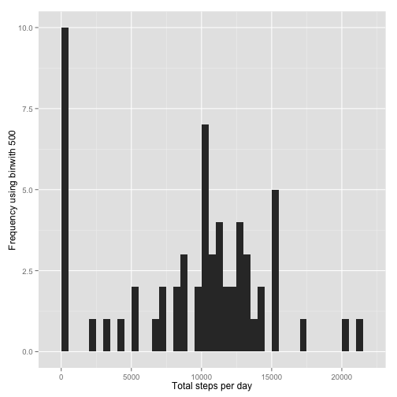](https://github.com/TomLous/coursera-reproducible-research-peer-assessment1/blob/master/figure/unnamed-chunk-5.png)

**2. Calculate and report the mean and median total number of steps taken per day**

stepsByDayMean <- mean(stepsByDay)

stepsByDayMedian <- median(stepsByDay)

* Mean: 9354.2295
* Median: 10395

**What is the average daily activity pattern?**

averageStepsPerTimeBlock <- aggregate(x=list(meanSteps=activityData$steps), by=list(interval=activityData$interval), FUN=mean, na.rm=TRUE)

**1. Make a time series plot**

ggplot(data=averageStepsPerTimeBlock, aes(x=interval, y=meanSteps)) +

geom_line() +

xlab("5-minute interval") +

ylab("average number of steps taken")

[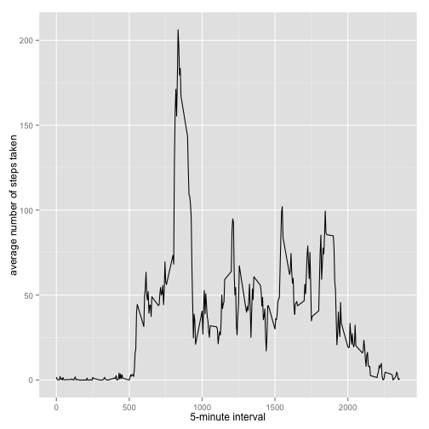](https://github.com/TomLous/coursera-reproducible-research-peer-assessment1/blob/master/figure/unnamed-chunk-8.png)

**2. Which 5-minute interval, on average across all the days in the dataset, contains the maximum number of steps?**

mostSteps <- which.max(averageStepsPerTimeBlock$meanSteps)

timeMostSteps <- gsub("([0-9]{1,2})([0-9]{2})", "\\1:\\2", averageStepsPerTimeBlock[mostSteps,'interval'])

* Most Steps at: 8:35

**Imputing missing values**

**1. Calculate and report the total number of missing values in the dataset**

numMissingValues <- length(which(is.na(activityData$steps)))

* Number of missing values: 2304

**2. Devise a strategy for filling in all of the missing values in the dataset.**

**3. Create a new dataset that is equal to the original dataset but with the missing data filled in.**

activityDataImputed <- activityData

activityDataImputed$steps <- impute(activityData$steps, fun=mean)

**4. Make a histogram of the total number of steps taken each day**

stepsByDayImputed <- tapply(activityDataImputed$steps, activityDataImputed$date, sum)

qplot(stepsByDayImputed, xlab='Total steps per day (Imputed)', ylab='Frequency using binwith 500', binwidth=500)

[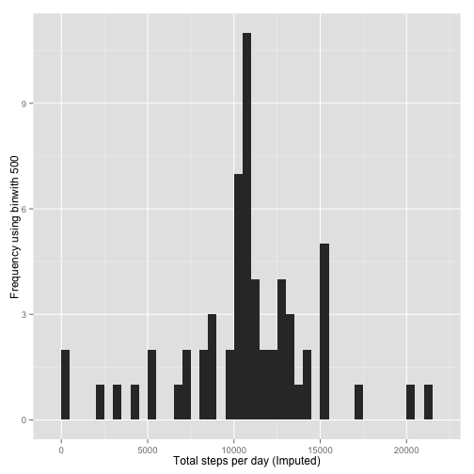](https://github.com/TomLous/coursera-reproducible-research-peer-assessment1/blob/master/figure/unnamed-chunk-12.png)

**... and Calculate and report the mean and median total number of steps taken per day.**

stepsByDayMeanImputed <- mean(stepsByDayImputed)

stepsByDayMedianImputed <- median(stepsByDayImputed)

* Mean (Imputed): 1.0766 × 104
* Median (Imputed): 1.0766 × 104

**Are there differences in activity patterns between weekdays and weekends?**

**1. Create a new factor variable in the dataset with two levels – “weekday” and “weekend” indicating whether a given date is a weekday or weekend day.**

activityDataImputed$dateType <- ifelse(as.POSIXlt(activityDataImputed$date)$wday %in% c(0,6), 'weekend', 'weekday')

**2. Make a panel plot containing a time series plot**

averagedActivityDataImputed <- aggregate(steps ~ interval + dateType, data=activityDataImputed, mean)

ggplot(averagedActivityDataImputed, aes(interval, steps)) +

geom_line() +

facet_grid(dateType ~ .) +

xlab("5-minute interval") +

ylab("avarage number of steps")

[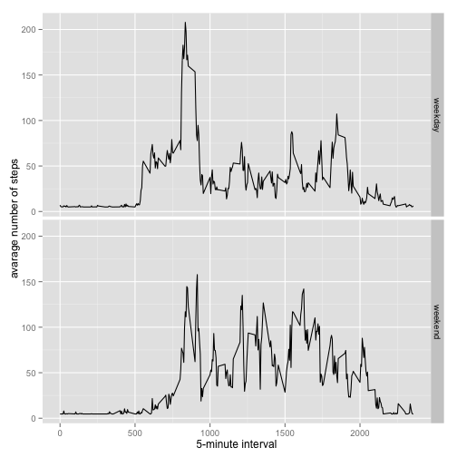](https://github.com/TomLous/coursera-reproducible-research-peer-assessment1/blob/master/figure/unnamed-chunk-15.png)