Data Preprocessing & Exploratory Data Analysis Report
As the Data Preprocessing Team at City Hospital, this report documents our work in preparing and structuring patient data for advanced analytics. By performing exploratory data analysis and data preprocessing steps, our team was able to uncover patterns useful to build an Analytics Base Table (ABT).

Objective & Audience
This report’s main goal is providing a thorough description of the data preprocessing and data exploration methods used on patient data. The target audience is composed of data scientists and analysts who will use the ABT table for further analysis, predictive modelling and decision-making purposes.

Part A: Data Understanding & Cleaning
Data Overview & Understanding
After importing all the needed libraries, we imported the dataset as a pandas DataFrame (named data) and set the column ‘Patient ID’ as the index, since its purpose is to differentiate the clients’ appointments - each row is a different appointment. Then, we accessed the shape attribute and concluded our dataset has 10008 records and 15 features. In addition, the following methods were called to obtain an initial overview of the dataset:
- head(): visualization of the first 5 records of the dataset;
- info(): exploration of the number of missing values per column, as well as their datatypes;
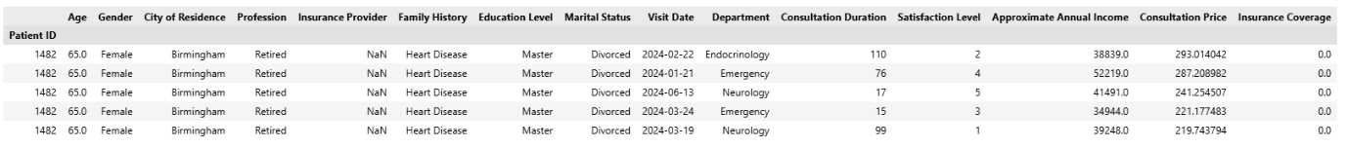
- describe(): generation of statistical summaries for numerical, categorical and datetime features.
Figure 1: head() method output
After getting an initial idea of the dataset, it is important to inspect it for missing values, outliers, potential inconsistencies and duplicates.

Missing values
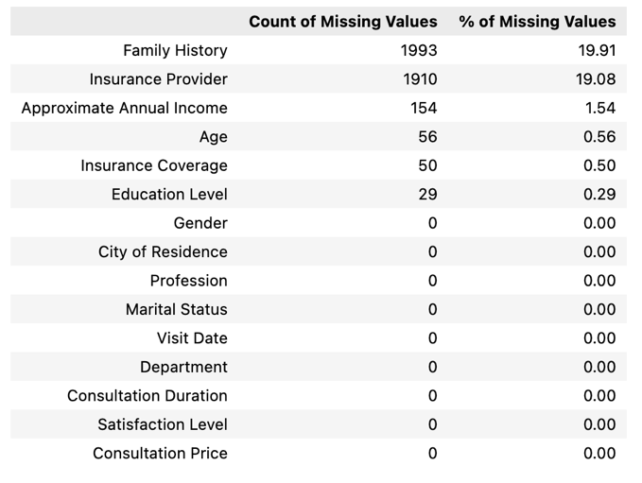
We computed the number of missing values per column (as well as its proportion) and concluded that the most problematic variable is Family History (19.91% of missing values), followed closely by Insurance Provider (19.08% of missing values).

Figure 2: Missing values analysis
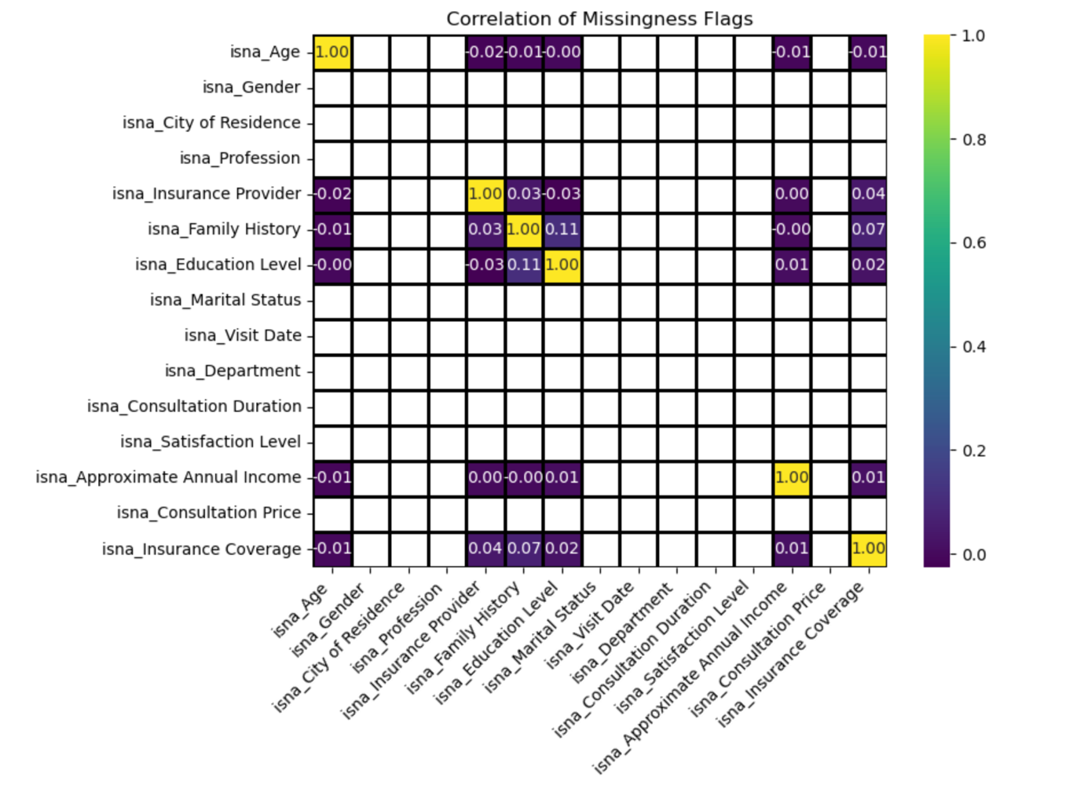
To explore the missingness type of the missing values, we decided to compute the correlation between the missing values of all the columns. Our goal was to identify Missing at Random (MAR) missing values – its missingness depends on other variables; however, this analysis did not reveal any meaningful insights, which suggests that the missingness is not highly correlated across features.
Figure 3: Heatmap of the correlation between the missingness flags

Therefore, to explore the missingness type, another approach was used. A patient-level imputation strategy was used for most of the features, since each patient may have multiple consultation records associated. The baseline approach (patient-level carry-forward imputation) consists of:
- Identifying patients (by Patient ID) who have at least one missing value in the feature;
- Retrieving all rows for those patients and obtain the first non-missing value of the feature for each patient;
- Filling all missing values of that feature for that patient with the obtained value.
This approach guarantees that each patient’s missing values are determined using their own information and not assumptions from other patients, preserving data integrity throughout all the consultations. For some features, this strategy was sufficient, while for others additional strategies were used.
Missing Completely at Random (MCAR)
The following missing values were considered Missing Completely at Random (MCAR) since the missingness is random and completely unrelated to the actual value or any other feature.

Age
For this feature, the patient‑level carry‑forward imputation completely resolved mreissing values.
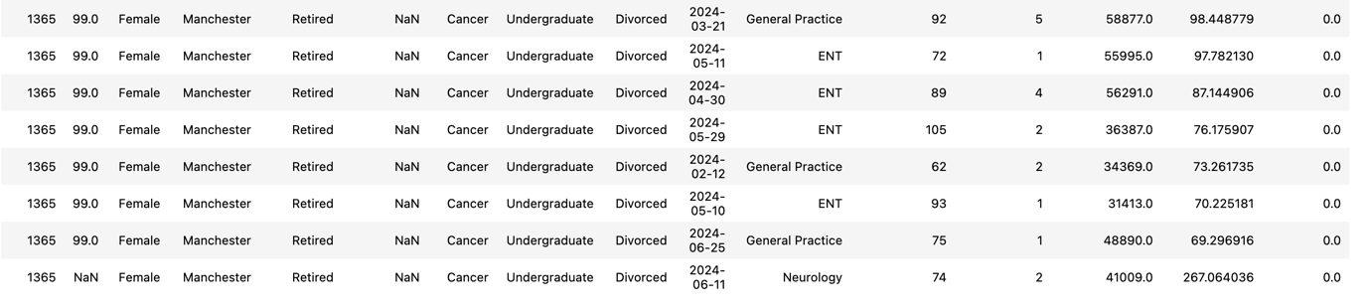
Figure 4: Patient ID 1365 Consultations
For instance, Patient ID 1365 had a missing value for age in one of the rows so the value 99.0 was retrieved from the previous rows and used to impute the missing value.
Missing At Random (MAR)
The following missing values were considered Missing at Random (MAR), since their absence is related with other observed features, but not to the values of the feature itself.
Insurance Provider & Insurance Coverage
These features were handled at the same time because the missing values in Insurance Coverage are Missing At Random, depending on Insurance Provider and Consultation Price, rather than the Insurance Coverage itself. Therefore, 4 categories were inspected, in order to fill in the missing values:
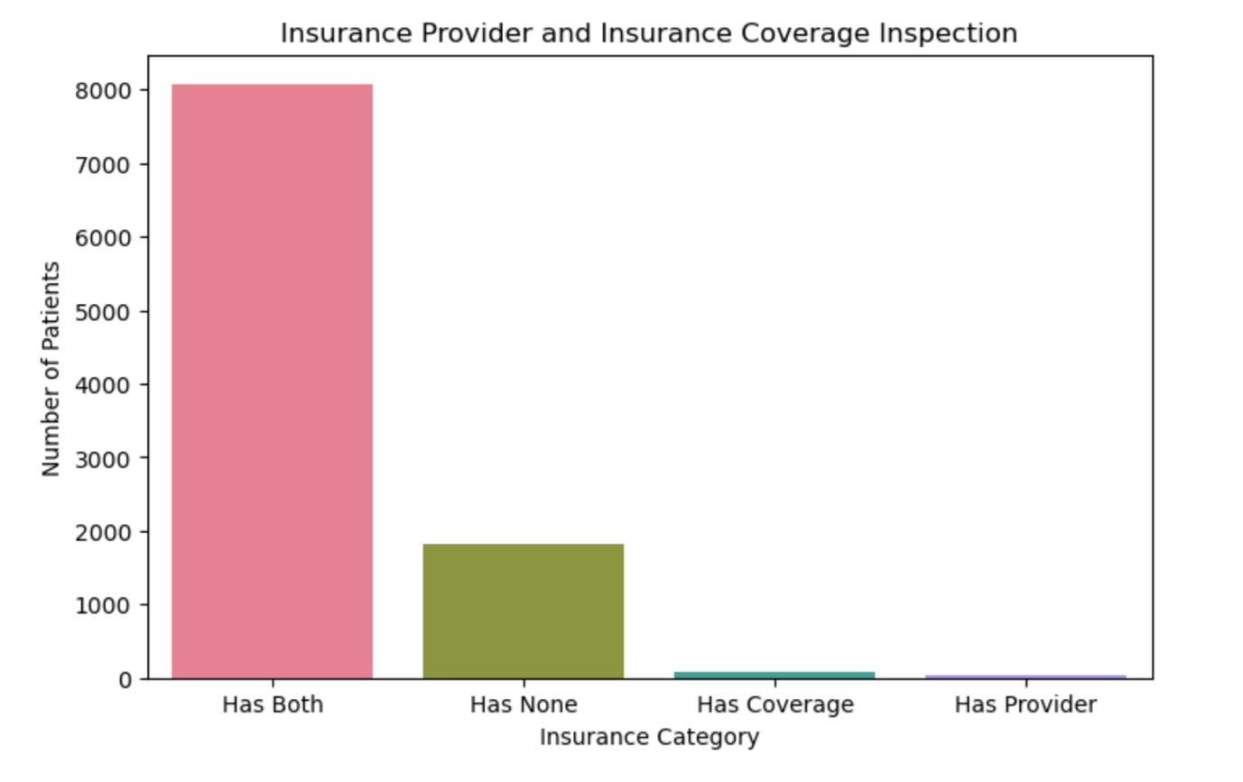
Figure 5: Distribution of patients by Insurance Provider and Insurance Coverage

Has Both: Insurance Provider and Insurance Coverage both present no action.
Has None: both variables missing or zero Insurance Provider set to "None" and Insurance Coverage set to 0.0, reflecting patients without insurance.
Has Coverage: Insurance Coverage present but Insurance Provider missing missing provider values filled using the patient-level carry-forward approach.
Has Provider: Insurance Provider present but Insurance Coverage missing provider specific rules applied.
For the Has Provider group, the missing values were analyzed separately for Provider B and Provider D, since those were the only two providers associated with missing Insurance Coverage. Before imputing, it is important to note that there are no patients with Insurance Provider and an Insurance Coverage equal to 0.0. Therefore:
- Provider D: In all non‑missing records, Provider D covered 100% of the consultation price. The missing values for Insurance Coverage for this provider were set equal to the corresponding consultation price. Any inconsistencies where the Insurance Coverage exceeded the consultation price were corrected by capping coverage at the Consultation Price.
- Provider B: In all non-missing records, Provider B covered 90% of the consultation price. The missing values for Insurance Coverage for this provider were imputed as 90% of the consultation price. Any inconsistencies where the Insurance Coverage surpassed the consultation price were replaced with 90% of the Consultation Price.
Lastly, the dataset was inspected for more cases of data inconstancies - where Insurance Coverage surpassed the Consultation Price. Since there was another record where this happened, the Insurance Coverage Percentage of the Insurance Provider, in this case Provider A, was checked. The Insurance Coverage Percentage was approximately 80% for all patients with Provider A, so the Insurance Coverage was replaced with 80% of Consultation Price for this case.
Education Level
The missing values in Education Level were considered Missing At Random, as they seem to depend on the patients’ age.
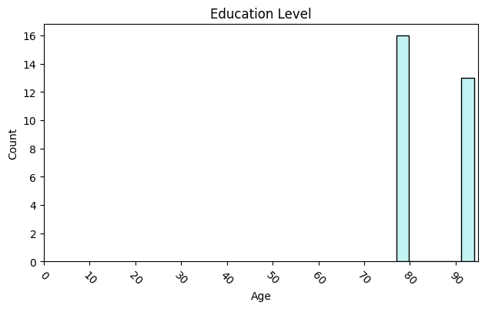
Figure 6: Distribution of Education Level by Age

As demonstrated by the visualization above, only patients with ages between 77 and 94 had missing values in Education Level. However, the baseline approach of checking other rows proved to be effective: for these patients, the patient‑level carry‑forward imputation completely resolved all missing values.
Approximate Annual Income
The missing values in Approximate Annual Income were considered MAR, as they depend on patient characteristics such as Profession and Education Level. A stepwise strategy was applied:
- Patient‑level carry-forward approach: When a patient had a missing income between two known consultations, the missing value was filled using the value from the closest consultation.
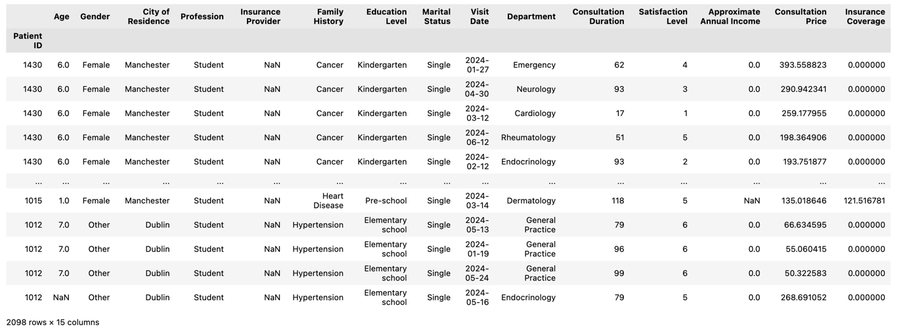
- Students: For students, income was set to 0.0, in compliance with the discovered pattern that all students had an income of 0.0.
Figure 7: Income of patients that are students.
- Median‑by‑profession imputation: The remaining missing values were imputed using the median income of patients within the same profession.
Missing Not At Random (MNAR)
The following missing values were considered Missing Not At Random (MNAR) since their missingness is related to the actual value that is missing.
Family History
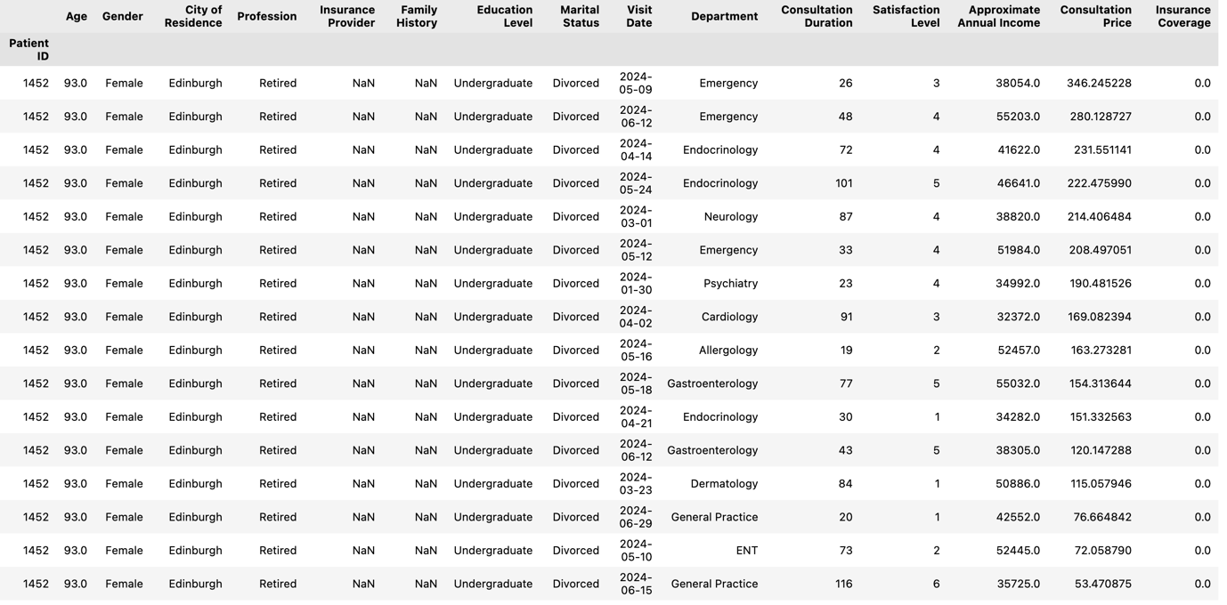
All patients with missing values for this feature had it missing for all their consultations. Since the feature is categorical, the uncertainty of the Family History of these patients was encoded with the category ‘Unknown’.
Figure 8: Patient ID 1452 consultations
For example, patient ID 1452 had missing values in Family History throughout all the consultations, therefore, there is not enough data to infer any diseases.
Distribution and Skewness Analysis
To determine the degree of skewness and the need for data transformations, the distributions of the variables were examined. The skewness was computed for all numerical features to classify their distributions as approximately symmetric, left-skewed, or right-skewed.
Approximately Symmetric (but not normal):
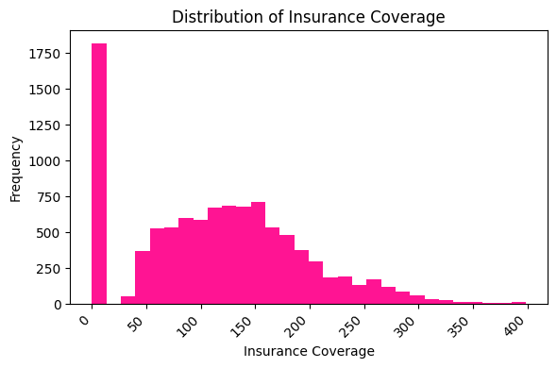
Insurance Coverage has an approximately symmetric distribution (0.323230), with a substantial peak at 0, reflecting the patients with no Insurance Provider.

Figure 9: Distribution of Insurance Coverage

Moderate right-skewed:
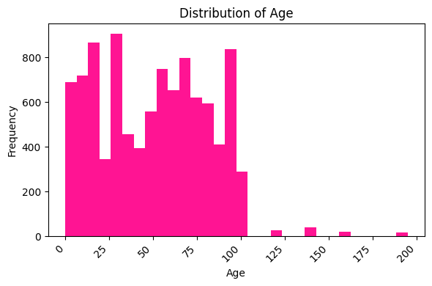
Age exhibits a moderate right-skewness (0.285089), with a slight right-tail indicating the presence of some implausible high values.

Figure 10: Distribution of Age

Consultation Duration shows moderate right-skewness (1.545225), indicating occasional long consultations.
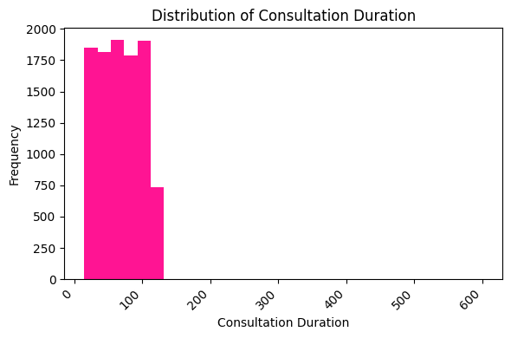

Figure 11: Distribution of Consultation Duration

High right-skewness:
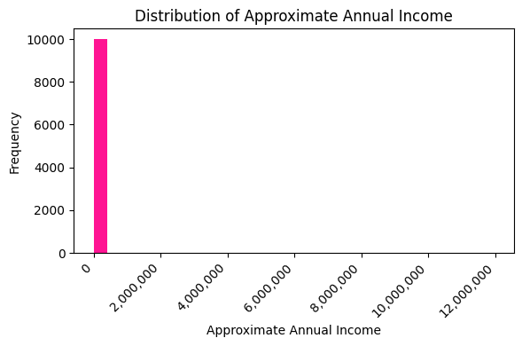
Approximate Annual Income exhibits a significant high right-skewness (42.533492), which reflects the presence of a few extremely high incomes.

Figure 12: Distribution of Approximate Annual Income

Consultation Price displayed a significant high right-skewness (39.858178), indicating the presence of a few extremely high prices.
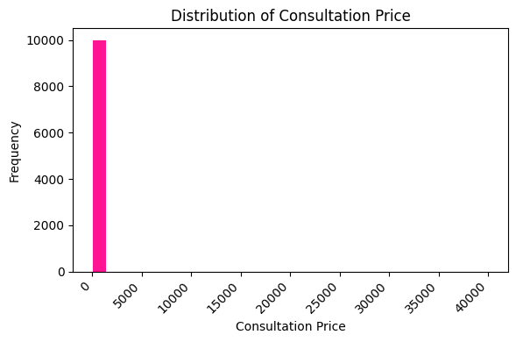

Figure 13: Distribution of Consultation Price

Outliers
In the process of Exploratory Data Analysis, several numerical features showed the presence of extreme values. To maintain the quality of the data and the accuracy of further analysis, an outlier treatment was conducted – capping (replacing outliers beyond a certain threshold with the value of that threshold), based on domain knowledge and the Interquartile Range technique (IQR). This technique considers to be outliers any value below Q1–k∗IQR or above Q3+k∗IQR, with IQR being Q3-Q1 and k, although normally set to 1.5, any positive number.
Age
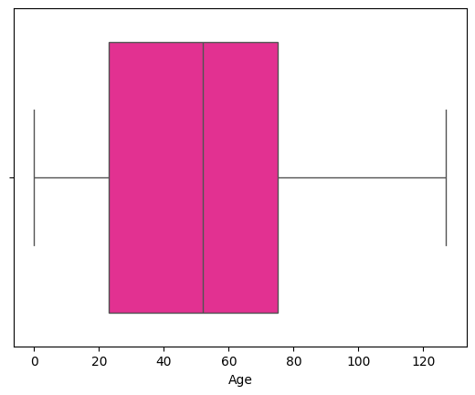
All observations above 127 (corresponding to Q3+IQR, with k set to 1) were capped. If the default value for k was used, the capping threshold would be even higher, allowing unrealistic ages to remain in the dataset.
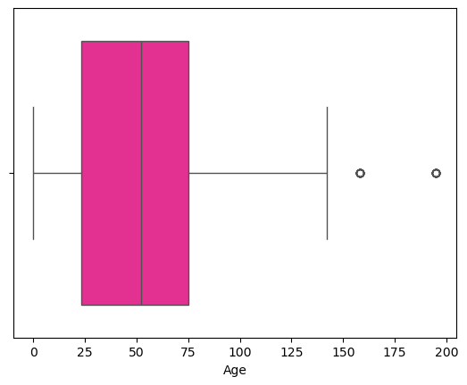

Figure 14: Boxplots of Age before and after clipping
Consultation Duration
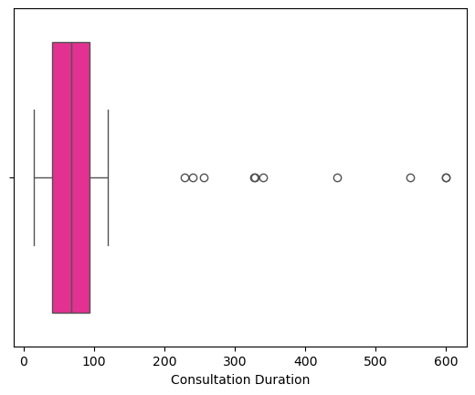
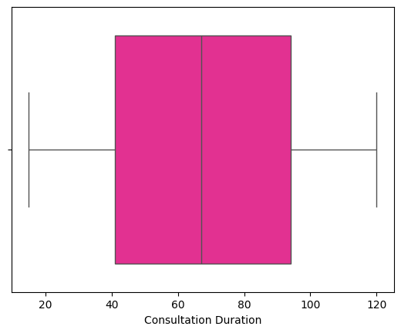
All observations above 173.5 minutes (corresponding to Q3+IQR, with k set to 1.5) were considered outliers. Although the lower bound was also calculated with the IQR method, it is a negative value. As consultation durations cannot be negative, no outliers were removed at the lower end.

Figure 15: Boxplots of Consultation Duration before and after clipping

Satisfaction Level
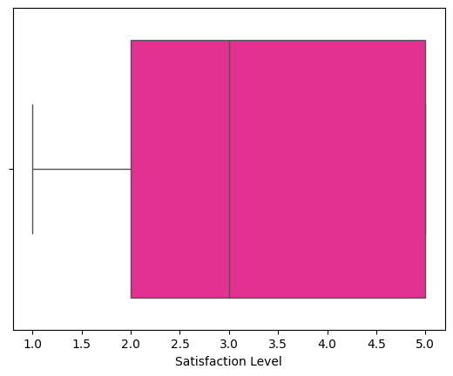
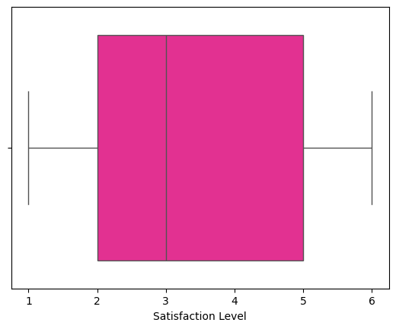
Since this feature has only a range of 1 to 5, all values outside this range were considered data errors, and so all observations higher than 5 were replaced by 5.

Figure 16: Boxplots of Satisfaction Level before and after clipping
Approximate Annual Income
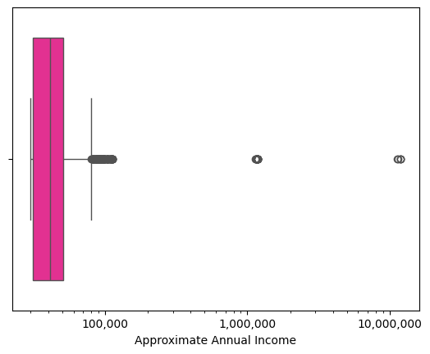
Although this feature includes some high incomes, they are plausible values, so they were not considered data errors. As such, no removing or clipping was applied.

Figure 17: Approximate Annual Income boxplot

Consultation Price
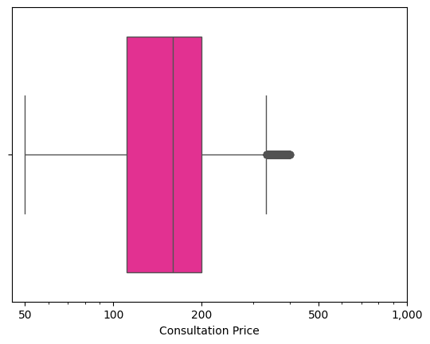
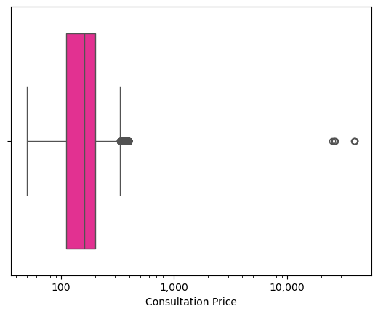
Extreme high values (above 10 000) were considered data errors and removed, while values within a plausible range, even if high, were maintained.
Figure 18: Boxplots of Consultation Price before and after removal

Insurance Coverage
Some observations in this column had high values, however, they were plausible given that the corresponding Consultation Price was also high. Therefore, no removal or clipping was applied.
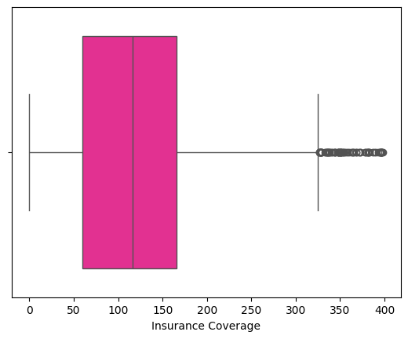

Figure 19: Boxplot of Insurance Coverage

Data Types
For memory optimization and improved performance, a mapping of the appropriate datatypes for each column was applied.
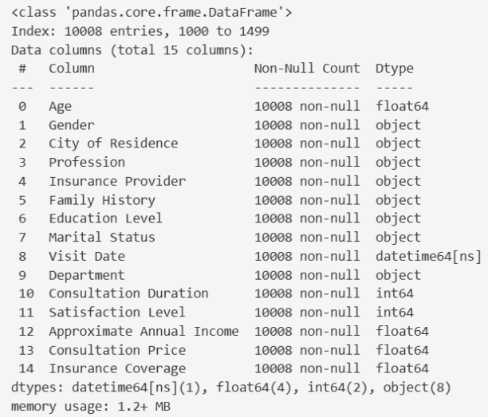
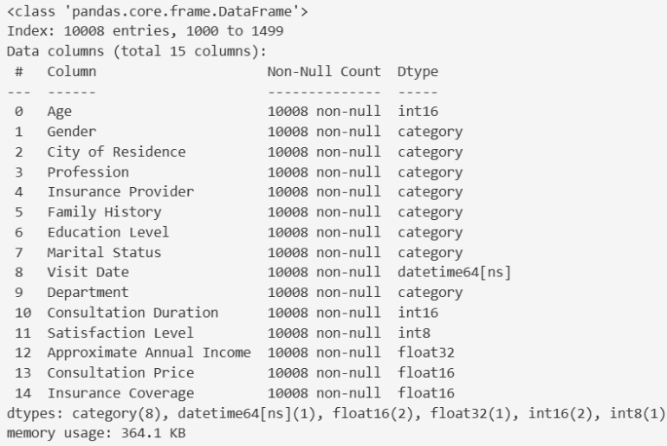

Figure 20: data.info() before and after data type conversion
Deduplication
For data integrity purposes, the duplicates in the dataset were identified and then removed.
Part B: Feature Engineering & ABT Construction
Feature Engineering
Some new features were created to capture meaningful patterns for modelling and the construction of the Analytical Base Table.
Income_log and Consultation_price_log – These features were created by applying log transformations to the original ones with the goal of reducing skewness for predictive modelling.
Insurance Coverage Percentage – This new column consists in the ratio between Insurance Coverage and Consultation Price, revealing that different Insurance Providers are associated with different coverage percentages. This is important to understand factors such as financial stress and future consultations.
Age Range – This column consists in the process of discretization / binning applied to the column Age. This new feature is composed of 3 intervals, from 0 to 17 – representing Children, from 18 to 64 – representing Adults and from 65 to 127 – representing Elders.
Age Group – This column consists of a mapping of the three intervals associated with each Age Range with a category – Children, Adults and Elders.
Days since last visit – This feature records the number of days since the last consultation, for each patient, which is crucial to understand their current health status, since longer periods of time might indicate a decease progression.
These new features were included alongside the original ones in the Analytical Base Table to enrich the dataset, enhance model performance, and enable deeper insights from further analysis.
Analytical Base Table (ABT) Construction
To construct the table, the following steps were executed.
Aggregation
Patient‑specific data was aggregated to obtain one consolidated record per patient that summarizes the history and most recent attributes.
Features | Aggregation method | Rationale
Age  Visit Date | ‘max’ | Captures the latest age and the most recent consultation date
Gender | ‘first’ | Assumed to be maintained overtime
City  Profession  Insurance Provider  Family History  Education  Marital Status  Age Range  Age Group  Days since last visit  Approximate Annual Income  Income_log | ‘last’ | Captures the most recent information
Department | List of elements | Captures all the departments visited by the patients (with the oldest department first)
Consultation Duration  Satisfaction Level  Consultation Price  Insurance Coverage  Insurance Coverage Percentage  Consultation_price_log | ‘mean’ | Represents typical consultation patterns per patient

Column renaming and data types
For a better understanding of what each column represents, the column names were adjusted to reflect the aggregations applied. For example, the column Approximate Annual Income was modified to Average Approximate Annual Income and Visit Date to Last Visit Date.
The feature ‘Last Visit Date’ was converted back to the datatype string instead of remaining of a datetime object so that, upon exporting the table to CSV, the dates appear appropriately formatted.
Exporting
The resulting Analytical Base Table was saved as a CSV file named ‘ABT_city_hospital’, providing a pre-processed and clean basis for modelling and analysis.
Part C: Exploratory Visualization & Insights
Patient Demographics - Distributions
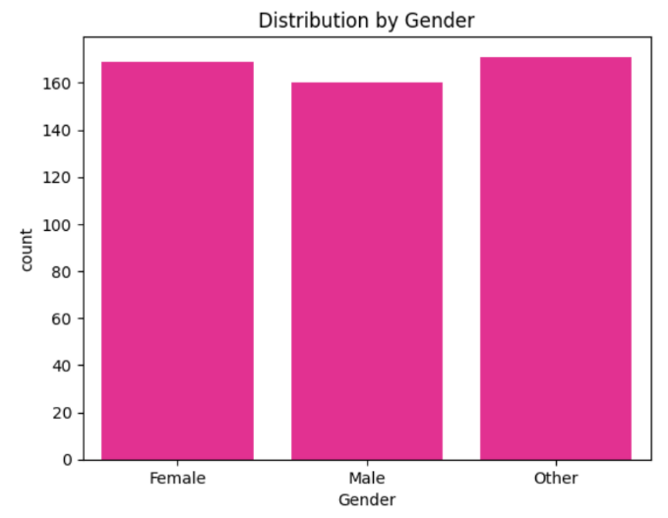
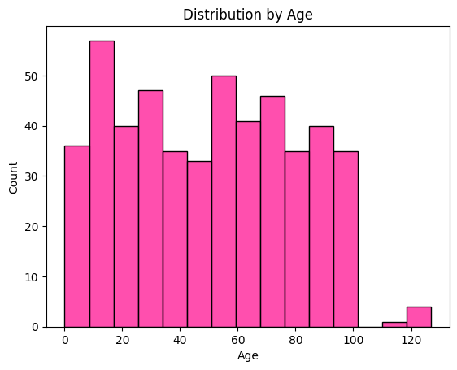
Distributions of Age, Gender, Approximate Annual Income and Income_log

The first graph shows the distribution of patients by Age. The 9-16 range is the most frequent, with more than fifty patients. This graph shows discontinuity as there are no patients with an age between 102 and 110 years old.
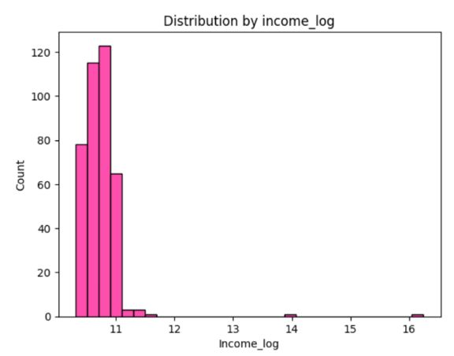
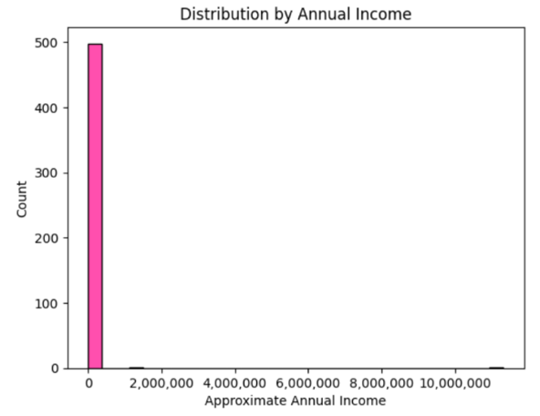
The second graph represents the distribution of patients by the Gender categories: Female, Male, and Other. They have similar frequency, with Other taking the lead. This distribution is not common in real life, so we might be facing a case of people who chose the Other option when, in fact, it did not represent their situation.

The figure above on the left shows the distribution of patients by the Approximate Annual Income. Almost every patient registered an annual income between 0 and 377077. Two patients are outside of this group. One of them registered two million, and the other ten million.
The one beside it is a log transformation of the previous graph, in order to reduce the skewness and facilitate the analysis of the distribution of the graph as well as predictive modelling.
Number of visits per department over time
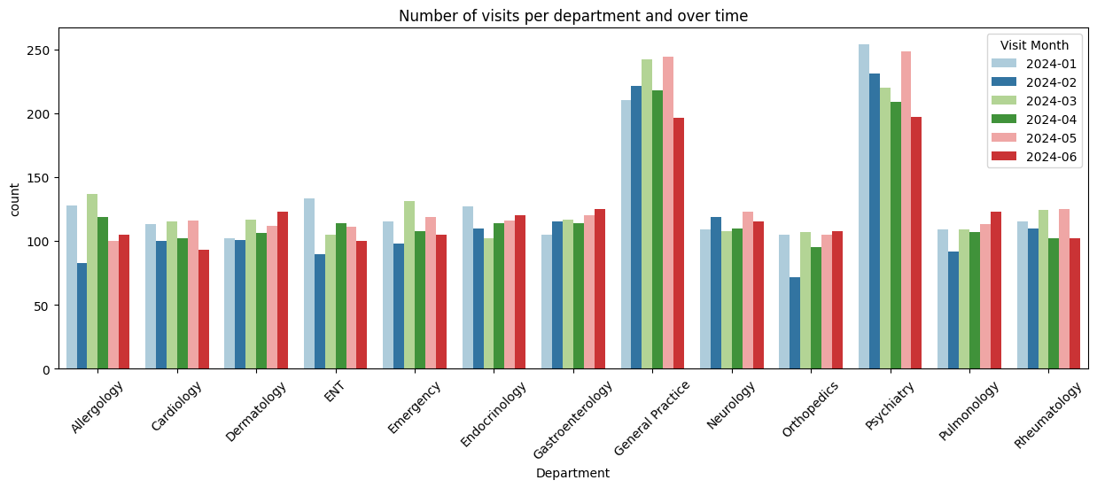
This figure shows the distribution of visits per Department over the months covered by this data – January, February, March, April, May and June of 2024. The department with the most visits was the Psychiatry department in January (246 visits). The least visited department was the Orthopedics department in February (72 visits). Departments like Cardiology, Dermatology, Emergency, Endocrinology, Gastroenterology, Neurology, Pulmonology and Rheumatology present small fluctuations over the months, with the difference between the highest and lowest number of visits being smaller than 35. The biggest gap was between January and June in the Psychiatry department.

Department visits by Gender
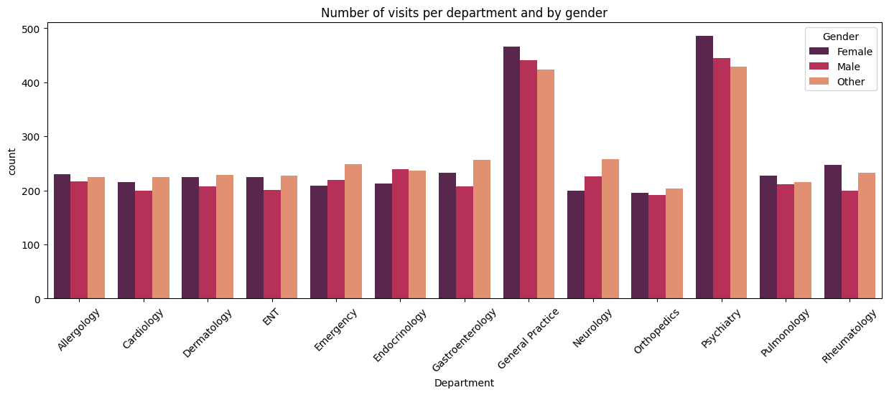The figure shows the number of visits per Department, broken down by Gender. The Psychiatry is the most visited department, with Female being the largest group, with 486 visits, followed closely by Male (440 visits) and Other (429). General Practice, the second most visited department, has a similar distribution, although the Female group has slightly fewer visits. The least visited department is Orthopedics, with a similar distribution between the Gender groups. The largest Gender gap is 60 and appears in the Psychiatry department. Overall, gender distributions across departments show minor fluctuations. In seven departments, Allergology, Cardiology, Dermatology, ENT, Endocrinology, Orthopedics, and Pulmonology, the gender gap is smaller than 30 patients.
Satisfaction Level by Department and by Age Range
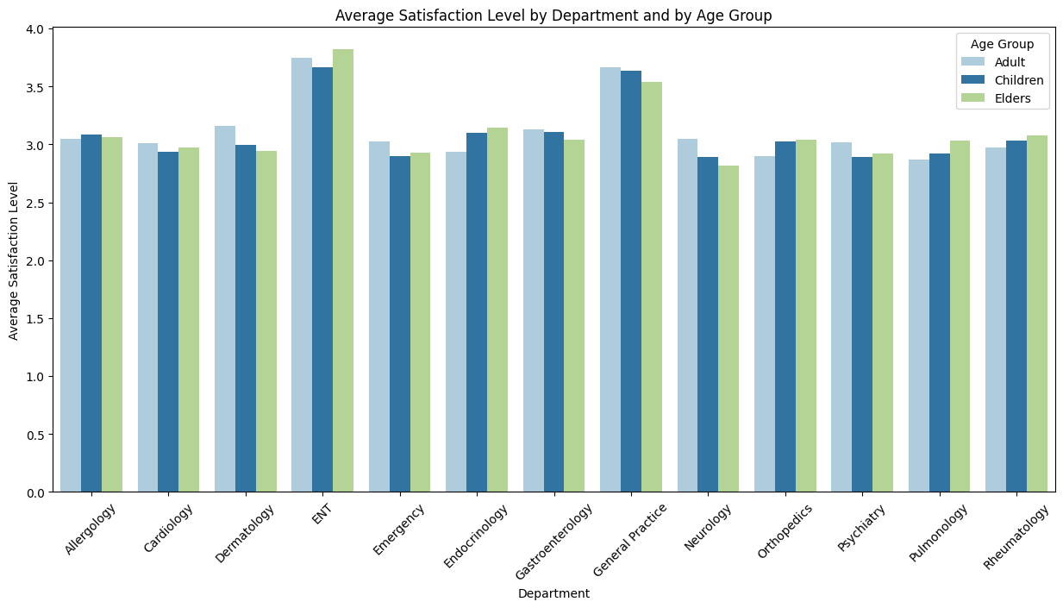
The figure above displays the average Satisfaction Level per Department and per Age Group. The department with the best Satisfaction Level across all ages appears to be ENT, with the highest value for the Elders group, followed by General Practice. Overall, age group distributions show minor fluctuations across most departments.

Consultation Price and Duration by Satisfaction Level
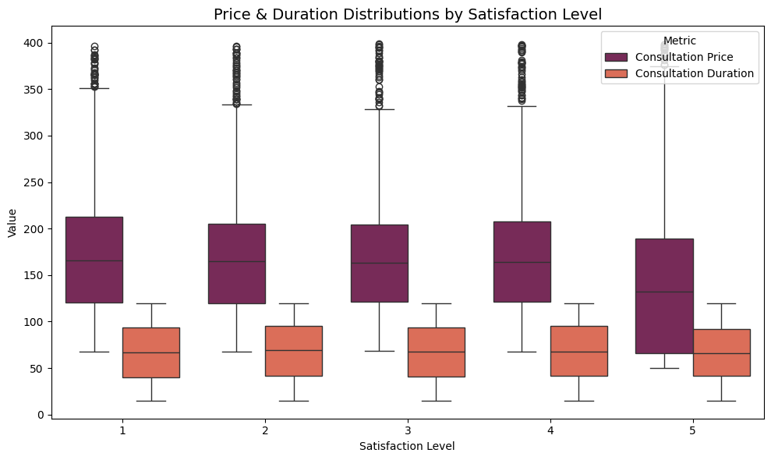

This graph represents the Consultation Price and Duration, broken down by Satisfaction Level. The distribution of Consultation Price is similar across all Satisfaction Levels. The Consultation Duration also does not have fluctuations. Therefore, we can conclude that there is no relation between Consultation Price and Satisfaction Level, or between Consultation Duration and Satisfaction Level.
Relationship between Consultation Price and Insurance Coverage by Insurance Provider
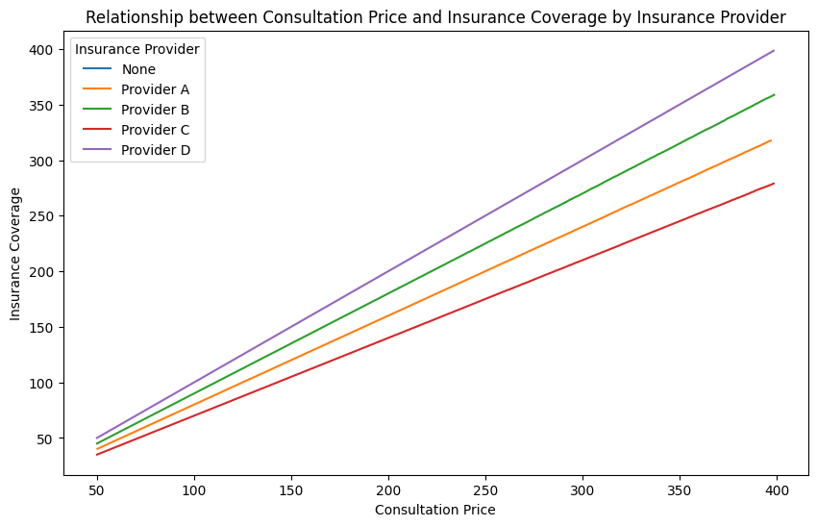
This graph represents the relationship between Consultation Price and Insurance Coverage, where each of the lines represents a different Insurance Provider. Since we only have straight lines, each provider covers a fixed percentage of the consultation, no matter the department or consultation type. The provider D covers the full price, followed by providers B, A, and C, in descending order.
Consultation Price by Department
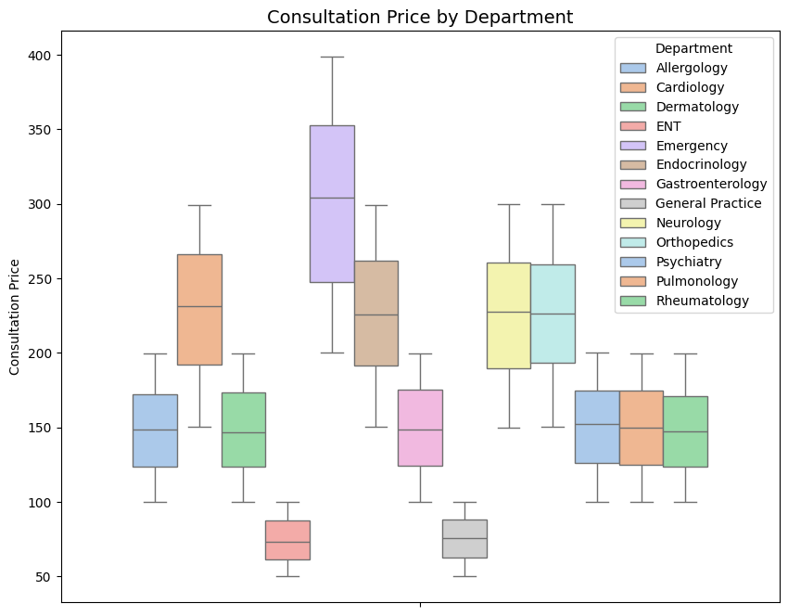

This figure represents the variation of Consultation Price by Department. This analysis allowed us to group the departments according to their Consultation Price variations:
- Low Price – In the ENT and General Practice departments, the consultation price varies between fifty and one hundred pounds.
- Medium Price – In the Allergology, Dermatology, Gastroenterology, Psychiatry, Pulmonology and Rheumatology, the consultation price varies between one hundred and two hundred pounds.
- Medium-High Price – In the Cardiology, Endocrinology, Neurology, and Orthopedics, the consultation price varies between one hundred and fifty and three hundred pounds.
- High Price – In the Emergency department, the consultation price varies between two hundred and four hundred pounds.
We can also verify that the higher the department is in the classification, the higher the variance.

Department visits by Age Group
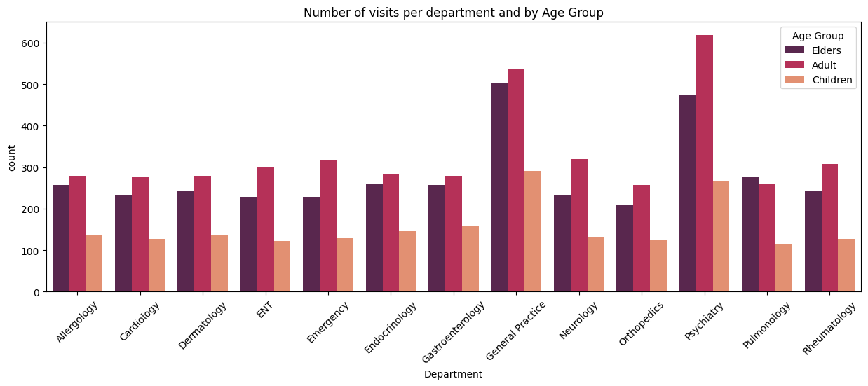
This graph shows the number of Department visits by Age Group. Most clients are Adults, and the most visited departments by them are General Practice and Psychiatry, with the highest occurrence being visits to Psychiatry. The people who visit less are Children, their most visited department being General Practice.
Average Annual Income by Age Group and Gender
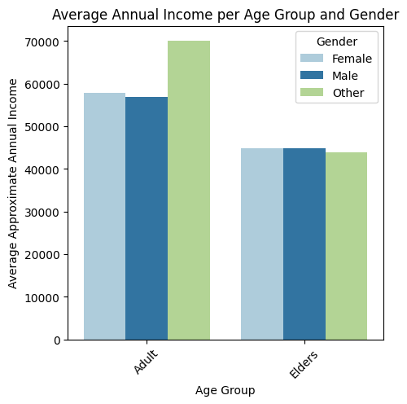

This graph shows the Average Annual Income by Age Group and Gender. The highest Average Income is for Adults for gender Other. For the Age Group Elders the Average Annual Income is almost the same independently of the Gender. The Age Group Children is not shown in the graph as Children have no Income.
Conclusion
This report provides a comprehensive analysis of patient demographics, service usage, pricing, duration and satisfaction across departments. Having this analysis as a basis, the next analytics team can develop predictive models and more in-depth client segmentation. Features such as Days since last visit and even Satisfaction Level can be used to identify patients at risk (that had bad experiences or missed their appointments). Segmentation might be done using features like Age Range and Age Group, Insurance Provider or even Department, as they can reveal clusters of patients that might be useful, for instance, for targeted service improvements and other initiatives.

