Here is the db design which I think should suffice, however if requirement changes in future we could manipulate as well. Right now I am putting it in “InReview” section so that we could discuss it in next meeting.

This db will consist of the 2 tables one for the place and one for the player. Following is the schema for the db.

**Table#1:**

**Table Name**: cx_info

**Create Table Query:**

CREATE TABLE "cx_info" ("cx_id" INTEGER, "cx_name" TEXT, "cx_score" INTEGER, "cx_hints" INTEGER, "cx_lives" INTEGER)

**Table Structure:**

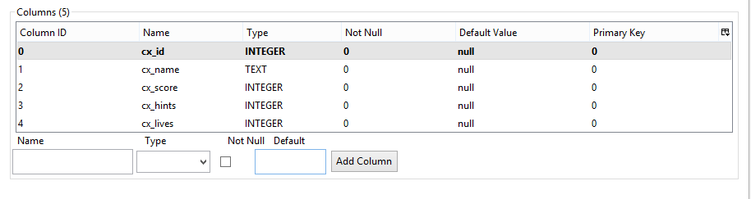

**Table Name**: plsce

**Create Table Query:**

CREATE TABLE "place" ("place_id" INTEGER PRIMARY KEY NOT NULL UNIQUE , "place_name" TEXT, "place_img1" TEXT, "place_img2" TEXT, "place_img3" TEXT, "place_img4" TEXT, "place_hint1" TEXT, "place_hint2" TEXT, "place_hint3" TEXT)

**Table Structure:**

