**Treasure Hunt : Purpose , About the game and how to play the game**

**Purpose:**

The game is built to illustrate concept of finite state automata. The purpose of building this game is so that by playing the game, the concept of finite state automata can be understood in a more simple and fun way.

**What is finite state automata ?**

“A **finite-state machine** (**FSM**) or **finite-state automaton** (**FSA**, plural: *automata*), or simply a **state machine**, is a mathematical [model of computation](https://en.wikipedia.org/wiki/Model_of_computation) used to design both [computer programs](https://en.wikipedia.org/wiki/Computer_programs) and [sequential logic](https://en.wikipedia.org/wiki/Sequential_logic) circuits. It is conceived as an [abstract machine](https://en.wikipedia.org/wiki/Abstract_machine) that can be in one of a finite number of [*states*](https://en.wikipedia.org/wiki/State_(computer_science)). The machine is in only one state at a time; the state it is in at any given time is called the *current state*. It can change from one state to another when initiated by a triggering event or condition; this is called a *transition*. A particular FSM is defined by a list of its states, its initial state, and the triggering condition for each transition.”

(Source for above: wikipedia).

For example in the following image, there are two states for a switch: ***On and Off.*** When switch flips down, a transition occurs from on to off state. Similarly when switch flips up, a transition occurs from on to off state. The transitions occurs due to the events flip switch down and flip switch up.

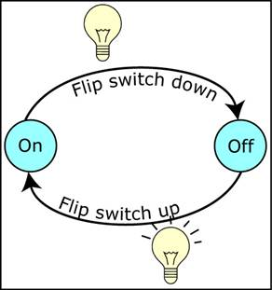

**How does our game implement FSA**

In the treasure hunt game, the user has to go from one place to another after crossing hurdles and answering hints.

* These places are the states that a user will be in at a given time.
* The answers to questions will be the events that will trigger transition from one place(state) to another.

**About the game**

The game aims to find out a hidden treasure. The player has to cross seven levels to reach the place where the hidden treasure is. Crossing a level involves crossing hurdles and giving correct answers to the hints that come up. Finally on reaching the place where the treasure is hidden, the player has to cross the hurdles to grab the treasure. Hurdles in the game involves killing sharks and skeletons. The game is a multiplayer game, the first player to grab the treasure is the winner.

**How to play the game**

* There are two ways in which you can play the game, offline and online.
* In the offline mode the player doesn’t need to connect to the server. And can play the game individually.

Following are the rules for playing the game in offline mode.

* At each level there will be four images displayed to you, one of which will be the correct answer and your gateway to next level.
* First a ***Text hint*** will come up, for you to guess the correct answer. If you guess the answer correctly you will proceed to next level. Else you lose a life, which are the ships displayed in the top right corner. 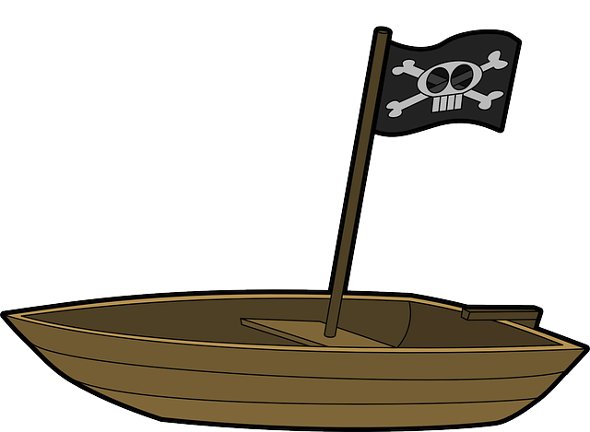
* If you answer the first hint wrong, then a second hint will come up. It will be in the form of an ***image***. For this also if you guess the answer correctly you will proceed to next level. Else you lose a life..
* If you answer the second hint wrong, then a third hint will come up. It will be in the form of an ***audio***. For this also if you guess the answer correctly you will proceed to next level. Else you lose a life.
* Since there are ***total of five lives***, for crossing all the levels, use your lives carefully.
* At some levels you might face hurdles in from of sharks and skeletons which you have to kill. If a shark or skeleton touches you, you lose a life.
* To kill these sharks and skeletons you have to launch anchors at them which will kill them by touching them. The anchors can be launched by clicking on the pirate.
* Kudos if you have crossed all the levels and reached the place where treasure is kept. But your journey has not ended. Cross the skeleton hurdles and grab the treasure.
* You win the game if you grab the treasure.

Following are the rules for playing the game in online mode.

* In online mode the player cannot start the game until there are five people in the game room. The number of people should be exactly five for the game to start, neither more nor less than five.
* A player cannot join an active online game session.
* Once a player enters a session, the rules for playing the game are same as in offline mode.
* When playing game in online mode, if a player has already grabbed the treasure you lose the game, no matter what level you are at, or how many lives are left for you.

Hope you have understood how the game works!! So now begin your journey to find the hidden treasure.