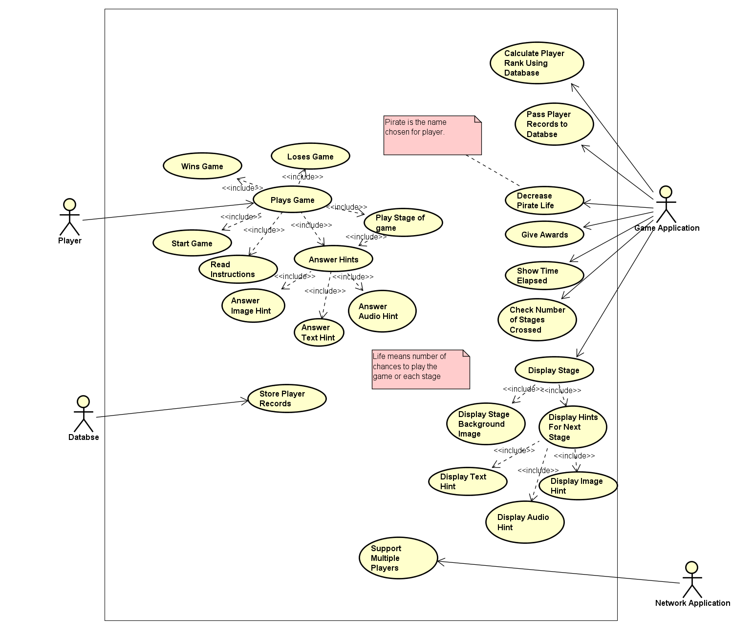

|  |  |
| --- | --- |
| Use Case ID | 1 |
| Use case Name | Play Game |
| Actor | Player |
| Description | Player plays the treasure hunt game. |
| Precondition | 1. Player must have access to a desktop   system or laptop.  2. Game must be installed on their  system. |
| Post Condition | Player should have completed the game. |
| Basic Flow | 1. Player accesses the game on their system. 2. Player starts the game 3. Player reads the game instructions 4. Player answers the type of hints that come up in a stage. 5. Player moves through all the stages, reaches the final stage and completes the game. |
| Alternate Course | 1. Player gives wrong answers for the hints for a stage. 2. Player loses life and eventually game. |
| Includes | * Start Game * Read Instructions * Play Stage of game * Wins Game * Loses Game |

|  |  |
| --- | --- |
| Use Case ID | 2 |
| Use case Name | Start Game |
| Actor | Player |
| Description | Player presses the start button to start the game |
| Precondition | Game should have been loaded(double clicked) |
| Post Condition | Actor should be able to see read instructions screen.. |
| Basic Flow | 1. Player presses the start button |
| Alternate Course | None |
| Includes | None |

|  |  |
| --- | --- |
| Use Case ID | 3 |
| Use case Name | Read Instructions |
| Actor | Player |
| Description | Player reads the instruction shown on the screen |
| Precondition | Start button should have been pressed |
| Post Condition | Player should have read the instructions. |
| Basic Flow | 1. Player reads the instructions. |
| Alternate Course | None |
| Includes | None |

|  |  |
| --- | --- |
| Use Case ID | 4 |
| Use case Name | Play Stage of game |
| Actor | Player |
| Description | Player answers the hints that come in the stage of the game he is at. |
| Precondition | Game should have been started |
| Post Condition | Player should be at next stage of the game |
| Basic Flow | 1. Player presses the start button |
| Alternate Course | Player gives wrong answers for hints, loses life and has to leave game. |
| Includes | Answer Hints |

|  |  |
| --- | --- |
| Use Case ID | 5 |
| Use case Name | Answer hints |
| Actor | Player |
| Description | Player answers the hints that come in the stage of the game he is at. |
| Precondition | Player should be at a stage |
| Post Condition | Player should be at next stage of the game |
| Basic Flow | Player give answer to the hint that comes up to move to the next stage of the game. |
| Alternate Course | Player gives wrong answers for hints, loses life and has to leave game. |
| Includes | * Answer Image Hint * Answer Text Hint * Answer Audio/Video Hint |

|  |  |
| --- | --- |
| Use Case ID | 6 |
| Use case Name | Answer Image Hint |
| Actor | Player |
| Description | Player answers the image hints that come in the stage of the game he is at. |
| Precondition | Player should be at a stage |
| Post Condition | Player should be at next stage of the game |
| Basic Flow | Player give answer to the image hint that comes up to move to the next stage of the game. |
| Alternate Course | Player gives wrong answers for hint.  Hints come up or player loses life |
| Includes | None |

|  |  |
| --- | --- |
| Use Case ID | 7 |
| Use case Name | Answer Text Hint |
| Actor | Player |
| Description | Player answers the text hints that come in the stage of the game he is at. |
| Precondition | Player should be at a stage |
| Post Condition | Player should be at next stage of the game |
| Basic Flow | Player give answer to the text hint that comes up to move to the next stage of the game. |
| Alternate Course | Player gives wrong answers for hint.  Hints come up or player loses life |
| Includes | None |

|  |  |
| --- | --- |
| Use Case ID | 8 |
| Use case Name | Answer Audio/Video Hint |
| Actor | Player |
| Description | Player answers the audio/video hints that come in the stage of the game he is at. |
| Precondition | Player should be at a stage |
| Post Condition | Player should be at next stage of the game |
| Basic Flow | Player give answer to the audio/video hint that comes up to move to the next stage of the game. |
| Alternate Course | Player gives wrong answers for hint.  Hints come up or player loses life |
| Includes | None |

|  |  |
| --- | --- |
| Use Case ID | 9 |
| Use case Name | Wins Game |
| Actor | Player |
| Description | Player wins the game. |
| Precondition | Player should be at the last stage, with number of lives used. |
| Post Condition | Player has won the game. |
| Basic Flow | Player crosses all the stages of the game and uses minimum lives. |
| Alternate Course | None |
| Includes | None |

|  |  |
| --- | --- |
| Use Case ID | 10 |
| Use case Name | Loses Game |
| Actor | Player |
| Description | Player loses the game. |
| Precondition | Player is at some stage of the game. |
| Post Condition | Player has lost the game. |
| Basic Flow | Player gives wrong answers to hints  Player loses life |
| Alternate Course | None |
| Includes | None |

|  |  |
| --- | --- |
| Use Case ID | 11 |
| Use case Name | Store Player Records |
| Actor | Database |
| Description | Player records are stored in database. |
| Precondition | Player is playing the game |
| Post Condition | Player records are stored in the database. |
| Basic Flow | Player starts playing the game  All the records are stored over the course of the game. |
| Alternate Course | None |
| Includes | None |

|  |  |
| --- | --- |
| Use Case ID | 12 |
| Use case Name | Support Multiple Players |
| Actor | Network Application |
| Description | Makes sure that more than one players can play the game. |
| Precondition | Application is up and running |
| Post Condition | More than one players are able to play the game |
| Basic Flow | Set up configurations  Make necessary connections to game application and database |
| Alternate Course | None |
| Includes | None |

|  |  |
| --- | --- |
| Use Case ID | 13 |
| Use case Name | Support Multiple Players |
| Actor | Network Application |
| Description | Makes sure that more than one players can play the game. |
| Precondition | Application is up and running |
| Post Condition | More than one players are able to play the game |
| Basic Flow | Set up configurations  Make necessary connections to game application and database |
| Alternate Course | None |
| Includes | None |

|  |  |
| --- | --- |
| Use Case ID | 14 |
| Use case Name | Calculate Player Rank Using Database |
| Actor | Game Application |
| Description | Calculates who won the game using data stored in database |
| Precondition | Multiple players are playing |
| Post Condition | Game results, who won the game are out. |
| Basic Flow | Calculate lives used by each player, the one with minimum lives is the winner.  Declare Results. |
| Alternate Course | In case of a tie in number of lives used, calculate time to complete the game.  Declare Results |
| Includes | None |

|  |  |
| --- | --- |
| Use Case ID | 15 |
| Use case Name | Pass Player Records to Database |
| Actor | Game Application |
| Description | Pass the data associated with a player to the database application. |
| Precondition | Players are playing |
| Post Condition | Data is successfully passed to database. |
| Basic Flow | As the game proceeds the data associated with a player is passed through function calls to the database storing the player records. |
| Alternate Course | None |
| Includes | None |

|  |  |
| --- | --- |
| Use Case ID | 16 |
| Use case Name | Decrease Pirate Life |
| Actor | Game Application |
| Description | Decrement the lives of a player by 1. |
| Precondition | Player is playing |
| Post Condition | Life of a player decremented by 1.. |
| Basic Flow | For every wrong answer to a hint, decrement the life of a player by 1. |
| Alternate Course | None |
| Includes | None |

|  |  |
| --- | --- |
| Use Case ID | 17 |
| Use case Name | Give Awards |
| Actor | Game Application |
| Description | Give an award to a player. |
| Precondition | Player is playing |
| Post Condition | Player has received some awards. |
| Basic Flow | Give an award to a player. |
| Alternate Course | None |
| Includes | None |

|  |  |
| --- | --- |
| Use Case ID | 18 |
| Use case Name | Show Time Elapsed |
| Actor | Game Application |
| Description | Show time being taken to play game. |
| Precondition | Player is playing. |
| Post Condition | Time elapsed to play game being displayed. |
| Basic Flow | Displaying the time elapsed while playing the game. |
| Alternate Course | None |
| Includes | None |

|  |  |
| --- | --- |
| Use Case ID | 19 |
| Use case Name | Check Number of Stages Crossed |
| Actor | Game Application |
| Description | Keeping track of stages crossed by a player in game. |
| Precondition | Player is playing. |
| Post Condition | Stages crossed by a player are known. |
| Basic Flow | Note the stage number(s) crossed by a player. |
| Alternate Course | None |
| Includes | None |

|  |  |
| --- | --- |
| Use Case ID | 20 |
| Use case Name | Display Stage |
| Actor | Game Application |
| Description | Show all the graphics for a stage. |
| Precondition | Player reached at a stage. |
| Post Condition | All data and graphics for a stage have been displayed. |
| Basic Flow | * Load Stage Background Image. * Display hints for going to next stage |
| Alternate Course | None |
| Includes | * Display Stage Background Image * Display Hints For Next Stage |

|  |  |
| --- | --- |
| Use Case ID | 21 |
| Use case Name | Display Stage Background Image |
| Actor | Game Application |
| Description | Show the background image. |
| Precondition | Player reached at a stage. |
| Post Condition | An image being displayed |
| Basic Flow | Load Stage Background Image. |
| Alternate Course | None |
| Includes | None |

|  |  |
| --- | --- |
| Use Case ID | 22 |
| Use case Name | Display Hints For Next Stage |
| Actor | Game Application |
| Description | Display hint |
| Precondition | Player reached at a stage. |
| Post Condition | A hint has been displayed to user. |
| Basic Flow | Display a hint to the player to answer for going to next stage. |
| Alternate Course | None |
| Includes | * Display Text Hint * Display Audio/Video Hint * Display Image Hint |

|  |  |
| --- | --- |
| Use Case ID | 22 |
| Use case Name | Display Text Hint |
| Actor | Game Application |
| Description | Display text hint |
| Precondition | Player reached at a stage. |
| Post Condition | A hint has been displayed to user. |
| Basic Flow | Display a textual hint to the player to answer for going to next stage. |
| Alternate Course | None |
| Includes | None |

|  |  |
| --- | --- |
| Use Case ID | 23 |
| Use case Name | Display Image Hint |
| Actor | Game Application |
| Description | Display image hint |
| Precondition | Player reached at a stage. |
| Post Condition | A hint has been displayed to user. |
| Basic Flow | Display an image that serves as hint to the player to answer for going to next stage. |
| Alternate Course | None |
| Includes | None |

|  |  |
| --- | --- |
| Use Case ID | 24 |
| Use case Name | Display Audio/Video Hint |
| Actor | Game Application |
| Description | Display audio/video hint |
| Precondition | Player reached at a stage. |
| Post Condition | A hint has been displayed to user. |
| Basic Flow | Play an audio or video clip that serves as hint to the player to answer for going to next stage. |
| Alternate Course | None |
| Includes | None |