Creating a lambda function

Step 1:

Upload src folder as zip file for lambda function

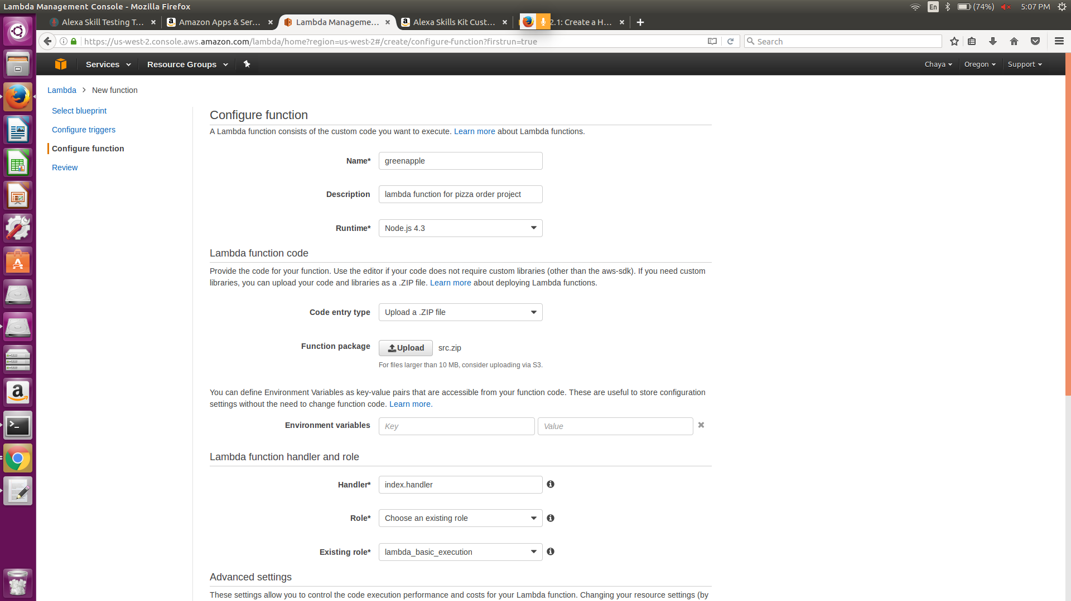

Step2: Click on create function

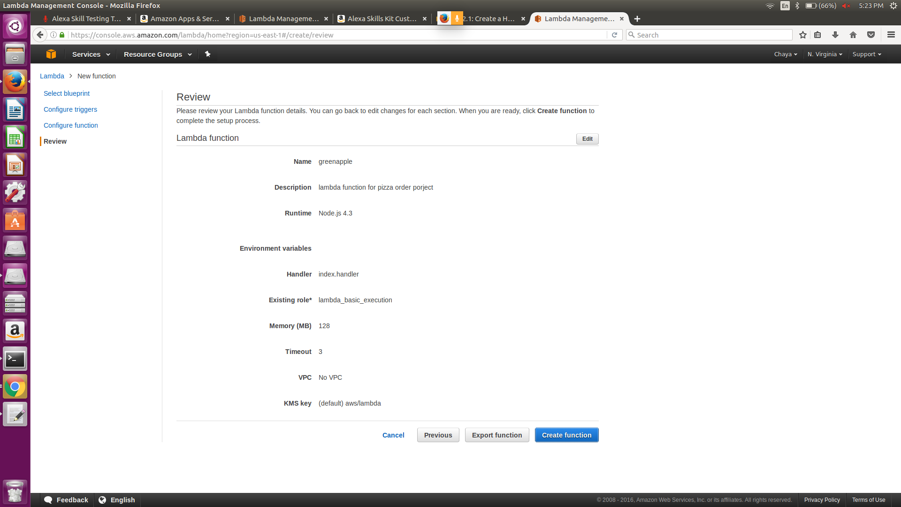

Step3: Lambda func created

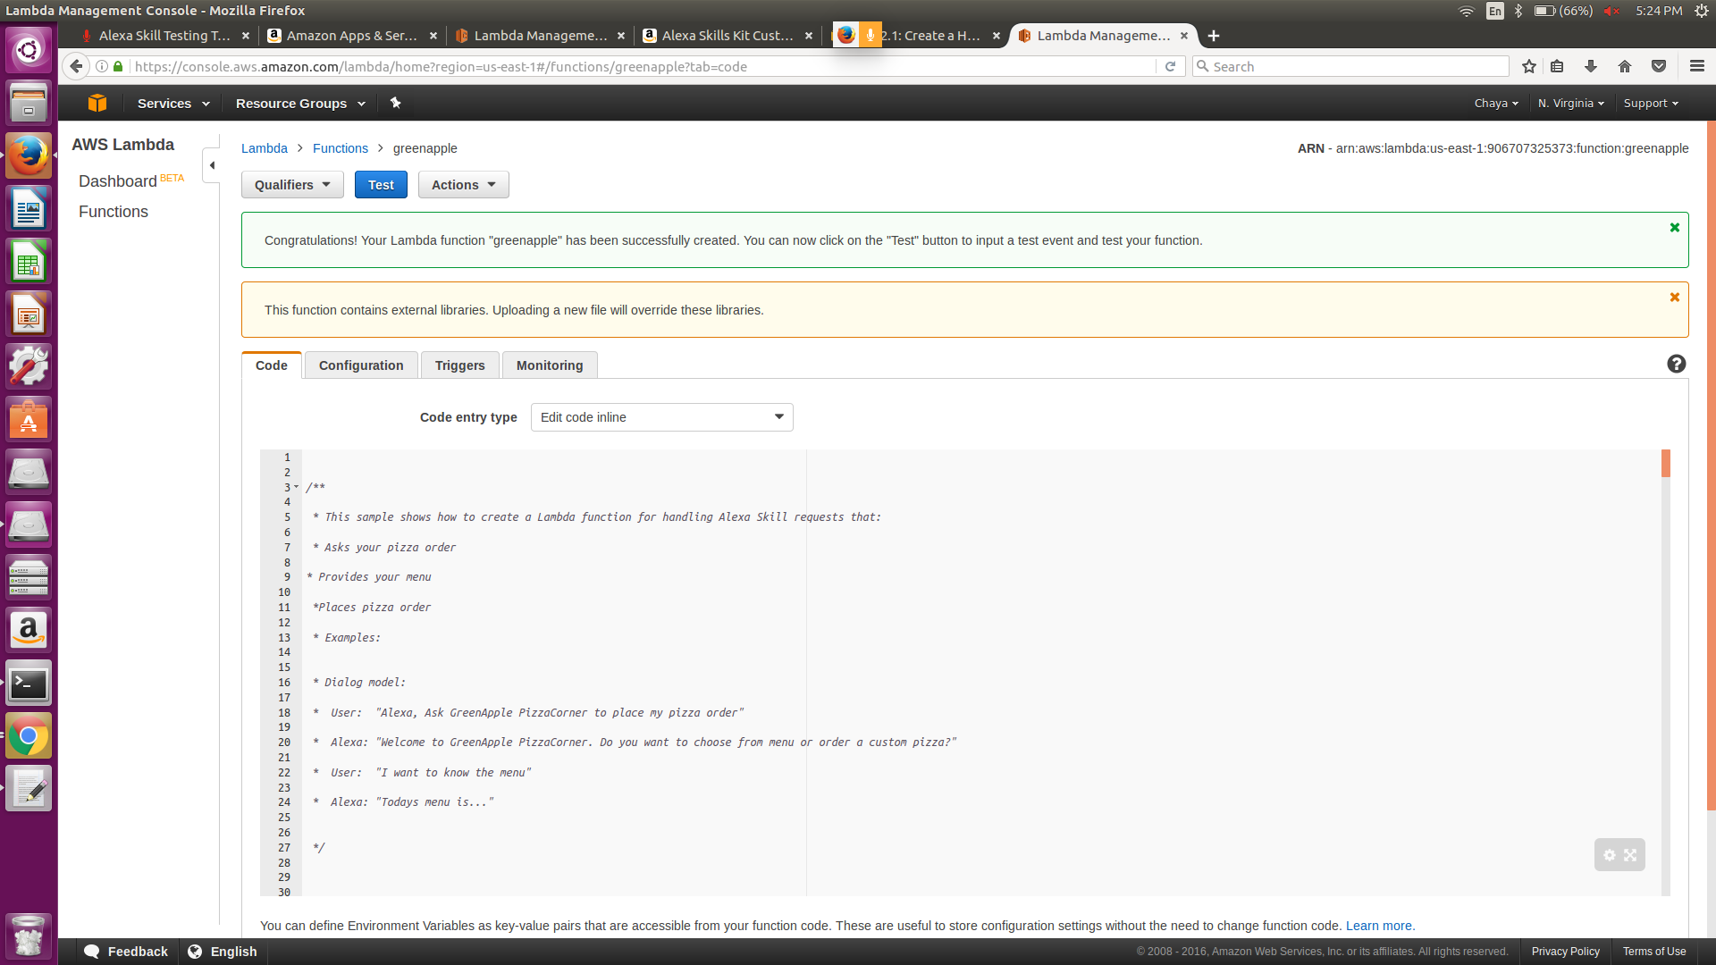

Setting up your alexa skills

Step1:

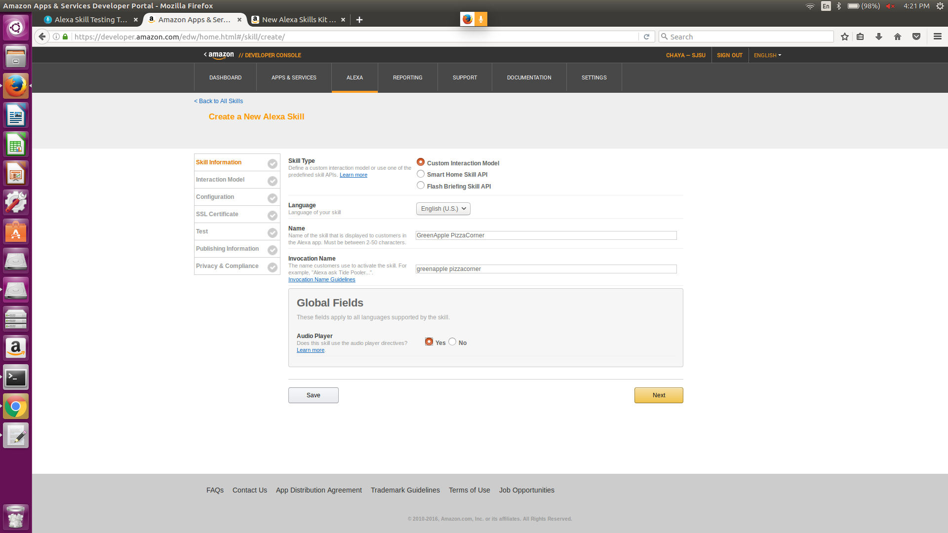

Step2: adding slot,intent and utterances

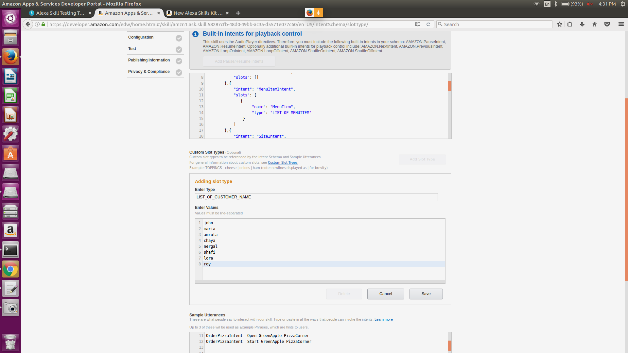

Step3:slots added

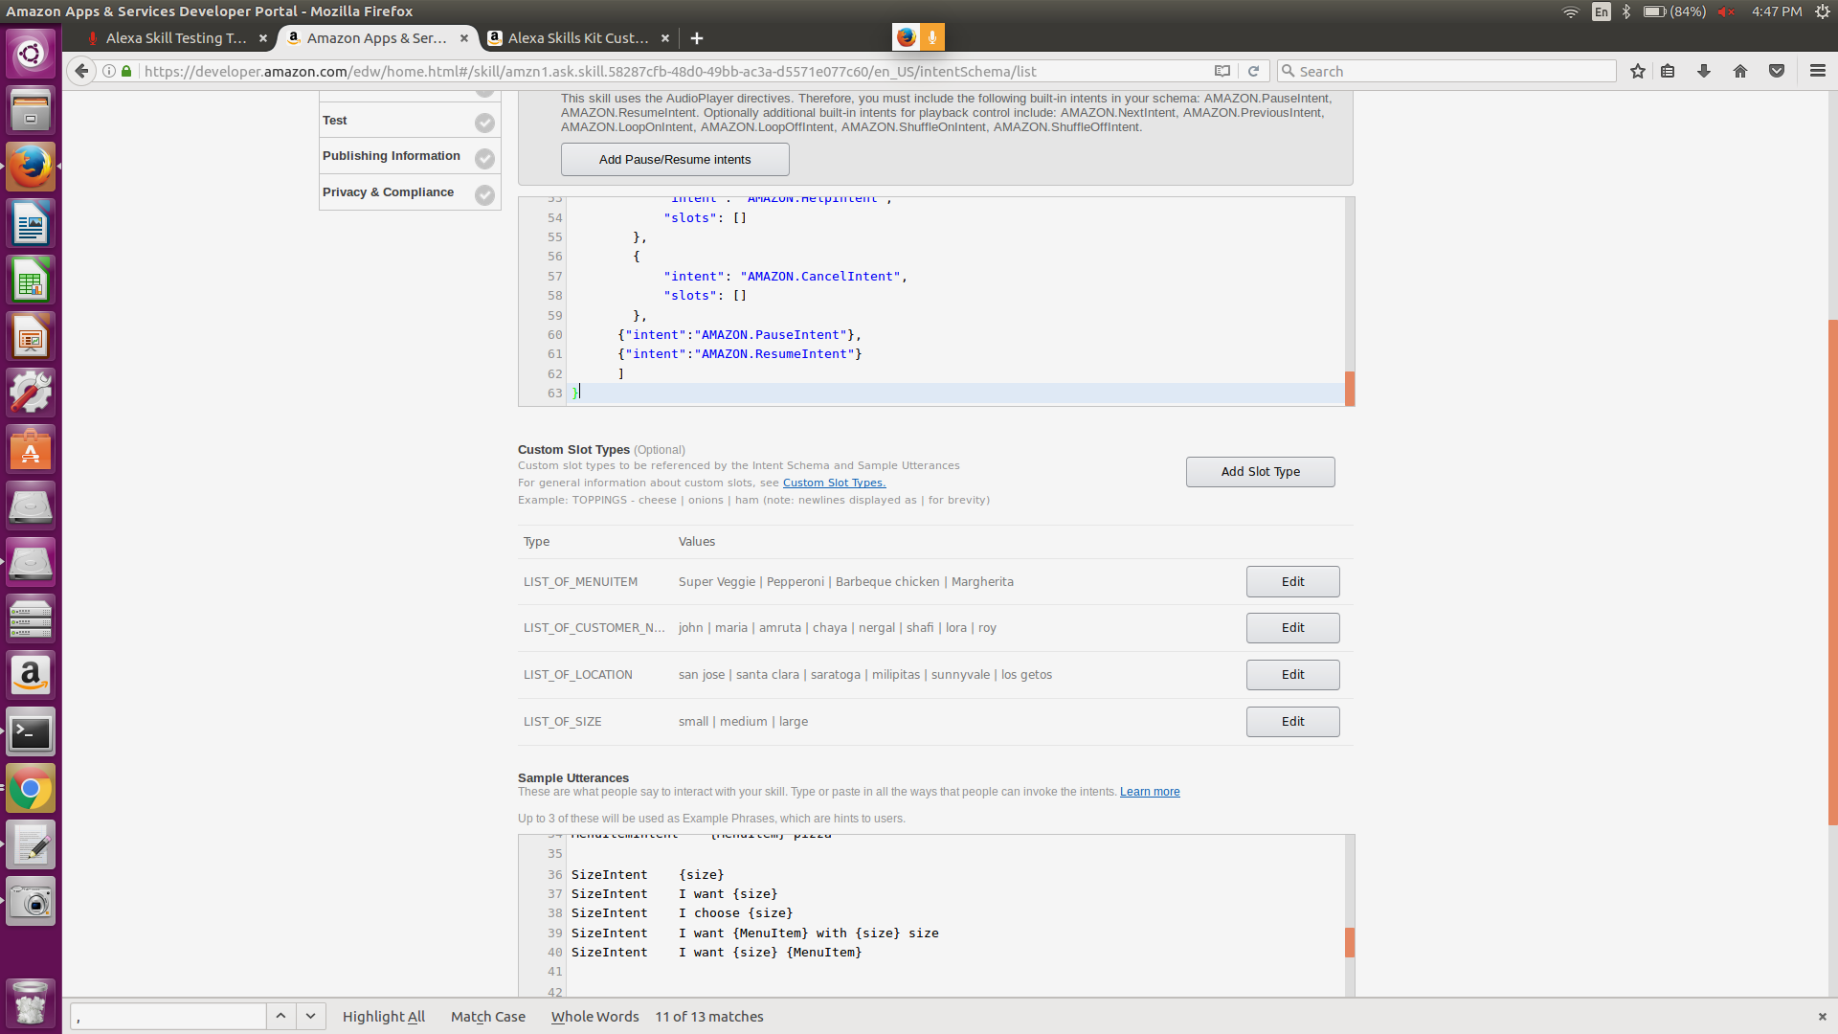

Step4: Link skill to lambda by copying arn id in textbox below north america

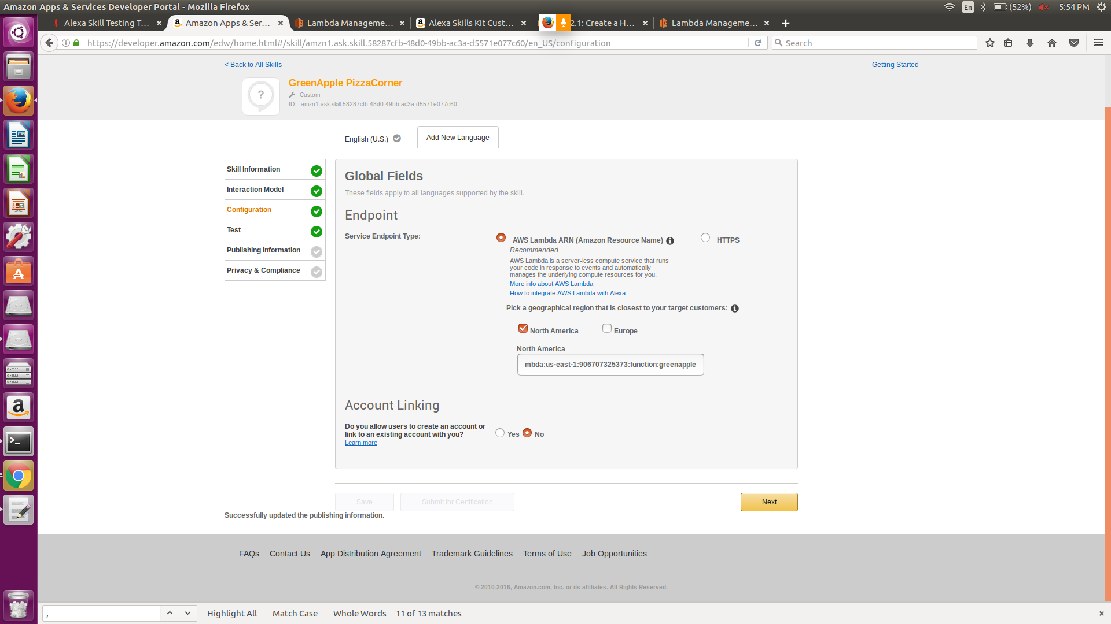

Step5:Go to amazon lambda function

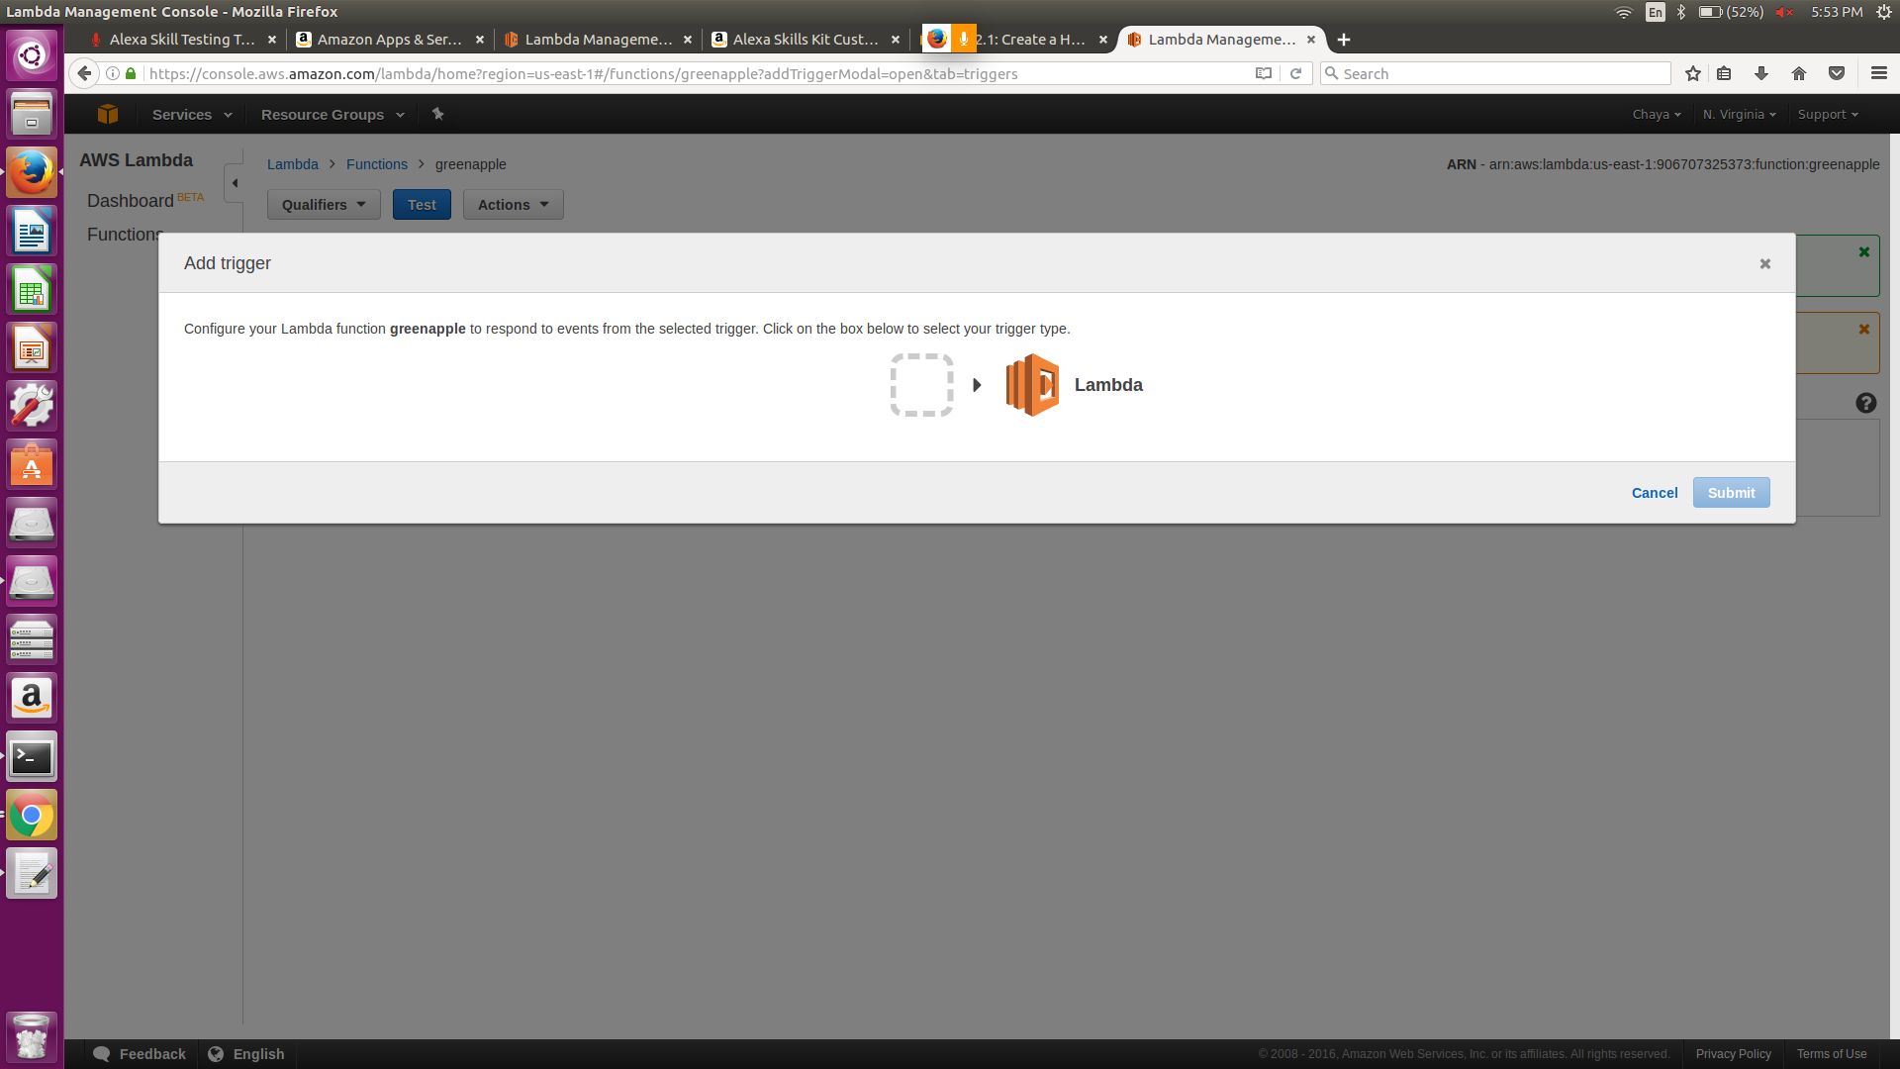

Step 6:Click on arrow and select alexa skills set

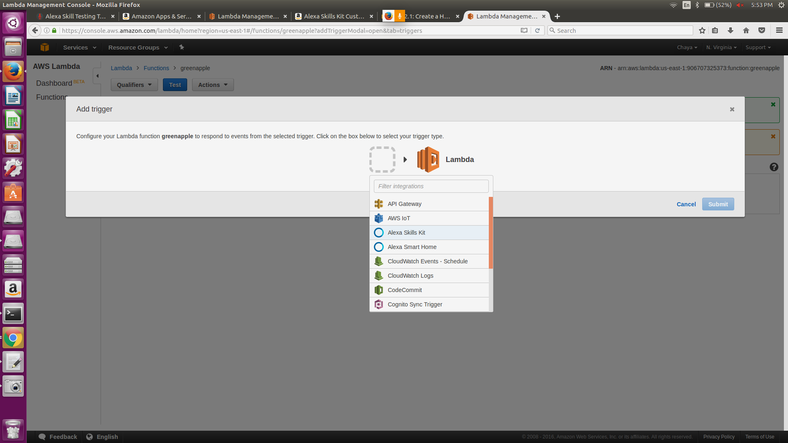

Step 7: To test and link:

Copy selected id

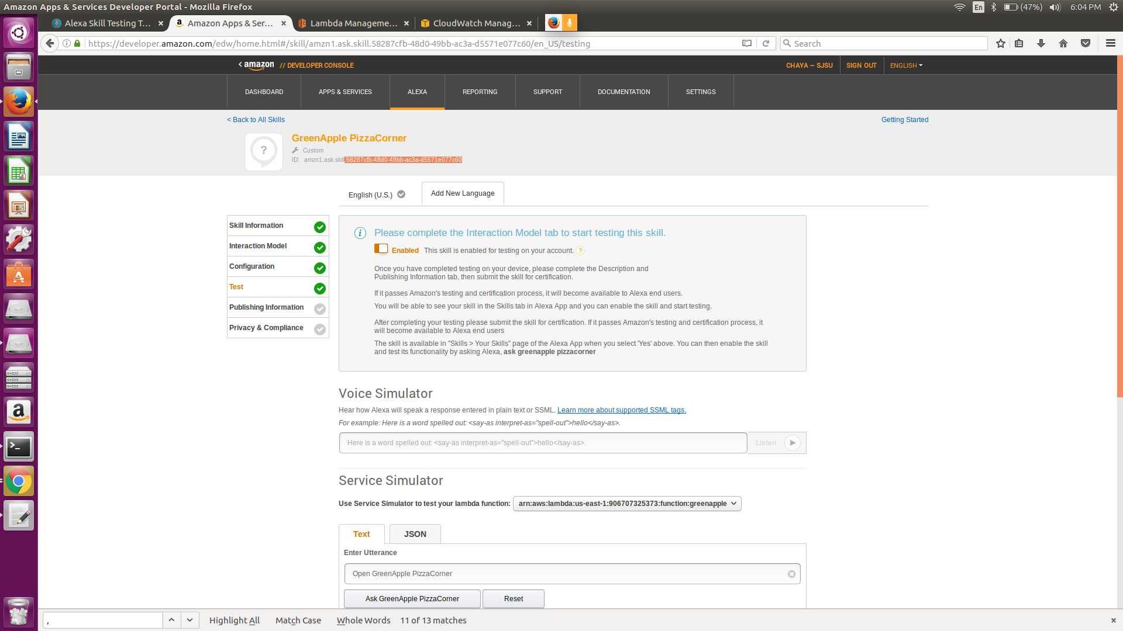

Paste selected id:

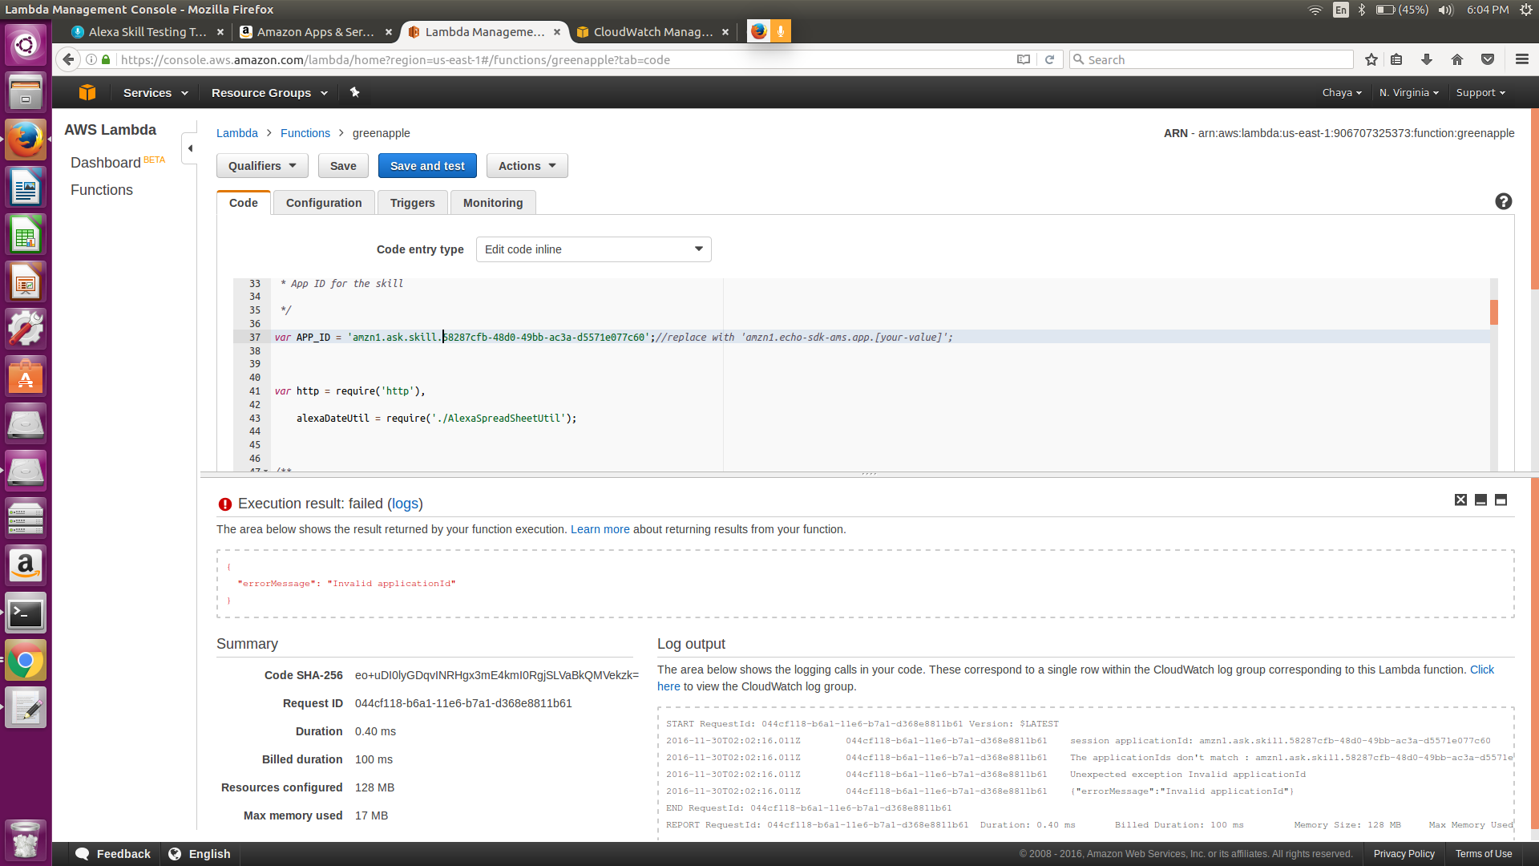

Also paste the id in test option

This should be the output for success:

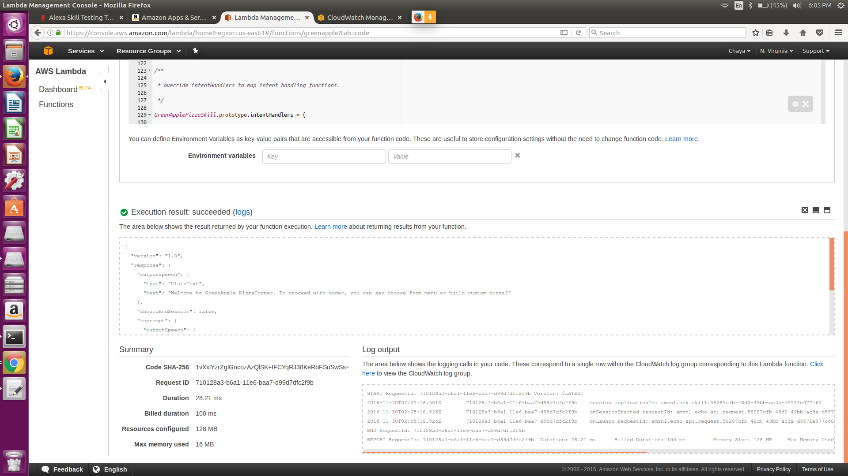

This should be the output for failure:

