EXAM 2

1.

library(deSolve)

# pred prey growth function

pred_prey <- function(t, y, p) {

H <- y[1]

Z <- y[2]

with(as.list(p), {

dH.dt <- (r * H * (1 - H / K)) - (b * H * Z)

dZ.dt <- (c * H * Z) - (m * Z)

return(list(c(dH.dt, dZ.dt)))

})

}

#specify parameter values and initial conditions

t <- 1:100

y0 <- c('H' = 1, 'Z' = 0.1)

p <- c('r' = 1,

'c' = 1,

'b' = 1,

'm' = 0.1,

'K' = 1)

#runs and stores solution data for the ode

sim <- ode(y = y0, times = t, func = pred_prey, parms = p, method = 'lsoda')

sim <- as.data.frame(sim)

#plots equations

plot(H ~ time, type = 'l', col = 'blue', bty = 'l', data = sim, ylim = c(0, 2))

points(Z ~ time, type = 'l', lty = 2, data = sim)

Humans = _____________

Zombies = ---------------

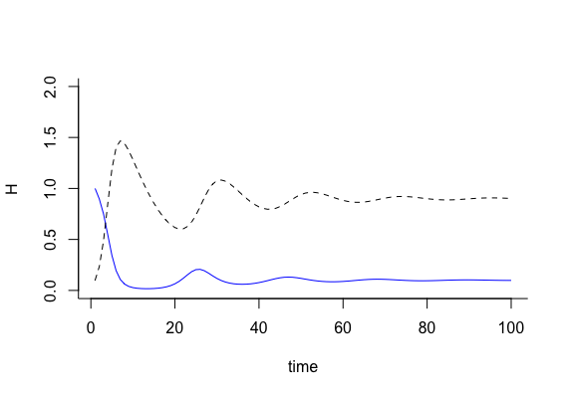

2.

library(deSolve)

# pred prey growth function with biocontrol

pred_prey <- function(t, y, p) {

H <- y[1]

Z <- y[2]

P <- y[3]

with(as.list(p), {

dH.dt <- (r * H * (1 - H / K)) - (b * H * Z)

dZ.dt <- (c * H * Z) - (m * Z) - (d * Z * P)

dP.dt <- (e * Z * P) - (n * P)

return(list(c(dH.dt, dZ.dt, dP.dt)))

})

}

# specify parameter values and initial conditions

t <- 1:100

y0 <- c('H' = 1, 'Z' = 0.1, 'P' = 0.1)

p <- c('r' = 1,

'c' = 1,

'b' = 1,

'm' = 0.1,

'K' = 1,

'd' = 1,

'e' = 1,

'n' = 0.1)

#runs and stores solution data for the ode

sim <- ode(y = y0, times = t, func = pred_prey, parms = p, method = 'lsoda')

sim <- as.data.frame(sim)

# plots equations

plot(H ~ time, type = 'l', col = 'blue', bty = 'l', data = sim, ylim = c(0, 2))

points(Z ~ time, type = 'l', lty = 2, data = sim)

points(P ~ time, type = 'l', lty = 2, data = sim, col = 'red')

Humans = _____________ Zombies = --------------- Biocontrol = ---------------

