Homework 3

1.

6.1

The systems we see in nature correspond to sable solutions of the models we use to describe these equilibriums. . However variability of natural population can be high and difficult to determine. Further, stability relates only to behavior near equilibrium. However, we really want to understand overall population dynamics of two species systems, not just the behavior near equilibrium, but it is a good first step. When looking at stability we use the idea of systems being perturbed by an arbitrarily small number, however, this is not expected in the real world, but is convenient for the mathematical equations we use. Also we can allow perturbations of arbitrary size, but in the confines of a particular model, as to not simply only pay attention to these small perturbations. This can help when a system leave the confines, as this allows us to make some guesses to what is happening in the population. I think stability is a good concept to use when understanding communities in nature, because it helps to give us a sense of how the community acts as a whole, as in which direction the community is likely to go. It further allows us to make predictions about what could happen, and also what could happen if specific factors change.

6.3

For competition models, all entries are negative (-). For predator-prey models the effect of the prey on the predator is positive (+), and the effect of the predator on the pray is negative (-), and for mutualism they are positive (+).

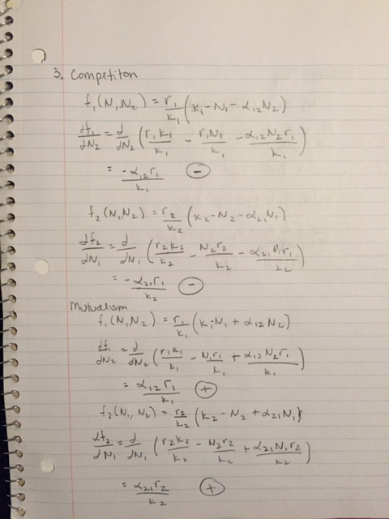

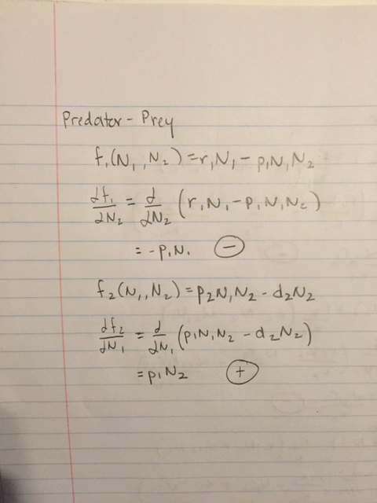

2.

In chapter 6 αij represents the elements of the community matrix. In chapter 7 αij represents the interspecific and intraspecific density dependence. The effect of one species (i) on another (j), or itself. I would say to change one in chapter 7 to $α_{i}^{j}$, with the same meanings as before.

3.

As p increases, more people leave one population (New York) and go to another (California). This decreases the slop of the equilibrium line, moving it towards the axis labeled California, and increases the population of California.