SSN College of Engineering, Kalavakkam
Department of Computer Science and Engineering
UCS3513 - System Design Laboratory
B.E. Computer Science and Engineering, V Semester, Academic Year 2026-27
Mini Project Report
Scalable Human Resource Management System
(Problem Statement 6)
Submitted by
Name | Register Number
Dravid Ranjan A.M | 3122245001046
Guhanesh M.L | 3122245001049
Hansika N.M | 3122245001052
Saisaravanan S | 3122245001310

October 2026

Abstract
This project designs, builds and evaluates a horizontally scalable Human Resource Management System (HRMS) for a large organisation. It covers employee records, attendance, leave, payroll, recruitment and performance reviews. The system runs as 10 Docker containers: an API gateway, three stateless HR application nodes, four MongoDB shards, Redis as the key-value store, and a set of simulated job portals. Eight system-design components carry the scale: Snowflake unique IDs, application-level sharding, consistent hashing with virtual nodes, a Redis key-value store, a token-bucket rate limiter, trie-based autocomplete, a URL shortener and a BFS web crawler. On a 10,000-employee data set the trie answers prefix queries in 0.005 ms against 16.1 ms for a regex search across all shards. Adding a fourth shard moved 26.5% of employees (ideal 25%, modulo hashing ~75%). Killing an HR node mid-load produced 0% errors, and the KV cache cut MongoDB CPU from about 297% (baseline) to 27% at the same request rate. Throughput was bounded at roughly 395 requests/s by the single test laptop, which hosted both the system and the load generator. The report discusses this limit openly.

1. Introduction and objectives
Large organisations run HR operations for tens of thousands of employees. Those operations are read-heavy (profile and leave-balance lookups, search), have write bursts (daily check-in, month-end payroll), and need to stay available while the system is being scaled or when a server fails. The problem statement asks for an HRMS that supports employee onboarding, attendance, leave, payroll, recruitment and performance reviews. It must be built so that each of eight system-design components does real work, and evaluated under load.
Objectives:
- Implement every functional module end to end, with role-based access for HR administrators, managers and employees.
- Map each of the eight required components to a concrete HRMS function and justify the choice.
- Run the system as a multi-node, multi-shard deployment that can grow (add a node, add a shard) at runtime.
- Measure latency, throughput, success rate and resource use at low, medium and high load, and compare against a single-node, single-database baseline.
- Show what happens when a node or a database shard fails.

2. Requirements

2.1 Functional requirements
Module | Capabilities
Authentication | Login/logout, session token in Redis (8 h TTL), BCrypt password hashes, role checks on every request (HR_ADMIN, MANAGER, EMPLOYEE)
Employees | HR registers employees; profile view/edit (self: contact fields, HR: all); search by name, department or skill with autocomplete; list by department
Attendance | Check-in/check-out, one record per employee per day (idempotent); monthly view; HR summary
Leave | Apply (casual 12, sick 10, earned 15 days per year); manager/HR approve or reject; balance (cached); overlap, weekend-only and date-order validation
Payroll | Monthly run for one department or all employees: gross - PF - tax slab - loss of pay; payslip view restricted to the owner and HR; expiring short link to a payslip
Recruitment | Job postings with public short links, public apply page, pipeline APPLIED -> SCREENING -> INTERVIEW -> OFFER -> HIRED/REJECTED (illegal jumps rejected), hiring creates an employee, crawler-imported external jobs
Performance | Goals per review cycle (weights must total 100), manager reviews with a 1-5 rating
Notifications | In-app notifications on leave decisions, payslips, reviews and stage changes
System (HR) | Live view of nodes, shards, ring ownership, cache hit ratio, limiter and crawler; add shard-3 and rebalance

2.2 Non-functional requirements
Quality | Requirement and how it is met
Scalability | Stateless HR nodes behind a consistent-hash router; data partitioned over shards; nodes and shards can be added at runtime with only ~1/N of keys moving
Availability | Gateway health-checks nodes every 2 s and retries on the next node; a failed shard affects only its own partition; cached reads keep working
Latency | Read-heavy lookups served from Redis; search-as-you-type served from an in-memory trie
Security | BCrypt password hashing, server-side sessions, role checks, per-IP login rate limiting (brute force), payslips visible only to their owner and HR
Privacy | All data is synthetic; salaries are never exposed to other employees; links to payslips expire

3. System-design challenges and component mapping (Deliverable 1)
The HRMS workload has four characteristics that drive the design. Data grows with employees x days, mostly through attendance. Most requests are reads of a single employee's records. Several nodes create records at the same time. And recruitment needs data from outside the organisation. Table 1 maps each required component to the HRMS function it serves.
# | Component | HRMS functionality | Design | Justification
1 | Unique ID generator | IDs for every entity (employees, attendance, leave, payslips, jobs, candidates, reviews, notifications, short codes) | Snowflake 64-bit: 41-bit ms timestamp since 2026-01-01, 10-bit node ID, 12-bit sequence | Three nodes write at once without a central counter or a database round-trip; IDs sort by time
2 | Sharding | All employee-owned data (shard key employeeId); jobs and candidates (own ID) | Application-level hash sharding over 4 MongoDB instances; an employee's records are co-located | Attendance grows fastest; co-location keeps per-employee queries on one shard. Only org-wide search and reports scatter-gather
3 | Consistent hashing | (a) gateway -> node routing, (b) employeeId -> shard placement | MurmurHash3 32-bit ring, 150 virtual nodes per member, TreeMap ceiling lookup | Adding a member remaps ~1/N keys instead of ~(N-1)/N; virtual nodes even out the load
4 | Key-value store | Sessions, login index, cache-aside for profile/leave balance/payslip, limiter buckets, short links, shard map, pub/sub | Redis 7; cache-aside with TTL and invalidate-on-write | Any node can serve any user (shared sessions); hot reads avoid MongoDB
5 | Rate limiter | All /api/** traffic; strict buckets for login and payroll runs | Token bucket in an atomic Redis Lua script; default 100 burst / 50 per s per user; login 5/min per IP; payroll 2/min | Stops login brute force and repeated expensive payroll runs; limits hold across gateway restarts
6 | Autocomplete | Employee search (name, department, skill) and job-title search | Trie with cached top-10 completions per node; built from all shards; updates broadcast over Redis pub/sub | Each keystroke would otherwise scatter a regex query to every shard
7 | URL shortener | Public job links, expiring payslip and offer links | Base62 of a Snowflake ID; Redis with TTL plus a durable MongoDB copy; /s/{code} -> 302 | Shareable links with no login needed; links expire automatically
8 | Web crawler | Import external job listings into recruitment | BFS from 3 portal seeds; depth 3; 200 ms politeness; robots.txt; URL and job-content dedup | Required by the problem statement; dedup stops the same job being imported from several portals

Table 1: Functionality x component x justification.
Two design decisions deserve a note:
- Why a trie and not a database regex for autocomplete. A prefix regex has to run on every shard and merge the results for every keystroke. In our measurements it took 16.1 ms on average, against 0.005 ms for the trie, over 3,000x faster, with identical top-10 results (precision@10 = 1.00).
- Why employee-owned data is co-located on one shard. Attendance, leave, payslips, reviews and notifications all use employeeId as their shard key. A profile page, a leave approval or a payslip view then touches exactly one shard, and moving an employee during rebalancing moves all of that employee's data together.

4. Architecture (Deliverable 2)
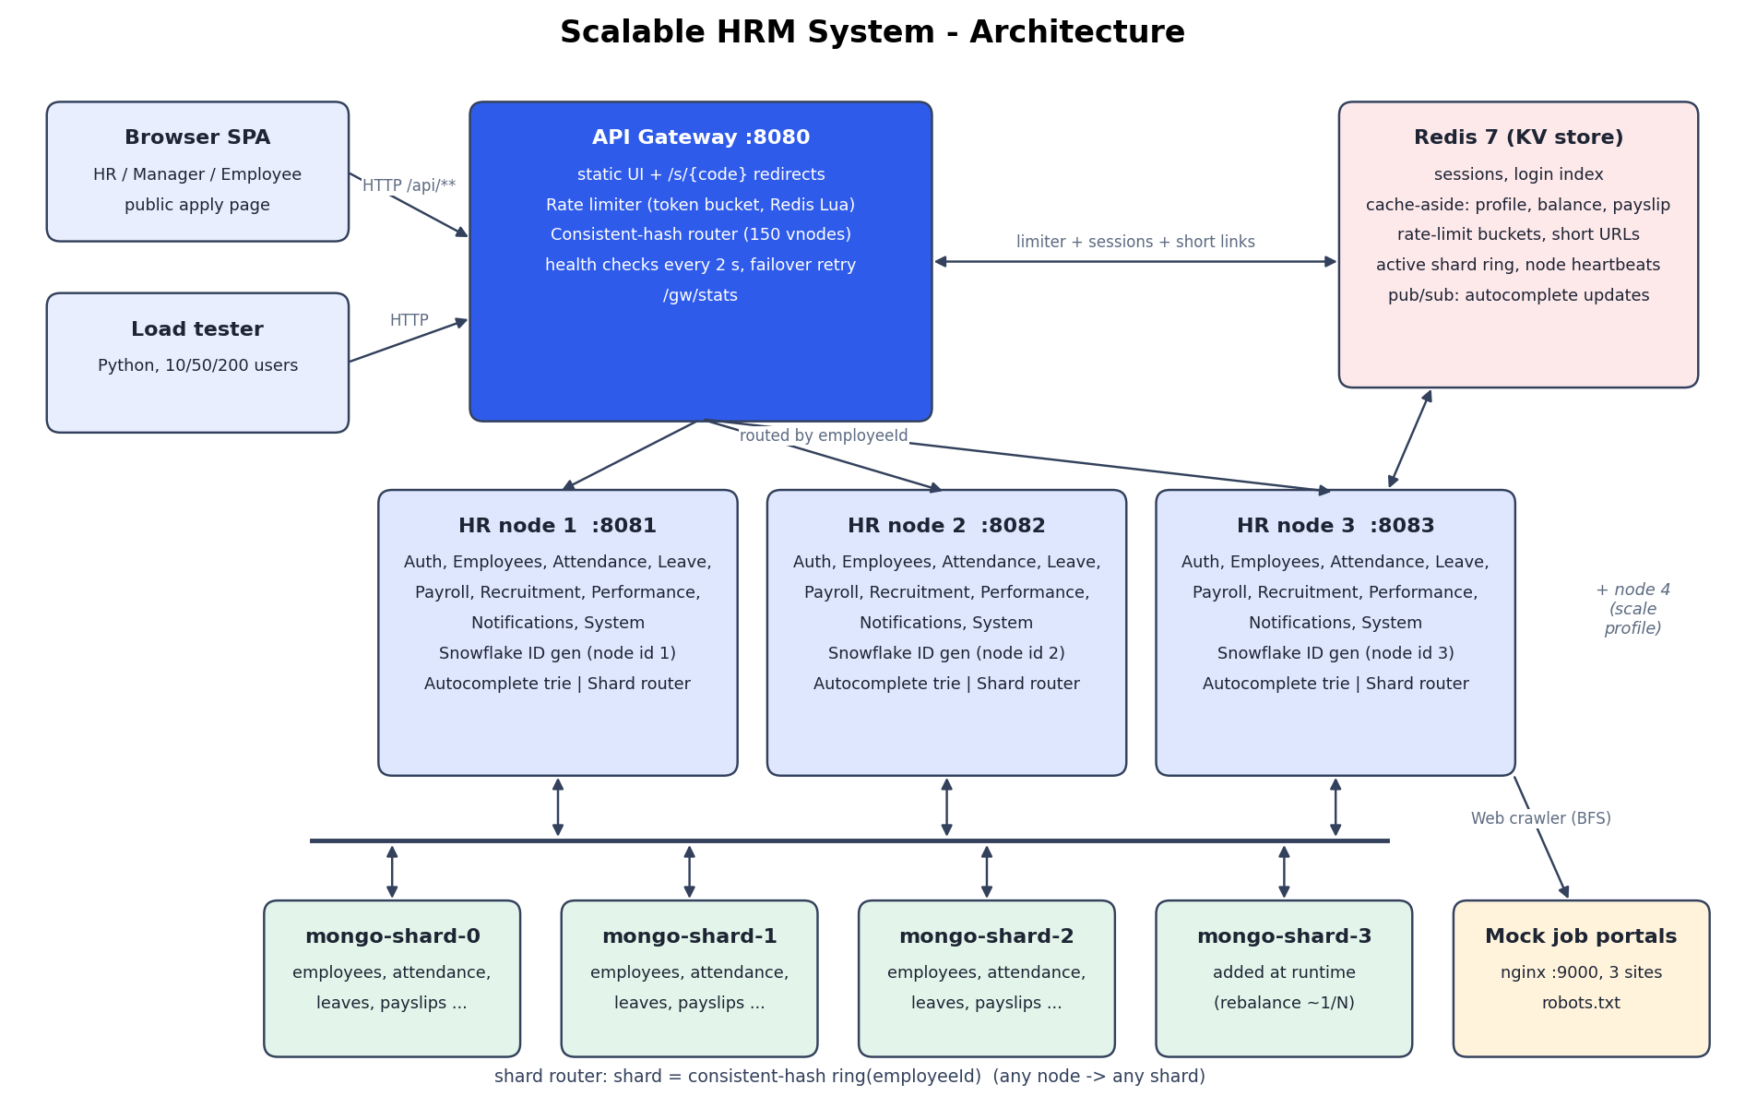
Figure 1: System architecture

4.1 Request walkthrough
An employee opens their leave balance:
- The browser calls GET /api/leaves/balance/{id} on the gateway (:8080) with its session token.
- The gateway's rate limiter runs the token-bucket Lua script in Redis for that user. An empty bucket returns 429 with Retry-After.
- The gateway picks the HR node that owns the routing key (the employee ID) on the node ring and forwards the request. If the node does not answer, the gateway retries once on the next node on the ring.
- The node resolves the session from Redis and checks the role and ownership.
- The node reads the balance from Redis (cache-aside). On a miss it finds the owning shard on the shard ring, reads MongoDB and stores the result in Redis with a 5-minute TTL.
- The response returns through the gateway, which adds X-Served-By so the UI and the load test can see which node answered.

4.2 Data model
Collection | Main fields | Shard key
employees | name, email, passwordHash (BCrypt), role, department, skills, managerId, salary, leaveBalance, status | _id (employeeId)
attendance | employeeId, date, checkIn, checkOut, hours | employeeId
leaves | employeeId, type, from, to, days, status, approverId | employeeId
payslips | employeeId, month, gross, pf, tax, lop, net | employeeId
reviews | employeeId, cycle, goals[], rating, comments | employeeId
notifications | employeeId, message, read, createdAt | employeeId
jobs | title, department, location, status, source (INTERNAL/CRAWLED), shortCode | _id
candidates | jobId, name, email, stage, history[] | _id
short_urls | target, expiresAt (durable copy; Redis is primary) | _id (code)

Login looks up email -> employeeId in a Redis hash (login:email), falling back to a scatter-gather query.

5. Component design and algorithms

5.1 Unique ID generator (Snowflake)
id = (now_ms - EPOCH) << 22 | nodeId << 12 | sequence
if now_ms == last_ms: sequence = (sequence + 1) & 4095; if sequence == 0: spin to next ms
if now_ms < last_ms: refuse (clock moved backwards)
Generation is O(1) with no I/O. One generator produced 3,803,482 IDs/s. Generating 300,000 IDs on three generators with distinct node IDs gave 0 collisions. Deliberately giving all three the same node ID gave 192,273 collisions, which shows why the node-ID bits matter.

5.2 Consistent hashing
add(member): for v in 0..149: ring[murmur3(member + '#' + v)] = member
owner(key): h = murmur3(key); e = ring.ceilingEntry(h) ?: ring.firstEntry(); return e.value
Lookup is O(log V), where V = members x 150. Table 2 shows how virtual nodes even out 100,000 keys over 3 shards.
Virtual nodes | shard-0 | shard-1 | shard-2 | Std-dev % | Max / min
1 | 70,478 | 8,745 | 20,777 | 80.2 | 8.06
10 | 37,315 | 30,665 | 32,020 | 8.6 | 1.22
50 | 27,870 | 33,022 | 39,108 | 13.8 | 1.40
150 | 34,704 | 33,728 | 31,568 | 3.9 | 1.10
500 | 34,332 | 32,144 | 33,524 | 2.7 | 1.07

Table 2: Key distribution vs virtual nodes.
Going from 3 to 4 shards remapped 25.9% of keys with consistent hashing, against 75.1% with hash-mod-N (ideal 25%).
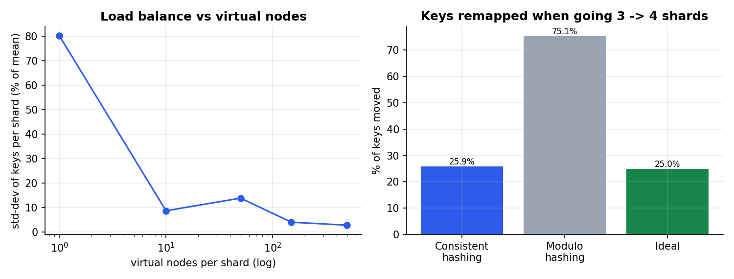
Figure 2: Distribution vs virtual nodes, and keys moved when adding a shard

5.3 Sharding and rebalancing
ShardStore routes single-employee operations to the owning shard and runs org-wide queries in parallel on all active shards (scatter-gather). It returns partial results and the list of failed shards when a shard is down. Adding shard-3 updates the ring held in Redis (key cluster:shards:active). A rebalance job then scans each existing shard and copies, then deletes, every document whose key now belongs to shard-3. During the move, reads check the new owner first and then the old one (dual read).

5.4 Key-value store (Redis)
Redis holds sessions (8 h TTL), the email -> ID login index, cache-aside entries (profile 10 min, leave balance 5 min, payslip 1 h, invalidated on write), limiter buckets, short links, the active shard set, node heartbeats, and the pub/sub channel index:updates that keeps every node's trie in sync.
A Redis lookup took 1.18 ms on average (p95 2.04 ms), against 1.50 ms (p95 2.85 ms) for the same record from its MongoDB shard, a 1.28x speed-up. Both run on the same host, so the gap is small; the larger gain is the load taken off MongoDB (Section 8). With live traffic the node cache hit ratio was 99.7% (4,138 hits, 13 misses, measured in the first evaluation run after the smoke test).
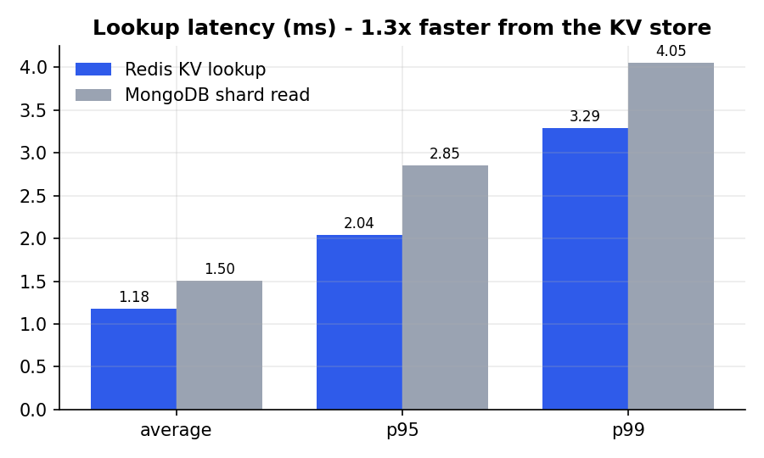
Figure 3: Lookup latency: Redis vs MongoDB

5.5 Rate limiter (token bucket)
tokens = min(capacity, tokens + (now - last) * rate)
if tokens >= 1: tokens -= 1; allow else: reject 429, Retry-After = (1 - tokens) / rate
-- executed atomically as one Redis Lua script (HMGET / HMSET / PEXPIRE)
A burst of 600 requests at 329 req/s from one user allowed 189 (the theory predicts about 191: the burst capacity plus refill) and rejected 411 (68.5%). In the login brute-force test, 5 wrong passwords got 401 and the next 7 attempts were blocked with 429. The baseline, which has no limiter, let all requests through.
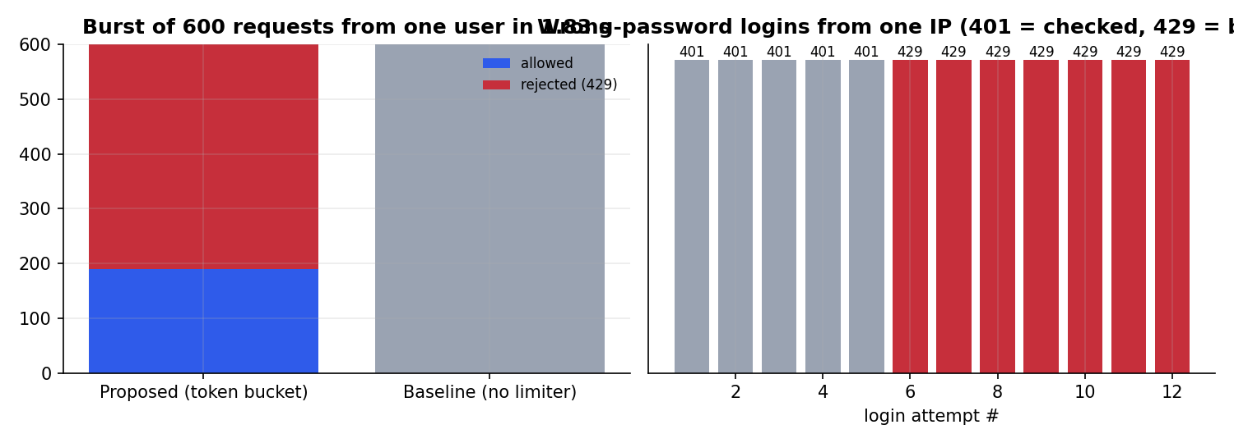
Figure 4: Rate limiter under burst and login brute force

5.6 Autocomplete (trie with top-k)
Each trie node stores the top 10 completions for its prefix, so a lookup costs O(length of prefix) and does not depend on the number of employees. The trie is built from all shards at startup. When an employee is created or changed, the node publishes the change on Redis pub/sub and every node updates its own copy. It indexed 69,980 terms (names, departments and skills).
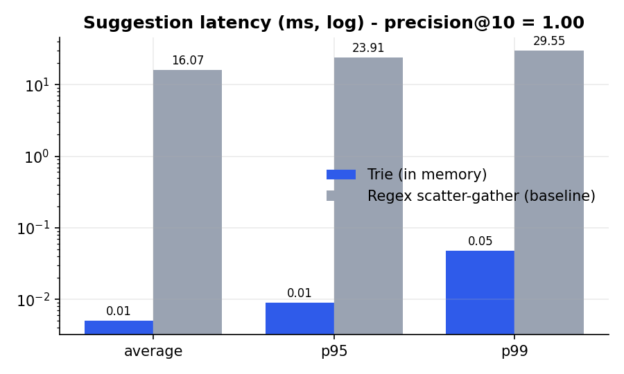
Figure 5: Autocomplete: trie vs regex scatter-gather

5.7 URL shortener
A short code is the Base62 encoding of a Snowflake ID. The code -> target mapping goes to Redis with the link's TTL (payslip 24 h, offer letter 7 d, job posting until closed) and to MongoDB as a durable copy. /s/{code} on the gateway answers with a 302 redirect. Over 500 requests the redirect took 9.1 ms on average (p95 12.9 ms), with 500 correct 302s. The baseline averaged 11.2 ms.

5.8 Web crawler
frontier = queue(seeds); visited = {}
while frontier and pages < 500:
url, depth = frontier.pop(); if sha1(normalize(url)) in visited or robots.disallows(url): skip
wait politeness(host, 200 ms); page = fetch(url); jobs += parse(page) # Jsoup
for link in page.links: if depth < 3: frontier.push(link, depth + 1)
dedup jobs by hash(title, company, location); import new ones
Against the three simulated portals the crawler fetched 136 pages (5.00 pages/s, limited by the politeness delay), with 0 failures. It skipped 2 pages disallowed by robots.txt, found 102 unique jobs and dropped 18 duplicates that were listed on more than one portal.

6. Implementation (Deliverable 3)
Layer | Technology
Application | Java 17, Spring Boot 4.1 (one jar; role = gateway or node)
Data | MongoDB 7.0 x 4 (one per shard), Spring Data MongoDB
Key-value store | Redis 7 (AOF persistence), Lua scripting, pub/sub
Web UI | Single-page app in plain HTML/CSS/JavaScript, served by the gateway
Crawler targets | nginx serving three generated job-portal sites
Deployment | Docker Compose; 10 containers; baseline in a separate compose file
Testing | JUnit 5 + AssertJ (57 tests); Python smoke test (41 end-to-end checks)
Evaluation | Python load generator, docker stats sampler, matplotlib graphs

6.1 REST API
Area | Endpoints
Auth | POST /api/auth/login, POST /api/auth/logout, GET /api/auth/me
Employees | POST /api/employees, GET|PUT /api/employees/{id}, GET /api/employees/search, /suggest, /departments, /{id}/team
Attendance | POST /api/attendance/check-in, /check-out, GET /api/attendance/{employeeId}, /summary
Leave | POST /api/leaves, GET /api/leaves/balance/{employeeId}, /pending, POST /{employeeId}/{leaveId}/decision, /{leaveId}/cancel
Payroll | POST /api/payroll/run, GET /api/payroll/{employeeId}/{month}, POST /{employeeId}/{month}/share
Recruitment | GET|POST /api/recruitment/jobs, /jobs/{id}/close, /candidates, /candidates/{id}/stage, POST /crawl, GET /crawl/status
Public | GET /api/public/jobs/{id}, POST /api/public/jobs/{id}/apply, GET /s/{code}
Performance | PUT /api/performance/{employeeId}/{cycle}/goals, POST .../review, GET /team, /cycle
Notifications | GET /api/notifications, POST /{id}/read, POST /read-all
System (HR) | GET /api/system/stats, POST /api/system/shards, /reindex, /bench/{name}; GET /gw/stats

6.2 User interface
The web UI has role-specific pages for the dashboard, employees (search with autocomplete), attendance, leave, payroll, recruitment (pipeline and crawler status), performance, notifications and the System page, which shows the live ring, shard counts, node health and cache statistics.
[TO FILL IN: insert UI screenshots - login, dashboard, employee search with autocomplete, payroll result, recruitment with crawl status, System page]

7. Experimental setup
[TO FILL IN: test laptop hardware - CPU model and cores, RAM, OS (run `systeminfo` on the test laptop)]
Item | Setting
Deployment | All 10 containers and the load generator on one laptop (Docker Desktop, WSL2)
JVM | -Xmx384m, Serial GC, per HR node and gateway
MongoDB | WiredTiger cache 0.25 GB per shard
Data set | 10,000 synthetic employees with 20 working days of attendance, leaves and salary structures (~203k documents)
Workload mix | profile 30%, autocomplete 20%, check-in 15%, leave balance 10%, notifications 10%, payslips 5%, job list 5%, short-link redirect 5%
Load levels | low = 10, medium = 50, high = 200 concurrent virtual users; 10 s warm-up, 60 s measured
Load-test users | Sessions drawn round-robin from every shard
Baseline | 1 node, 1 MongoDB, no cache, no rate limiter, regex search instead of the trie

8. Performance evaluation (Deliverable 4)
Load | System | Req/s | Avg ms | p95 ms | p99 ms | Success % | Error % | Node CPU % | Mongo CPU % | Mem MiB
Low (10) | Proposed | 394.6 | 25.4 | 36.1 | 42.3 | 100.00 | 0.00 | 226 | 27 | 2,000
 | Baseline | 393.7 | 25.4 | 56.6 | 64.8 | 100.00 | 0.00 | 109 | 290 | 884
Medium (50) | Proposed | 361.9 | 138.5 | 232.2 | 289.0 | 100.00 | 0.00 | 102 | 27 | 2,006
 | Baseline | 396.9 | 126.2 | 205.7 | 248.8 | 100.00 | 0.00 | 69 | 305 | 884
High (200) | Proposed | 361.4 | 542.6 | 1,112.1 | 1,478.5 | 100.00 | 0.00 | 72 | 26 | 2,015
 | Baseline | 364.2 | 544.7 | 983.6 | 1,287.9 | 100.00 | 0.00 | 62 | 296 | 891

Table 3: Load-test results, proposed vs baseline. CPU is summed over the containers in the group (100% = one core).
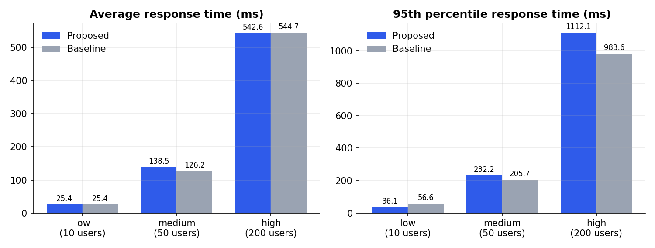
Figure 6: Average and p95 response time by load
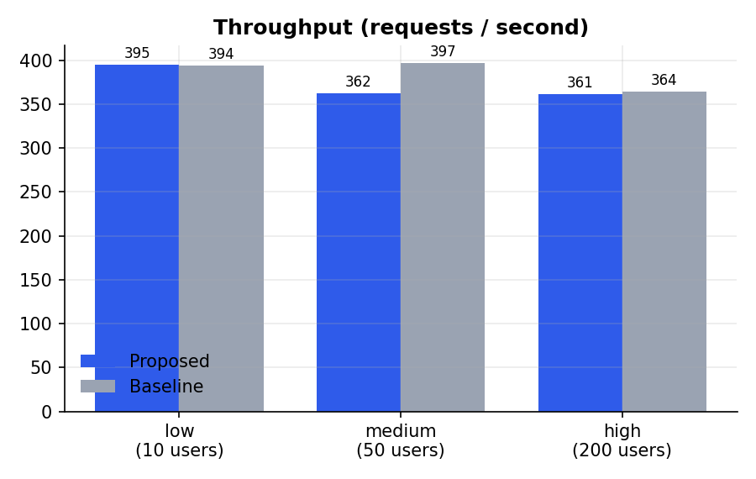
Figure 7: Throughput by load
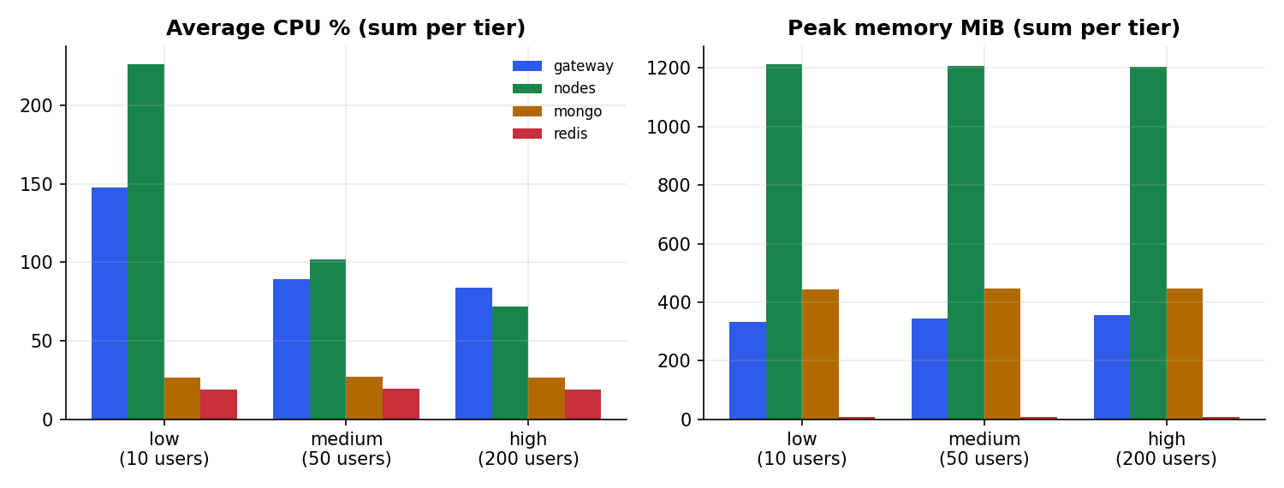
Figure 8: CPU and memory by load
What the numbers show:
- Both systems serve every request at every level. Success was 100% for both at 10, 50 and 200 users, with no 5xx errors.
- Throughput is flat at about 361-395 req/s for both. The load generator, the gateway, the nodes and the databases all share one laptop's CPU. Once that CPU is saturated, extra users only queue: average latency grows almost linearly with users (25 -> 138 -> 543 ms), as Little's law predicts (200 users / 361 req/s = 553 ms).
- Where the proposed design wins is database load. At the same request rate MongoDB used on average 297% CPU in the baseline against 27% across all four shards in the proposed design, about 11x less. The cache and the trie absorb the read-heavy part of the workload. On a real cluster, with one machine per shard, that headroom is what allows throughput to grow.
- Tail latency at low load is better in the proposed design (p95 36 ms vs 57 ms), because search no longer waits for a regex scan. At high load the extra gateway hop and the three JVMs competing for the same CPU make p95 slightly worse (1112 vs 984 ms).

8.1 Component metrics
Component | Metric | Proposed | Baseline
Snowflake | IDs per second (one generator) | 3,803,482 | 4,095,591
Snowflake | Collisions in 300k IDs, 3 nodes | 0 | 0
KV store | Lookup avg / p95 (ms) | 1.18 / 2.04 | no cache
KV store | Cache hit ratio (live traffic) | 99.7% | 0% (disabled)
Rate limiter | Burst rejection rate | 68.5% | 0.0%
Rate limiter | Brute-force attempts blocked (of 12) | 7 | 0
Consistent hashing | Std-dev of 3-shard split, 150 vnodes | 3.9% | single DB
Consistent hashing | Keys moved 3 -> 4 shards | 25.9% | 75.1% (modulo)
Autocomplete | Avg latency (ms) | 0.005 (trie) | 37.8 (regex)
Autocomplete | Precision@10 | 1.00 | -
URL shortener | Redirect avg / p95 (ms) | 9.1 / 12.9 | 11.2 / 14.1
Web crawler | Pages/s, jobs, duplicates dropped | 5.00 / 102 / 18 | -

Table 4: Component metrics.

9. Scalability and failure analysis (Deliverable 5)

9.1 S1 - Scaling out HR nodes
Nodes | Req/s | Avg ms | p95 ms | Requests per node
1 | 360.2 | 278.0 | 556.8 | node-1: 13,664
2 | 308.0 | 324.1 | 648.7 | node-1: 5,234, node-2: 6,444
3 | 348.6 | 287.6 | 513.4 | node-1: 3,671, node-2: 4,356, node-3: 5,201
4 | 361.6 | 276.7 | 504.6 | node-1: 3,380, node-2: 3,161, node-3: 4,644, node-4: 2,536

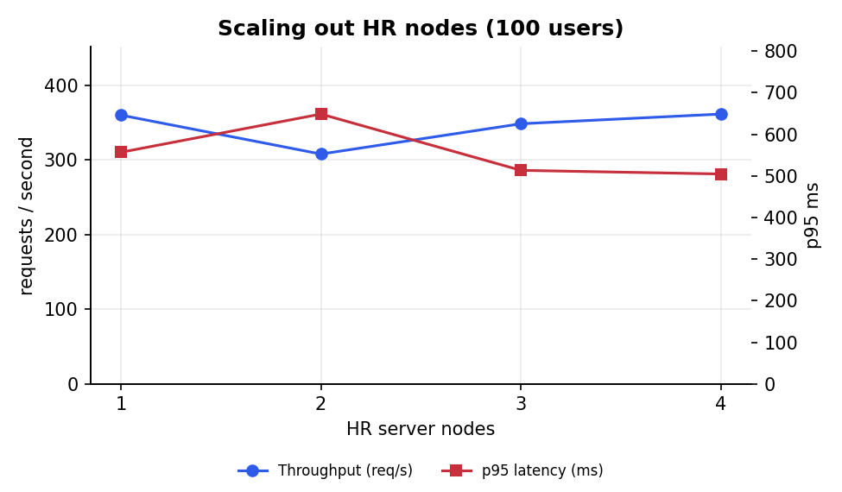
Figure 9: Throughput and p95 latency as HR nodes are added (100 users)
The router spreads requests over every live node, and node 4 starts taking traffic seconds after it starts. Throughput, however, stays roughly constant. The bottleneck is the single laptop's CPU, not the number of application processes: each extra JVM competes for the same cores. The design is still sound for horizontal scale, since nodes are stateless and only ~1/N of routing keys move. Demonstrating a throughput gain needs the nodes on separate machines.

9.2 S2 - Adding a shard and rebalancing
Shard-3 was added to a live system holding 10,000 employees. The rebalance scanned 202,505 documents and moved 53,581 (26.5%) in 6.7 s. That is 26.5% of employees, close to the ideal 25%. Every employee's attendance, leaves and payslips moved with them.
 | shard-0 | shard-1 | shard-2 | shard-3
Before | 3,477 | 3,303 | 3,220 | 0
After | 2,367 | 2,529 | 2,457 | 2,647

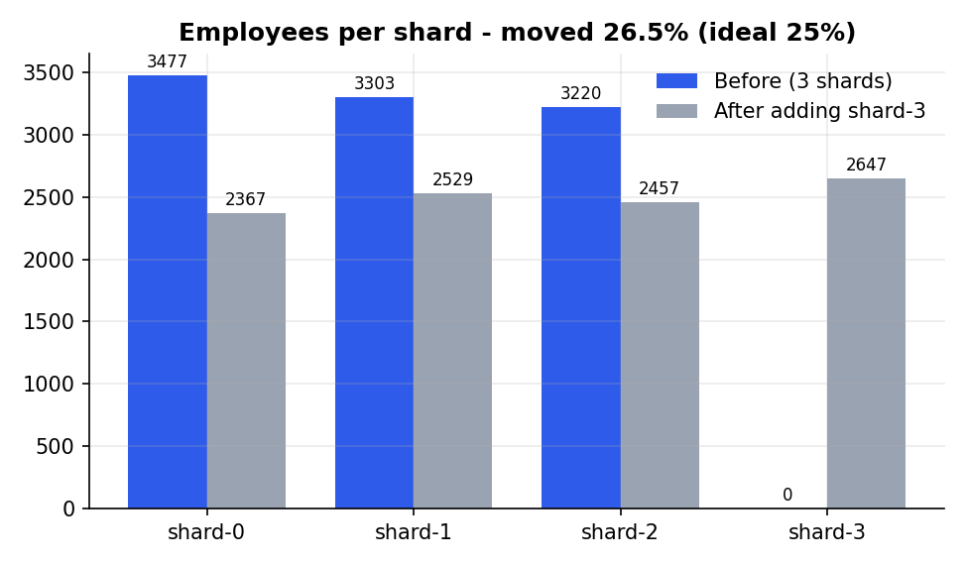
Figure 10: Employees per shard before and after adding shard-3

9.3 S3 - HR node failure
hrms-node-2 was killed 20 s into a 50-user run and restarted at 40 s. Over 22,164 requests the success rate was 100.00% and p95 stayed at 224 ms. The gateway retried in-flight requests on the next node, and the health check dropped the dead node from the ring within 2 s. Because sessions and caches live in Redis, the surviving nodes could serve the failed node's users immediately.
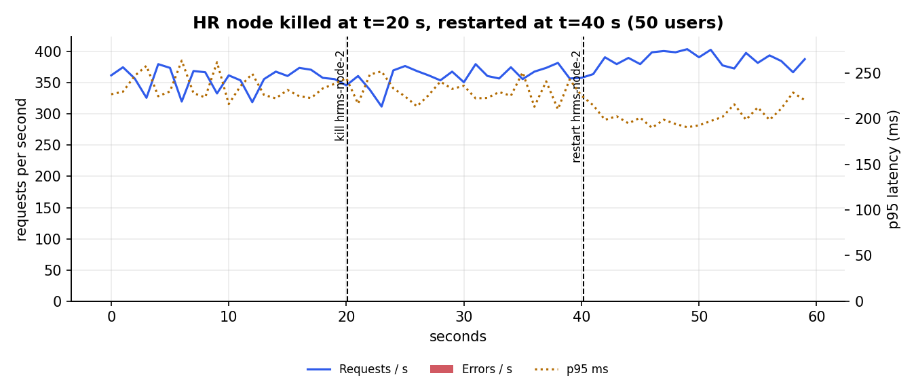
Figure 11: Requests, errors and p95 latency while node 2 is killed and restarted

9.4 S4 - Database shard failure
mongo-shard-1 was killed 20 s into a 50-user run and restarted at 40 s. Overall success was 99.13%. Errors (HTTP 503 with a clear retry message) came only from operations that need the dead shard's data for users on that shard: check-ins (75), leave balance (3), notifications (55), payslips (31). Leave balance failed only 3 times because it is normally served from the Redis cache. Operations answered from Redis or the in-memory trie never failed: profile reads, autocomplete, short-link redirects. Org-wide job listings (scatter-gather) did not fail either; they returned partial results, but each query first waited for the driver's 2 s server-selection timeout. This is the p99 of 2030 ms. The system recovered on its own within seconds of the shard's restart.
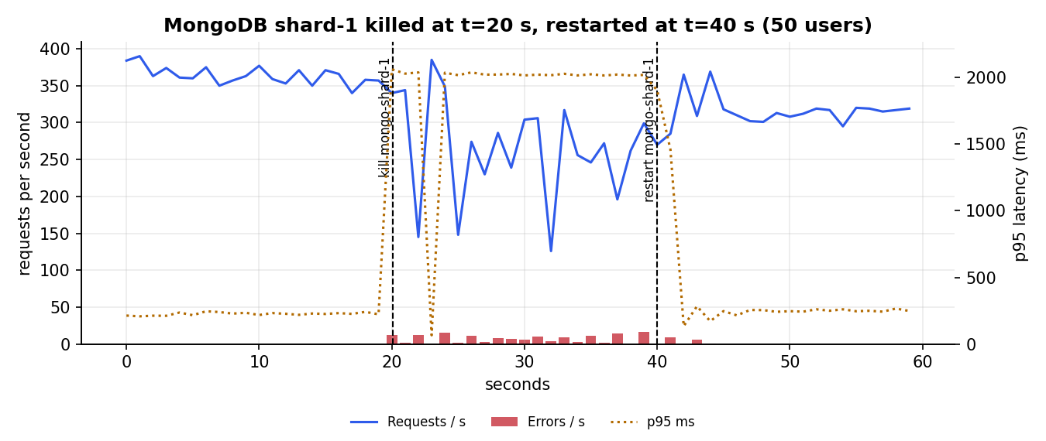
Figure 12: Requests, errors and p95 latency while shard-1 is killed and restarted

9.5 Observed bottlenecks
- Single host. Every container and the load generator share one laptop, so CPU, not design, caps throughput (Section 8).
- Python load client. A thread-per-user generator adds its own scheduling delay at 200 users.
- Scatter-gather queries. Org-wide search and job listings touch every shard and wait for the slowest. A dead shard costs them the 2 s driver timeout.
- Payroll batch. A full payroll run touches every shard; it runs shard-parallel and is rate-limited to 2 per minute.

10. Design trade-offs
Decision | Gain | Cost
Application-level sharding | Full control of placement and rebalancing; no mongos/config servers | The application must route every query and implement rebalancing itself
Co-locating employee data | Single-shard reads and writes for nearly every request | Org-wide reports scatter-gather
Cache-aside with TTL | Large cut in database load | Reads can be stale for up to the TTL if an invalidation is missed
In-memory trie per node | Microsecond suggestions | Memory on every node; kept in sync via pub/sub
Redis as shared state | Stateless nodes, shared sessions and limits | Redis is a single point of failure (no replica in this deployment)
Gateway retry on failure | Node failures invisible to users | A retried non-idempotent request could run twice

11. Limitations, ethics and data privacy
- All personal data is synthetic; no real employee information was used.
- Passwords are stored as BCrypt hashes; sessions expire after 8 hours; payslips are visible only to their owner and HR, and shared payslip links expire after 24 hours.
- No replica sets: a shard failure makes that partition unavailable until restart. MongoDB replica sets and Redis Sentinel would remove this.
- Evaluated on one machine, so horizontal throughput gains could not be demonstrated.
- No email/SMS, OAuth or password reset; notifications are in-app only.

12. Conclusion and future work
The HRMS implements every required module and gives each of the eight system-design components a real job. The measurements confirm the behaviour each component was chosen for:
- unique IDs across nodes;
- about 25% data movement when a shard is added;
- even distribution with virtual nodes;
- autocomplete over 3,000x faster than a database scan;
- abusive traffic rejected;
- an HR node lost without failed requests.
Future work:
- deploy on several machines to measure horizontal throughput;
- add MongoDB replica sets and Redis Sentinel;
- make retries idempotent with request IDs;
- move payroll to a queue-based batch.

References
- Twitter Engineering, "Announcing Snowflake," 2010.
- D. Karger et al., "Consistent Hashing and Random Trees," Proc. ACM STOC, 1997.
- A. Appleby, "MurmurHash3," SMHasher project.
- A. Xu, System Design Interview - An Insider's Guide, Vols. 1 and 2.
- MongoDB Inc., MongoDB Manual 7.0; Redis Ltd., Redis documentation (EVAL, pub/sub).
- M. Koster, "A Standard for Robot Exclusion" (robots.txt), and RFC 9309.

Appendix A: How to run
git clone https://github.com/amdravidranjan/HumanResourceManagementSystem.git
cd HumanResourceManagementSystem
docker compose up -d --build
docker logs -f hrms-node-1 (wait for 'Search index rebuilt: 10000 employees')
open http://localhost:8080 (admin@hrms.local / admin123)
pip install -r evaluation/requirements.txt
python evaluation/smoke.py (41 end-to-end checks)
python evaluation/run_all.py (full evaluation, ~40 min)

