CITY IMPORT INSTRUCTIONS

Below is the screenshot of a sample csv file for city importing.

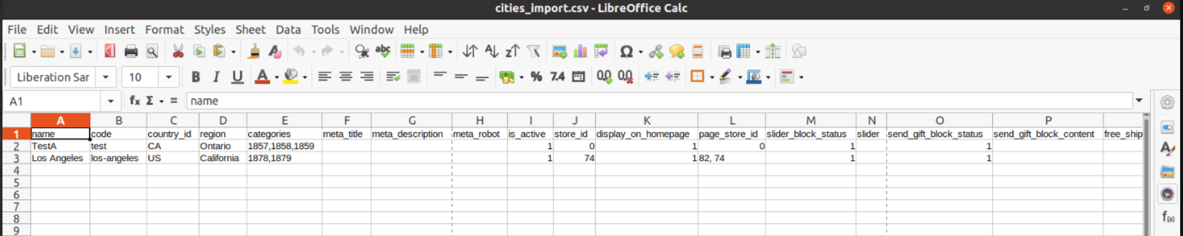
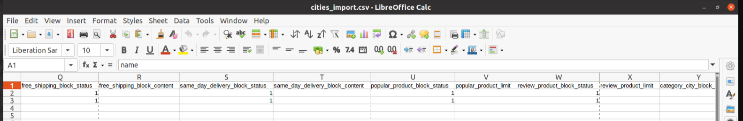
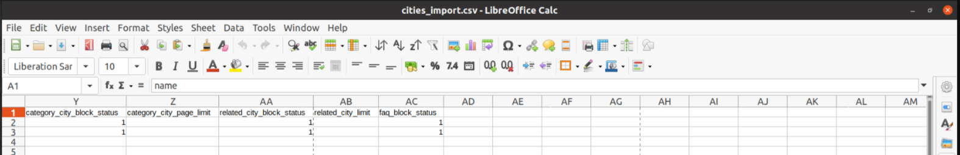

FIELDS

1. name

Name of the city. This is a required field. Example “Toronto”

2. code

This is a code for the city. This should be a unique value and cannot be empty. No spaces are allowed in this value. If there is any space, then that will be replaced with hyphen. Keep the code in small letter. Example “toronto”. This code is also using for the url building for the city.

3. country_id

This should be the two letter country code of the city. This is also a required field. Eg: for Canada its “CA” and for USA its “US”.

4. region

Name of the region of the city. This is a required field. Eg: “Ontario”

5. categories

This is the list of category ids of the city. This is a comma separated value. Based on the categories specified here, module will generate the city + category page. If no category ids specified, then no category page will be genearted for the city. But you can later add categories to the city from admin side and regenrate the page.
If the city is for all websites, then put the category ids from each websites you want to link. So the value will be like eg: 1857,1856,1475

6. meta_title

Meta title for the city page. Keep this empty so the module will generate it for you based on the default template. The template is
“{name} {category} Gift Basket Delivery | Send {category} Gift Basket Delivery to {name}, {region} | {website}”
Here the things in curly braces will be dynamically replaced.

7. meta_description

Meta description for the city page. Keep this empty so the module will generate it for you based on the default template. The template is
“Buy {category} Gift Baskets Online - Free Shipping to {name} ({region}, {country}) | Same-Day Delivery in {name} | Over 3200 Custom Designs ⏩ Order Now!”
Here the things in curly braces will be dynamically replaced.

8. meta_robot
Meta robot value for the city page. Keep this empty so the module will set default value as “INDEX,FOLLOW”

9. is_active

This will determine to enable / disable the city and city page. If value is 1, then enabled and 0 disabled.

10. store_id

This is the id of the store in which the city should be available. You can sepcify the id of the store view where this city should be available. To make the city available for all store views, then put 0 as the value.

11. display_on_homepage

This is used to show / hide the city in the homepage city list. If the value is 1, then it will display in homepage and if 0 then it will not be displayed.

12. page_store_id

This is list of store id’s separated by comma for which the page should be generated. Ie, if you want the city page should be genearted for a specific store view, then put the store id here Or if you want to generate it for all store view (commonly use) then put 0 as the value. If no value is added here, then by default it will assigned for all store view and page will be generated for all stores

13. slider_block_status

This is used to show/hide the slider block in the city and city + category page. If the value is 1, then the slider block will be displayed else it will be hidden in both pages.

14. slider

Here the slider content is specified. We have used magento default slider feature which is available in wyswing editor. So it will be a html content and the image should be added manually. Eg:

“<style>
#html-body [data-pb-style=K334GMG] {
justify-content: flex-start;
display: flex;
flex-direction: column;
background-position: left top;
background-size: cover;
background-repeat: no-repeat;
background-attachment: scroll
}

#html-body [data-pb-style=U70LA59] {
min-height: 300px
}

#html-body [data-pb-style=W2E84KI] {
background-position: center center;
background-size: cover;
background-repeat: no-repeat;
min-height: 300px
}

#html-body [data-pb-style=U2M6FCR] {
min-height: 300px;
background-color: transparent
}

#html-body [data-pb-style=AOLVA5Q] {
background-position: center center;
background-size: cover;
background-repeat: no-repeat;
min-height: 300px
}

#html-body [data-pb-style=RRWEJP5] {
min-height: 300px;
background-color: transparent
}
</style>
<div data-content-type="row" data-appearance="contained" data-element="main">
<div data-enable-parallax="0" data-parallax-speed="0.5" data-background-images="{}" data-background-type="image"
data-video-loop="true" data-video-play-only-visible="true" data-video-lazy-load="true"
data-video-fallback-src="" data-element="inner" data-pb-style="K334GMG">
<div class="pagebuilder-slider" data-content-type="slider" data-appearance="default" data-autoplay="false"
data-autoplay-speed="4000" data-fade="false" data-infinite-loop="false" data-show-arrows="false"
data-show-dots="true" data-element="main" data-pb-style="U70LA59">
<div data-content-type="slide" data-slide-name="" data-appearance="poster" data-show-button="never"
data-show-overlay="never" data-element="main">
<div data-element="empty_link">
<div class="pagebuilder-slide-wrapper"
data-background-images="{\&quot;desktop_image\&quot;:\&quot;{{media url=wysiwyg/city-slider-default-image1.jpg}}\&quot;}"
data-background-type="image" data-video-loop="true" data-video-play-only-visible="true"
data-video-lazy-load="true" data-video-fallback-src="" data-element="wrapper"
data-pb-style="W2E84KI">
<div class="pagebuilder-overlay pagebuilder-poster-overlay" data-overlay-color="" aria-label=""
title="" data-element="overlay" data-pb-style="U2M6FCR">
<div class="pagebuilder-poster-content">
<div data-element="content"></div>
</div>
</div>
</div>
</div>
</div>
<div data-content-type="slide" data-slide-name="" data-appearance="poster" data-show-button="never"
data-show-overlay="never" data-element="main">
<div data-element="empty_link">
<div class="pagebuilder-slide-wrapper"
data-background-images="{\&quot;desktop_image\&quot;:\&quot;{{media url=wysiwyg/city-slider-default-image2.jpg}}\&quot;}"
data-background-type="image" data-video-loop="true" data-video-play-only-visible="true"
data-video-lazy-load="true" data-video-fallback-src="" data-element="wrapper"
data-pb-style="AOLVA5Q">
<div class="pagebuilder-overlay pagebuilder-poster-overlay" data-overlay-color="" aria-label=""
title="" data-element="overlay" data-pb-style="RRWEJP5">
<div class="pagebuilder-poster-content">
<div data-element="content"></div>
</div>
</div>
</div>
</div>
</div>
</div>
</div>
</div>”

Here you can find the image name in this html and that image, we should manually upload in backend.

Keep this field empty so a default slider content will be used by the module.

15. send_gift_block_status

This will show/hide the gift block content block (in the screenshot). If the value is 1, then displayed and if 0 hide.
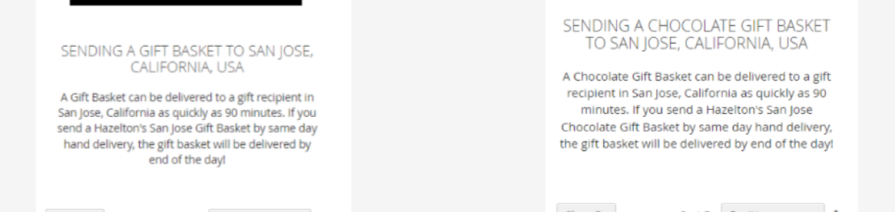

16. send_gift_block_content

This is the content field of the above block. Keep this field empty so that module will generate a content for you based on the template. The template is
“A {category} Gift Basket can be delivered to a gift recipient in {city},{region} as quickly as 90 minutes. If you send a {website} {city} {category} Gift Basket same day hand delivery, the gift basket will be delivered by end of the day!”

17. free_shipping_block_status

This will show/hide the free shipping information block. If the value is 1, then displayed and if 0 hidden.
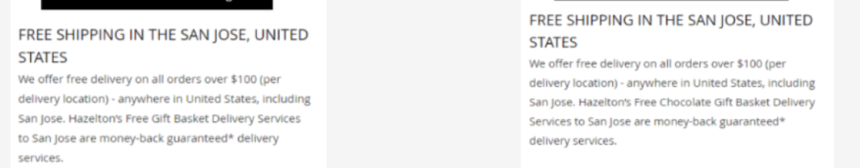

18. free_shipping_block_content

This is the content field of the above block. Keep this field empty so that module will generate a content for you based on the template. The template is
“We offer free delivery on all orders over $100 (per delivery location) - anywhere in united {country}, including {city}. {website} free {category} Gift Basket delivery services to {city} are money-back guaranteed* delivery services.”

20. same_day_delivery_block_status

This will show/hide the same day delivery content block. If the value is 1, then displayed and if 0 then hidden.
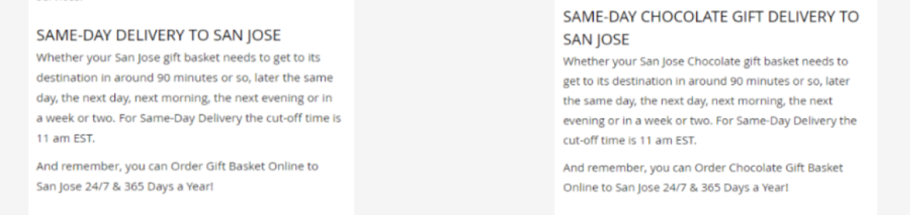

21. same_day_delivery_block_content

This is the content field of the above block. Keep this field empty so that module will generate a content for you based on the template. The template is
“Whether your {city} {category} gift basket need to get to its destination in around 90 minutes or so, later the same day, the next day, next morning, the next evening or in a week or two. For same-day delivery the cut-off time is 11 am EST. <br/> And remember, you can order {category} gift basket online to {city} 24/7 & 365 days a year!.”

22. popular_product_block_status

This will show/hide the popular products table block. If the value is 1, then displayed and if 0 hidden.
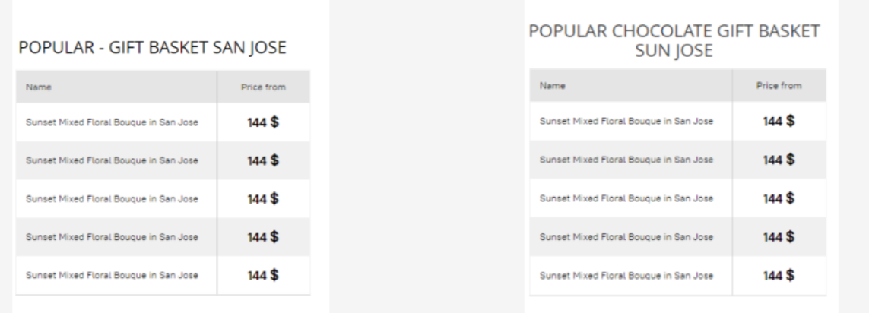

23. popular_product_limit

This is the limit value of the popular products. This much of products will be displayed as the popular products table. If empty then by default 6 items will be displayed.

24. review_product_block_status

This will hide/show the review prodcuts listing block. If the value is 1, then displayed and if
0 hidden.
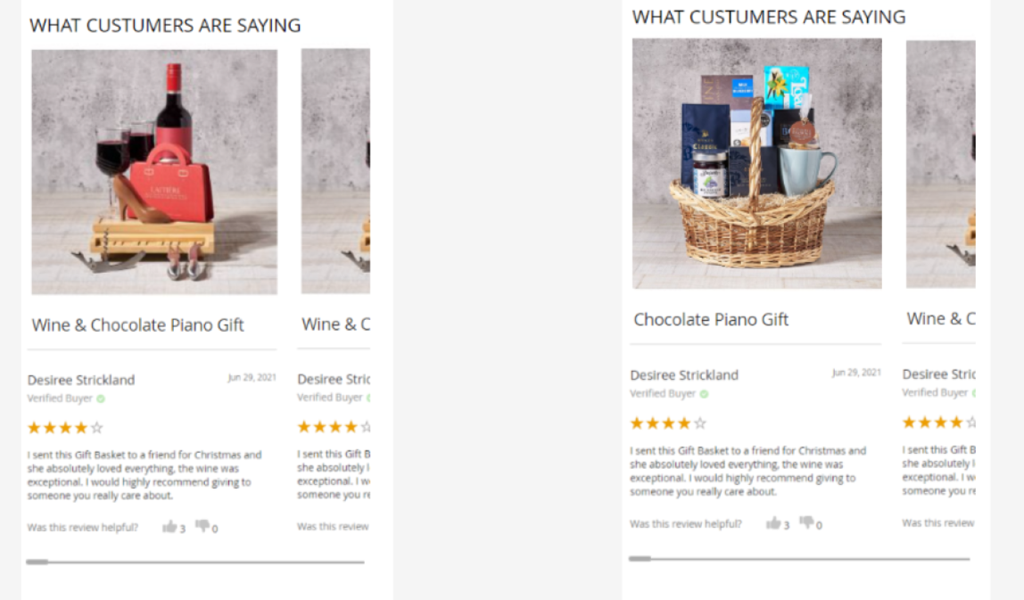

25. review_product_limit

This is the limit value of the review products. This much of products will be displayedin the carousel. If empty then by default 10 items will be displayed.

26. category_city_block_status

This will show/hide the category page list block. If the value is 1, then displayed and if 0 hidden.
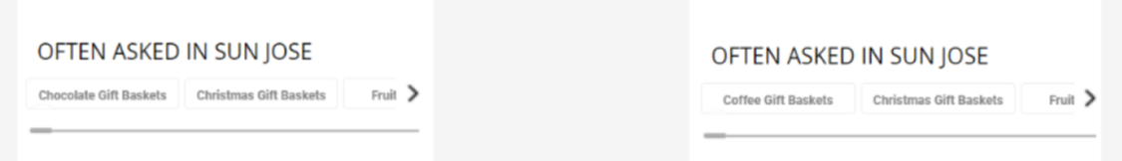

27. category_city_page_limit

This is the limit value of the category page list. This much of category pages links will be displayed in the city page. If empty then by default 20 items will be listed.

28. related_city_block_status

This will show/hide the related cities block. If the value is 1, then displayed and if 0 then hidden
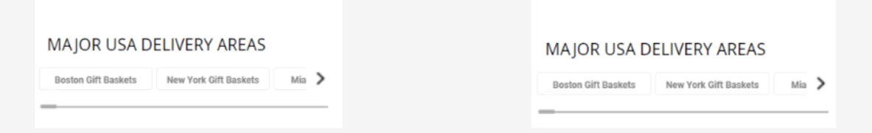

29. related_city_limit

This is the limit of the related cities list. This much of cities list will be listed as carousel in city page. If empty by default 30 items will be displayed.

30. faq_block_status

This will show/hide the faq block. If the value is 1, then displayed and if 0 then hidden.
