CITY PAGE MANAGEMENT

City pages can be managed from admin on the menu Admin -> Gift Group -> Geo Pages

1. City Management

City list view

In this first menu, all the cities will be listed and we can add/edit/delete cities from this section. There will be a grid to list all the cities as below.

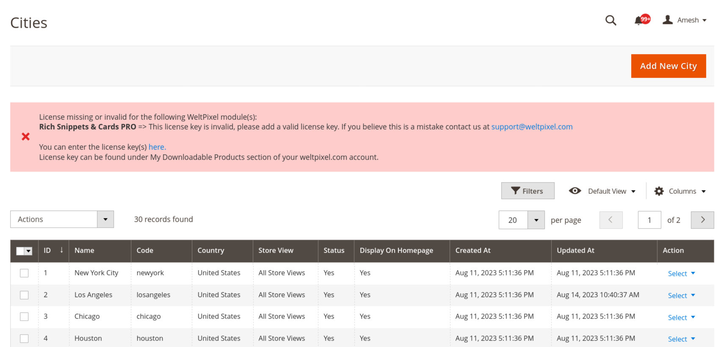
To add a new city, click on “Add New City” button.
There is mass action feature with that some operations can be done for a set of items.

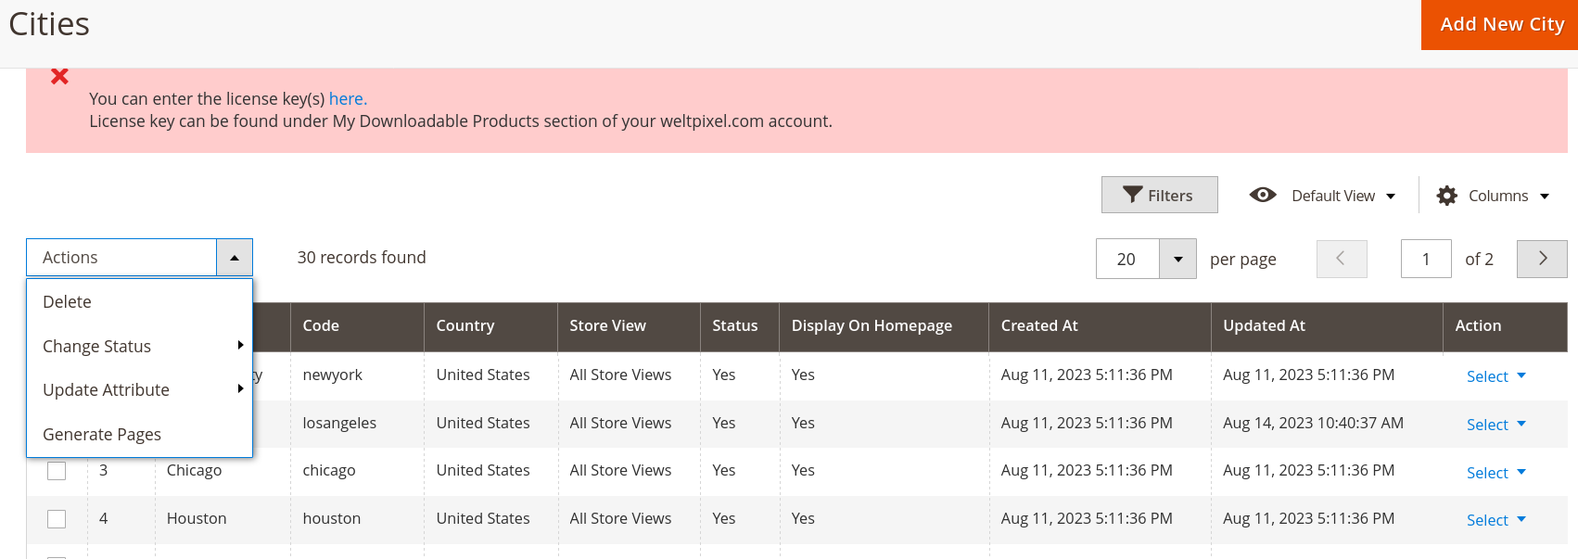
- Delete – delete one or more cities
- Change status – enable/disable one or more cities
- Update attribute
  - Show in homepage – show the city in homepage list
  - Hide from homepage – hide the city from homepage list
- Generate page – this is used to generate the city pages for one or more cities. Every time when a city is created, then need to generate the page for it. More about generate page will be explanined below.

Add / Edit form

To create a new city, button clicked and will show a form as below.
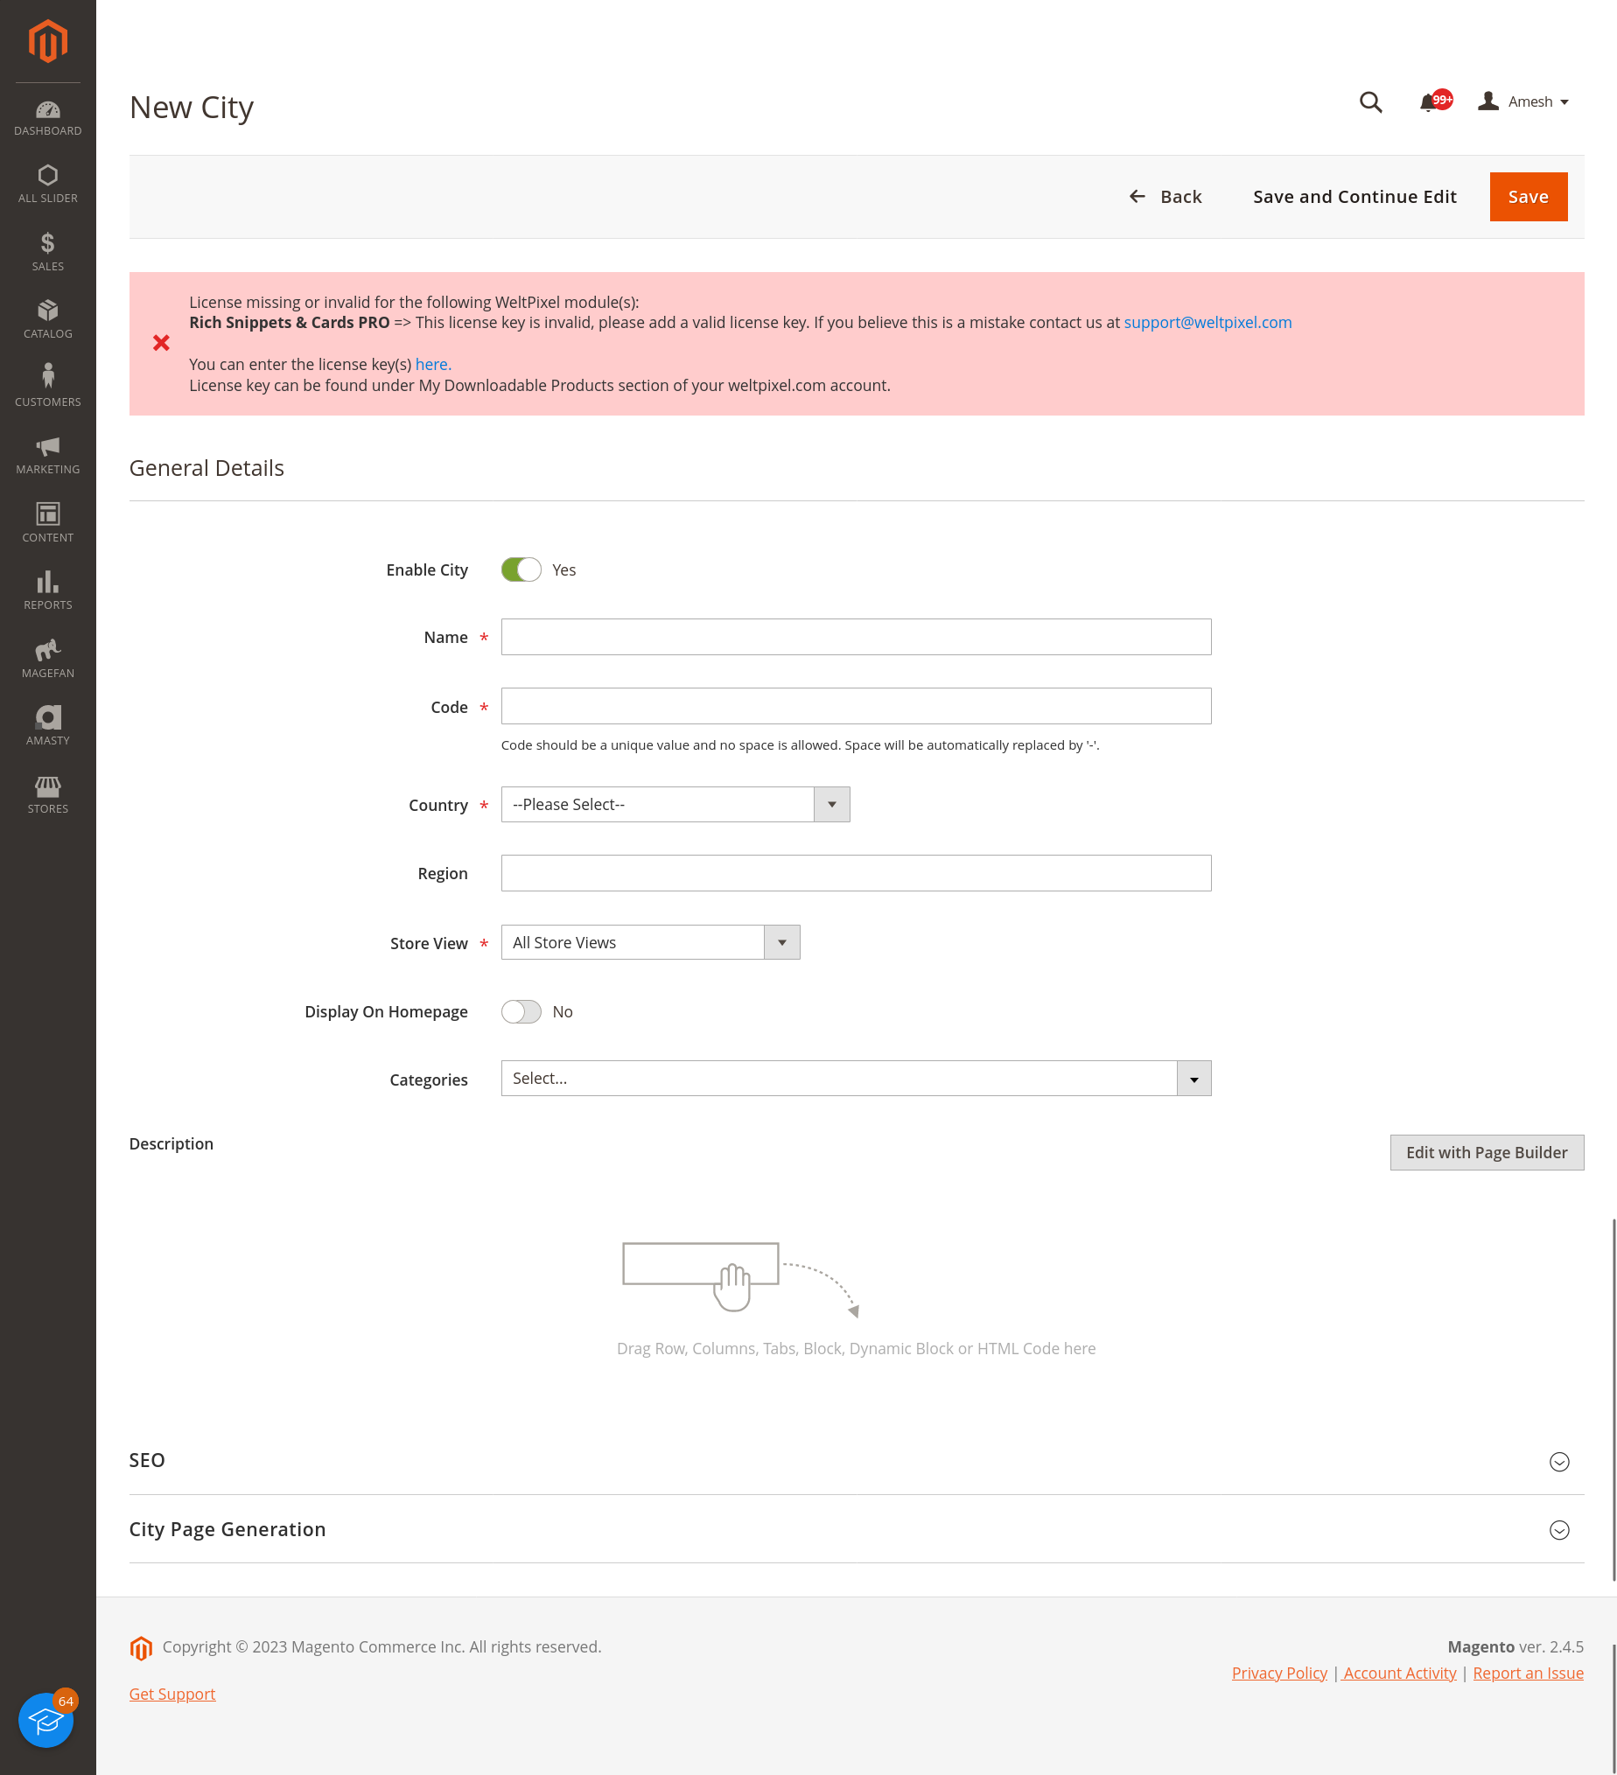
- General details
  - Enable city – enable/disable city. If the city is disabled, then it will not be shown wnyehere and also the city page also will be not available (even if the city page is enabled in its section).
  - Name – city name
  - Code – city code. City code should be a unique value. No spaces are allowed, if there is a space it will be replaced with hyphen.
  - Country – country of the city
  - Region – region of the city
  - Store view – store view of the city. If the city need to be for all the websites, then select the “All store view” and if only for a specific website, then select the corresponding website from the list.
  - Display on homepage – show/hide the city in homepage
  - Categories – city categories. If any category is selected here, then a page will also assigned to it.
  - Description – category description currently this field is not used anywhere, but we can use in future if we want.
- SEO
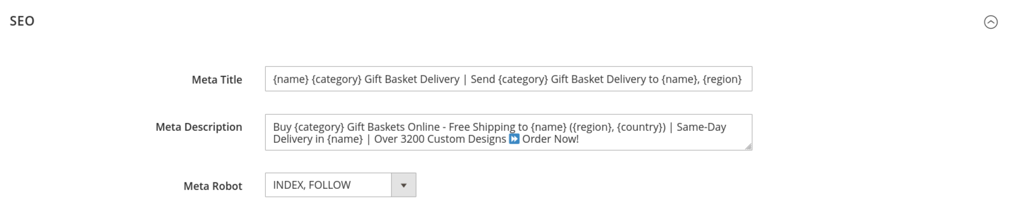
  - Meta title – meta title. Some predefined shortcodes can be used in some of the text fields. Which will be given as a table on the end of the doc.
  - Meta description
  - Meta robot
- City page generation
This is actually a default configuration/value section and this is used to generate the city page contents. Most of the fields use default template, so no need much customisation. Just cross check the page content section value templates and if everything ok, save the city and you will ge a “Generate page” button on top. On clicking that based on the configurations, there will be generated the city page (same one used for city + category view also).
NOTE: The configurations under this section is global configuration for the city page. Ie, if the settings disabled for the city page, then that will be considered. Eg, is the slider block status is disabled in city page confguration and enabled city page of any website then it will not be displayed on frotnend since it is disabled in global configuration.

  - Generate page for – this will determine for which all store views, the page should be generated. Since for both the city and city + category same page structure, there is a common page content config and generation settings is available. The same content and blocks will be used in the city + category page with the requirements in the coresponding page types. If the page needed in all websites, then you can select the “all store view” option from the list.
  - Slider block
    - Status – show/hide the slider in city and city + category page. For all the generated pages, this value will be set as the default value.
    - Slider – this is the slider adding section. In the page builder slider can be added by first adding a row and then adding slider from media element. Then select image and configure it. Keep this empty to render a default slider in frotnend.
  - Send gift info block
    - status - show/hide the block in city and city + category page. For all the generated pages , this value will be set as the default value.
    - Content – content for the block. By default there will be a default template inside the textbox. Keep this as it is to render the default one or can change it. So when page is generated this will be applied to all the store view city and city + category pages.
  - Product list block
This section is for the products list section in city and city + category pages. The products will be automatically generated and saved. Admin hev no access to it, the random generated products will be displayed in frotnend.
    - product limit – This is the limit of the products to be generated automatically and displayed. Default value is 200
  - Free shipping info block
    - status - show/hide the block in city and city + category page. For all the generated pages , this value will be set as the default value.
    - Content - content for the block. By default there will be a default template inside the textbox. Keep this as it is to render the default one or can change it. So when page is generated this will be applied to all the store view city and city + category pages.
  - Same day delivery info block
    - status - show/hide the block in city and city + category page. For all the generated pages , this value will be set as the default value.
    - Content - content for the block. By default there will be a default template inside the textbox. Keep this as it is to render the default one or can change it. So when page is generated this will be applied to all the store view city and city + category pages.
  - What customers saying block
    - show block - show/hide the block in city and city + category page. For all the generated pages , this value will be set as the default value.
    - Product limit – in this section products having reviews will be displayed. So this limit of products will be randomly displayed. Default value is 10
  - Popular products block
    - show block - show/hide the block in city and city + category page. For all the generated pages , this value will be set as the default value.
    - Product limit – in this section, a list of popular products (best seller and/or most viewed) by randomly displayed as table. The limit will be configured here and default value is 6
  - Faq block
    - show block - show/hide the block in city and city + category page. For all the generated pages , this value will be set as the default value.
    - FAQ – currently this field is not used, the faq will be automatically generated for the two questions and displayed in frotnend.
  - Category list (often asked) block
    - show block - show/hide the block in city and city + category page. For all the generated pages , this value will be set as the default value.
    - Limit – no of city page links to be displayed in frotnend. This will be carousel display in frotnend. Default value is 20
  - Related city list (major delivery areas) block
    - show block - show/hide the block in city and city + category page. For all the generated pages , this value will be set as the default value.
    - Limit – no of other related city pages displayed in frotnend. Random city pages will be displayed in same country.Default value is 30.

Note : “Generate Page” / “Re-Generate page” button in new city / edit city pages respectively is used to generate the city pages. Generated city pages is available in “City pages” menu in same level. Generated city page is actually for both both city and city + category page. So if you change anything in the generated city page, it will be updated to the category page also

Note : city code and store view of a city cannot be edited once you save it.

Note : If you want to link some categories to cities after the page is generated, then you should need to add the categories in the city page form. Adding in city form will not work.

2. City pages

Here all the generated city pages can be found. Once you generate city pages against city, then manage the pages from this menu. If you want to do something globally for a city page in all store views eg: if you want to disable the city page from all the store views, then you can go to the city view in the previous menu and disbale it there. So the city will be disabled and will not show in any of the websites.
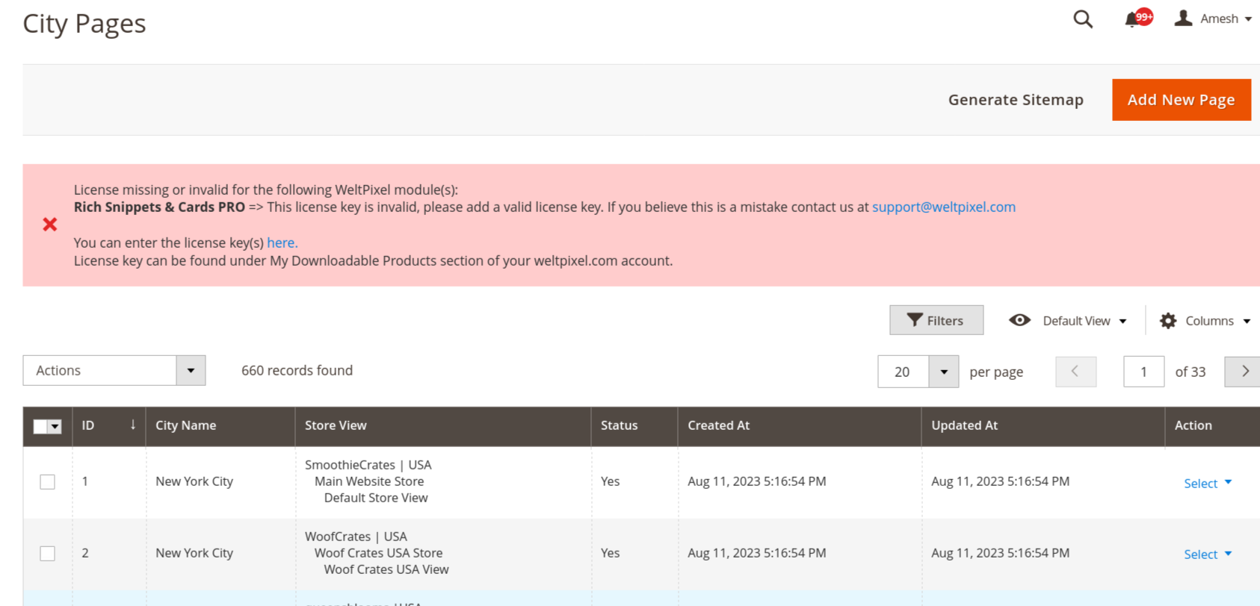
- Add new page button – add a new city page for store view.
- Generate sitemap – this is to generate sitemap for the city and city + category pages. File will be generated to pub/sitemaps/ folder.
Note : currently only one sitemap will be there for each website and that will be added in the google console. So either after generating this one time add the new sitemap for the city in google console OR we need to edit the main sitemap and make it as a index sitemap file.

Add / edit form

Add/edit form will be almost same as the city form. There will be a general section for global configuration and seo section for the seo data and page content data section.
Usage of these section is same as explained for the city. You can refere it there. Once a page is added, then the city and store cannot be edited.

3. City import

City import can be done from admin side by going to the menu “City import”. In the coming page select “cities import” from the dropdown. Select the configurations from the next forms and upload csv and click on check data button and then import. After import we need to generat pages for the imported cities.

After the cities are imported
- go to “City management” menu
- from the grid, select the newly imported pages
- from the mass action menu, click on generate page

Short codes for city page contents

You can use the below shortcodes for rendering dynamic data in frotnend for city and city + category pages. These can be used in all the content related fields.
Shorcode | Value
{category} | Display the category name if it s a city + category page.
{city} | Display the current city name in city and city + category page
{region} | Display the region name of the city
{country} | Display the country name of the city
{website} | Display the current website name

