Greg Jones 11/3/04
AI23 Coursework 2

1. Braitenberg vehilces in BEAST

(a) Run the Braitenberg demo. Describe the behaviour of the two vehicles. (Try positioning them at various places in the model world & describe how they "react".)

One vehicle follows the path of dots, and the other stays still. If the still one (vehicle 2a) is moved near the dots it turns away from them. If it's placed in the middle of the two lines of dots, so it has dots on either side, it will move forward through them as it turns away from the dots from both sides.

(b) How do the vehicles use sensory information to control the orientation and velocities? What file did you have to look at to find the answer?

The vehicles have two sensors, one showing the proximity of 'dots' to the right and one to the left, and also two motors controlling a left 'wheel' and a right 'wheel'. By activating one motor but not the other, turning left or right is achieved, and by activating both motors simultaneously the vehicle will move straight forward.

(c) What specific control laws govern the motor behaviour of each vehicle? What change could you make in the code to test your conclusion?

On Vehicle 2a the left proximity sensor excites the left 'wheel' and right proximity sensor excites the right wheel. This causes the vehicle to move away from dots, since if it detects a dot to the left, the left motor will be activated causing it to turn right.

The code below controls this behaviour.

This.Controls["left"] = This.Sensors["left"]->GetOutput();
This.Controls["right"] = This.Sensors["right"]->GetOutput();

On Vehicle 2b the connections are crossed so the left proximity sensor excites the right 'wheel' and right proximity sensor excites the left wheel. This causes the vehicle to move towards dots. The code below controls this behaviour.

This.Controls["left"] = This.Sensors["right"]->GetOutput();
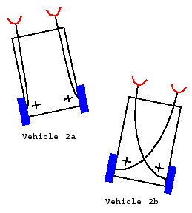
This.Controls["right"] = This.Sensors["left"]->GetOutput();

To test this conclusion I tried changing the code above so that they both had straight-through connections (left sensor to left motor). This made them both behave as vehicle 2a (turn away from dots).

I then changed them so they both had crossed connections (left sensor to right motor), and noticed they both behaved as vehicle 2b (turn towards dots).

(d) Can you ascribe any intelligence to the vehicles? Explain and argue your case.

In his book, Braitenberg describes the two vehicles as cowardly and aggressive, which is probably how you would describe the behaviour of an animal doing the same thing. But since we know that the mechanism behind these behaviours is so simple we are unsure about using those kind of words. Certainly they appear very lifelike, but they don't show any of the properties we associate with intelligence, like learning or creativity. Braitenberg describes more complicated vehicles with different types of sensor, and connections which decrease motor activity as well as increase it, and notes that very complex behaviour arises and it is not so obvious exactly what is going on. He claims that when observing animal behaviour we often assume the mechanisms behind it are far more complex than they actually are. I would ascribe a small degree of intelligence to them as you could imagine an organism using a similar mechanism to move around, but to be seriously considered as intelligent some kind of different internal states must be possible, allowing for behaviour to adapt to different circumstances.

2. Mouse demo in BEAST

(a) Run the mouse demo. Describe the evolution of the behaviour of the mice. (How do they behave initially, as evolution progresses, and after a long evolutionary time?) Provide supporting evidence.

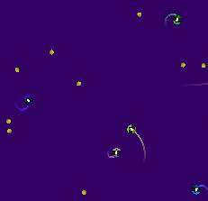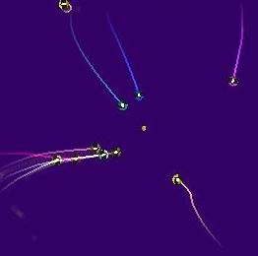
Mice at early stage of evolution Mice after 500 generations

To begin with the mice move slowly, and generally in circles. Occasionally, one or two of them randomly collide with cheese, but since they move so slowly and in circles staying in roughly the same position, even random collisions with cheese are rare in the short life of a generation. Gradually the mice get faster and move in straighter lines, and more cheese is eaten. Eventually they head straight for the cheeses as though the can 'see' them.

(b) What collective behaviour is observed, if any? Give supporting evidence. Explain why collective behaviour is possible/impossible in this demo.

No obvious collective behaviour was noticed. After very long evolutionary time some mice appear to move in clusters because they are all heading for the same cheese. However, strong collective behaviour is not possible with these mice as their only sensor gives them information about the location of cheeses, not about other mice. When another mouse eats nearby cheese, the disappearance of the cheese can be sensed, but not the other mouse itself. This causes many mice to all rush for the same piece of cheese, and of course only one of them gets it so adding a sensor to detect other mice would be an evolutionary advantage as it would prevent them from heading towards cheeses which other mice are already nearer to.

(c) Describe the fitness or performance of the mice over the generations. Do the mice progressively improve? Do they reach a stable evolutionary solution, and if so what is it? Furthermore, how do fitness values of the population and the individuals in it evolve over time? Explain and provide supporting evidence for your answers.

The fitness of the mice progressively improves for roughly the first 200 generations by and then stays more or less constant from there on, so they reach a stable evolutionary solution.

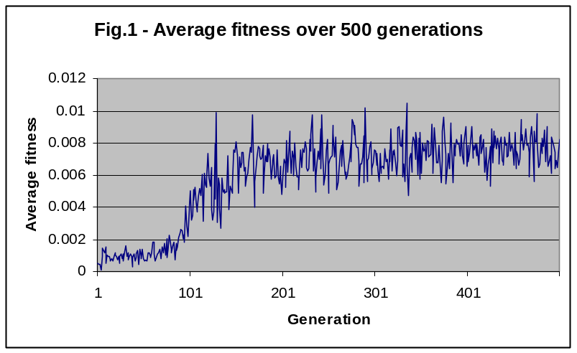
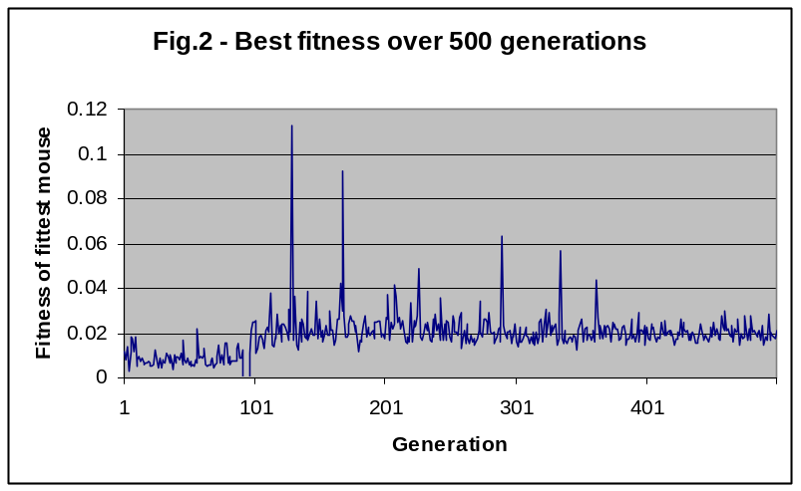
As the two graphs show, the average fitness values eventually reach around 0.007, and the fitness of the fittest mouse in the population reaches stays around 0.02. Although there are some cases of mice with very high fitness in comparison, presumably this is down to chance (just happening to collide with six cheeses one after another for example) as otherwise they would have survived longer and brought the whole population up to those high fitness values.

(d) What is the fitness function used in this GA? Find it in the code and justify it. Does this fitness function produce an "optimal" strategy for these mice? Explain.
Recommendation: In order to help you answer this question, try to think of other formulations of the fitness function, edit the code and try them out; compare your findings with the original and modified fitness functions. Can you explain the discrepancies you found (if any)?

Fitness function is number of cheeses eaten divided by distance travelled:

virtual float GetFitness()const
{
return This.cheesesFound > 0 ? static_cast<float>(This.cheesesFound) / This.DistanceTravelled.as<float>() : 0;
}

So the optimum mouse would find the shortest path to collect the most cheeses. This does not take speed into account, but since the animats have a fixed maximum speed (I assume) this isn’t too important.

I tried changing it to just the number of cheeses eaten (see mouse_v1.cc). This made the log window show exactly how many cheeses the best mouse had eaten, which occasionally reached four after a while. Once evolved by a few hundred generations (see Mice_justcheeses.pop), their behaviour became very different to the original mice. They moved in straight lines, suddenly spinning on the spot to change direction in a jerky, insect-like way, whereas the original mice moved in long smooth curves. This must be because the original mice had to collect the most cheeses in the shortest distance, and spinning on the spot to change direction would ‘use up’ valuable distance (since presumable distance is measured by the amount their wheels have moved rather than how far they have moved from their original position).

I considered changing the fitness function to be the number of cheeses found plus the number of cheeses found by the nearest five mice. In theory this should make small groups help each other, perhaps by not all rushing for the same cheese, but looking for another cheese if another mouse in the group is nearer to a cheese. This would be as if the mice were in fact a single organism, as they would be equally likely to help their neighbouring mice as themselves (this probably wouldn’t happen in practice since the mice aren’t even aware of each other). However, I could not find a way of implementing this in the code.

(e) What modifications would you incorporate in this code (in the neural network, sensors, fitness function or combination thereof) to improve the performance of these mice? Be as specific as possible in the suggestions you make and justify your answer.

I decided to change the neural network to a dynamical (recurrent) network instead of a feed forward one. This would have the potential for more complex, flexible behaviours to emerge, as well as being more biologically realistic. However, the feed forward network may have already found the optimal solution for the mice in this configuration, and so the dynamical net might not necessarily bring any improvement.

To make the mice potentially more complex I decided to add a proximity sensor as well as an angle sensor. Being able to sense the angle to the nearest cheese is not realistic in the physical world. The mouse has no idea how far away the nearest cheese is or how many cheeses are nearby. In situations where there are many nearby cheeses it may cause problems, as the mouse might have to turn back on itself to get the nearest cheese which might mean using more power than getting the slightly further away one which is straight ahead. To see what the difference was I tried changing the sensor to just a proximity sensor alone, with the original feed forward net configuration (I have not had much luck with the dynamical net). Their behaviour was very different. If no cheese is within their sensor they spin around as though trying to find cheese on a radar and gradually move along until some cheese comes within range of their sensor. Their average fitness gets to around 0.003 which is not nearly as good as the angle sensor mice.

I then restored the original angle sensor so they had both types of sensor, and made the feed forward network a little bigger to allow for processing of the extra input (Four hidden neurons instead of two – see mouse_v2.cc). Their behaviour was similar to the original mice, as though they were just using the more useful angle sensor, and their fitness values were very similar to the original mice.

I then tried using both the two types of sensor and a dynamical network.

(f) Implement your solution and test it.

When I changed to a dynamical network the fitness actually got worse, the mice did not improve with time at all (see mouse_v3.cc and figure 3 below).
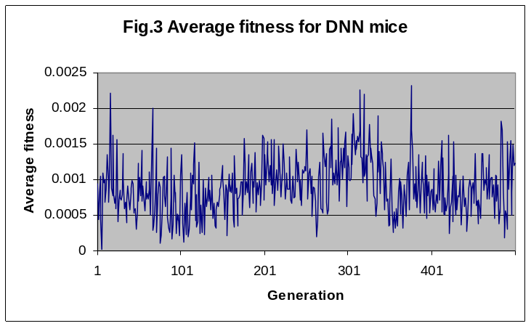
I first tried this with four neurons in total (two of which were output and one input), with multiple inputs per node set to true and multiple outputs per node set to false (the default). On finding this didn’t work I then tried having eight neurons in total instead of four and found no improvement. I also tried different value of the multiple inputs/outputs per node, but still found no improvement. This seemed strange as I would have expected the dynamical net to work at least as well as the feed forward one if not better. I assumed it was because of me not implementing it correctly in the code.

Strangely however, when I added the second sensor as well, fitness improved with time (see mouse.cc and Mice_dnn_both.pop). It took longer to reach a stable solution than with the feed forward network, so I set the number of generations to 2000, and made the network a bit bigger (6 neurons in total) to allow for potentially more complex behaviour. The average fitness reaches around 0.01, which is higher than the original mice. They appear to be mainly relying on their proximity sensor; slowing down or spinning when there’s no cheese within range. They also appear to turn tight corners rather than move in long curves. I am pleased with this result, but I still can’t explain why the simply adding the second sensor made quite so much difference.

