Greg Jones
AI23 Assignment 3
Bacterial colonies in BEAST

1. Fractal pattern formation in bacterial colonies
Use the bacterial colony simulation to generate fractal patterns. Recall, minimal fractal patterns can be generated when all chemotactic signalling or sensors are turned off and without bacterial motility. (a) Start by turning off all non-essential components and tune the remaining parameters to generate fractal-like patterns.
(Note: various "costs" such as reproductive cost, metabolic cost, etc. do NOT require tuning and may be regarded as fixed. Distributions need not be changed either.)

To generate fractal patterns, I set the nutrient, attractant and repellent responses to zero, and modified the death threshold, energy rate, reproduction threshold and reproduction cost until a pattern was formed. I also set the timesteps to 1500, to allow the bacteria more time to generate an interesting pattern (see bacteria.cc).

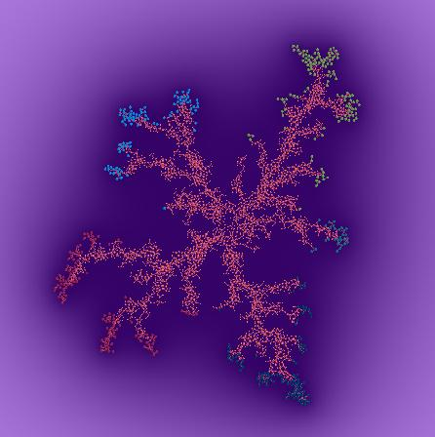
Figure 1 – After 5000 timesteps running BacteriaFractal
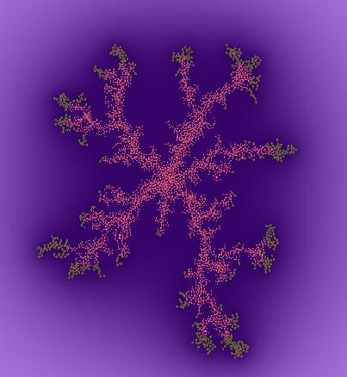
Figure 2 – after 5000 timesteps running BacteriaFractalSim

(b) Explain how the patterns are generated and why the parameters you found are suitable for this purpose.

With plenty of food, the bacteria will just grow in a large blob, gradually getting bigger, but in a hostile environment this is not possible. The patterns arise because the bacteria are starved, and so they need to spread themselves across the maximum area in order for each bacterium to have access to food. Since they’re not motile, they cannot just scatter themselves across the available space, they move by reproducing and gradually occupying more space. Bacteria completely surrounded by other bacteria will not have access to food and so will die, so the surviving bacteria are spread out in a connected pattern. I changed the parameters to make things hard for the bacteria – increasing the metabolic cost of reproduction and the energy rate. I also ensured motility was switched off (by setting the minimum and maximum speeds to zero and switching off chemotaxis as apparently this interferes with motility).

2. Evolving bacterial colonies

Discuss:
- Could you have evolved the parameters to "learn" to generate fractals?

Yes, what’s needed is an objective fitness function of what makes fractal pattern, and to make the parameters involved part of the genotype.

- If so what fitness function would you implement?

Under the right conditions, all that’s needed to form fractals is the most bacteria with access to food in the least space. Access to food just means each bacterium needs its own little bit of free space (which contains nutrients). Since bacteria without access to food die, this fitness function is already in place (the current fitness function is the number of alive bacteria at the end of the simulation run). However fractals only form when the conditions are sufficiently harsh, which is difficult to evolve using the current fitness function.

A more direct way of doing it would be to have the longest perimeter of the shape of bacteria for the least bacteria. Since the bacteria are not motile they always form a single connected shape. So the fitness function would be length of perimeter divided by number of bacteria. Scoring high on this function wouldn’t necessarily require self-similar fractals but since the bacteria do not move randomly, forming fractal shapes is likely to be the only way they will maximise their perimeter. Finding the length of the perimeter of the shape would be tricky to implement but it’s possible (area of screen occupied might be easier to implement than perimeter). Also for this to evolve, the parameters used to set up the harsh conditions in question 1 would need to be introduced into the genotype.

- Is your fitness function biologically realistic?

The original fitness function is realistic (the number of alive bacteria at the end), and since real bacteria do form fractal patterns under certain conditions it is sufficient. The problem is that when there is plenty of food they can just form a big circle and still all survive. The perimeter function is not very realistic although it could be argued that a longer perimeter (surface area) means more bacteria will have access to food and therefore more will survive.

- What selection method would you adopt? In your answer, specify whether selection should be performed at the individual or group level.

I would use rank selection (selecting the bacteria which rank highest compared to the rest of the population), as this allows the fittest bacteria to be selected without making the occasional bacterium with a very high fitness score dominate the others. Since the fractal patterns are formed as a result of collective behaviour, selection should be performed at the group level.

(e) Discuss the two existing options for assessments (BacteriaFractalSim). Which method would you choose and why?

The two options are to either assess the bacteria in separate runs (BacteriaFractalSim2) or simultaneously (BacteriaFractalSim). If assessed separately, the simulation is run 30 times for each generation and started with an individual bacterium. If assessed altogether, a single simulation per generation is run and started with all 30 bacteria. I would choose to asses them separately because the purpose is to create regular, self-similar fractals, possibly with some degree of symmetry. If different strains are assessed together, not only will the fractals not be self-similar (different strains producing different parts of the pattern), but they will get in the way of each other and be far less likely to produce neat, symmetrical fractals (although they still produce interesting patterns).

3. Bacterial motility and chemotaxis

(a) Would the incorporation of chemotactic mechanisms be beneficial to the bacteria without motility? Explain.

No. Bacteria without motility have no control over their position and so chemical signals such as attractants and repellents would have no use since the bacteria are unable to respond to them.

(b) If motility is introduced? What role might chemotaxis play at low, intermediate and high motility speeds (relative to the nutrient diffusion rate)?

Motile bacteria could benefit greatly from chemotaxis. Repellents could be used to keep other bacteria away from areas low nutrient content, and attractants could be used to attract other bacteria to areas with high nutrient content.

At very low motility speeds by the time the bacteria have responded to chemotactic signals by moving towards attractants or away from repellents, the nutrients may have diffused to other areas – i.e. the bacteria cannot ‘keep up’ with the nutrients and so chemotaxis brings little benefit.

At intermediate speeds the bacteria are able to respond faster making chemotaxis more beneficial, and at high speeds it will still be very useful, although at the bacteria tend to become very spread out and so the chemotactic signals make take a long time to reach other bacteria, by which time nutrients may have diffused (depending on the diffusion rate relative to the chemotaxis diffusion rate).

(c) How does the balance between nutrient response, attractant response and repulsive response affect the collective dynamics and self-organised pattern formation?

With zero nutrient response the bacteria all just move gradually upwards – they’re not trying to head towards areas of high nutrient content. The ones at the front reproduce a lot since they’re coming into contact with more nutrient all the time but the ones at the edges just sit there and if the nutrient diffusion rate is low they’ll starve.

With high nutrient response they’re all ‘chasing’ the nutrients – they spread out uniformly into a growing circle. Introducing repellents makes them even better at this, but attractants don’t appear to improve things. Adding a small attractant response makes little difference but increasing it produces the clumping behaviour described in the next question.

(d) Simulate the fractal-generating bacteria with added motility and nutrient-gradient response. Demonstrate and describe the effects of attractive chemotaxis, repulsive chemotaxis, and combined attraction-repulsion effects. Specify and justify your choice of parameter values. Provide code and results.

Figure 3 – Attrantant signalling only, after 500 timesteps

When only responding to attractants, they swirl in the middle in a clump. Presumably this is because although some bacteria are moving outwards towards the nutrients and releasing attractants, others further in are doing the same and so they turn back on them selves to head for the attractant and end up swirling round. This leads to them not reproducing nearly as much and so getting a very low fitness value.
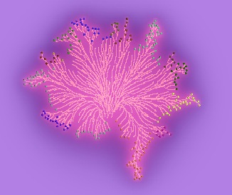
Figure 4 – Repellent signalling only, after 500 timesteps

When responding to only repellents (and nutrients) they do very well. Bacteria no longer get stranded in the middle and die.

When responding to both with equal weight, they do better than with no chemotactic response but not as good as with repellent only – i.e. the attractant response is dragging down the fitness. I considered that although a large attractant response made things worse, a small one (with respect to nutrient and repellent response) might be an improvement. However with attractant response values of 0.5 and 0.3 (relative to 1 for the other two responses) there was still no improvement on the average fitness score for repellent only (see below). To try to keep things equal to assess the qualities of attractants and repellents, I set attractant and repellent rates both to 0.5.

At 500 timesteps per assessment, nutrient response set to 1.0 and running BacteriaFractal:
 | Average Fitness | Best Fitness
Equal response to attractant and repellent | 6.6 | 30
Attractant response of 0.5, repellent of 1.0 | 7.8 | 31
Just attractant response | 1.2 | 6
Just repellent response | 8.4 | 30
Neither (nutrient response only) | 6.2 | 33

For both attractants and repellents, see bacteria_v1.cc, for attractants only see bacteria_v2.cc, and for repellents only see bacteria_v3.cc.

(e) Assume chemotactic signalling involves a metabolic cost. What fitness function would you choose to evolve chemotactic behaviour in motile bacterial colonies? Justify your answer.

Useful chemotactic signalling is when signals are only released when they result in more nutrient being consumed (and so more energy gained) than the metabolic cost of releasing them. By ‘more nutrient consumed’ I mean more nutrient consumed by the bacteria in general rather than by the individual bacterium releasing the signals. So I would choose a fitness function involving the total amount of energy gained (which reflects the total amount of nutrient consumed). However since fitness functions generally work better as a ratio of two variables rather than a single variable I would choose the total energy gained divided by the total number of bacteria.

It is probably best to assess strains separately as strains assessed together might not use chemotaxis as much to avoid helping the competing strains.

4. Evolutionary simulations

Use the parameters from your answer to Question 3d and fitness function from your answer to Question 3e to try and evolve a functional chemotactic response of the bacterial colonies. A solution must be accompanied by a specification of the simulation method (e.g., "BacteriaFractal"). Partial implementations and partial success will be rewarded. Provide code and results.

Since chemotactic signalling involves a metabolic cost, I decided to introduce attractant and repellent thresholds into the genotype as an optimum value for these needs to be found. On the one hand we don’t want the bacteria releasing signals at the drop of a hat (low threshold values) since they’re costly and there is no point in releasing them when there’s not a particularly low/high amount of food. On the other hand if the thresholds are too high, signals will only be released under ‘extreme’ conditions and the bacteria might not release them at times when it would be beneficial. I also introduced the attractant, repellent and nutrient responses into the genotype, and set the parameters to start with random values to allow for a diverse range of behaviours.

I had originally wanted to assess strains separately (BacteriaFractalSim) but using this method with random values meant the first bacterium often died and there was nothing to evolve, so I chose to assess strains together (BacteriaFractal) which also had the advantage of taking much less time to run.

When trying a few different variations of my fitness function I realised it is very difficult to tell how ‘functional’ the chemotactic response is when the fitness function is being changed. I watched the bacteria after 500 generations and also recorded what the relevant parameters had evolved to using different fitness functions:

 | Original (NumAlive) | totalEnergy / numTotal | numTotal / totalEnergy
Nutrient response | 1.9 | 3.8 | 3.3
Attractant response | 0.5 | 0 | 1.3
Repellent response | 4.6 | 6.6 | 1.3
Attractant threshold | 1.9 | -1.6 | 0.8
Repellent threshold | -0.5 | 0.5 | -0.6

Interestingly, with my chosen fitness function (totalEnergy / numTotal), the attractant response evolved to zero. It seems attractants are not very useful since they cause the clumping behaviour described in question 3d. The attractant threshold evolved to a negative value because attractants were not generating a response and so there is no point in releasing them since they cost energy. The repellent response evolved to a high value, because repellents are very useful. See bacteria_v4.cc. The population file bacteria_v4.pop is the bacteria after evolving 500 generations with my fitness function (using bacteria_v4.cc).

I also tried totalEnergy / numAlive but the problem with this is if there are no alive bacteria you divide by zero.

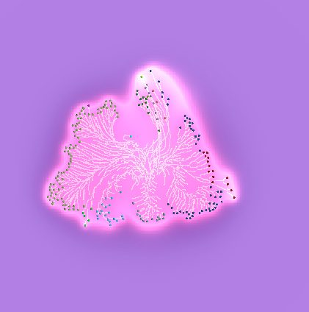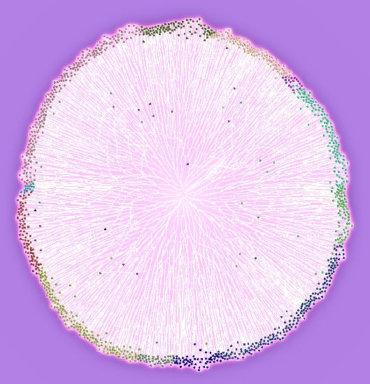
Fig 5 and 6: Using totalEnergy / numTotal as fitness function after 500 timesteps at generation one and 500 respectively. In generation one, the bacterium at the top is releasing a repellent despite being in an area of high nutrient content.
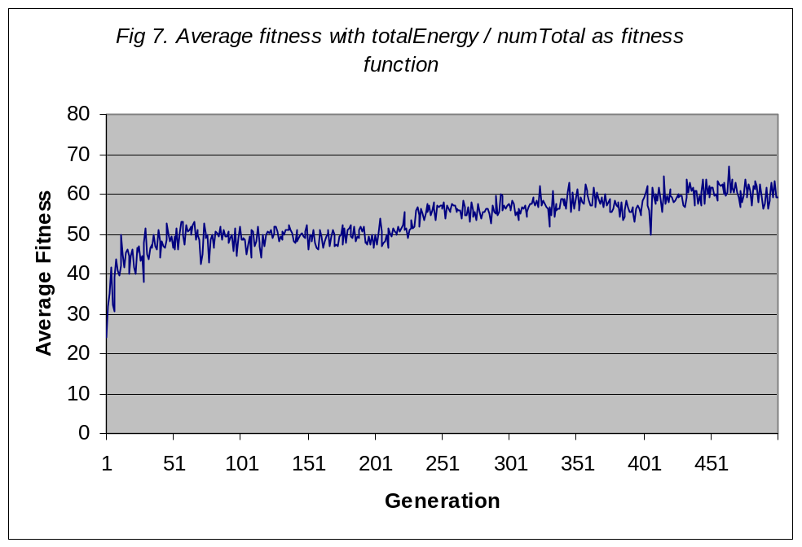
Although there only a gradual gain in fitness when evolving the bacteria with my fitness function, figures 5 and 6 show there is a noticeable difference in their chemotactic behaviour before and after evolving.

