**Guess the number**

Yes… Again ☺

Only this time:

1. You’ll add some HTML for the UI.
2. You’ll use a DB to save the results of the game.

As always, you’re free to design the page as you like.

Here’s an example of the page:

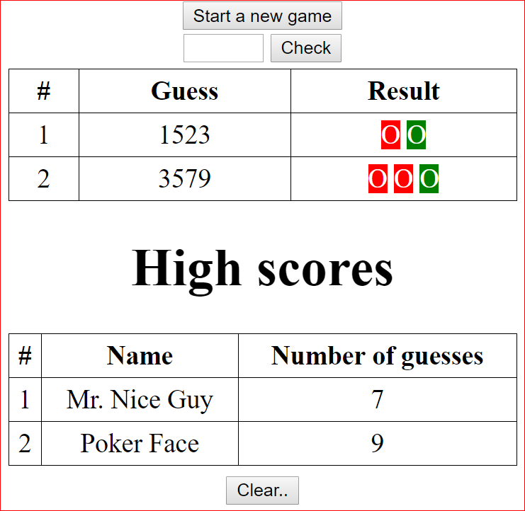

Implementation requirements:

1. At the beginning, only the “start a new game” button will be displayed.
2. There are exactly 4 digits to guess
   1. All are different
   2. ‘0’ can also be the first digit in the secret number
3. Once the user starts a new game, only the attempts grid will be displayed (don’t show the high scores grid).
4. The user will have up to 20 attempts only. If he fails to guess the number, he will lose and the high scores table will be displayed and the “check” button is disabled
5. If the user guesses the number, he will win and if the score should be added to the high scores table, the user will be prompted for his name. The high scores table will be displayed after that.
6. The number must NOT exist in the client side. Meaning, the user won’t be able to figure out the secret number by viewing the source code of the page
   1. This may require a unique ID of the game that will be acquired from the server when pressing the “start new game” button
   2. This ID will be in the server memory and it will be passed for each check
7. The “result” column for each guess is presented in such a way that the user can easily know which of the digits exist but are not in the right place and which are also in the right place.
8. When the user guesses the right answer, the program should check if this is a new high-score (only top 10 scores are saved).
9. Clearing the high scored will require an admin password (open a dialog / show another input text). For now, you can hard-code the admin password (on the server side)