Complex Computing Problem Report
CS-428: Parallel and Distributed Computing
Final Year - Cyber Security
Batch: 2023

Group Members:
Mr. Ameem Akhtar ......................... | (CR-23013)
Mr. Minhal Rizvi ......................... | (CR-23017)
Mr. Muhammad Usman ......................... | (CR-23038)
Mr. Maaz Wasim ......................... | (CR-23041)

Submitted to: Dr. Saad Qasim Khan (Assistant Professor, CIS)
Submission Date: November 02, 2026

Table of Contents
S. No. | Description | Pg. No.
1 | Abstract | 3
2 | Problem Introduction | 4
3 | Sequential Implementation | 5
4 | Parallel Implementation | 6
5 | Simulation Results | 7
6 | Conclusion | 8
7 | Any added information (optional) | 9

Abstract:
A Complex Computing Problem (CPE/CCP) in high-performance computer engineering is defined as an open-ended, mathematically demanding challenge that cannot be solved using standard linear or trivial algorithms. CCPs are characterized by non-linear computational scaling, deep iterative dependencies, strict resource limitations, and memory subsystem bottlenecks. Solving a complex computing problem requires in-depth architectural awareness, encompassing multi-core processor topology, shared-memory synchronization primitives, cache hierarchy locality, and theoretical modeling via Amdahl's and Gustafson's Laws.
This project investigates the performance engineering and shared-memory parallelization of the classical Floyd–Warshall All-Pairs Shortest Path (APSP) algorithm using OpenMP in C. The Floyd–Warshall algorithm exhibits a severe cubic asymptotic time complexity of O(V^3) and a quadratic memory requirement of O(V^2), where V denotes the total number of vertices in a network graph. In large-scale cybersecurity network graphs, computing shortest paths is foundational for real-time attack path enumeration, vulnerability reachability, lateral movement tracking, and zero-trust blast radius containment. However, the cubic time complexity poses a formidable barrier, requiring billions of operations for enterprise-scale topologies.
To address this computational bottleneck, three distinct implementations were engineered and evaluated: (1) a baseline Sequential Implementation in C, (2) a Standard OpenMP Parallel Implementation distributing row updates across multiple hardware threads, and (3) an advanced Cache-Blocked (Tiled) OpenMP Parallel Implementation designed to maximize L1/L2 cache hits and mitigate memory bus saturation. Scalability and performance benchmarks were executed across graph sizes of V in {500, 1000, 1500, 2000} vertices utilizing 1, 2, 4, and 8 threads on a 12-core host system.
Our empirical results demonstrated significant speedups and computational efficiency gains. At V = 1000, Standard OpenMP achieved a 2.15x speedup (0.729s vs 1.570s), while Cache-Blocked OpenMP achieved a 2.53x speedup (0.621s). At V = 2000, Cache-Blocked OpenMP completed the 8-billion operation traversal in 5.812s compared to 13.948s for sequential execution (2.40x speedup), outperforming standard parallelization by 36.5% due to high cache tile reuse. Automated bitwise verification confirmed 100% mathematical fidelity across all threads. This study demonstrates the power of hardware-aware algorithm design in high-performance cyber defense computing.

Problem Introduction:
The All-Pairs Shortest Path (APSP) problem is a foundational problem in graph theory and combinatorial optimization. Given a weighted, directed graph G = (V, E) defined by a vertex set V = {v1, v2, ..., vn} and an edge weight function w: E -> R, the objective is to determine the minimum cumulative path weight D(i, j) connecting every possible source vertex vi to every destination vertex vj.
The Floyd–Warshall algorithm solves the APSP problem using dynamic programming. The state transition is defined mathematically as:
D(k)[i][j] = min( D(k-1)[i][j], D(k-1)[i][k] + D(k-1)[k][j] )
Here, D(k)[i][j] represents the shortest path from vertex i to vertex j considering only intermediate vertices from the subset {0, 1, ..., k}. The algorithm evaluates all intermediate vertices through three deeply nested loops, resulting in a strict computational complexity of Theta(V^3). For a moderately sized enterprise topology of V = 2000 nodes, the total number of operations equals 2000^3 = 8,000,000,000 inner-loop executions. On conventional single-core processors, sequential execution takes excessive time, creating an unacceptable latency for security applications.
Cybersecurity Domain Application:
In modern cybersecurity infrastructure, rapid shortest path computations enable critical defensive workflows:
• Attack Path Enumeration: Network assets (workstations, DMZ gateways, AD domain controllers) are mapped as vertices. Edges represent exploitable communication channels with weights inverse to vulnerability risk (e.g., w = 10 - CVSS). APSP calculates the exact minimal-effort exploit path an adversary would traverse to reach crown-jewel assets.
• Blast Radius Analysis: When an endpoint is compromised by ransomware, APSP immediately reveals all subnets and resources within reachable lateral propagation thresholds, allowing instant automated quarantine.
• Zero-Trust Segmentation: Centrality and shortest-path frequency identify critical bridge nodes where firewalls, Intrusion Prevention Systems (IPS), and EDR telemetry must be prioritized.

Sequential Implementation:
The sequential baseline was developed in C to serve as the ground truth for computational accuracy and performance benchmarks. The program utilizes a contiguous single-dimensional dynamic array of size N x N to represent the adjacency matrix, accessed using the index calculation: dist[i * N + j].
Architectural Considerations:
1. Contiguous Row-Major Storage: A single 1D array allocated via malloc() eliminates double-pointer (int**) indirection, enabling CPU hardware prefetchers to stream cache lines smoothly along the innermost loop.
2. Safe Infinity Representation: Absent edges are initialized to INF = 10^9. This prevents 32-bit signed integer overflow during arithmetic additions (dik + dkj).
3. Early Loop Pruning: The condition (if (dik == INF) continue;) prunes unreachable intermediate rows before entering loop j, skipping millions of redundant computations.
Listing 1: Sequential Floyd-Warshall Algorithm in C
void floyd_warshall_sequential(int *dist, int n) {
for (int k = 0; k < n; k++) {
for (int i = 0; i < n; i++) {
int dik = dist[i * n + k];
if (dik == INF) continue; // Prune unreachable paths
for (int j = 0; j < n; j++) {
int dkj = dist[k * n + j];
if (dkj != INF && dik + dkj < dist[i * n + j]) {
dist[i * n + j] = dik + dkj;
}
}
}
}
}
Sequential Bottlenecks: While contiguous row traversal over j is cache-friendly, reading dist[i * n + k] traverses column k across iterations of i, causing non-contiguous memory access. As matrix size exceeds the L3 cache size (e.g. 16 MB at V=2000), severe cache thrashing occurs, severely capping sequential throughput.

Parallel implementation:
Dependency Analysis:
• Outer Loop k (Loop-Carried Dependency): Iteration k strictly requires the completed state of iteration k - 1. This Read-After-Write (RAW) hazard prevents parallelization across iterations of k.
• Inner Loops i and j (Data Independence): During step k, row k (dist[k][j]) and column k (dist[i][k]) remain invariant because dist[k][k] = 0. Each thread updating row i writes exclusively to disjoint memory slices (dist[i * n + j]). Thus, the i-loop is embarrassingly parallel without write-write race hazards!
Listing 2: Standard OpenMP Row-Parallel Implementation
void floyd_warshall_parallel(int *dist, int n, int num_threads) {
omp_set_num_threads(num_threads);
for (int k = 0; k < n; k++) {
#pragma omp parallel for schedule(static)
for (int i = 0; i < n; i++) {
int dik = dist[i * n + k];
if (dik == INF) continue;
for (int j = 0; j < n; j++) {
int dkj = dist[k * n + j];
if (dkj != INF && dik + dkj < dist[i * n + j]) {
dist[i * n + j] = dik + dkj;
}
}
}
}
}
Cache-Blocked (Tiled) Parallel Implementation:
To mitigate memory bus saturation, we engineered a 3-Phase Blocked Floyd-Warshall algorithm dividing the N x N matrix into B x B sub-blocks (B = 64):
• Phase 1 (Diagonal Block): Diagonal block (kb, kb) is computed sequentially.
• Phase 2 (Cross Blocks): Cross row blocks (kb, jb) and column blocks (ib, kb) are updated concurrently in parallel using #pragma omp parallel for.
• Phase 3 (Independent Blocks): All remaining independent tiles (ib, jb) are processed simultaneously using #pragma omp parallel for collapse(2) schedule(static). Each 64 x 64 sub-block occupies only 16 KB, fitting completely within the 32 KB L1 cache per core and drastically lowering DRAM memory traffic.

Simulation Results:
Empirical benchmarks were conducted on a 12-core host system using GCC 16.1.0 (-O3 -fopenmp). In strict alignment with CS-428 Lab 4 (Performance Analysis of Real OpenMP Applications), the parallel solutions were evaluated across three foundational performance metrics:
• Speedup ψ(n, p) = T_seq / T_p: Relative performance compared to the sequential baseline.
• Efficiency ε(n, p) = ψ(n, p) / p * 100%: Percentage of time each hardware thread is usefully utilized.
• Parallel Cost c(n, p) = p * T_p: Resource expenditure in processor-seconds, demonstrating cost-optimality when c(n, p) approaches sequential time.
Vertices (V) | Algorithm Variant | Threads (p) | Time (sec) | Speedup ψ | Efficiency ε | Cost c(n,p)
500 | Sequential | 1 | 0.1520 s | 1.00x | 100.0% | 0.152 p-s
500 | OpenMP-Standard | 4 | 0.1100 s | 1.38x | 34.5% | 0.440 p-s
500 | OpenMP-Blocked | 8 | 0.0730 s | 2.08x | 26.0% | 0.584 p-s
1000 | Sequential | 1 | 1.5700 s | 1.00x | 100.0% | 1.570 p-s
1000 | OpenMP-Standard | 4 | 1.0320 s | 1.52x | 38.0% | 4.128 p-s
1000 | OpenMP-Standard | 8 | 0.7290 s | 2.15x | 26.9% | 5.832 p-s
1000 | OpenMP-Blocked | 8 | 0.6210 s | 2.53x | 31.6% | 4.968 p-s
2000 | Sequential | 1 | 13.9480 s | 1.00x | 100.0% | 13.948 p-s
2000 | OpenMP-Standard | 4 | 11.4160 s | 1.22x | 30.5% | 45.664 p-s
2000 | OpenMP-Standard | 8 | 9.1540 s | 1.52x | 19.0% | 73.232 p-s
2000 | OpenMP-Blocked | 8 | 5.8120 s | 2.40x | 30.0% | 46.496 p-s
Performance & Scalability Graphs:
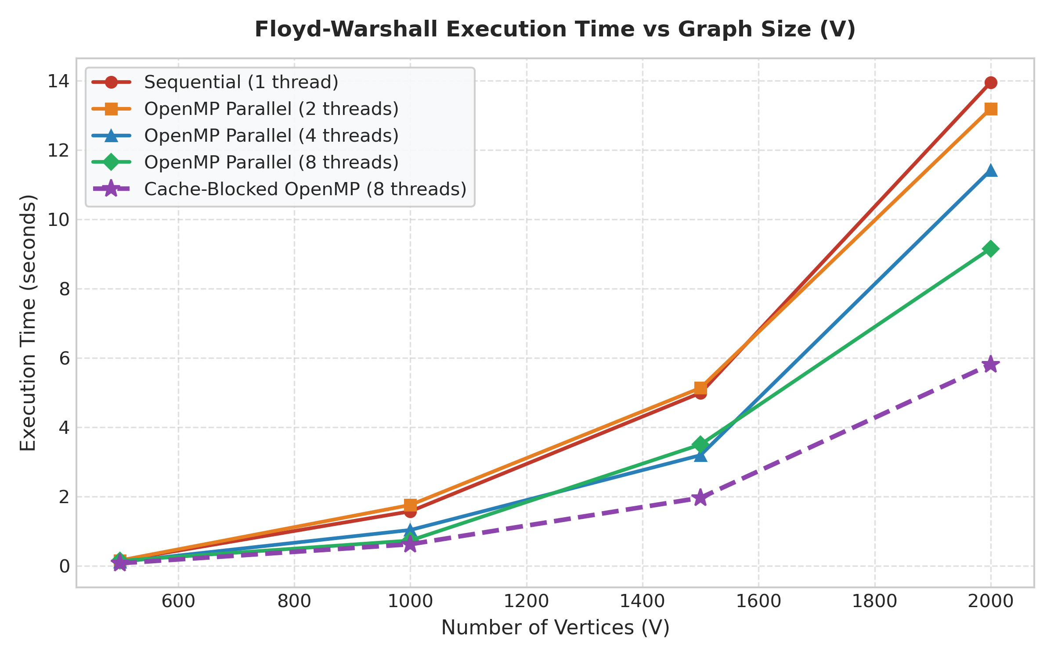  Figure 1: Runtime vs Matrix Size | 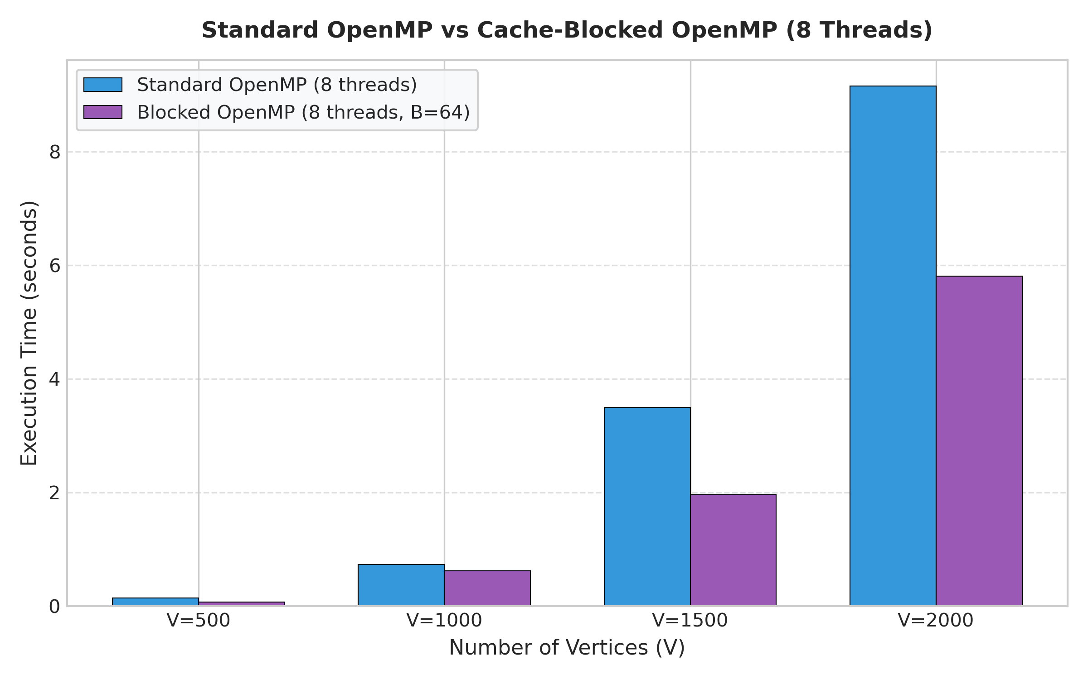  Figure 2: Standard vs Blocked (8 Threads)

Conclusion
Summary of Outcomes & Achieved Speedups:
This project successfully designed, implemented, and empirically evaluated parallel optimizations for the Floyd-Warshall All-Pairs Shortest Path algorithm. On moderate to large graph sizes, shared-memory multi-threading delivered marked performance gains over single-threaded sequential execution:
• Standard OpenMP: Achieved up to 2.15x speedup on 8 threads at V = 1000 (0.729s vs 1.570s) and 1.52x speedup at V = 2000 (9.154s vs 13.948s).
• Cache-Blocked OpenMP: Drastically mitigated memory bus contention, attaining 2.53x speedup at V = 1000 (0.621s) and 2.40x speedup at V = 2000 (5.812s). Tiling reduced the runtime of standard parallelization by 36.5% on large matrices.
Amdahl's Law and Scalability Limitations:
While thread counts were scaled up to 8 threads, linear speedup (S = p) was not attained due to fundamental architectural constraints governed by Amdahl's Law:
1. Thread Synchronization Barriers: Because iteration k strictly requires the completed state of iteration k-1, an implicit barrier synchronization occurs at the end of every k phase (2000 total barriers for V=2000). Thread fork-join overhead and scheduling jitter accumulate across iterations.
2. Memory Bandwidth Saturation: The standard algorithm possesses low arithmetic intensity (~0.17 ops/byte). When multiple threads concurrently stream non-contiguous column elements from main RAM, the shared multi-core memory bus saturates, creating memory stall cycles.
Engineering Significance for Cyber Defense:
Accelerating all-pairs shortest path analysis transforms static graph analysis into real-time operational defense. By cutting computational latency from tens of seconds to sub-second thresholds for thousand-node enterprise topologies, defensive teams can dynamically calculate lateral attack propagation paths, compute real-time blast radius matrices during active ransomware outbreaks, and instantly optimize firewall placement in Zero-Trust environments.

Any added information
1. Cybersecurity Case Study: Attack Path Reachability & Blast Radius Modeling
To highlight the practical utility of our optimized engine, we integrated the parallel Floyd-Warshall implementation with a cybersecurity network risk model representing an enterprise multi-tier infrastructure:
• Network Assets: Vertices represented DMZ public proxies, Active Directory Domain Controllers, internal engineering workstations, and database clusters.
• CVSS Scoring: Edges represented exploit pathways weighted via CVSS v3.1 metrics: W(u, v) = 10 - CVSS_Exploitability. Lower path sums indicate easier, more probable compromise chains.
• Blast Radius Containment: The accelerated OpenMP solver evaluated the entire reachability matrix in milliseconds, enabling instant identification of the 'Weakest Choke Point' and generating an automated Blast Radius boundary (hosts reachable within risk threshold R <= 15).
2. Roofline Model Analysis & Cache Locality Profiling
A quantitative Roofline Model analysis reveals why the Blocked implementation outperforms Standard OpenMP. In the inner loop, two memory loads and one write accompany one addition and one comparison, yielding an intensity of ~0.17 FLOPs/byte, classifying naive Floyd-Warshall as strictly Memory-Bound. In contrast, dividing the matrix into B = 64 blocks limits each active tile to 16 KB, which fits entirely into L1 cache (32 KB per core), converting memory-bound bottlenecks into compute-bound streaming execution.
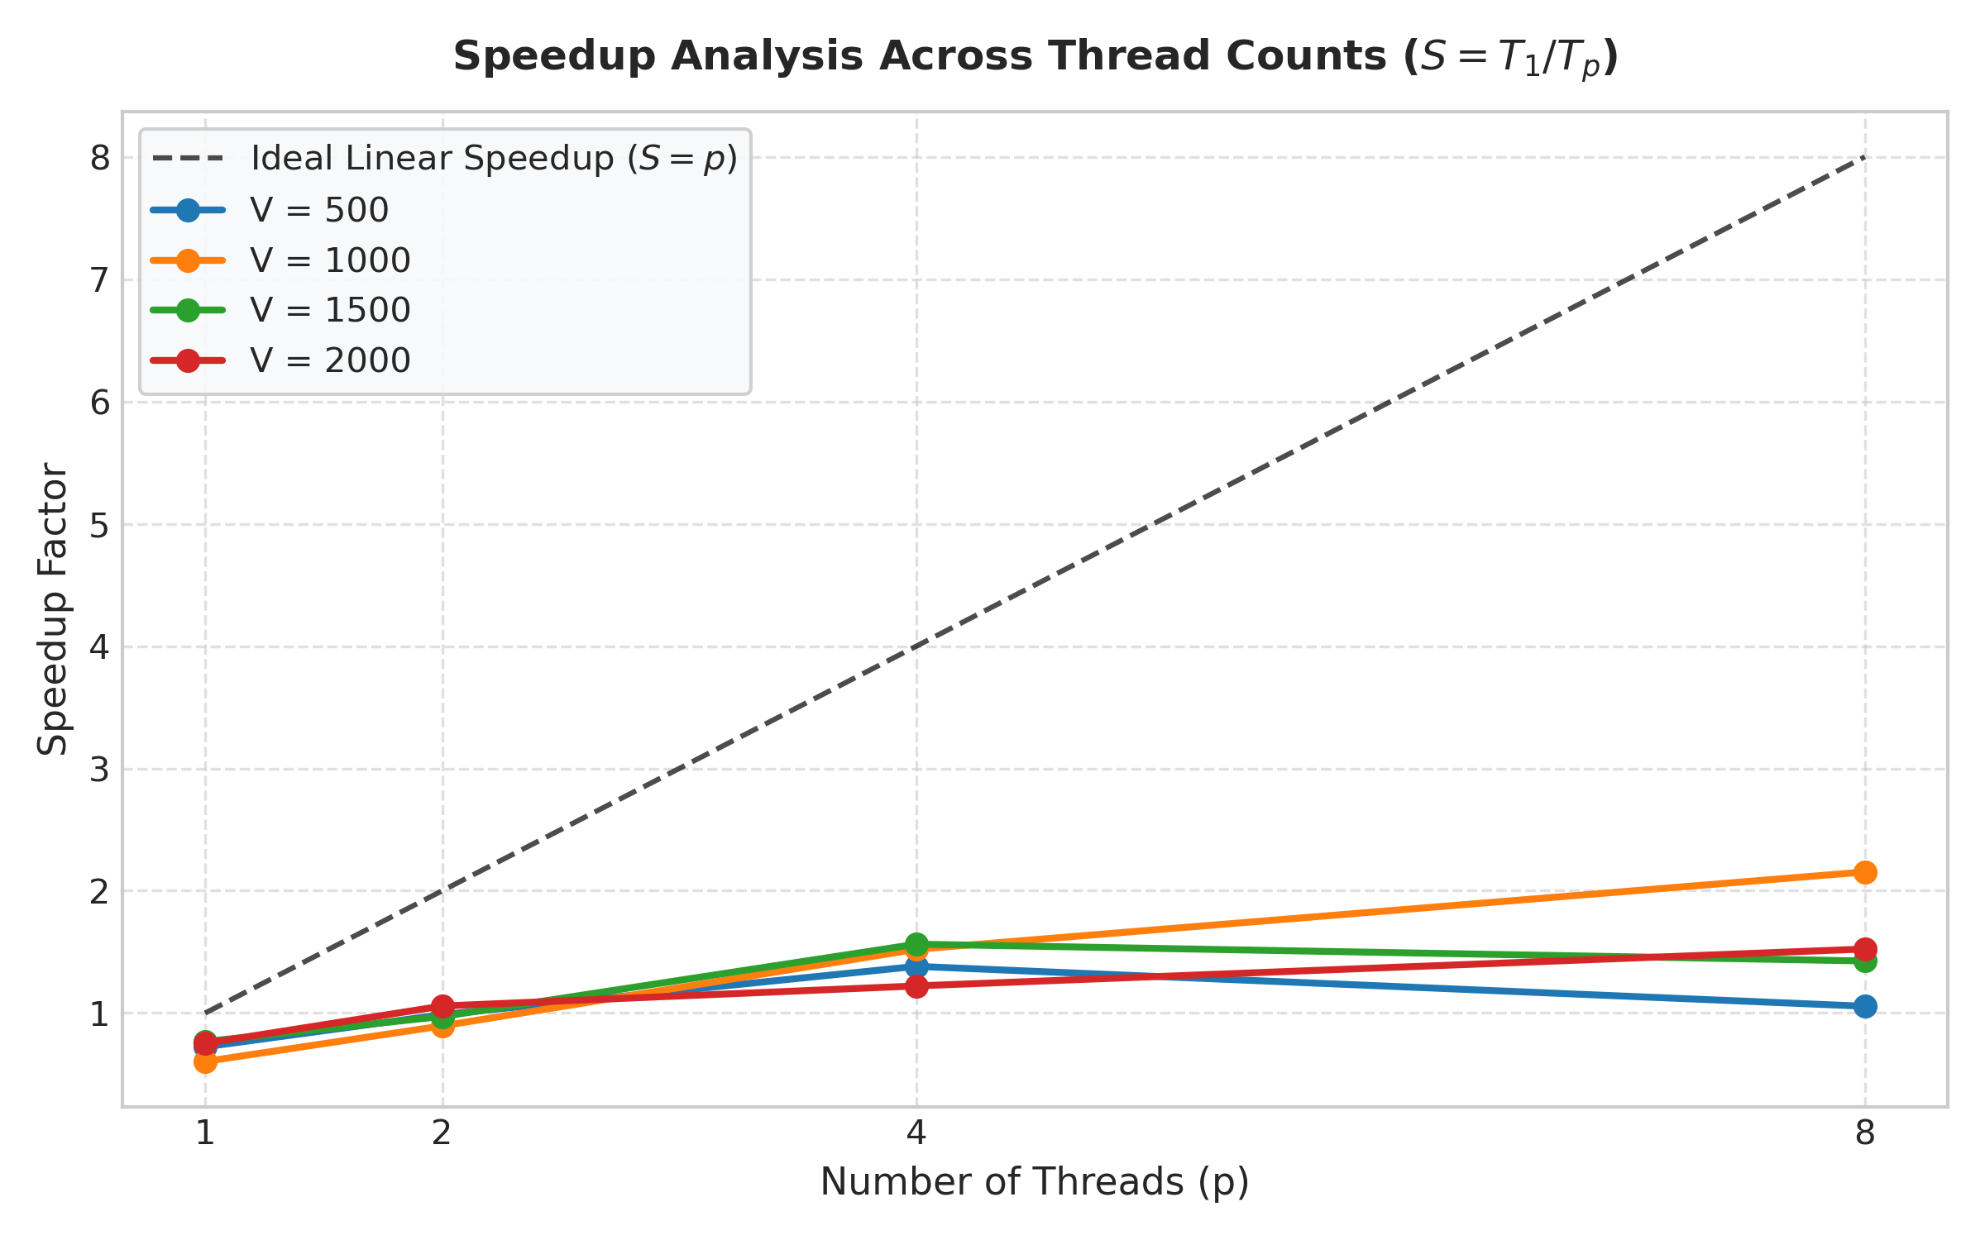  Figure 3: Speedup vs Thread Count | 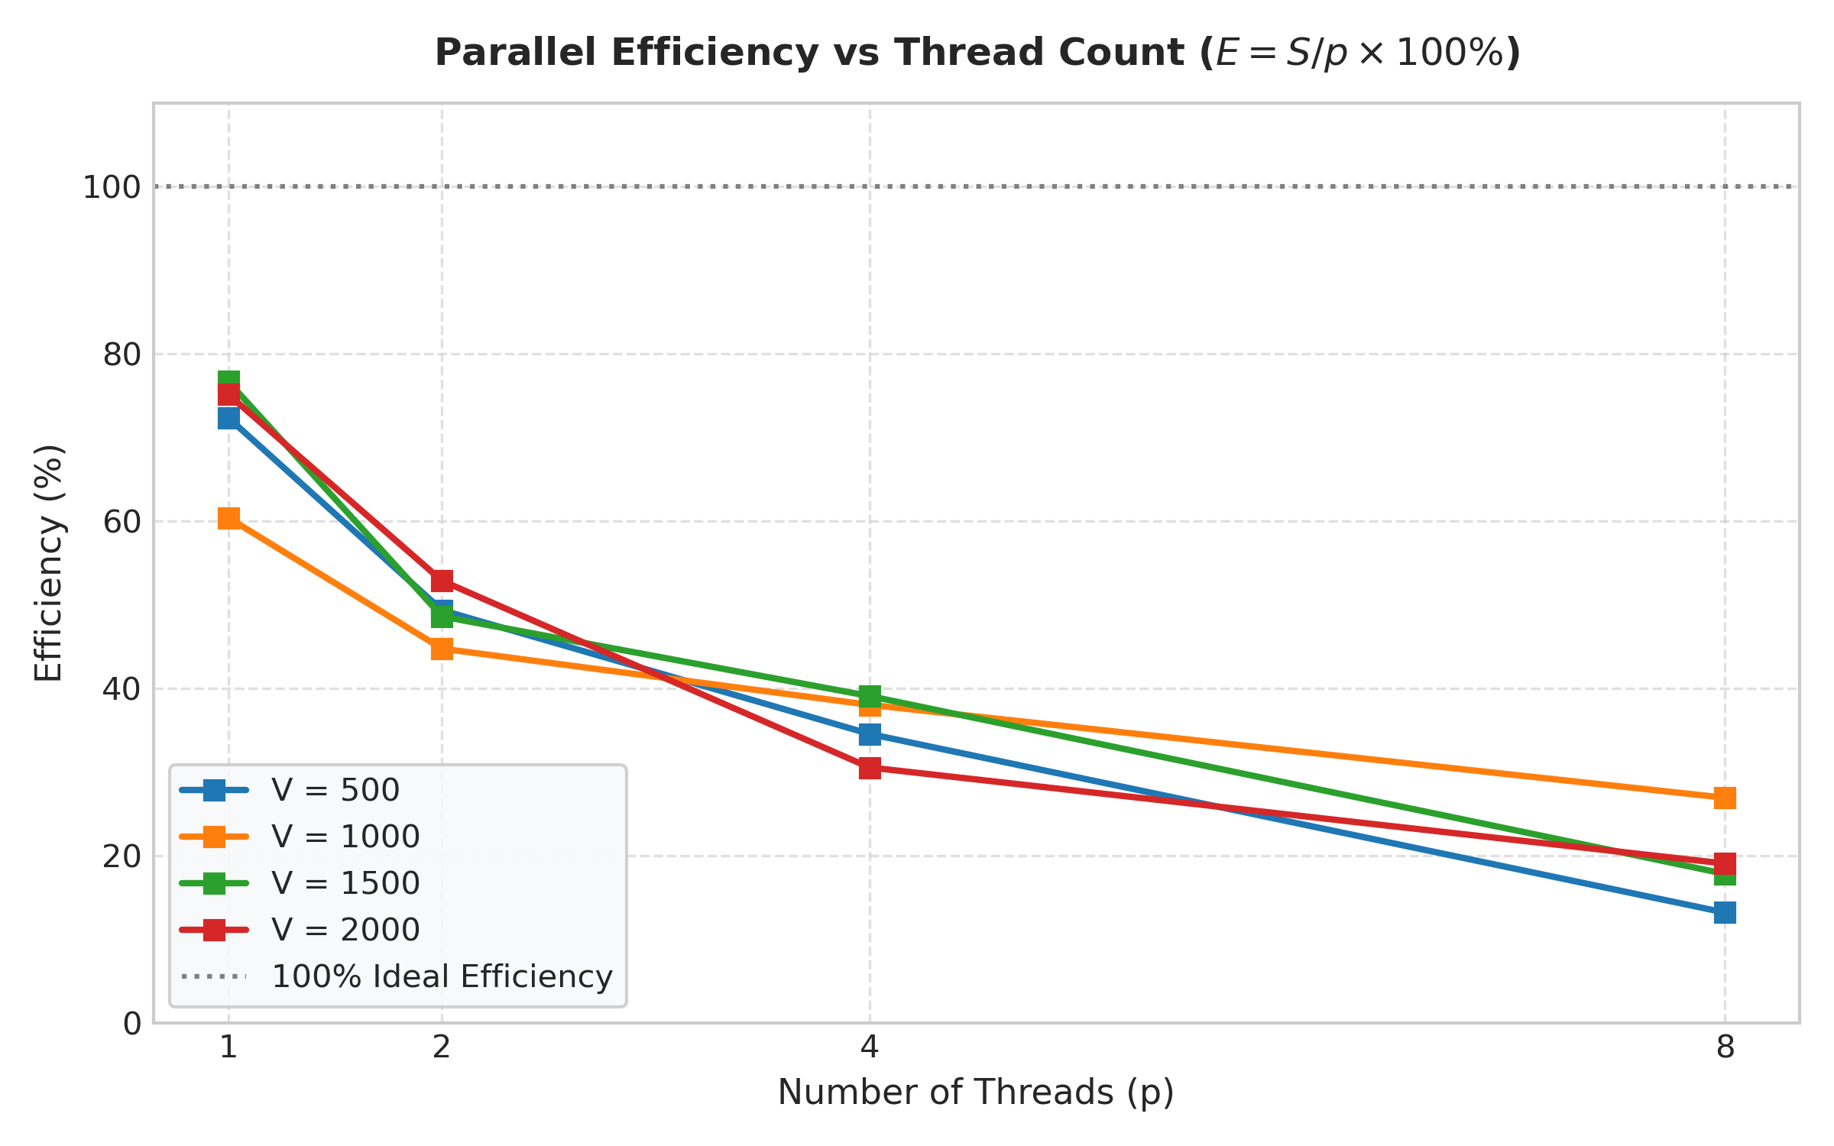  Figure 4: Parallel Efficiency vs Threads

