Exercise No. 2

Target: Create Spring Core Container and IoC with Annotation metadata Format.

* Every Spring /SpringBoot project will include by default the Spring Core module.
* Spring Core module is building the Spring Core Container - the place where the Beans of the Application classes will live and interact.
* the Spring Core Container will create, initialize and Manage the Beans based on metadata which developers should provide.
* The Control of Create the Beans in the Spring Core Container is moved from the Classes themselves to the Spring Core Container by the IoC -Inversion of Control

1. Open template for exercise 2 by using the following link: <https://gitlab.corp.amdocs.com/DAWODK/springbootframework/tree/master/Templates/Exercise2>
2. Find the Classes **Employee** and **Address** under ***ioc.annot*** package .

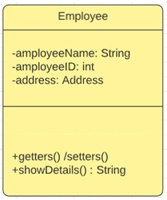 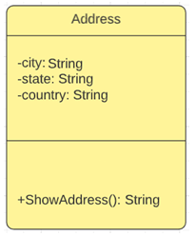

* 1. Address Class:
* Declare on the Class Address as a Component Use @Component
* Initiate the primitives and String Class data members with the @Value

@Value ("New Alabaz")

**private** String city;

* 1. Employee Class:
* Declare on the Class Employee as a Component Use @Component
* Initiate the primitives and String Class data members with the @Value

@Value ("1111")

**private** **int** id;

* Inject the dependency between the Employee Class and the Address Class by the Annotation @Autowired

1. Runner Class
   1. Open SpringMain Class
   2. Define the main Class as the configuration class by the annotation @Configuration
   3. Define the scanned packages “the packages which will include the Classes with the stereotype annotation with the annotation @ComponentScan
   4. Inside the main, create Spring Core Container context by Using the *AnnotationConfigApplicationContext* option with the annotation metadata.
   5. Create an employee bean by invoke the getBean() service of the context.
   6. Invoke the showDetails service from employee Bean.
   7. Close the Opened Context.

Please review below link for full solution:

[https://gitlab.corp.amdocs.com/DAWODK/springbootframework/tree/master/FullSolutions/Exercise2](https://gitlab.corp.amdocs.com/DAWODK/springbootframework/tree/master/FullSolutions/Exercise21)

Thank you.