Exercise No. 3

Target: Create Spring Core Container and IoC with Annotation metadata Format.

* Every Spring /SpringBoot project will include by default the Spring Core module.
* Spring Core module is building the Spring Core Container - the place where the Beans of the Application classes will live and interact.
* the Spring Core Container will create, initialize and Manage the Beans based on metadata which developers should provide.
* The Control of Create the Beans in the Spring Core Container is moved from the Classes themselves to the Spring Core Container by the IoC -Inversion of Control

1. Open template for exercise 3 by using the following link: <https://gitlab.corp.amdocs.com/DAWODK/springbootframework/tree/master/Templates/Exercise3>
2. Create new Class **Employee** and **Address** under “***ioc. clas***”.

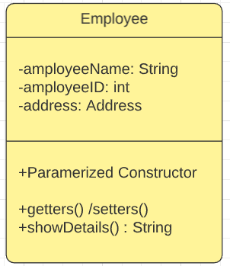 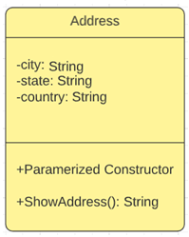

* 1. Address Class:
* Create Parametrized Constructor
* ShowAddress will print the Address details, it should invoke from the ShowDetails.
  1. Employee Class:
* Create Parametrized Constructor
* ShowDetails supposed to print the Employee Details include the Address

1. Open a Configuration Class **MetaData** , which will include the required metadata for the Spring Core Container to Create /initiate and manage the beans inside it .
   1. Declare it as the Configuration class by the annotation @Configuration
   2. Create 2 methods for the 2 Classes 1 for Employee and the other for the Adders

@Bean

**public** ReferenceType getRefernce()

{

**return** **new** ReferenceType ("”,…..);

}

1. Runner Class
   1. Create SpringMain Class
   2. Create main method inside the SpringMain class.
   3. Inside the main, create Spring Core Container context by Using the *AnnotationConfigApplicationContext* option with the MetaData.class metadata.
   4. Create an employee bean by invoke the getBean () service of the context.
   5. Invoke the showDetails service from employee Bean.
   6. Close the Opened Context.

Please review below link for full solution:

<https://gitlab.corp.amdocs.com/DAWODK/springbootframework/tree/master/FullSolutions/Exercise3>

Thank you.