Exercise No. 1

Target: Create Spring Core Container and IoC with XML metadata Format.

* Every Spring /SpringBoot project will include by default the Spring Core module.
* Spring Core module is building the Spring Core Container - the place where the Beans of the Application classes will live and interact.
* the Spring Core Container will create, initialize and Manage the Beans based on metadata which developers should provide.
* The Control of Create the Beans in the Spring Core Container is moved from the Classes themselves to the Spring Core Container by the IoC -Inversion of Control

1. Open the IDE and Create New workspace.
2. Create new Maven Project.

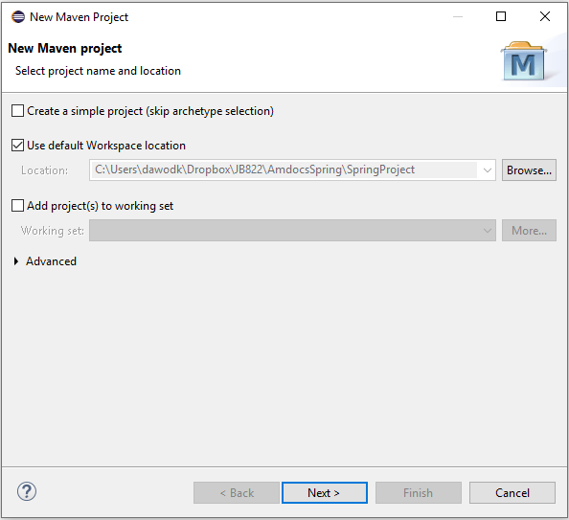

* Choose the Option of Create a simple Project.
* Click on next.

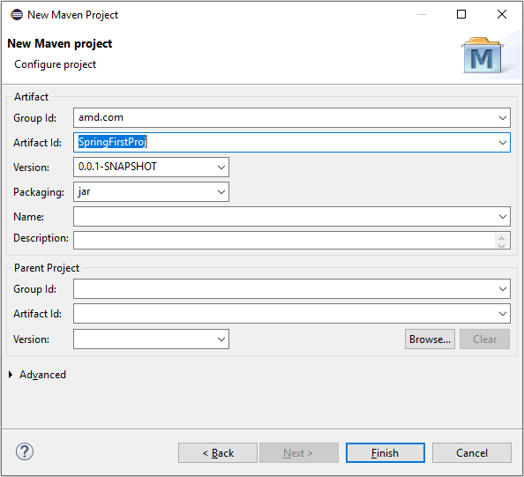

* Fill the GroupId (main package) and the ArtifactId (project name)
* Click on Finish.

1. Add 3 dependences to the pom.xml in <dependencies> parent tag.

<dependencies>

<dependency>

<groupId>org.springframework</groupId>

<artifactId>spring-core</artifactId>

<version>4.3.9.RELEASE</version>

</dependency>

<dependency>

<groupId>org.springframework</groupId>

<artifactId>spring-beans</artifactId>

<version>4.3.9.RELEASE</version>

</dependency>

<dependency>

<groupId>org.springframework</groupId>

<artifactId>spring-context</artifactId>

<version>4.3.9.RELEASE</version>

</dependency>

</dependencies>

1. Run update project option / (Alt +F5).

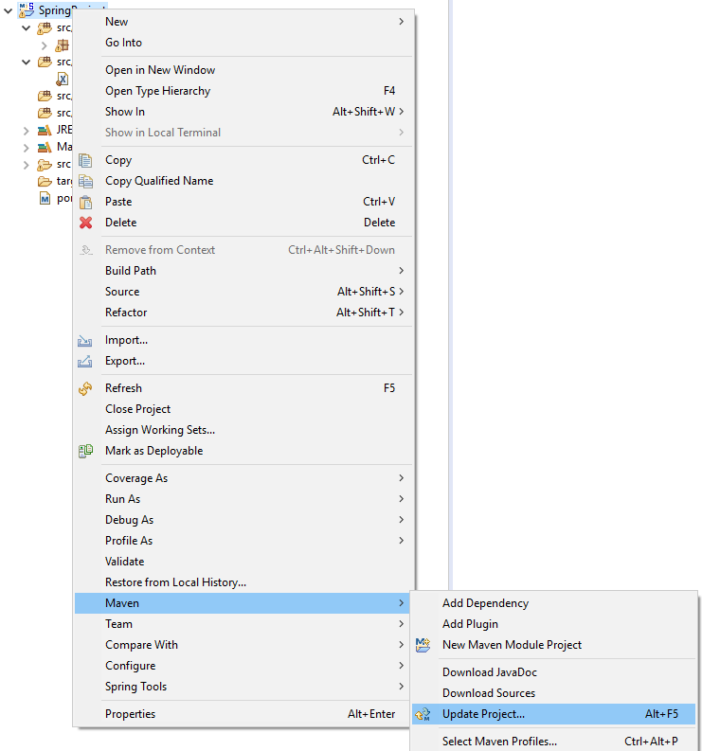

1. Create new sub package **ioc.xml** under - src/main/java
2. Create new Class Employee and Address under **ioc.xml**.

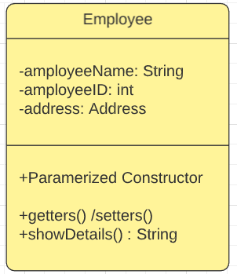 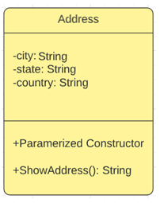

* ShowDetails supposed to print the Employee Details include the Address
* ShowAddress will print the Address details, it should invoke from the ShowDetails.

1. Create the metadata which we supposed to provide as a developer to the Spring Core Container , under resources (**metadata.xml**)

<?xml version=*"1.0"* encoding=*"UTF-8"*?>

<beans xmlns=*"http://www.springframework.org/schema/beans"*

xmlns:xsi=*"http://www.w3.org/2001/XMLSchema-instance"*

xsi:schemaLocation=*"http://www.springframework.org/schema/beans http://www.springframework.org/schema/beans/spring-beans.xsd"*>

<bean id=*"emplBean"* class=*"ioc.xml.Employee"*>

<constructor-arg value=*"86731"* type=*"int"*></constructor-arg>

<constructor-arg value=*"John Smith"* type=*"String"*></constructor-arg>

<constructor-arg> <ref bean=*"addrsBean"*/> </constructor-arg>

</bean>

<bean id=*"addrsBean"* class=*"ioc.xml.Address"*>

<constructor-arg value=*"Chicago"*></constructor-arg>

<constructor-arg value=*"Illinois"*></constructor-arg>

<constructor-arg value=*"USA"*></constructor-arg>

</bean>

</beans>

1. Create Runner Class
   1. Create main method
   2. Inside the main, create Spring Core Container context by Using the ***FileSystemXmlApplicationContext*** option with the xml metadata.
   3. Create an employee bean by invoke the getBean () service of the context.
   4. Invoke the showDetails service from employee Bean.
   5. Close the Opened Context.

Thank you.