Spring Core Exercise

Target: initiate Beans and define the relations between them by the dependency Injection.

* Every Spring /SpringBoot project will include by default the Spring Core module.
* Spring Core module is building the Spring Core Container - the place where the Beans of the Application classes will live and interact.
* the Spring Core Container will create, initialize and Manage the Beans based on metadata which developers should provide.
* The Control of Create the Beans in the Spring Core Container is moved from the Classes themselves to the Spring Core Container by the IoC -Inversion of Control
* DI - dependency Injection is the way that pass the relevant configuration and requirements to the spring core container for handling the beans.

In this Exercise we will train how to define the initiation and dependency definition per Bean by the Pattern DI -dependency injection.

1. Create new Maven Project
2. Bring the 3 mandatory dependencies that needed for Spring Core Container Creation
   1. Spring Core dependency
   2. Spring Context dependency
   3. Spring beans dependency
3. Create the root directory “com.mst”
4. Inside the root directory create new package “beans”
5. Create the three entity beans as described below :

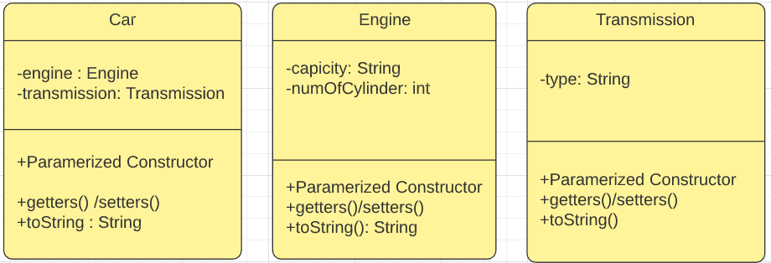

1. Create the main runner class under the root Runner.java
2. Inside the Runner class create bean of Care and invoke the method toString to show the bean content.