QUESTION 1:

package question1;

import org.openqa.selenium.By;

import org.openqa.selenium.JavascriptExecutor;

import org.openqa.selenium.Keys;

import org.openqa.selenium.WebDriver;

import org.openqa.selenium.edge.EdgeDriver;

import org.openqa.selenium.edge.EdgeOptions;

import org.testng.Assert;

import org.testng.annotations.AfterTest;

import org.testng.annotations.BeforeTest;

import org.testng.annotations.Test;

import io.github.bonigarcia.wdm.WebDriverManager;

public class Question1 {

static WebDriver driver;

@Test

public void test1() throws InterruptedException {

driver.navigate().to("https://www.amazon.in/Apple-iPhone-14-128GB-Starlight/dp/B0BDK8LKPJ/ref=sr_1_1_sspa?keywords=Apple%2BIPhone%2B14&qid=1683192020&sr=8-1-spons&sp_csd=d2lkZ2V0TmFtZT1zcF9hdGY&th=1");

JavascriptExecutor js=(JavascriptExecutor) driver;

js.executeScript("window.scrollBy(0,100)", "");

Thread.sleep(500);

driver.findElement(By.xpath("//*[@id=\"add-to-cart-button\"]")).click();

Thread.sleep(10000);

Assert.assertEquals("Added to Cart", driver.findElement(By.xpath("//*[@id=\"attachDisplayAddBaseAlert\"]/span")).getText());

System.out.println("Add to Cart Passed");

}

@Test

public void test2() throws InterruptedException {

driver.findElement(By.xpath("//*[@id=\"attach-sidesheet-view-cart-button\"]/span/input")).click();

Thread.sleep(1500);

driver.findElement(By.xpath("//*[@value=\"Delete\"]")).click();

Thread.sleep(500);

System.out.println("Delete Item Passed");

}

@Test

public void test3() throws InterruptedException {

driver.navigate().to("https://www.amazon.in/Apple-iPhone-14-128GB-Starlight/dp/B0BDK8LKPJ/ref=sr_1_1_sspa?keywords=Apple%2BIPhone%2B14&qid=1683192020&sr=8-1-spons&sp_csd=d2lkZ2V0TmFtZT1zcF9hdGY&th=1");

JavascriptExecutor js=(JavascriptExecutor) driver;

js.executeScript("window.scrollBy(0,100)", "");

Thread.sleep(500);

driver.findElement(By.xpath("//*[@id=\"add-to-cart-button\"]")).click();

Thread.sleep(10000);

driver.findElement(By.xpath("//*[@id=\"attach-sidesheet-view-cart-button\"]/span/input")).click();

driver.findElement(By.xpath("//*[@id=\"a-autoid-4\"]")).click();

Thread.sleep(1000);

driver.findElement(By.xpath("//*[@id=\"a-autoid-4\"]")).sendKeys(Keys.ARROW_DOWN,Keys.ENTER);

driver.findElement(By.xpath("//*[@id=\"sc-buy-box-ptc-button\"]/span/input")).click();

Assert.assertEquals("Checkout",driver.findElement(By.xpath("//*[@id=\"header\"]/div/div[3]/h1")).getText());

}

@BeforeTest

public void beforeTest() throws InterruptedException {

WebDriverManager.edgedriver().setup();

EdgeOptions opt=new EdgeOptions();

opt.addArguments("--remote-allow-origins=*");

driver=new EdgeDriver(opt);

driver.manage().window().maximize();

driver.get("https://www.amazon.in/");

driver.findElement(By.xpath("//*[@id=\"nav-link-accountList\"]/span")).click();

driver.findElement(By.id("ap_email")).sendKeys("+917339362038");

driver.findElement(By.id("continue")).click();

driver.findElement(By.id("ap_password")).sendKeys("@Meen123786");

driver.findElement(By.id("signInSubmit")).click();

Thread.sleep(10000);

Assert.assertEquals(driver.findElement(By.xpath("//*[@id=\"nav-link-accountList-nav-line-1\"]")).getText(), "Hello, Ameen");

System.out.println("Login Success");

}

@AfterTest

public void afterTest() {

}

}

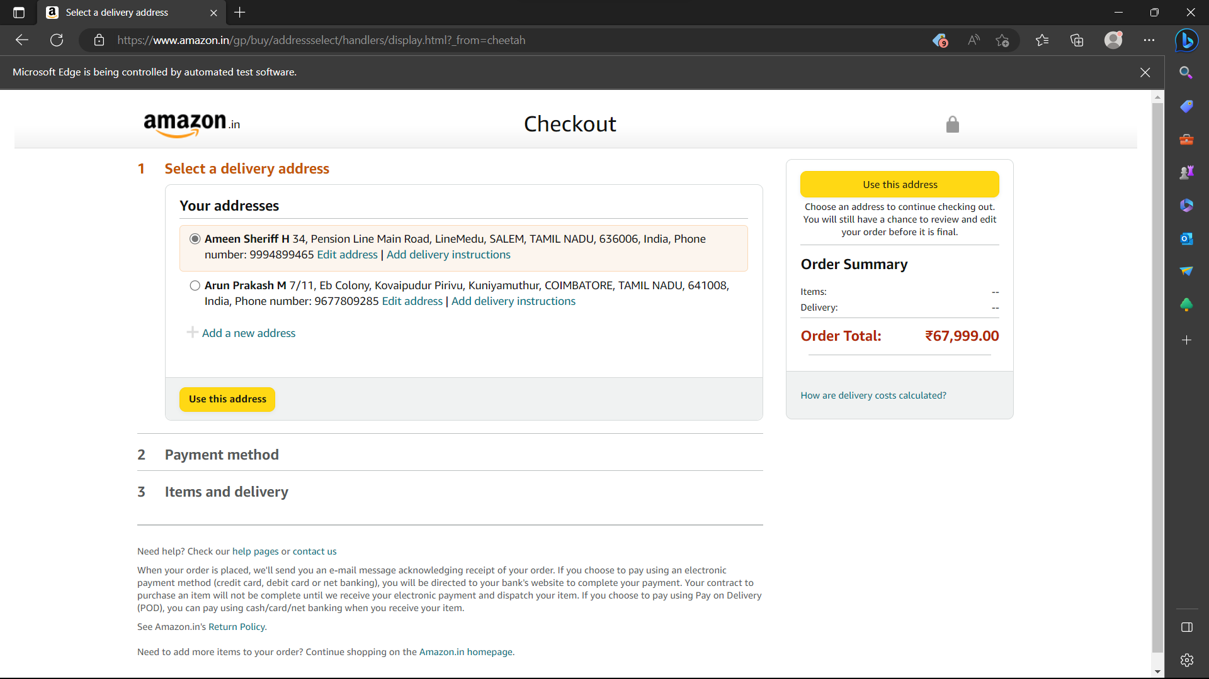

QUESTION 2:

package question2;

import java.util.List;

import org.openqa.selenium.By;

import org.openqa.selenium.WebDriver;

import org.openqa.selenium.WebElement;

import org.openqa.selenium.edge.EdgeDriver;

import org.openqa.selenium.edge.EdgeOptions;

import org.testng.Assert;

import org.testng.annotations.AfterTest;

import org.testng.annotations.BeforeTest;

import org.testng.annotations.Test;

import io.github.bonigarcia.wdm.WebDriverManager;

public class Question2 {

static WebDriver driver;

@Test

public void f() {

driver.findElement(By.xpath("//*[@id=\"twotabsearchtextbox\"]")).sendKeys("Gaming Laptop");

driver.findElement(By.xpath("//*[@id=\"nav-search-submit-button\"]")).click();

driver.findElement(By.xpath("//*[@id=\"p_89/HP\"]/span/a")).click();

for(int i=0;i<5;i++) {

System.out.println(driver.findElement(By.xpath("//*[@id=\"search\"]/div[1]/div[1]/div/span[1]/div[1]/div["+(3+i)+"]/div/div/div/div/div/div[2]/div/div/div[1]/h2/a/span")).getText());

}

}

@BeforeTest

public void beforeTest() throws InterruptedException {

WebDriverManager.edgedriver().setup();

EdgeOptions opt=new EdgeOptions();

opt.addArguments("--remote-allow-origins=*");

driver=new EdgeDriver(opt);

driver.manage().window().maximize();

driver.get("https://www.amazon.in/");

driver.findElement(By.xpath("//*[@id=\"nav-link-accountList\"]/span")).click();

driver.findElement(By.id("ap_email")).sendKeys("+917339362038");

driver.findElement(By.id("continue")).click();

driver.findElement(By.id("ap_password")).sendKeys("@Meen123786");

driver.findElement(By.id("signInSubmit")).click();

Thread.sleep(20000);

Assert.assertEquals(driver.findElement(By.xpath("//*[@id=\"nav-link-accountList-nav-line-1\"]")).getText(), "Hello, Ameen");

System.out.println("Login Success");

}

@AfterTest

public void afterTest() {

}

}

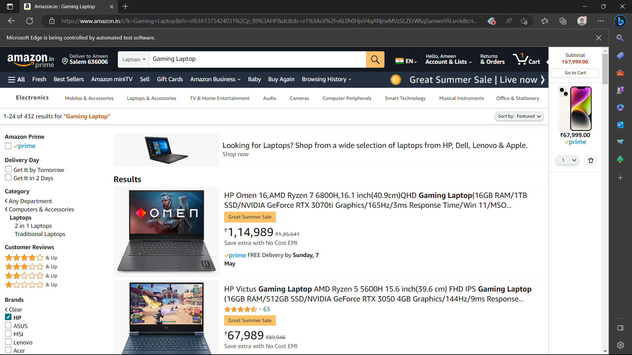

QUESTION 3:

package question2;

import org.openqa.selenium.By;

import org.openqa.selenium.WebDriver;

import org.openqa.selenium.WebElement;

import org.openqa.selenium.chrome.ChromeDriver;

import org.openqa.selenium.chrome.ChromeOptions;

import io.github.bonigarcia.wdm.WebDriverManager;

public class question3 {

public static void main(String[] args) {

ChromeOptions co=new ChromeOptions();

co.addArguments ("--remote-allow-origins=*");

WebDriverManager.chromedriver().setup ();

WebDriver driver=new ChromeDriver(co);

driver.get ("https://www.amazon.in/");

driver.manage().window().maximize() ;

String currentTitle=driver.getTitle();

System.out.println(currentTitle);

String expectedTitle="Online Shopping site in India: Shop Online for Mobiles, Books, Watches, Shoes and More - Amazon.in";

if(currentTitle.equals(expectedTitle)) {

System.out.println("Title Matched");

}

else {

System.out.println("Title not Matched");

}

driver.findElement(By.xpath("//*[@id=\"nav-link-accountList\"]")).click();

WebElement txtBoxl=driver.findElement(By.xpath("//*[@id=\"ap_email\"]"));

txtBoxl.sendKeys("+91733962038");

driver.findElement(By.xpath("//*[@id=\"continue\"]")).click();

WebElement txtBox2=driver.findElement(By.xpath("//*[@id=\"ap_password\"]"));

txtBox2.sendKeys("@Meen123786");

driver.findElement(By.xpath("//*[@id=\"signInSubmit\"]")).click();

driver.findElement(By.xpath("//*[@id=\"nav-link-accountList\"]")).click();

driver.findElement(By.xpath("//*[@id=\"a-page\"]/div[2]/div/div[2]/div[1]/a/div/div")).click();

driver.findElement(By.xpath("//*[@id=\"a-autoid-2-announce\"]")).click();

driver.findElement(By.xpath("//*[@id=\"ordersInPackage-container\"]/div/div/a[1]")).click();

}

}

