QUESTION 1:

Code:

package task1;

import org.openqa.selenium.By;

import org.openqa.selenium.WebDriver;

import org.openqa.selenium.WebElement;

import org.openqa.selenium.edge.EdgeDriver;

import org.openqa.selenium.edge.EdgeOptions;

import org.testng.Assert;

import io.github.bonigarcia.wdm.WebDriverManager;

public class Task1 {

static WebDriver driver;

static String homeurl="https://www.saucedemo.com/";

public static void login() {

driver.findElement(By.id("user-name")).sendKeys("standard_user");

driver.findElement(By.id("password")).sendKeys("secret_sauce");

driver.findElement(By.id("login-button")).click();

Assert.assertNotEquals(homeurl, driver.getCurrentUrl());

System.out.println("Login Passed");

}

public static void addToCart() throws InterruptedException {

WebElement addtoc=driver.findElement(By.xpath("//*[@id=\"add-to-cart-sauce-labs-backpack\"]"));

String buttonmsg=addtoc.getText();

addtoc.click();

Thread.sleep(500);

try {

driver.findElement(By.xpath("//*[@id=\"remove-sauce-labs-backpack\"]"));

System.out.println("Add to Cart Passed");

}

catch(Exception e){

System.out.println("Add to Cart Failed");

}

}

public static void viewCart() {

String homepage=driver.getCurrentUrl();

driver.findElement(By.xpath("//*[@id=\"shopping_cart_container\"]/a")).click();

Assert.assertNotEquals(homepage,driver.getCurrentUrl());

}

public static void checkOut() {

driver.findElement(By.id("checkout")).click();

Assert.assertEquals("Checkout: Your Information", driver.findElement(By.xpath("//*[@id=\"header_container\"]/div[2]/span")).getText());

System.out.println("Checkout Page Passed");

}

public static void fillCheckOut() throws InterruptedException {

driver.findElement(By.id("first-name")).sendKeys("ABC");

driver.findElement(By.id("last-name")).sendKeys("XYZ");

driver.findElement(By.id("postal-code")).sendKeys("560076");

Thread.sleep(500);

driver.findElement(By.id("continue")).click();

Thread.sleep(500);

Assert.assertEquals("Checkout: Overview", driver.findElement(By.xpath("//*[@id=\"header_container\"]/div[2]/span")).getText());

System.out.println("Overview Page Passed");

}

public static void displayItem() {

String itemname=driver.findElement(By.xpath("//*[@id=\"item_4_title_link\"]/div")).getText();

String itemprice=driver.findElement(By.xpath("//*[@id=\"checkout_summary_container\"]/div/div[1]/div[3]/div[2]/div[2]/div")).getText();

System.out.println("Item Name: "+itemname);

System.out.println("Item Price: "+itemprice);

}

public static void checkTitleUrl() {

Assert.assertEquals("Swag Labs", driver.getTitle());

System.out.println("Assert Title Passed");

Assert.assertEquals("https://www.saucedemo.com/checkout-step-two.html", driver.getCurrentUrl());

System.out.println("Assert URL Passed");

}

public static void main(String args[]) throws InterruptedException{

WebDriverManager.edgedriver().setup();

EdgeOptions opt=new EdgeOptions();

opt.addArguments("--remote-allow-origins=*");

driver=new EdgeDriver(opt);

driver.manage().window().maximize();

driver.get(homeurl);

login();

Thread.sleep(500);

addToCart();

Thread.sleep(500);

viewCart();

Thread.sleep(500);

checkOut();

Thread.sleep(500);

fillCheckOut();

Thread.sleep(500);

displayItem();

Thread.sleep(500);

checkTitleUrl();

}

}

Output:

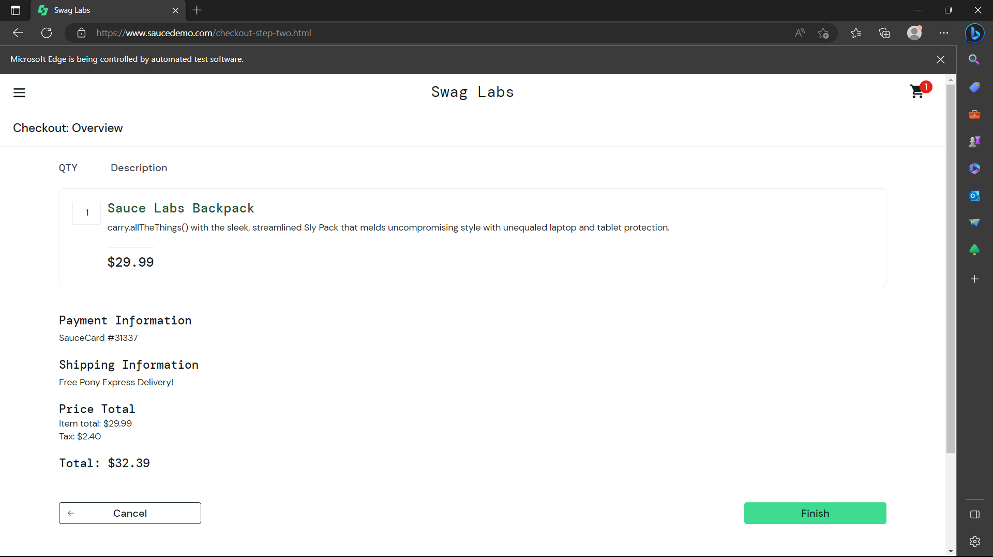

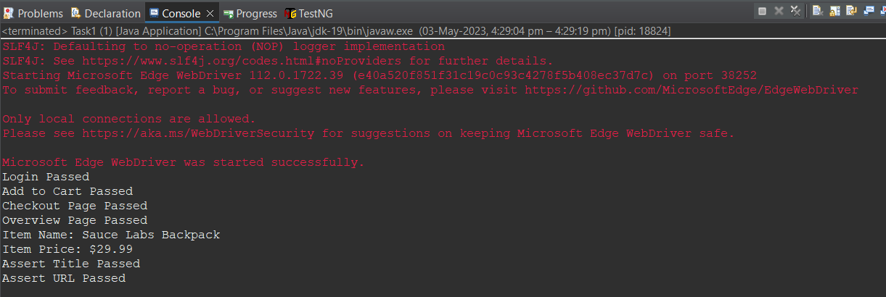

QUESTION 2:

Code:

package task2;

import java.util.List;

import org.openqa.selenium.By;

import org.openqa.selenium.Keys;

import org.openqa.selenium.WebDriver;

import org.openqa.selenium.WebElement;

import org.openqa.selenium.edge.EdgeDriver;

import org.openqa.selenium.edge.EdgeOptions;

import org.testng.Assert;

import io.github.bonigarcia.wdm.WebDriverManager;

public class Task2 {

static WebDriver driver;

static String homeurl="https://www.saucedemo.com/";

public static void login() {

driver.findElement(By.id("user-name")).sendKeys("standard_user");

driver.findElement(By.id("password")).sendKeys("secret_sauce");

driver.findElement(By.id("login-button")).click();

Assert.assertNotEquals(homeurl, driver.getCurrentUrl());

}

public static void filteratoz() throws InterruptedException {

WebElement drop=driver.findElement(By.xpath("//*[@id=\"header_container\"]/div[2]/div/span/select"));

drop.click();

Thread.sleep(1500);

drop.sendKeys(Keys.ENTER);

Thread.sleep(1500);

List<WebElement> products=driver.findElements(By.className("inventory_item_name"));

List<WebElement> prices=driver.findElements(By.className("inventory_item_price"));

System.out.println("A TO Z : ");

System.out.println(products.get(0).getText()+" "+prices.get(0).getText());

}

public static void filterztoa() throws InterruptedException {

WebElement drop=driver.findElement(By.xpath("//*[@id=\"header_container\"]/div[2]/div/span/select"));

drop.click();

Thread.sleep(1500);

drop.sendKeys(Keys.ARROW_DOWN,Keys.ENTER);

Thread.sleep(1500);

List<WebElement> products=driver.findElements(By.className("inventory_item_name"));

List<WebElement> prices=driver.findElements(By.className("inventory_item_price"));

System.out.println("Z TO A : ");

System.out.println(products.get(0).getText()+" "+prices.get(0).getText());

}

public static void filterltoh() throws InterruptedException {

WebElement drop=driver.findElement(By.xpath("//*[@id=\"header_container\"]/div[2]/div/span/select"));

drop.click();

Thread.sleep(1500);

drop.sendKeys(Keys.ARROW_DOWN,Keys.ENTER);

Thread.sleep(1500);

List<WebElement> products=driver.findElements(By.className("inventory_item_name"));

List<WebElement> prices=driver.findElements(By.className("inventory_item_price"));

System.out.println("Low to High : ");

System.out.println(products.get(0).getText()+" "+prices.get(0).getText());

}

public static void filterhtol() throws InterruptedException {

WebElement drop=driver.findElement(By.xpath("//*[@id=\"header_container\"]/div[2]/div/span/select"));

drop.click();

Thread.sleep(1500);

drop.sendKeys(Keys.ARROW_DOWN,Keys.ENTER);

Thread.sleep(1500);

List<WebElement> products=driver.findElements(By.className("inventory_item_name"));

List<WebElement> prices=driver.findElements(By.className("inventory_item_price"));

System.out.println("High to Low : ");

System.out.println(products.get(0).getText()+" "+prices.get(0).getText());

}

public static void main(String args[]) throws InterruptedException {

WebDriverManager.edgedriver().setup();

EdgeOptions opt=new EdgeOptions();

opt.addArguments("--remote-allow-origins=*");

driver=new EdgeDriver(opt);

driver.manage().window().maximize();

driver.get(homeurl);

login();

filteratoz();

filterztoa();

filterltoh();

filterhtol();

}

}

Output:

