AI Agent & Automation Storyboard: Customer Side
Oct 1, 2026 · @Naveena

The short answer
Use an AI agent where the customer is unsure what to do and must explain it in their own words. Use plain automation where the next step is already known and only has to happen on time. Leave fixed, rule-driven steps alone: payment, OTP and validation already work and gain nothing from AI.
On the customer side this gives three high-value places for an agent and three for automation:
- Agent: service advisor ("what do I need?"), document checker on upload, and a status + compliance assistant in the dashboard chat.
- Automation: nudges for abandoned applications, compliance reminders, and quote / payment follow-ups.
- Upgrade, not new: the name check, NIC code and trademark class steps are labelled "AI" but are keyword simulations today. A real model (plus live MCA / IP India data) makes them trustworthy.
As read from the code: ChatSection / ChatPage use mock data, no LLM provider is wired in, and FlowRunner already records every step. That means an agent can be added behind existing screens without redesigning the flows.

Storyboard
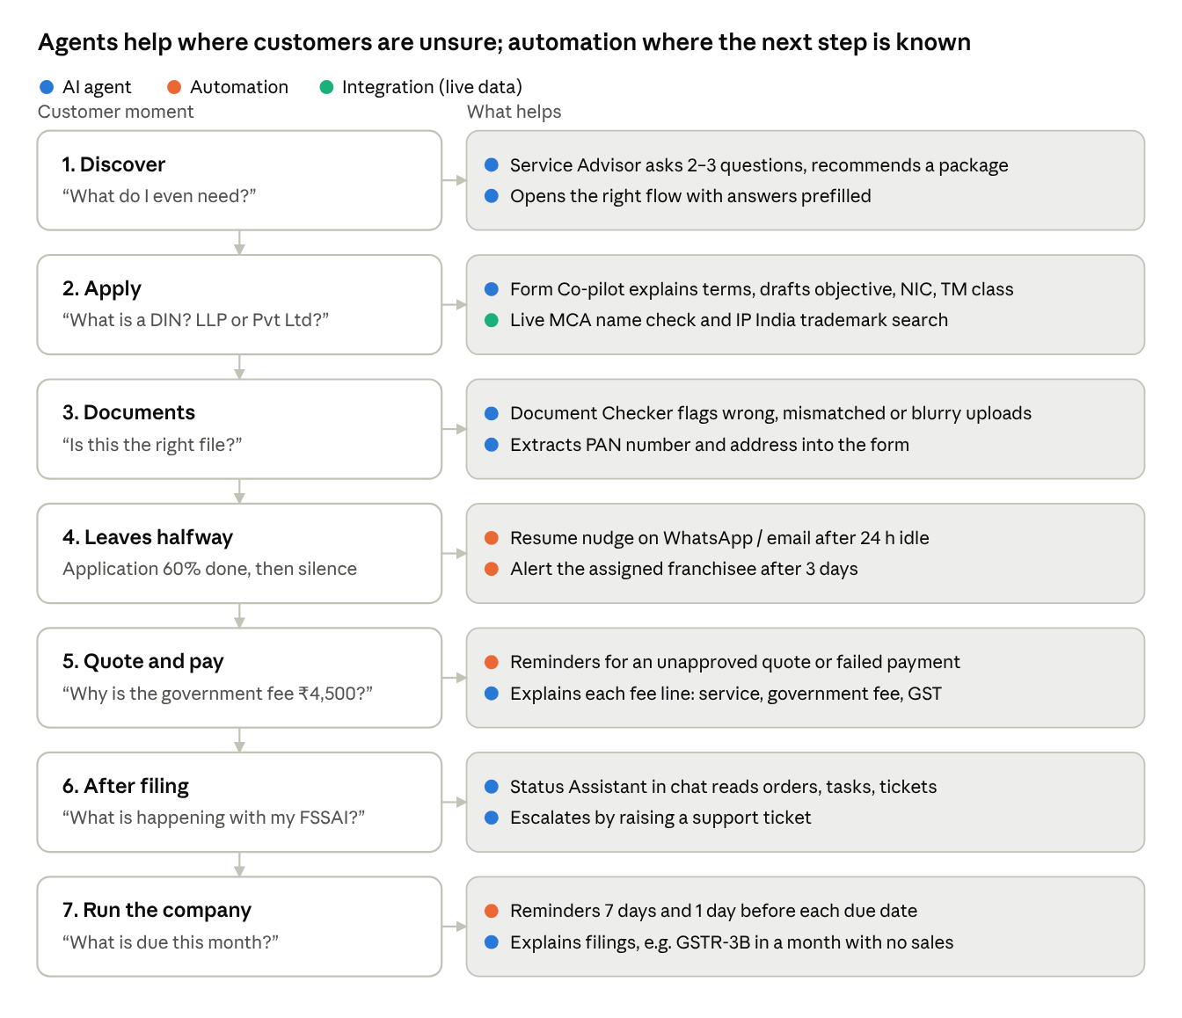
customer storyboard · 7 scenes, AI and automation touchpoints
Agents (blue) cluster at the start and after filing, when the customer has a question. Automation (orange) fills the gaps where the customer goes quiet.

Scene by scene
Each scene follows one customer, Priya, who wants to start a food brand and later runs it as an existing company.

Scene 1: "What do I even need?" (Discover)
- Today: Priya sees four service cards and an existing-company menu with about 20 options. ExistingNeedsMenu admits it: "Not sure which applies? Pick the closest option."
- AI agent (Service Advisor): she types "I want to sell homemade snacks online from Kochi". The agent asks 2–3 follow-ups and recommends a package (Proprietorship + FSSAI + GST), with a reason for each item.
- Hand-off: it opens /startbusiness/apply with flowId and initialSet prefilled, the same mechanism the menus already use.
- Outcome: fewer wrong-service starts; the "I'm not sure" advisor call becomes the fallback, not the default.

Scene 2: Filling the application (Apply)
- Today: long forms; "Help Me Choose", name suggestions, business objective, NIC code and trademark class are keyword rules.
- AI agent (Form Co-pilot): a side panel that answers "what is a DIN?" or "should I pick LLP or Pvt Ltd?" using the current step and answers. It drafts the business objective, NIC codes and trademark class from her description.
- Automation: a real MCA name check and IP India trademark search instead of runNameCheckSim / runTrademarkSearchSim.
- Guardrail: the agent suggests and the customer confirms; it never submits for her.

Scene 3: Uploading documents (Documents)
- Today: uploads go through with no check; errors are found later by the ops team.
- AI agent (Document Checker): reads each upload and flags problems such as "this is the back of the Aadhaar", "PAN name doesn't match the director name", or "blurry, please retake". It can also extract fields (PAN number, address) to fill the form.
- Outcome: fewer rejections and back-and-forth after filing.

Scene 4: She leaves halfway (Abandon)
- Today: progress is saved in the browser and a Lead exists, but nothing brings her back.
- Automation: after 24 h with no progress, send WhatsApp / email / SMS: "Your FSSAI application is 60% done — continue", with a resume link built with flowRoute(). Then after 3 days, alert the assigned franchisee or employee.
- No AI needed: the trigger and the message are fixed.

Scene 5: Quote and payment (Pay)
- Today: the quote opens in a new tab; if she doesn't approve, nothing follows up.
- Automation: reminders for an unapproved quote and a failed payment, plus an auto-raised callback ticket after N reminders.
- AI agent (light): answers "why is the government fee ₹4,500?" or "what does GST on this mean?" from the quote lines.

Scene 6: "What's happening with my application?" (After filing)
- Today: status lives across orders, tasks, deliverables and tickets; the customer opens a ticket to ask.
- AI agent (Status Assistant) in the dashboard chat (replacing the mock ChatSection) reads orders, getServiceTasks, deliverables and tickets. It answers in plain words, e.g. "Your FSSAI is with the department; expected in 7–10 days; we need your rent agreement." It escalates by creating a support ticket.
- Outcome: fewer "status?" tickets; customers get answers at any hour.

Scene 7: Running the company (Compliance)
- Today: ComplianceCalendar shows due dates, but she has to check it herself.
- Automation: reminders 7 days and 1 day before each due date, plus an overdue alert.
- AI agent: explains a compliance item ("what is GSTR-3B and do I need to file it if I had no sales?"). It suggests related services, e.g. a trademark after a few months of sales, based on her company profile.

Agent, automation, or leave it
The test: if the input is free text, an image or a question, it needs an agent. If it is a known event on a timer, automation is enough.
Idea | Needs | Why | Value | Effort
Service Advisor (Scene 1) | AI agent | Customer describes the business in their own words | High | Medium
Status Assistant in chat (Scene 6) | AI agent + read APIs | Free-text questions over orders, tasks, tickets | High | Medium
Document Checker (Scene 3) | AI agent (vision) | Has to read images and PDFs | High | Medium–High
Form Co-pilot, objective / NIC / TM class (Scene 2) | AI agent | Replaces keyword rules with understanding | Medium | Low–Medium
Compliance explainer (Scene 7) | AI agent | Questions about rules | Medium | Low
Abandoned-application nudges (Scene 4) | Automation | Fixed trigger: no progress for 24 h | High | Low
Compliance reminders (Scene 7) | Automation | Fixed due dates already in getCompanyCompliances | High | Low
Quote / payment follow-ups (Scene 5) | Automation | Fixed status: quote created, not approved | High | Low
Live MCA name check / IP India search (Scene 2) | Integration | A data lookup, not reasoning | Medium | Medium
OTP, payment, field validation, step order | Leave as is | Rule-driven and already working | — | —

Rollout
Start with automation: it is cheap, low-risk and fixes the biggest leak, customers who go quiet. Add agents one at a time, read-only first.
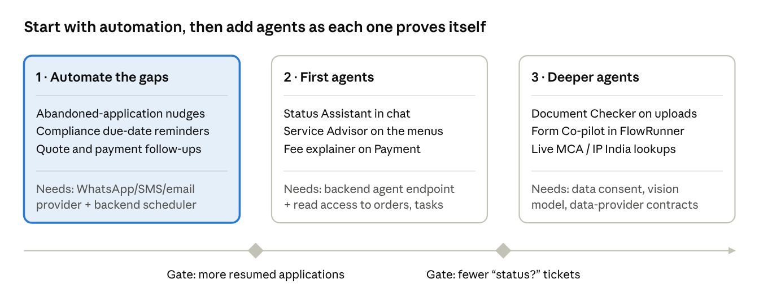
rollout · 3 phases, 2 gates
Phase 2 agents only read data and raise tickets, so mistakes are cheap. Phase 3 handles identity documents and changes form answers, so it waits until consent and review rules are settled.

Open questions
- ☒ Which channel do customers actually respond to: WhatsApp, SMS or email? This decides the automation tool.
- ☒ Where does the agent run? It should be a backend endpoint that holds the model key and calls existing APIs, never a key in the React app.
- ☐ What may the agent do on its own (prefill, create a ticket) versus only suggest (choose a business type, approve a quote)?
- ☒ Languages: the lead form already offers 9 (English, Hindi, Tamil, Malayalam and others). Should the agent reply in the customer's preferred language?
- ☐ Data consent for reading PAN / Aadhaar images with a model, and how long extracted data is kept.
- ☐ Success measures to track from day one: wrong-service starts, abandonment rate per step, "status?" tickets per month, document rejection rate.

