**TITLE**

**Authors List and Affiliations: Group 5**

* Burak Yilmaz: [yilmaz2@uwindsor.ca](mailto:yilmaz2@uwindsor.ca)
* Ameen Al-Kaisi: alkaisi@uwindsor.ca
* Daniel Xue: xued@uwindsor.ca
* Darren Fernandes: ferna11p@uwindsor.ca

**ABSTRACT**

**KEYWORDS**

1. Data Manipulation
3. Data Filtering
4. Data Representation
5. Data Accessibility

**ACKNOWLEDGMENT**

Special Acknowledgement to Dr.Kobti: ------

Project Phase 1: Inception, was a group effort where all group members contributed equally to the completion of the Inception report

Project Phase 2: Elaboration, The use-model, sequence diagram, class diagram, and the domain model was completed by Ameen Al-Kaisi and Burak Yilmaz while the elaboration report was put together and written by Darren Fernandes and Daniel Xue.

Project Phase 3: Elaboration 2/Final Report;

Ameen Al-Kaisi:  Experimental setup or Demonstration

Burak Yilmaz: Approach, Appendix

Darren Fernandes: Abstract, Discussion, Conclusion

Daniel Xue: Introduction, Related work, Future work

**REFERENCES**

[1]C. Larman, *Applying UML and patterns: an introduction to object-oriented analysis and design and the unified proces*. Upper Saddle River (New Jersey): Prentice-Hall, 2005.

**APPROACH**

In phase one of the project, we had an ambitious goal in mind of creating a GUI for a large variety of data types in Windsor. Some examples of this data would be police records, hospital records, etc. After some research of our own as well as some insightful input, we came to realize the project we were attempting to take on would be too big in comparison to the time given to complete this project. To narrow the scope of our project, it was decided to focus primarily on a single data type to make available to the public. This data type was decided to be the Hospital Records in Windsor. This included the coordinates of the hospitals in Windsor, the FID of each hospital mentioned, the name and the address of each hospital, and the facility ID. Our goal was to primarily focus on these attributes for each hospital in Windsor and to make this data accessible and viewable by the public. Therefore, the elaboration phase was started with a class diagram, sequence diagram,  use-case model, and domain model. The listed diagrams are shown below:

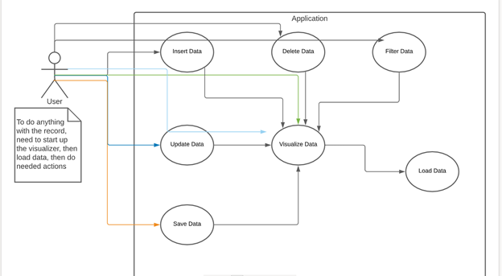

Figure 1: Use-Class Diagram

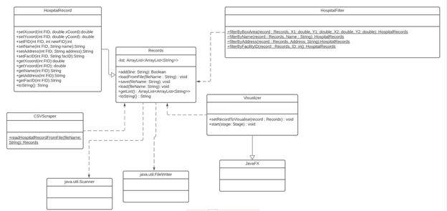

Figure 2: Class Diagram

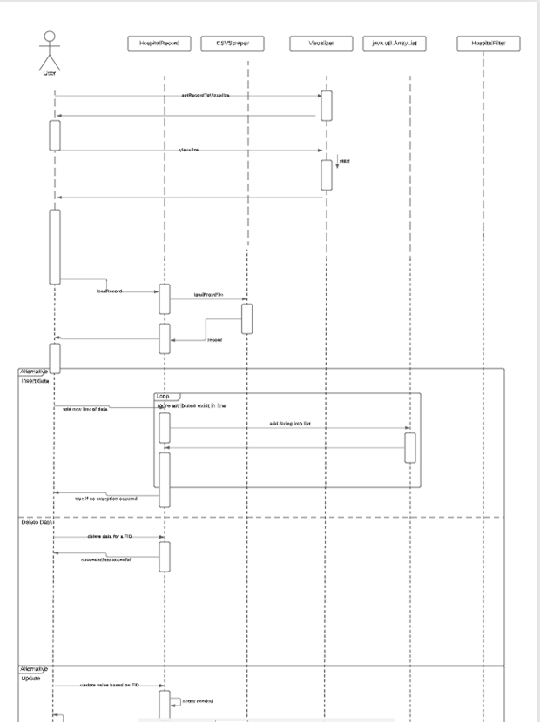

Figure 3: Sequence Diagram

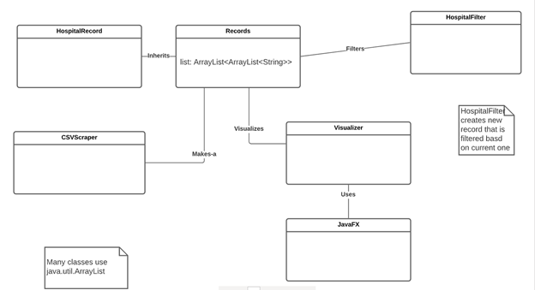

Figure 4: Domain Model

Using these diagrams, the approach to the project became clear and the coding of the GUI and filters came next. The coding language decided on was Java as this was a familiar language for all group members and was an object-oriented language. The inception report was worked upon by all group members at the same time and caused time loss. Therefore, the elaboration phase was done by separating into groups of two. Burak Yilmaz and Ameen Al-Kaisi completed the class diagram, domain model, sequence diagram, and use-class diagram. Darren Fernandes and Daniel Xue put together and completed the elaboration report. For the coding of the early stages of the project, each group coded a class and once done, the code was brought together and debugged. Hence, a final product was created that performs the task of presenting the public with filtered data of Hospitals in Windsor.

**APPENDIX**

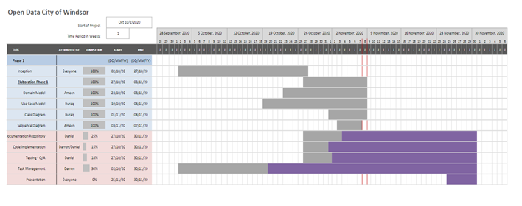

Figure 5: Appendix

As mentioned as before, the group worked collaboratively on the Inception report and phase. Following that, the group decided to split into partners for the Elaboration report and phase where Ameen Al-Kaisi and Burak Yilmaz worked on the diagrams mentioned in figure 5 while Darren Fernandes and Daniel Xue worked together to complete the report. As for the coding of the project, the same principles applied in the elaboration phase were applied here. All group members completed a class for the project, but had a partner to peer review any bugs that may have occurred. The partners were Burak and Ameen and Daniel and Darren.

**DISCUSSION**

The initial prototype focused on giving us access to the data and presenting it in a readable format. One of the biggest and major changes that happened while moving from Phase 1 to 2 was having to build an application offline rather than focussing on adding functionality to the already existing website of the city of Windsor.

While the plan initially was to prepare an application that would run online, after speaking to the professor of the course we cam to the realisation that we needed to only build an application which would make use of the data available at the city of Windsor's data repository.

After a lot of discussion and understanding of the project required, we finally settled in on building a java application with the data provided and provide an innumerable amount of functionalities to the user.

Testing of the final application took a certain amount of time since we had to test different functionalities and every execution of an individual functionality took us a little away from what our original plan was but we managed to settle in on an application with functionalities we all agreed should be incorporated.

The was a big change while making the application work offline as that steered us away from our original inception plan which took into consideration and online addition to the city of Windsor’s website.

**CONCLUSION**

The initial thought or initial final application expected was close to being achieved, there were a few issues that needed to be solved before the final application was completed.

Throughout the project, quite a lot of additions and removals were done on the final desired application. While most of the task we set out to achieve and those mentioned in the inception report, as well as the phase 1 elaboration, were achieved along with more additions which were thought of and implemented while the project was underway keeping in mind our agile approach to the project.

Some limitations which we came across were certain additions needed to have their licenses bought for a considerable fee, which would have been great had it not been for the cost.

Others limitations that we came across included out of date additions to the application, while research was conducted before having an addition made this ensured an addition was only added if it did not have any extra needs or licensing fees.

One of the major limitations of the prototype is its inadequacy to work online, this causes issues while reading and filtering the data for the client as the client must have the data present on their system. A solution for this issue has been found but it is still under development and may be included in future additions.

**FUTURE WORK**

While some additions as mentioned above were unsuccessful due to being a paid service or out of date, newer solutions are being done to incorporate them.

Some other additions include providing maps on the application since the x and y coordinates of a location are present in the data since the use of Google Maps is a paid service it could be implemented but not for the time being.

One of the most important additions we plan on adding our accessibility services to all which include text to speech and more. The application main goal is to be able to provide as much accessibility as possible to an array of users.

One feature that could not be added was a representation of data using more elaborate methods such as graphs and charts which would make the data more understandable to the user. This could not be done with the current data as the required amount of data was not met to implement the graphs and more.

**EXPERIMENTAL SETUP OR DEMONSTRATION**

Since the current product is not complex enough to use a separate prototype, the prototype the project itself then testing it on available databases in the system. This is the best method of prototyping as it is the quickest way of testing that old functionality keeps working and new functionality is working.

The experiment can be replicated using the following procedure:

1. Execute program
2. Navigate the graphical interface until at the location of testing
3. Test the functionality

The execution happens through IntelliJ IDEA. This is the IDE used in developing the GUI portion of the program. Assuming JavaFX is set up correctly at current project, place sample CSV files (possibly collected through City of Windsor database) into the project location. Then run in IntelliJ to execute.

Navigating the graphical interface would test the old functionality works as new features are implemented, and as there are limited amounts of non navigational-related features, this serves as a good and quick method for testing.

Testing can be done by using the new feature, and observing of any exceptions that happen, or irregular values in the database (using navigation by the back and next buttons), or irregular buttons/names going into the database (from database selection menu).

Here are some points in execution to collect data and further details:

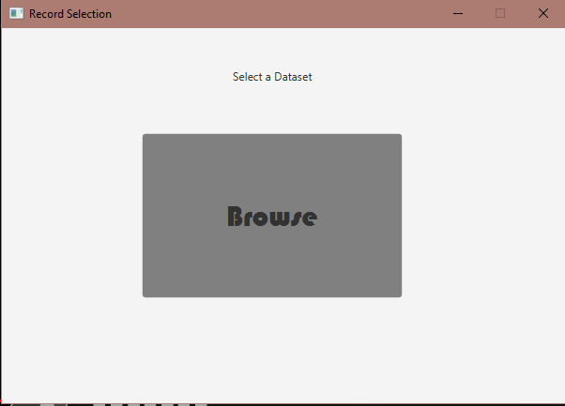

Check that the initial GUI menu loads without issues

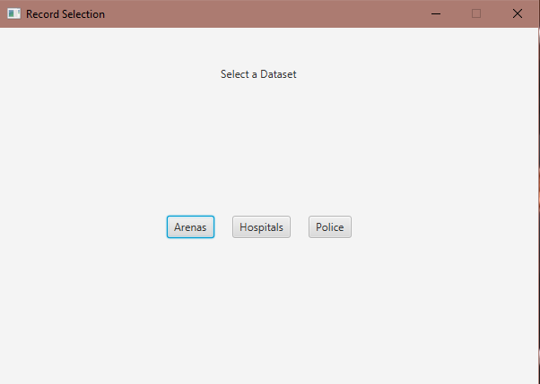

After clicking browse, it will load all the CSV’s in the project directory. In here check the following:

1. Buttons are set up with correct names
2. Clicking each CSV and loading them shows same records as ones in each database respectively

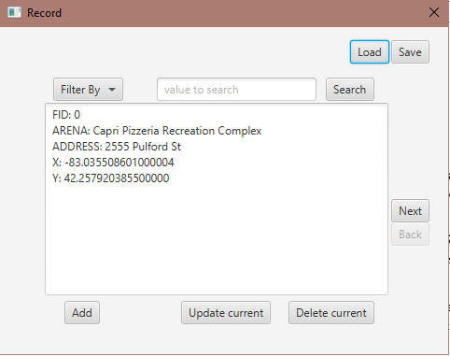

Before loading, can check functionalities of buttons on empty database

After loading, click and test each button, update, and add have their own section

Also look for help texts during testing, and after filtering check everything again

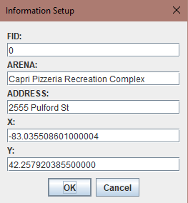

Add and update should pop up a JOptionPane confirm window, look for the following:

1. Labels are set up correctly
2. Update should have prefilled the current element, while add should have empty elements
3. Cancelling at any point would not crash or throw an exception

After updating/adding, check the updates or adds are present, then load to see that reloading works, or save to see that saving changes the file in the system.