PROJECT REPORT

ON

SDLC HEALTHCARE MANAGEMENT SYSTEM

Submitted to

NMAM INSTITUTE OF TECHNOLOGY, NITTE

(Off-Campus Centre, Nitte Deemed to be University, Nitte 574 110, Karnataka, India)

In the partial fulfilment of requirements for the award of degree

BACHELOR OF ENGINEERING

IN

INFORMATION SCIENCE AND ENGINEERING

By

A AMEEN AHMED NNM25IS501

Under the guidance of

Dr. JASON ELROY MARTIS

Associate Professor



Abstract
But beneath the surface, this analysis will review three of the traditional software development methodologies: Waterfall, Incremental Development, and Spiral, and answer a simple question with very high stakes: How well do these methodologies work in practice when developing the Epic Electronic Health Record (EHR) system for an acute care hospital? Healthcare IT is not like other software development projects
With the consideration of the architecture of the Epic Chronicles database and the HL7 FHIR standards, it is evident that there is no development paradigm that fits perfectly
The Incremental Development approach is very flexible, especially when it comes to the staged go-live approach, where the hospitals will implement the modules one by one.

GitHub Repository Link
GitHub URL: https://github.com/ameenann/SDLC-on-healthcare-management.git

Introduction
When the Cleveland Clinic implemented its Epic EHR system in 2014, it was not only the implementation of a new software application—it was the management of a massive and high-risk transformation. Consider the coordination of 4,400 hospital beds, over 180 outpatient facilities, and the training of 40,000 employees all at the same time. It took three years and over $250 million, and that should give one pause. And, quite frankly, that’s the entire story. A project of this type is not a software application but a transformation that has to be planned, developed, and coordinated from day one.
Epic Systems Corporation is the leading vendor in the U.S. hospital EHR market with a market share of around 31% as of 2024, catering to everyone from small community hospitals to large ones such as Mayo Clinic, Johns Hopkins Medicine, and Massachusetts General Hospital. At the heart of Epic is Chronicles, its unique and unorthodox database that doesn’t think in SQL tables like everyone else. Rather, it thinks in a layered and multidimensional fashion that can mirror the messy, complicated world of real-life practice in a remarkably precise way. This is extremely powerful—it helps hospitals organize their work around real patient needs—but it also makes integrating Epic with other systems a bit like trying to communicate in two different languages.

Problem Statement

When hospitals first embark on an Epic EHR implementation, what hospital leaders are essentially asking is this in the healthcare industry, there is little room for do-overs.
When a hospital first starts to implement Epic, the question being asked is: How do we keep this huge project on track without derailing healthcare and breaking the bank? It’s not a risk you take. In the healthcare industry, there is little margin for error, so it is imperative that it is done correctly the first time.
This assessment also has some non-negotiables. Patient information must be protected by HIPAA at every single point, and there is no middle ground on this matter. And, quite frankly, hospitals just can’t support two systems; it’s just too much to ask of the staff to enter information into two separate systems.

Dataset Description and System Context

This analysis will not require any clean lab data or case studies—it will use the Epic system itself as the “dataset.” The Epic system is more than just a system.it is the backbone of a hospital’s operations.
The Chronicles database in Epic is what really drives the implementation strategy that hospitals must take. The problem is that it makes it impossible to integrate Epic with other software, as most software is organized in a more relational way.
The issue of how to do Epic in a 500-bed hospital is a huge puzzle. You are talking about 120 to 150 workflows that have to be specified in very small detail, from the admission and discharge workflow to the medication ordering workflow with decision support, nursing documentation templates, surgical documentation, ED triage, to imaging orders.

Tools and Technologies Ecosystem
Epic is not only an application; it has a very advanced tech stack. At the core of its development is the toolkit developed by Epic itself, and the Hyperspace Studio is the primary IDE used for the development of workflows and UIs.
Epic projects use a mix of programming languages depending on the project. In the system, Epic uses its own scripting language that handles workflows, validation, and calculations. This is a hybrid model where the right language is matched with the right task to keep the hospital’s technology ecosystem in sync.
The hardware requirements of Epic’s system are not trivial and are considered among the criteria for determining which SDLC will work best. Production is done on enterprise class servers with redundancy for high availability, although more and more, hospitals are opting for Epic’s cloud hosting solution on AWS or Google Cloud

Methodology: Comparative Analysis of SDLC Models

The Waterfall Model: Sequential Rigor in Healthcare IT
The hardware requirements of Epic’s system are not insignificant and are definitely a factor in how the strategy of the SDLC should be. The production environment is usually supported by redundant enterprise-class servers, although more and more hospitals are taking advantage of Epic’s cloud hosting solution on AWS or Google Cloud
Waterfall’s approach is also well aligned with the regulatory environment that Epic maintains in its tight regulatory world. First, the hospitals need to understand not only what they want to achieve with the system, but all the regulations that the system must adhere to.
In Waterfall Epic projects, the design documents are utilized not only for configuration purposes but also as proof for the regulators. After the audit notices are received from HIPAA, CMS, or Joint Commission surveys, the design documents will ensure that the critical result routing, privacy, and clinical decision support were not mere random events but well-planned strategies.
For Waterfall Epic projects, the most time-consuming task is the building and testing task. This is followed by the specialty modules of Inpatient, Ambulatory, ED, OR, and Revenue Cycle, which may take another eight to twelve months depending on the customization requirements.
The Waterfall Epic project testing in the water is all about patient safety and cannot be bypassed. Integration testing verifies that orders, such as an order for a chest x-ray, are properly transmitted to the radiology department and that the results are properly returned to the patient record.
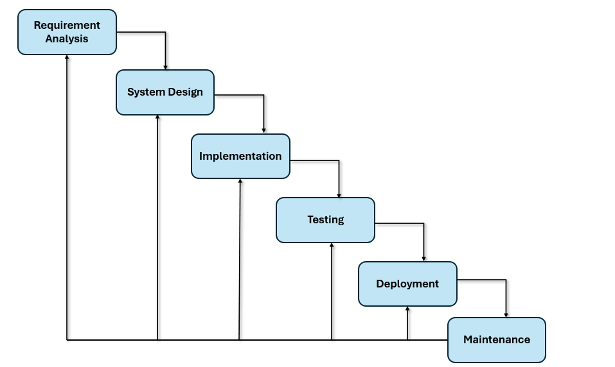

Incremental Development: Modular Deployment Strategy
Phased Rollout Minimizes Risk – Hospitals like Partners HealthCare adopted a phased rollout approach, thereby steering clear of the “big bang” approach to go-lives, where Epic was deployed in phases. Brigham and Women’s Hospital went live first, followed by Massachusetts General Hospital six months later, and then the community hospitals in phases.

Increment by Increment Value – Each increment brings concrete clinical value: start with low-risk tasks such as patient registration, ambulatory documentation, emergency department operations, inpatient processes, and finally revenue cycle management. Healthcare professionals can derive benefit from the system’s functionality right from the start while the system is still being developed to its fullest potential.

Continuous Improvement – What has been learned from each increment has helped shape the next. For example, triage templates were revised after the ED go-live and then used for inpatient admission screens.

Coordination and Resource Challenges – Having some areas of the business running on Epic while other areas are still running on legacy systems can create information gaps

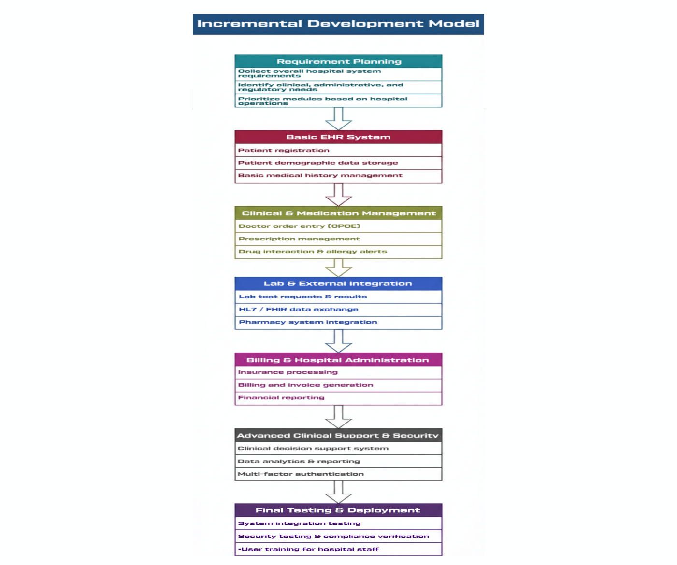

Spiral Model: Risk-Driven Iterative Development
Risk-First Approach – Spiral: The Spiral approach emphasizes risk-prone areas first. At Stanford Health Care, the risk-prone area was the ordering of medications because it directly affected patients or led to alert fatigue. A prototype was developed to confirm the high-risk safety functionality related to allergies, duplicate therapy, and medication reconciliation.

Iterative Expansion – After completing the high-risk areas, the second phase of the spiral model emphasizes medium- and lower-risk functionality. After completing the high-risk areas, the integration of the lab system received the highest priority to provide accurate test results, followed by other modules such as scheduling, patient portal, and so on.

Stakeholder Feedback Loops: Feedback from physicians, pharmacists, and nurses is collected for each prototype developed. Feedback from stakeholders helps in improving the workflow, adjusting the volume of alerts, and also helps to identify what constitutes a high-risk region. This ensures that Epic remains connected to the real world of healthcare and not the world of ideas.

Embedded Compliance and Security – HIPAA compliance and privacy issues are addressed early in each spiral. Role-based access controls, audit trails, encryption guidelines, and patient consent limits are addressed early on, avoiding costly rework at the end of the project that could otherwise result in a go-live delay.

Advanced Project Management – Spiral project management is complex: risk workshops, likelihood and impact scoring, and success criteria evaluation. Smaller hospitals may not have the experience and resources needed, although this detailed planning ensures that risk management is deliberate and comprehensive.

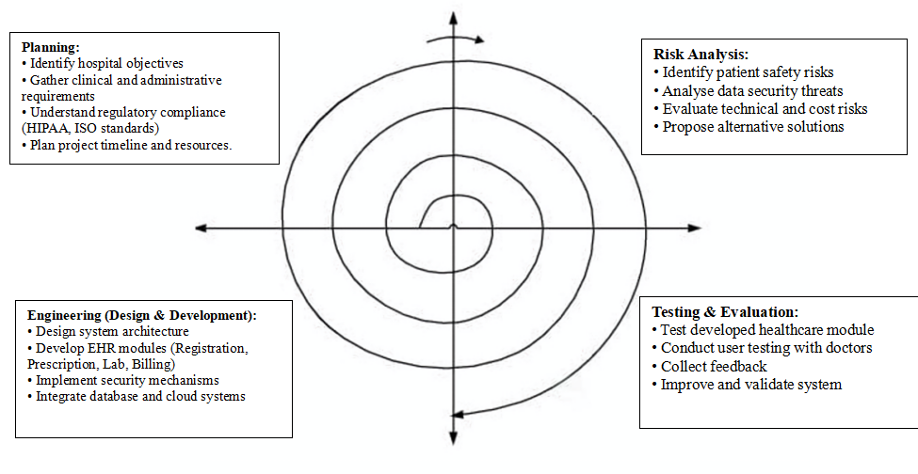

Comparative Analysis: Model Evaluation Framework

Requirements Handling: Waterfall freezes all workflows from the very beginning, providing excellent traceability but very limited flexibility after design decisions have been made. Incremental handles requirements incrementally, allowing each module to learn from the previous one and adapt to real-world applications.

Performance, Security, and Non-functional Requirements – Waterfall goes directly to full-scale production from the very beginning, but it is better to test performance at the end of the project to avoid nasty surprises. Incremental tests performance and security increment by increment, although the first modules may not represent the full system load
The comparative analysis reveals that Epic implementation success depends less on identifying a universally 'best' SDLC model and more on matching methodology to specific organizational contexts and risk tolerances. integrated delivery network migrating from a legacy Cerner platform to Epic across twenty hospitals.
Organizations with limited prior EHR experience and strong preferences for predictability might rationally select Waterfall methodology despite its inflexibility.

Requirement Specification of Epic
Functional Requirements
Electronic Orders having Safety Checks.
The system should enable the providers to place medication, lab, imaging, and nursing orders electronically. In case of medication request, it should automatically examine allergies, history of medication cases, laboratory findings, and health issues. It should warn providers of possible dangers in terms of clear severity levels.
Clinical Documentation
The system should allow provider and nursing documentation templates to consist of free-text and structured information. It must automatically enter such data as vital signs and laboratory results when they are present. The shortcuts (smart phrases) allow the providers to save time. Co-signatures ought to have documentation and a complete version history.
Review and Communication of Results.
Lab, imaging, and other outcomes should be sent straight into the system. What matters is critical results that have to alert the concerned provider
Patient Portal
Patients should be in a position to access their health records, communicate with care teams, book appointments, order refills, and fill forms on the internet. Delicate outcomes can be postponed to be looked at by the provider.
Revenue and Billing Integrity.
Billing should be related to clinical documentation. The system should provide proposals to charge that are founded on registered service and that they conform to requirements of codification

Non-Functional Requirements
Availability and Reliability.
The system should be up at 99.9 percent exclusive of the scheduled maintenance. Downtime must be performed or carried out at late evening. The backup systems should not allow data loss; recovery should be in four hours and a minimum data loss (but not more than 15 minutes).
Security
Encryption of all the patient data should be performed. The access should be on role-based permission and log the activity. The system ought to identify suspicious access and also embrace multi-factor authentication and automatic session timeouts.
Performance
The majority of operations are to load within less than two seconds. The most crucial activities such as medication ordering have to be even more rapid. A system that is capable of supporting 5,000 users simultaneously should be used and be able to be expanded with organization growth
Regulatory Compliance
The system should be in accordance with the HIPAA and other healthcare regulations. It must be in favor of electronic prescribing, health information exchange, and regulatory reporting standards, such as FHIR and C-CDA.
Scalability
The system should be able to deal with increased volumes of patients and rising hospital networks without being radically redesigned. It must be able to integrate with new systems and store long term data efficiently.

Strategies Requirement validation strategy is required.

Requirements validation is a very important stage in the implementation of Epic EHR, as it ensures that the requirements are recorded properly to address the clinical needs, and with the requirements being technically feasible within the architectural limitations of Epic, and finally ensuring that stakeholders agree on these requirements before costly building processes are initiated.

Stakeholder Engagement Framework.

The main requirement validation constituency will be comprised of clinical stakeholders because physicians, nurses, pharmacists, and allied health professionals will be the most directly involved stakeholders in configurated Epic workflows in the delivery of patient care.

Validation Methodologies

Workflow simulation sessions render a very effective form of requirements validation where by, the stakeholders were guided through precise scenarios that showed how the requirements are then converted into real Epic workflows. These sessions make use of Epic demonstration or workflow diagrams that show step-by-step user interactions.

Formal requirements traceability matrices define a two-way relationship between original requirements statements, Epic build components, which execute those requirements, test scenarios, which ensure proper implementation and training documentation, which educates users about functionality.

Expected Validation Issues.

The most enduring validation problem in healthcare settings has been the presence of stakeholders. Doctors have busy clinical schedules with the corresponding patient care responsibilities, which pose difficulties in re-scheduling to include validation meetings.

Requirement ambiguity hampers the validation process when the different stakeholders view broadly-defined requirements in opposite ways. A that the system will assist in medicine reconciliation processes implies entirely different things to different clinicians: emergency physicians may think about the rapid and effective.

Such ambiguity is usually brought to light during the validation sessions when tangible Epic workflow examples come to light that bear contradictory stakeholder expectations, requiring the way of refining the requirements to give specificity that removes misinterpretation.

Conclusion

Incremental Development approach is compatible with the modular design of Epic and the real operating environment that a hospital cannot change all its clinical sectors at the same time. Every increment offers the benefit of learning to be applied in subsequent deployments, and workflows and templates are improved on the basis of real experience of production and no longer based on theoretical assumptions of planning.

The Spiral model is based on the introduction of risk management as the organizing principle, and the systematic identification and mitigation of risks are the priority of the development activities. This risk-based strategy proves to be very persuasive in healthcare situations where the safety of patients is at stake because of implementations failure. Domaines such as chemotherapy dosing calculations, workflows in blood product administration, or radiation therapy planning are high-risk and require a lot of prototype development and test before being deployed into production- which is exactly how Spiral methodology uses.

The Epic implementation requirement engineering aspect is equally more crucial in the choice of methodology. Functional requirements that cover pre-computerized provider order, clinical documentation, results management, patient portal functionality, and revenue cycle integration must be dimensioned in as fine a way as is possible to guide Epic configuration and yet flexibly enough so as to allow interaction between clinical stakeholders and actual system functionality.

Requirement validation turns out to be the most critical point between the specifications that are documented and the successful implementation of Epic. The challenges of validation identified, included: limited availability of stakeholders, the requirements ambiguousness and pressure of scope creep, as well as constraint of technical feasibility are some predictable barriers that the validation measures must explicitly resolve using adaptable engagement frameworks, accurate statement of requirements, formal change controls and collaborative relationships between the clinical and technical teams.

References
[1] I. Sommerville, Software Engineering, 10th ed. Boston, MA: Pearson, 2015.
[2] B. W. Boehm, "A spiral model of software development and enhancement," Computer, vol. 21, no. 5, pp. 61–72, 1988.
[3] Epic Systems Corporation, Epic Technical Documentation: Chronicles Database Architecture. Verona, WI: Epic Systems, 2024.
[4] Health Level Seven International, FHIR Release 4 Specification. Ann Arbor, MI: HL7, 2023. [Online]. Available: http://hl7.org/fhir/
[5] U.S. Department of Health and Human Services, "HIPAA Security Rule Technical Safeguards," 45 CFR § 164.312, 2013.
[6] Centers for Medicare & Medicaid Services, "Promoting Interoperability Programs," CMS.gov, 2024. [Online]. Available: https://www.cms.gov/Regulations-and-Guidance/Legislation/EHRIncentivePrograms
[7] Joint Commission on Accreditation of Healthcare Organizations, "National Patient Safety Goals Effective January 2024," The Joint Commission, Oakbrook Terrace, IL, 2024.
[8] A. T. McCray et al., "Lessons learned from the Epic implementation at Partners HealthCare," J. Am. Med. Inform. Assoc., vol. 21, no. 5, pp. 851–856, 2014.
[9] R. S. Pressman and B. R. Maxim, Software Engineering: A Practitioner's Approach, 9th ed. New York, NY: McGraw-Hill Education, 2020.
[10] D. C. Kaelber et al., "A research agenda for personal health records (PHRs)," J. Am. Med. Inform. Assoc., vol. 15, no. 6, pp. 729–736, 2008.
[11] K. Zheng et al., "An interface-driven analysis of user interactions with an electronic health records system," J. Am. Med. Inform. Assoc., vol. 16, no. 2, pp. 228–237, 2009.
[12] J. S. Ash et al., "Categorizing the unintended sociotechnical consequences of computerized provider order entry," Int. J. Med. Inform., vol. 76, suppl. 1, pp. S21–S27, 2007.

Declaration of Academic Integrity
I hereby declare that this assignment is my original work and has not been copied or plagiarized from any source. All references and resources used have been properly cited. I understand that any violation of academic integrity will result in appropriate disciplinary action including forfeiting marks for this assignment.
Student Signature: 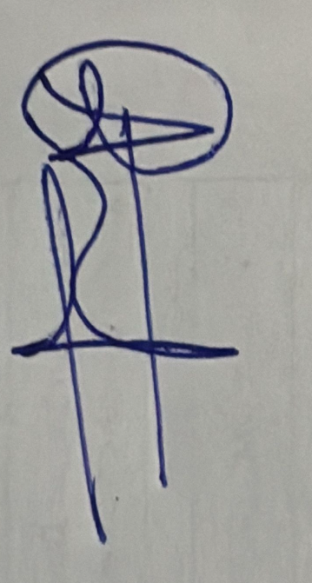

Date: 15-02-2026

