REAL ESTATE MANAGEMENT SYSTEM

SUBMITTED TO: SUBMITTED BY:

Ms. Ankitha philip Ameena sherin.v

RMCA-A

ROLLNO:12

PROJECT ABSTRACT

Real estate management system is a project which provides the facility where user can easily buy, sell their property such as land, house, buildings. This project is mainly designed for real estate professionals. It includes everything we will need to build a new website for real estate. This website can be controlled by an admin.

**Modules**

1.Admin

2.Property owner

3.Broker

4.Buyer

5.Enquiries and Reviews

**Functionalities**

1.Registration

Broker, Buyer, Property owner can register to this system by using email id, user name, password, phone number. In this function a status option is there, that is broker, buyer, and owner. This status is used for redirect all users to their own page.

2.Login

* Admin, buyer, broker, owner can login in this system by using their username and password. After this they are redirected to their own pages.

3.Property

* Admin can add and update property types. That is land, house, building etc.
* Owner, broker can add their own properties in this system for sale. In this function add the details like property title, description about that property, size, features, location, gallery, address etc.
* All users can search the property in search bar with city, property type. It is used for easy finding of properties

4.Add and update

* Admin can add and update property types. That is land, house, building etc.
* Admin can add and update the state, cities in the state, that used for search properties and add properties in those cities in state.

5.Enquiries

* In this section, buyer, broker, owner can request for enquiries about the properties viewed in the system. To give details such as name, phone number, email id, enquiry etc. in the enquiry page, And Owner, broker should give answer to the received request

6.Edit profile

* Admin, broker, buyer, owner can edit their profile using the edit profile option.
* All users can change their password by using the change password option.

7.Review

* All users can give reviews and complaints about the system.it is used for future development.

REAL ESTATE MANAGEMENT SYSTEM

TABLE DESIGN

SUBMITTED TO: SUBMITTED BY:

MS.ANGITHA PHILIP AMEENA SHERIN.V

RMCA-BATCH A

ROLL NO:12

Tbl_registration

|  |  |  |
| --- | --- | --- |
| Field | Datatype | Constraints |
| RID | int | Primary key |
| Full_name | Varchar(100) | NOT NULL |
| Address | Varchar(500) | NOT NULL |
| Mob no | Int(10) | NOT NULL |
| Status | Varchar(20) | NOT NULL |

Tbl_login

|  |  |  |
| --- | --- | --- |
| Field | Datatype | Constraints |
| UID | int | Primary key |
| RID | int | Foreign key |
| Email id | Varchar(100) | NOT NULL |
| Password | Varchar(100) | NOT NULL |
| Status | Varchar(20) | Foreign key |

Tbl_country

|  |  |  |
| --- | --- | --- |
| Field | Datatype | Constraints |
| CID | int | Primary key |
| CountryName | Varchar(100) | NULL |

Tbl_state

|  |  |  |
| --- | --- | --- |
| Field | Datatype | Constraints |
| SID | int | Primary key |
| CID | int | Foreignkey |
| StateName | Varchar(100) | NULL |

Tbl_district

|  |  |  |
| --- | --- | --- |
| Field | Datatype | Constraints |
| DID | int | Primary key |
| CID | Int | Foreign key |
| SID | Int | Foreign key |
| CityName | Varchar(100) | NULL |

Tbl_propertytype

|  |  |  |
| --- | --- | --- |
| Field | Datatype | Constraints |
| PID | int | Primary key |
| PropertyType | Varchar(100) | NULL |

Tbl_property

|  |  |  |
| --- | --- | --- |
| Field | Datatype | Constraints |
| ID | int | Primary key |
| PID | int | Foreign key |
| UserId | int | Foreign key |
| Property title | Varchar(100) | NULL |
| PropertyDescription | Varchar(100) | NULL |
| PropertyType | Varchar(50) | Foreign key |
| Status | Varchar(100) | NULL |
| Location | Varchar(200) | NULL |
| Area | Varchar(50) | NULL |
| Size | Varchar(50) | NULL |
| SalePrice | Varchar(20) | NULL |
| IMG_ID | Varchar(200) | Foreign key |
| Address | Varchar(200) | NULL |
| Country | Varchar(200) | Foreign key |
| State | Varchar(200) | Foreign key |
| district | Varchar(200 | Foreign key |

Tbl_enquiry

|  |  |  |
| --- | --- | --- |
| Field | Datatype | Constraints |
| EID | int | Primary key |
| PID | Int | Foreign key |
| UID | int | Foreign key |
| Message | Varchar(500) | NOTNULL |
| EnquiryDate | timestamp | NOTNULL |
| Status | Varchar(100) | NULL |
| Remark | Varchar(200) | NULL |
| RemarkDate | timestamp | NULL |

Tbl_feedback

|  |  |  |
| --- | --- | --- |
| Field | Datatype | Constraints |
| FID | int | Primary key |
| UrID | int | Foreign key |
| PID | int | Foreign key |
| UserRemark | Varchar(500) | NOTNULL |
| PostingDate | timestamp | NULL |

Tbl_img

|  |  |  |
| --- | --- | --- |
| Field | Datatype | Constraints |
| IMG_ID | int | Primary key |
| Image1 | int | NOT NULL |
| Image2 | Int | NULL |
| Image3 | int | NULL |

Real Estate management system

UML Diagrams

Submitted By:

Ameena sherin.v

RMCA Batch A

Roll No:12

UseCase Diagram

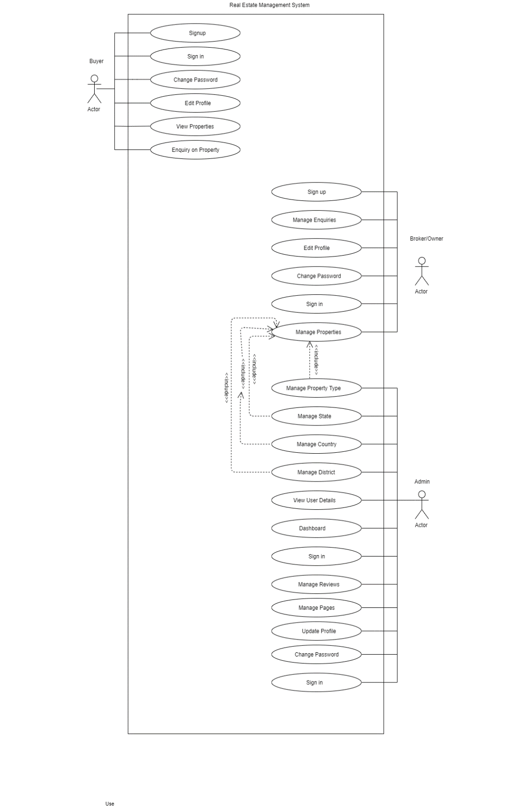

Activity Diagram

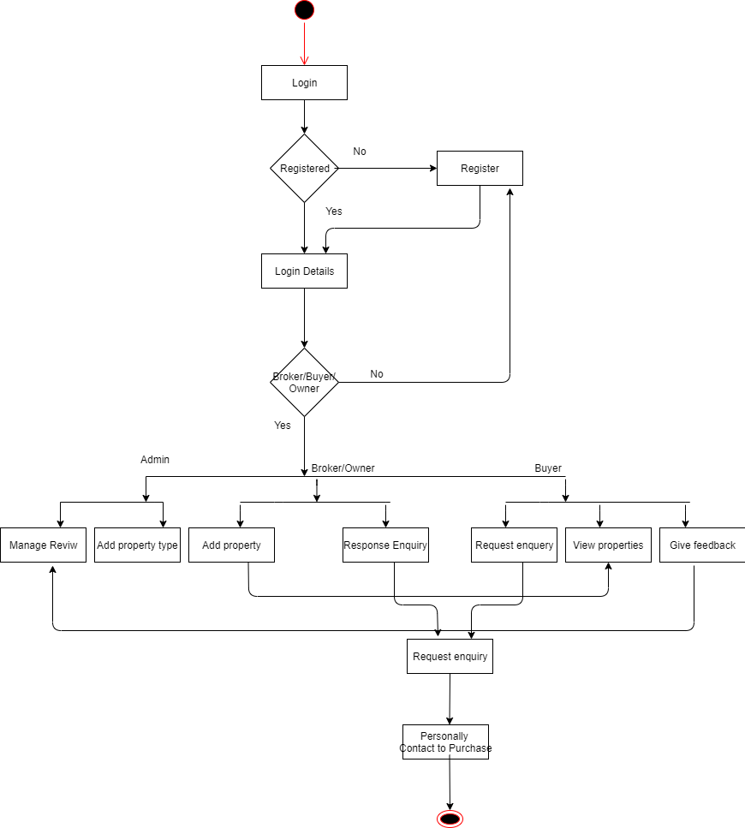

Sequence Diagram

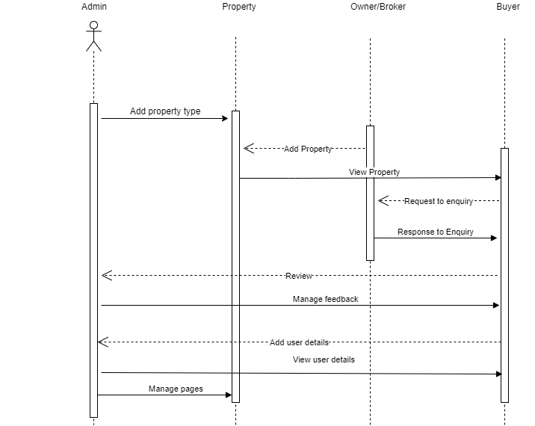

Class Diagram

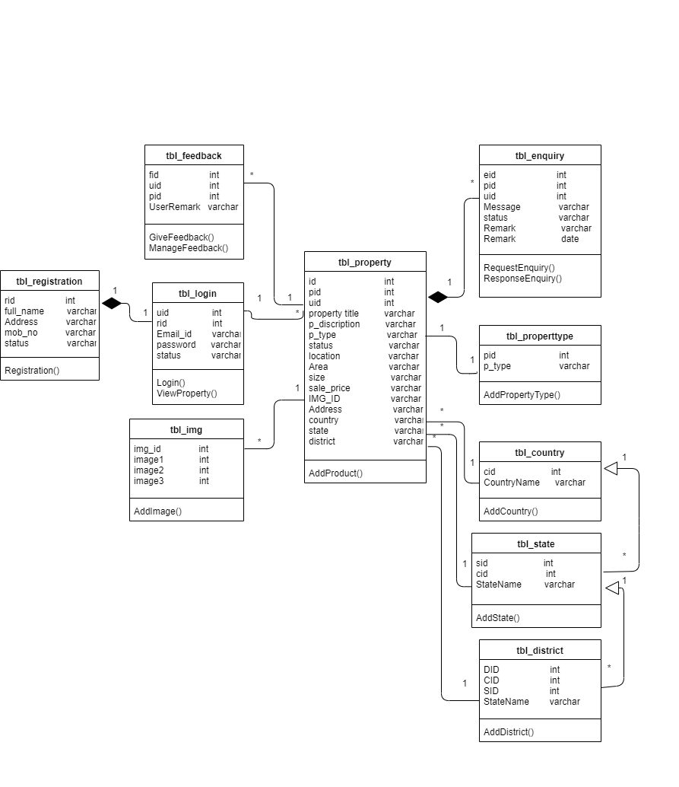

Component Diagram

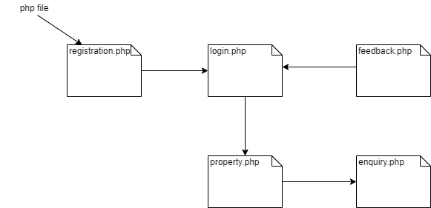

Object Diagram

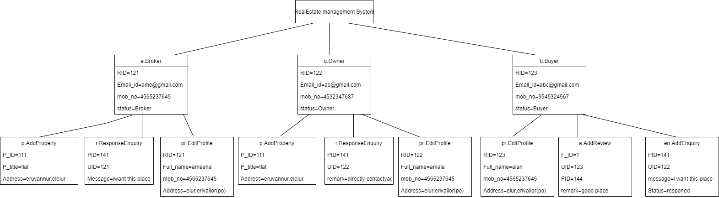

State Diagram

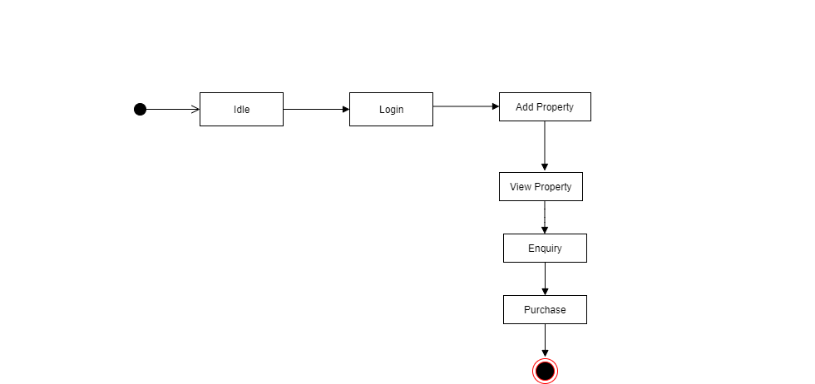

Deployment Diagram

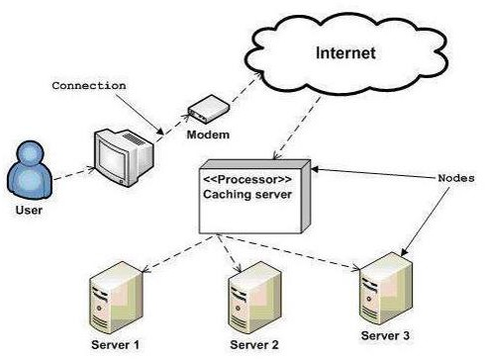

Real Estate management system

Prototypes

Home

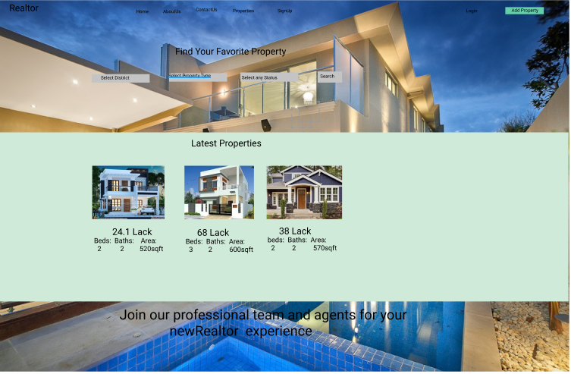

Aboutus

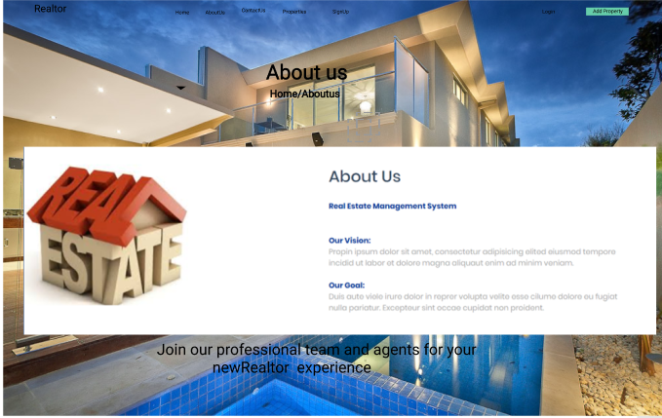

ContactUs



Property

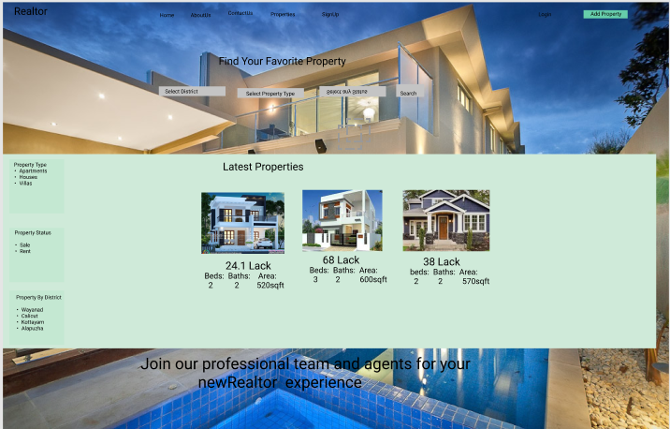

Registration

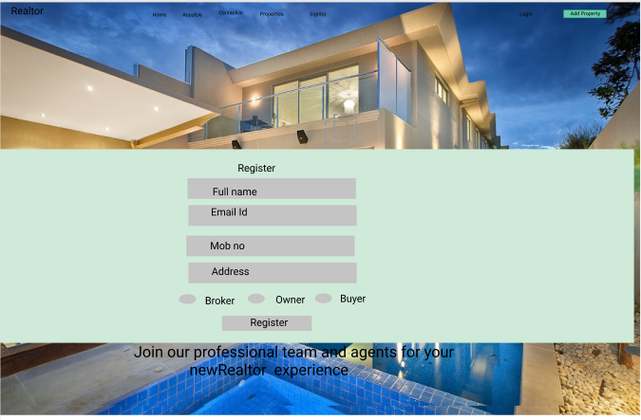

Login

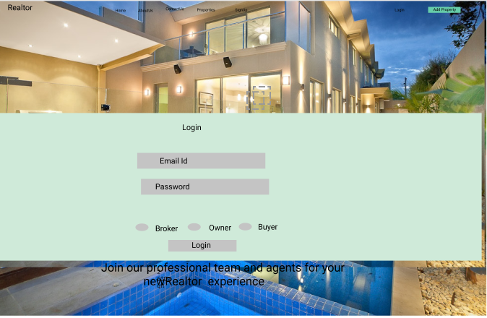

Enquiry

