SMB Plan Cards Revamp

- Mobile Plan Cards
Existing New
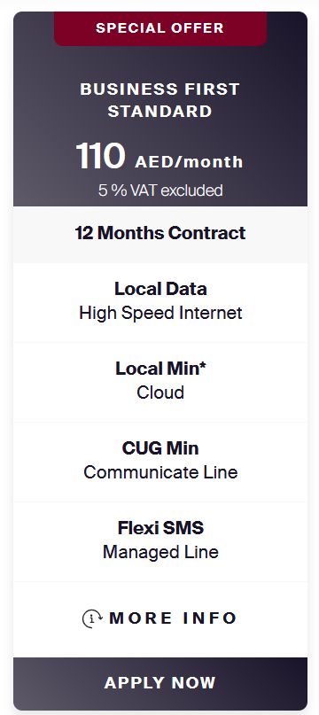
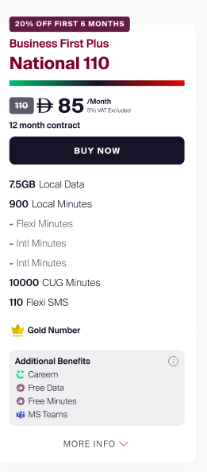

New Features/Changes that need to be implemented on the mobile plan cards are
- Attributes Modification
- Additional Benefits Section
- Filters Section
- Tab Section
- Sub Tab Section
- Popup

- Plan Cards(General & Device Plan Cards)
The below highlighted plan cards require new development.
