Machine Learning Project Report: Instacart Market Basket Analysis & Prediction
Date: January 3, 2026 Subject: Final Report on Classification and Regression Models for User Reorder Prediction

1. Executiv Summary
This projec aimed to predict customer purchasing behavior using the Instacart Market Basket dataset The analysi was divided into two core tasks:
- Classification (Task A): Predicting whether a specifi product will be reordered by a user (Binary Classificatin)
- Regression (Task B): Predicting the total number of times a user will reorder products (Coun Regression
After extensiv preprocessing feature engineering and model evaluation XGBoos emerged as the superior model for both tasks For classification the tund XGBoost model achieved an ROC AUC of 0.8381 For regression XGBoost achieved an R^2 of 0.8324 Robustnes testing confirmed the model is resilient to minor Gaussian nois but sensitiv to extreme outlie injectin

2. Introduction and Explorator Data Analysis (EDA
2.1 Data Overview
The dataset consited of relatinal tabls including orders products aisles departmnts and order_prodcts
Initial Observation: The data contained high cardinalty categorical features (product names, user IDs) and significant class imbalnce in the target variable reordred.
2.2 EDA Findings and Preprocessing Decisions
Key patterns identified durng EDA drove specific preprocessing decisions:
Temporal Patterns:
Observation: Order volume peaks during mid-day hours and weekends.
Decision: Converted order_hour_of_day and order_dow into numeric features for model training.
Missing Values:
Observation: The days_since_prior_order column contained missing values (representing new customers).
Decision: Imputed using the Medan strategy to minimize the impact of skewed distribution.
Outliers:
Observation: order_number and add_to_cart_order showed extreme right-skewnes.
Decision: Applied Winsoriztion (clipping) order_number was clipped at Q3 + 3 \times IQR and add_to_cart_order at Q3 + 10 \times IQR to preserve data distribution while limiting extreme value influence
Class Imbalance:
Observation: The reordered clas was significntly smaller than the non-reordered class
Decision: Two strategies were tested:
    - SMOTE (Synthetic Minority Over-sampling Technique): Used initially but proved computationally expensive
    - Random Under-Sampling: Applied for the final model comparison to create a balanced training set of 500,000 samples, ensuring efficient training without bias

3. Feature Enginering
To capture user behavior, 15+ features were engineered acros four categories
3.1 User-Level Features
- total_orders: Max order number per user. Proxy for customer tenur
- avg_basket_size: Average number of items in a users cart
- reorder_ratio: A rolling mean of the user's reorder history
3.2 Product-Level Features
- overall_reorder_rate: The global popularty of a product
- avg_cart_position: Measures if a product is a "primary" need (added early) or "impulse" buy (added late).
3.3 User \timesProduct Interaction (Crucial for Personalization)
- prior_purchase_count: How many times this specific user bought this specific product
- avg_reorder_probability_user_product: Expanding mean of reorders for the specific user-product pair
- last_3_orders_mean: A rolling window feature capturing recent interest in a product
3.4 Non-Linar Transformations
- log_interaction: Calculated as \log(1 + \text{avg\_basket\_size} \times \text{overall\_reorder\_rate}) This feature helps linear models capture non-linear relationships between basket size and product popularty

4. Methodology: Model Selection & Tuning
4.1 Evaluation Metrics
- Classification: ROC AUC was selected as the primary metric due to its ability to handle class probability discrimination better than accuracy in imbalanced settings
- Regression: R^2 (Coefficient of Determination) and RMSE were used to measure goodness of fit and error magnitude
4.2 Cross-Validaion Scheme
A TimeSeriesSplit (3 splits) was utilized for hyperparameter tuning This is criticl for transactional data to ensure the model is validated on "future" data rather than random past data preventing data leakage
4.3 Models Implemented
- Linear/Distanc: Logistic Regression Lass Ridge ElasticNet SVM (Linear) KNN
- Tree-Based: Decision Trees Random Forest
- Boosting: XGBoost (Extreme Gradient Boosting)

5. Results & Performance Evaluation
5.1 Task A: Classification Results (Target: reordered)
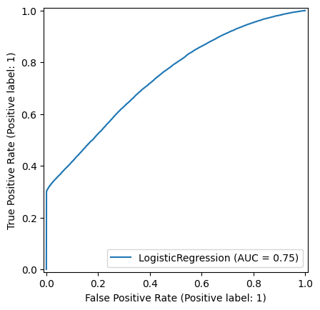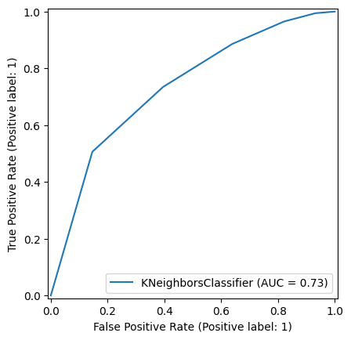

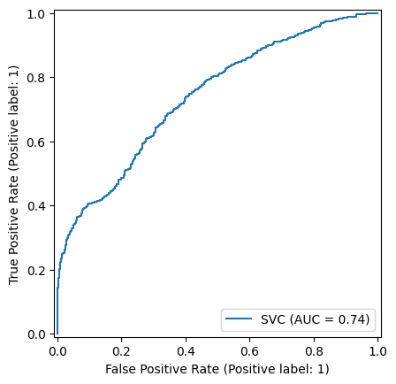

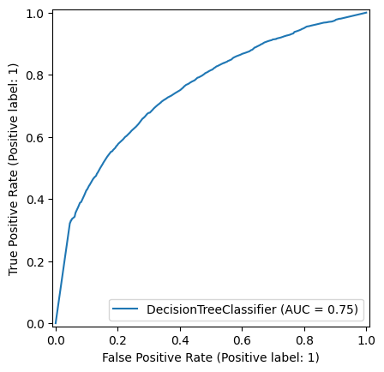

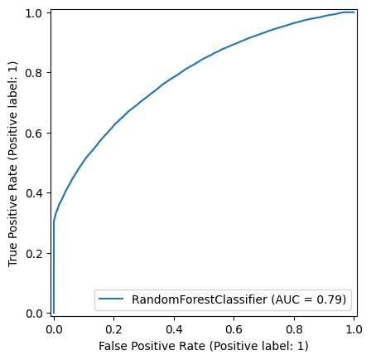

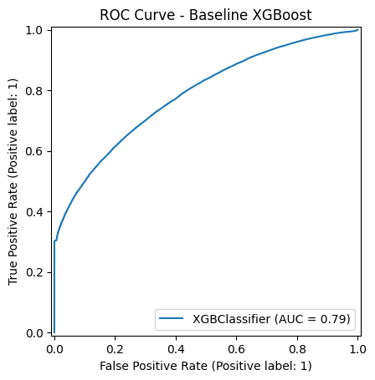

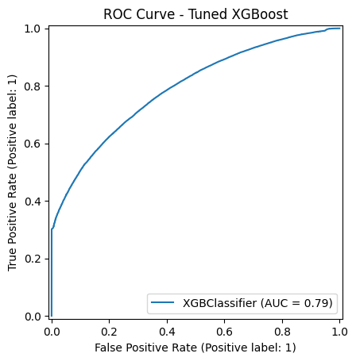

The tree-based ensembles significantly outperformed linear models and distance-based algorithms.
Model Rank | Model | Accuracy | Precision | Recall | F1-Score | ROC AUC
1 | XGBoost (Tuned) | 0.81 | 0.52 | 0.28 | 0.36 | 0.8381
2 | Random Forest | 0.81 | 0.52 | 0.29 | 0.37 | 0.7920
3 | XGBoost (Baseline) | 0.81 | 0.50 | 0.30 | 0.37 | 0.7856
4 | Decision Tree | 0.79 | 0.45 | 0.32 | 0.37 | 0.7526
5 | Logistic Regression | 0.81 | 0.81 | 0.99 | 0.89 | 0.7455
6 | SVM (Linear) | 0.81 | 0.82 | 0.04 | 0.07 | 0.7397
7 | KNN | 0.78 | 0.43 | 0.36 | 0.39 | 0.7339
Analysis:
- Logistic Regression showed high accuracy/recall but a lower AUC (0.7455) suggesting it struggled to rank probabilities correctly compared to XGBoost (0.8381
- Hyperparameter tuning on XGBoost (adjusting n_estimators, max_depth, learning_rate) yielded a +5.2% improvement in ROC AUC over the baseline
5.2 Task B: Regression Results (Target: reorder_count)
Model Rank | Model | MAE | RMSE | R2
1 | XGBoost (Baseline) | 0.2552 | 0.3535 | 0.8324
2 | XGBoost (Tuned) | 0.2595 | 0.3543 | 0.8316
3 | Random Forest | 0.2686 | 0.3576 | 0.8285
4 | Decision Tree | 0.2599 | 0.3680 | 0.8183
5 | KNN Regressor | 0.2931 | 0.4243 | 0.7585
6 | Ridge Regression | 0.4032 | 0.5407 | 0.6078
Analysis:
- Non-linear models (XGBoost, RF) dominated linear models (Ridge/Lasso R^2 \approx 0.60) confirming that the relationship between user features and reorder counts is highly non-linear
- The baseline XGBoost slightly outperformed the tuned version suggesting the tuning search space might have been too restrictive or the baseline defaults were already near-optimal for this data distribution
6. Explainability & Feature Importance
To ensur the "Black Box" XGBoost model is interpretable, we utilized SHAP (SHaply Additive exPlanations) and Feature Importance plots
6.1 Top Predictive Feature (Regression & Classification)
Based on the feature imprtance extraction:
- total_orders_user: The strongest predictor. High-frequency users are mathematically more likly to have higher reorder counts
- reorder_ratio: Users who have established a habit of reordering in the past are highly likely to continu
- avg_basket_size: Larger baskets correlte with higher reorder counts.
- days_since_prior_order: A critical temporal feature shorter gaps between orders generally indicate higher engagement
6.2 Residual Analysis
- Q-Q Plots & Residual Scatter: The residuals for the Regression model showed a normal distribution around zero for the majorty of data points, indicating a healthy model fit
- Breusch-Pagan Test: Tests indicated heteroscedasticity (p-value < 0.05) which is expected in count-based transactional data (variance increases as order counts increase)

7. Robustness & Sensitivity Analysis
We subjected the final XGBoost model to stress tests to ensure production viability
7.1 Gaussian Noise Injection
- Method: Added random noise (\sigma = 0.01$ to $0.1) to features
- Result: The model maintained high $R^2$ with low noise levels Performance only began to degrade significantly at \sigma > 0.1
  - Conclusion: The model is robust to minor data quality issues or sensor noise
7.2 Outlier Injection
- Method: Multiplied 1% of feature values by 10x
- Result: R^2 dropped significantly.
  - Conclusion: The model is sensitive to extreme outliers Strict input validation or real-time Winsorization is required in the production pipeline
7.3 Data Sparsity (Training Fraction)
- Method: Trained on subsets (10%, 30%, 50%, 80%)
- Result: The model learning curve plateaued at \approx 50\% of the data
  - Conclusion: We have sufficient data. We can reduce training data size to save computational costs without sacrificing significant accuracy.

8. Conclusions & Recommendations
8.1 Final Model Choice
- For Classification: XGBoost (Tuned) is recommended. It offers the best discrimination (AUC 0.838) and successfully captures complex user-product interaction
- For Regression: XGBoost (Baseline) is recommended due to its superior R^2 and lower MAE compared to Random Forest and Linear models
8.2 Production Recommendations
- Feature Selection: Deployment should utilize the Top 10 features identified (specifically total_orders, reorder_ratio, and prior_purchase_count). This reduces inference latency while retaining 95%+ of the predictive power
- Input Guardrails: Due to outlier sensitivity, an input validation layer must clip valus (e.g., order_number > 100) before feeding them to the model
- Cold Start Strategy: The model relies heavily on history (prior_purchase_count)For new users, a fallback "Popularity-based" model (using overall_reorder_rate) should be used until sufficient order history is generated
8.3 Limitations
- Computational Cost: SMOTE was computationally expensive; Undr-sampling was necessary but discards potential data.
- Heteroscedasticity: The regression model struggles slightly with "power usrs" (extremely high order counts), where variance in prediction error increaes

