

Name: Ameen UL Husnaat
Roll No: 2025-SET-05
Course Title: Software Configuration Mangement Technology
Course Code: ST-1206
Class: BS SET 2ND Semester (2025-2029)
Submitted To: Sir Fahad Nisar
Department: Software Engineering

Lab Tasks
Lab Task 1 # Install Git & Configure Identify Setting
Git Version:
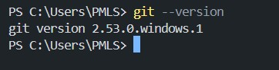

Username Configuration:
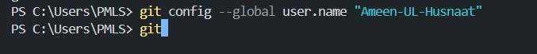

User Email Configuration:

Verify Setting:
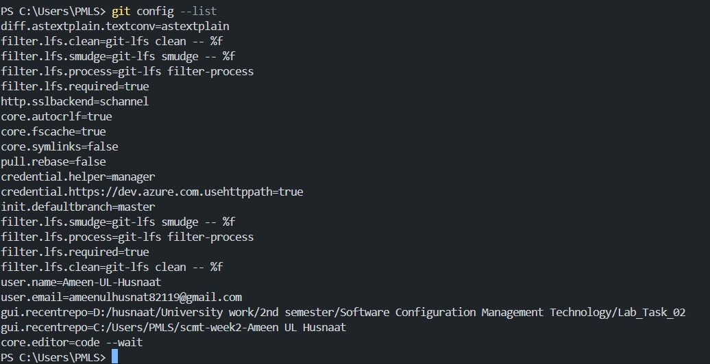

Lab Task 2 # First Repository & Git Workflow
Git Initializing:
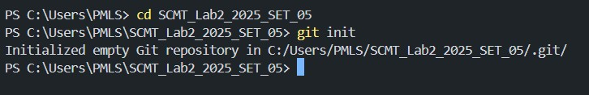

Git Check Status:
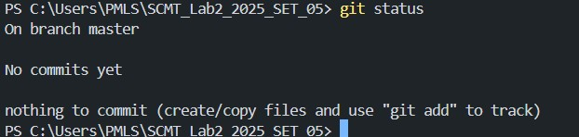

Git Status Untracked, Staged, Clean:
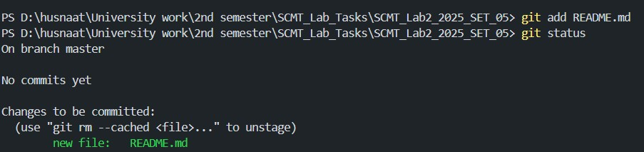

Git Commit Output:
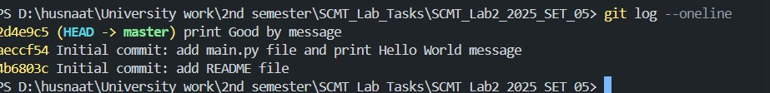

Git Commit History:
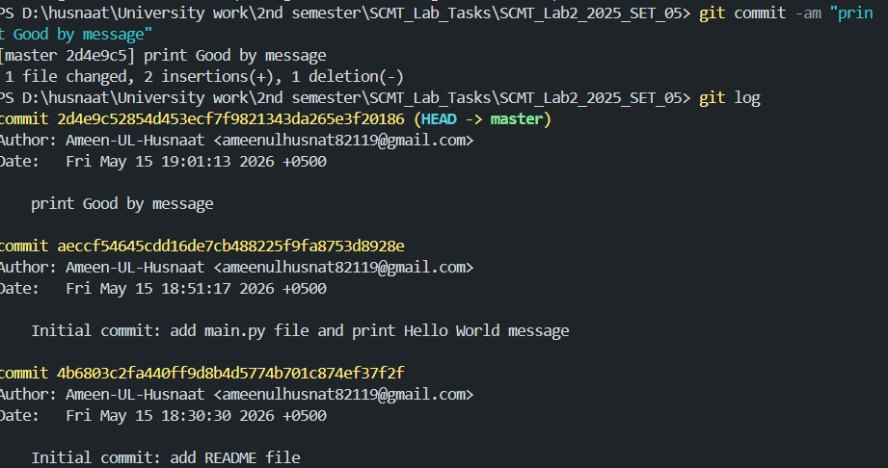

Git Commit Details:
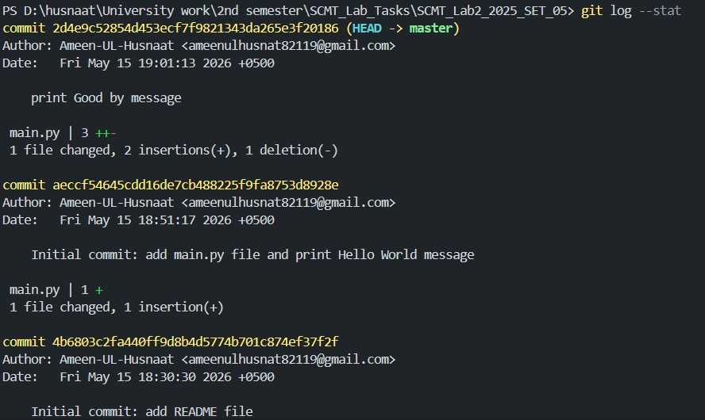

Lab Task 3 # Branching & Merging
Git Branch Creation:

Git Current Branch:
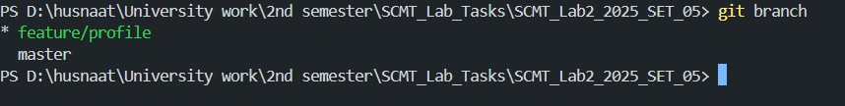

Git Commit on Feature Branch:
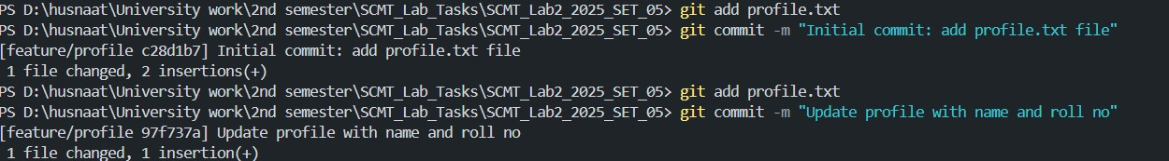

Git Switch Main Branch:
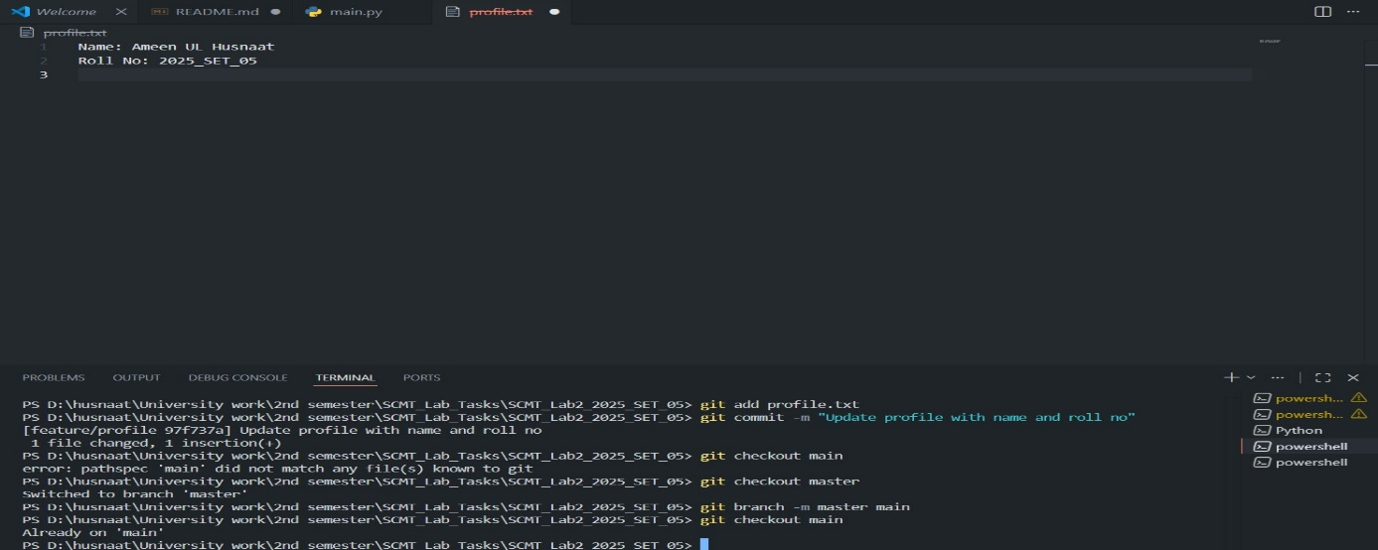
Git Merge Output:
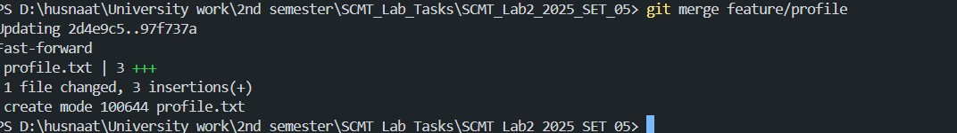

Git Branch Deletion:

Git Merge History:
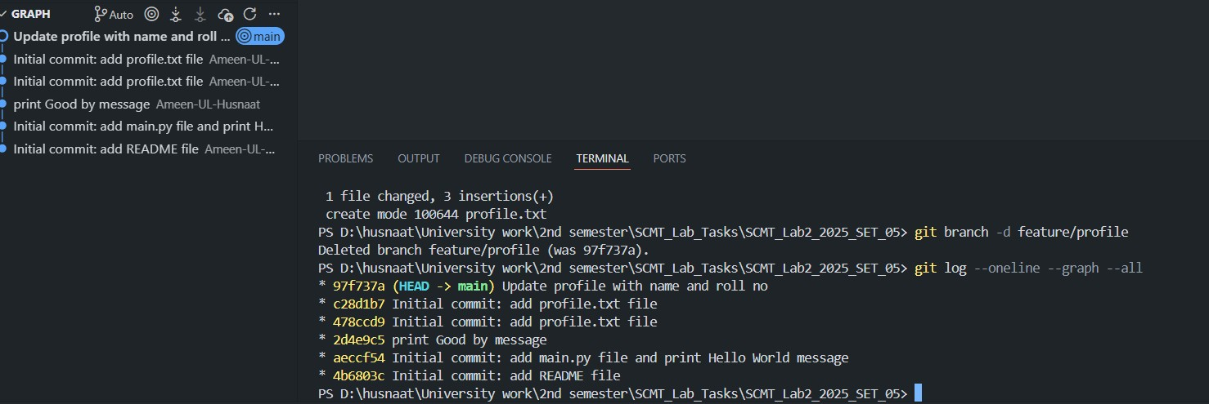

Lab Task 4 # Git Stash & Undoing Changes

Git Stash:

Git Stash List:

Git Stash Pop:
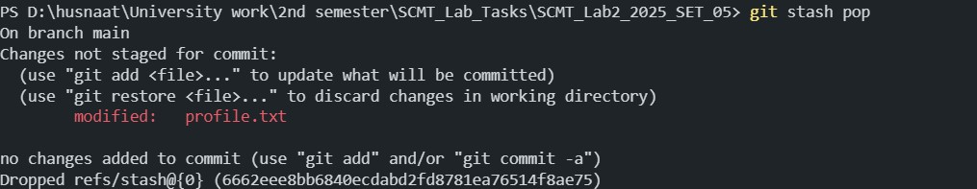

Git Reset –Soft & Status Afterward:
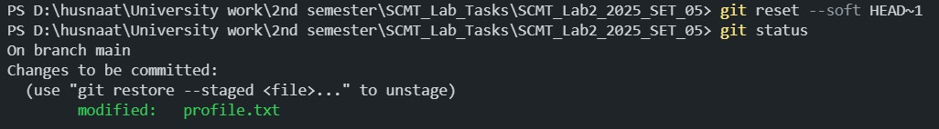

Git Revert Result & Commit Amend:
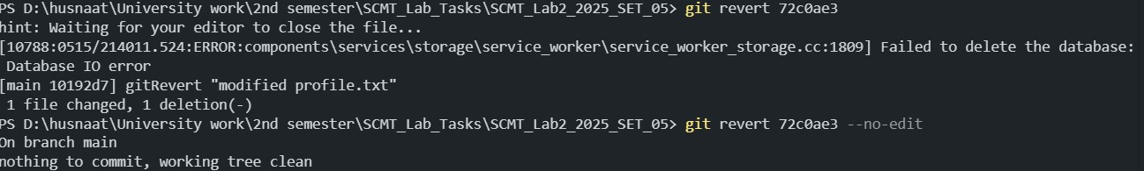

Git Reflog Output:
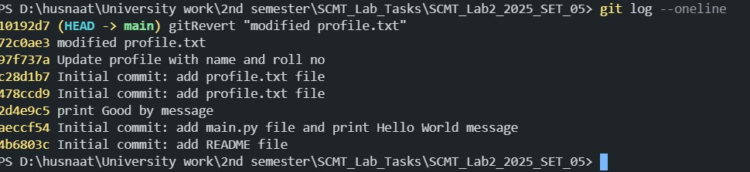

___________________ THE END _____________________

