

Name: Ameen UL Husnaat
Roll No: 2025-SET-05
Course Title: Software Configuration Mangement Technology
Course Code: ST-1206
Class: BS SET 2ND Semester (2025-2029)
Submitted To: Sir Fahad Nisar
Department: Software Engineering

Lab Tasks 5,6,7 & 8
Lab Task 5 # Create a GitHub Repository & Cloning a Public Repository
Step 1: Create a GitHub Account
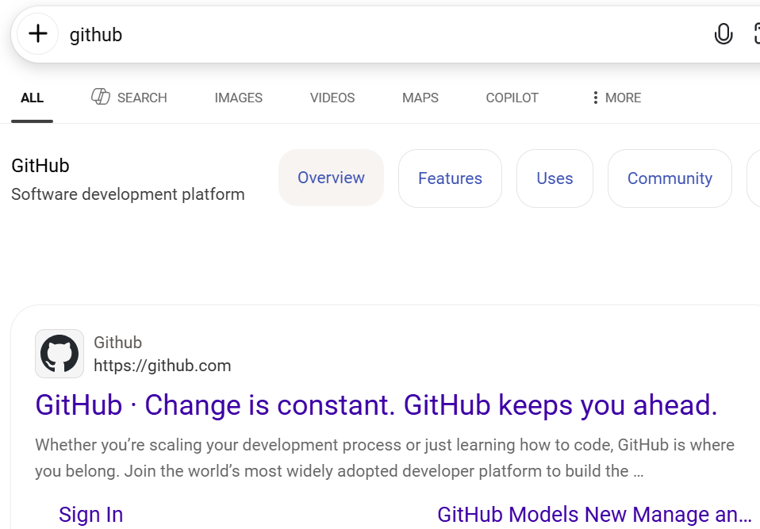

Step 2: Create a Public Repository to a local folder
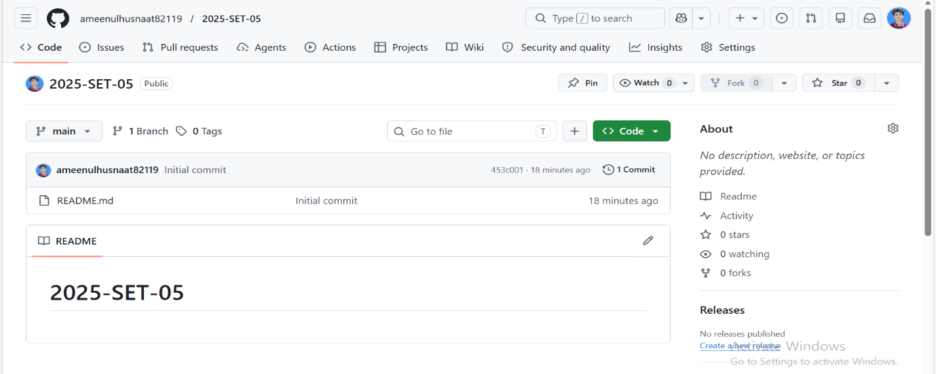

Step 3: Connect Remote Repository to a local Folder
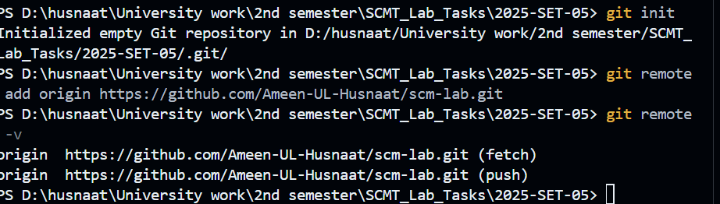

Step 4: Clone a Public GitHub Repository
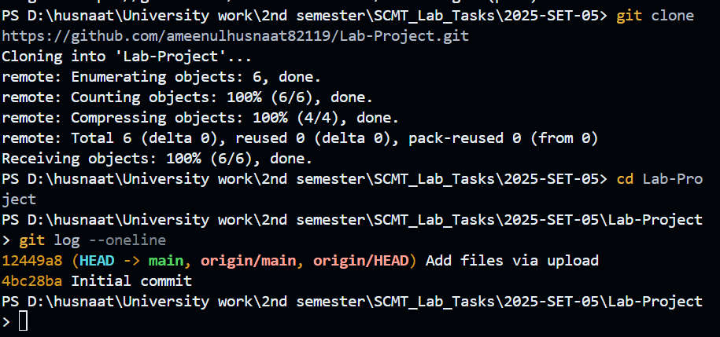

Lab Task 6 # Pushing Code to Remote Repository
(Main & Feature Branch)
Step 1: Push code to Main Branch
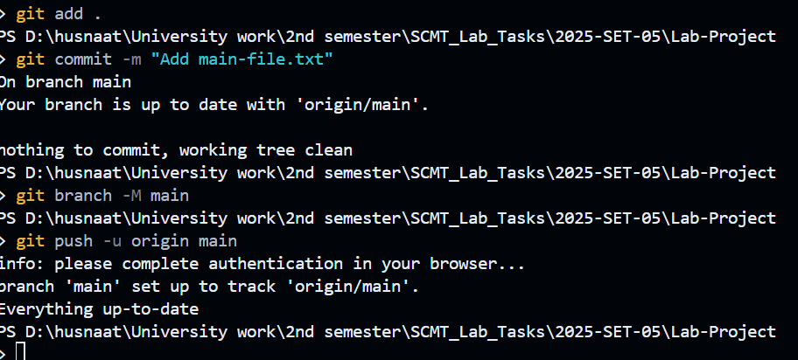

Step 2: Create a new branch push code
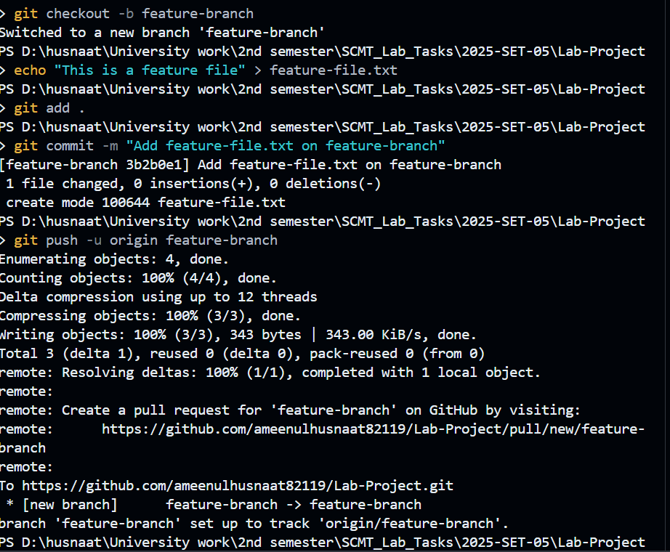

Step 3.1: Verify both Branches are on Github
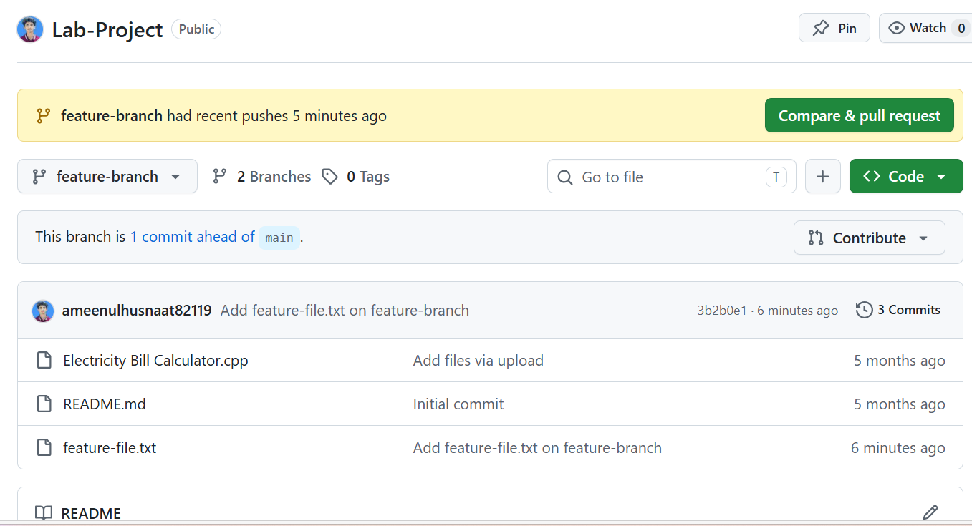

Step 3.2:
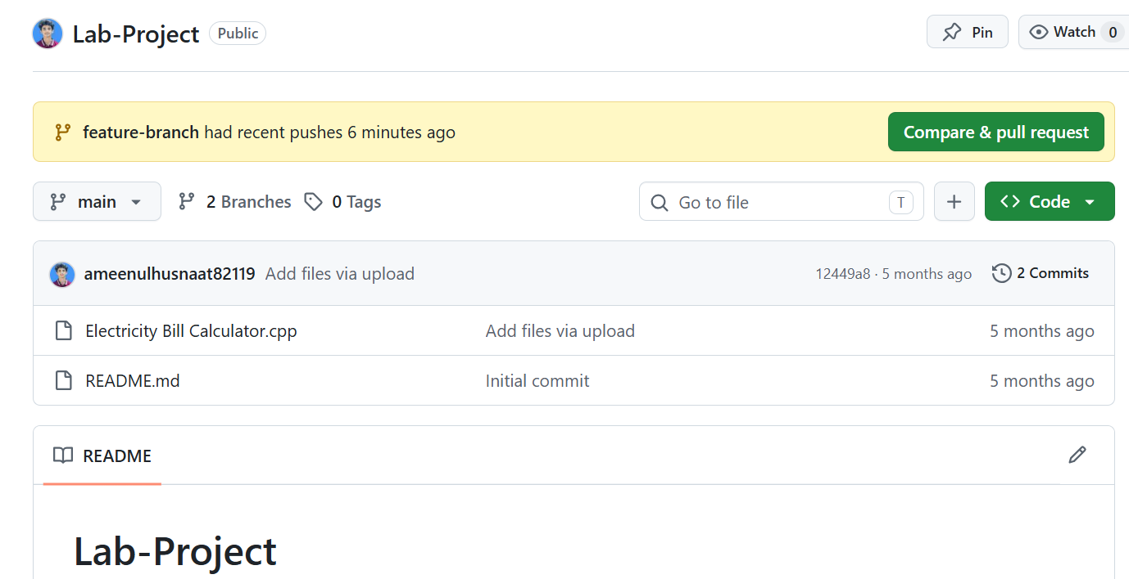

Lab Task 7 # Creating & Merging Pull Request on GitHub
Step 1: Open a pull request
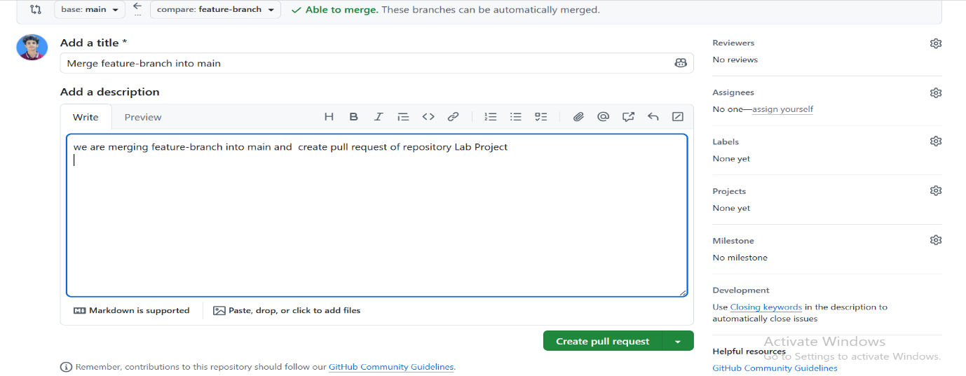

Step 2: Review for Merge Conflict
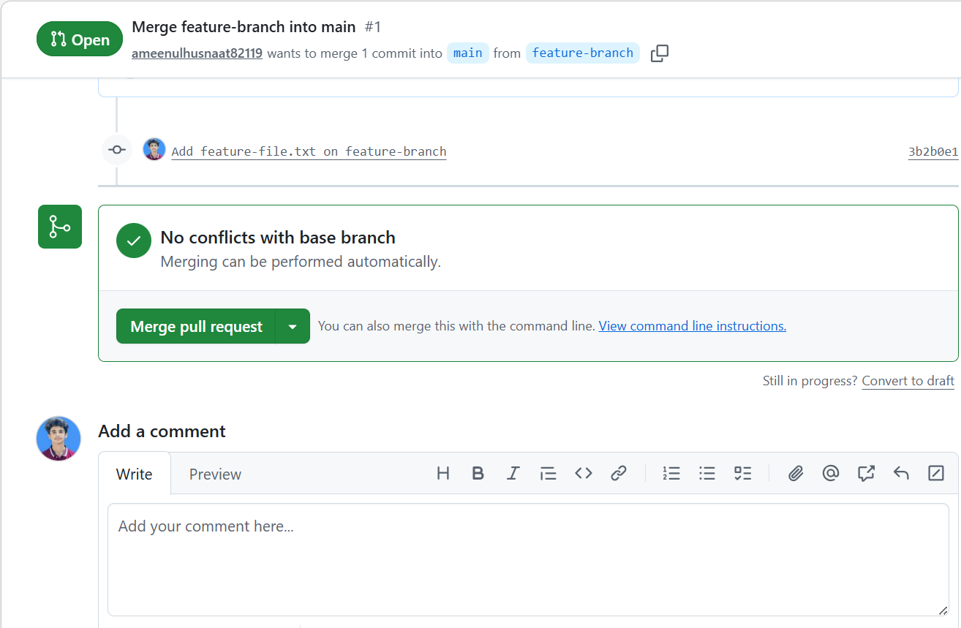

Step 3: Merge the Pull Request
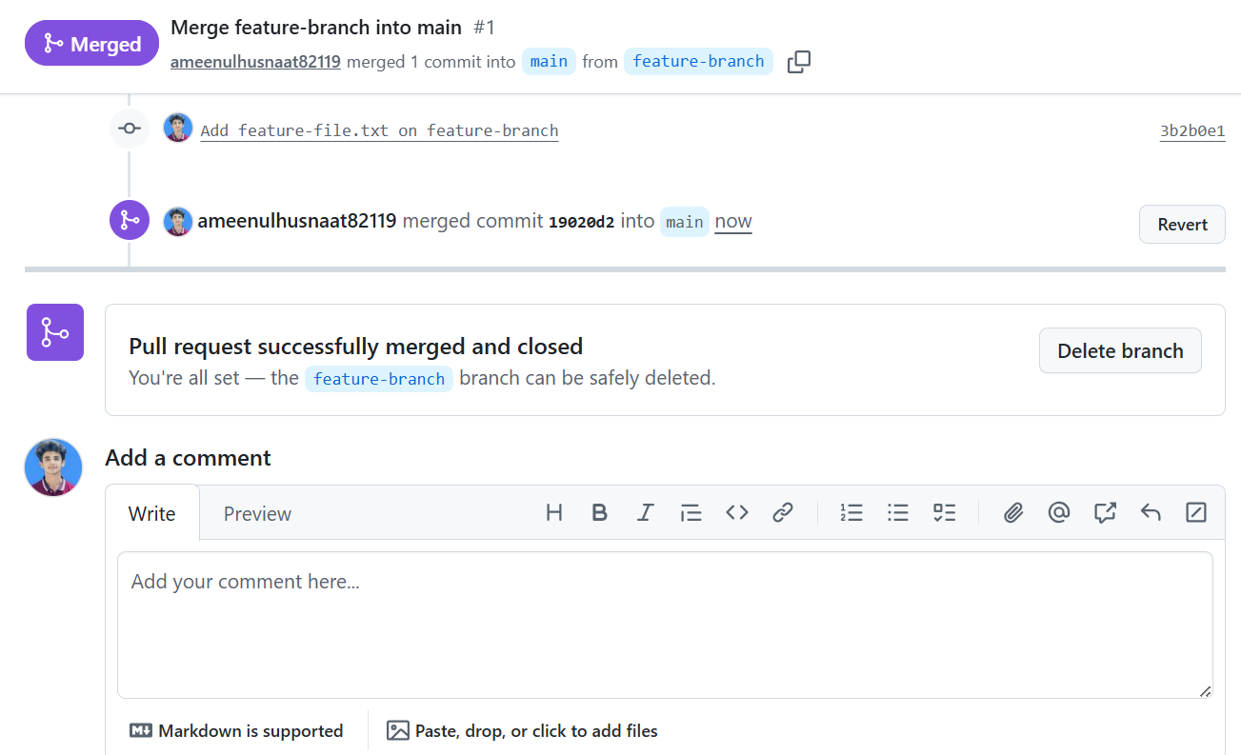

Step 4: Verify the Merge
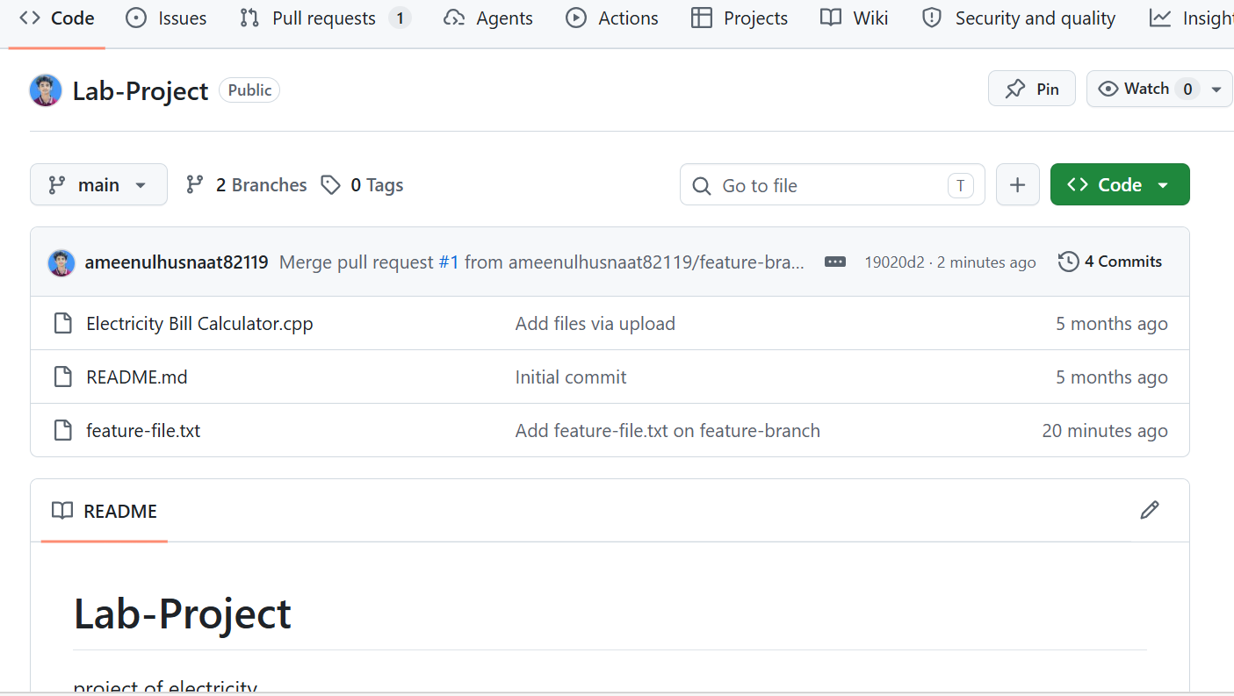

Lab Task 8 # Pulling Remote Changes to Your Local Repository

Step 1: Make a Change Directly on GitHub
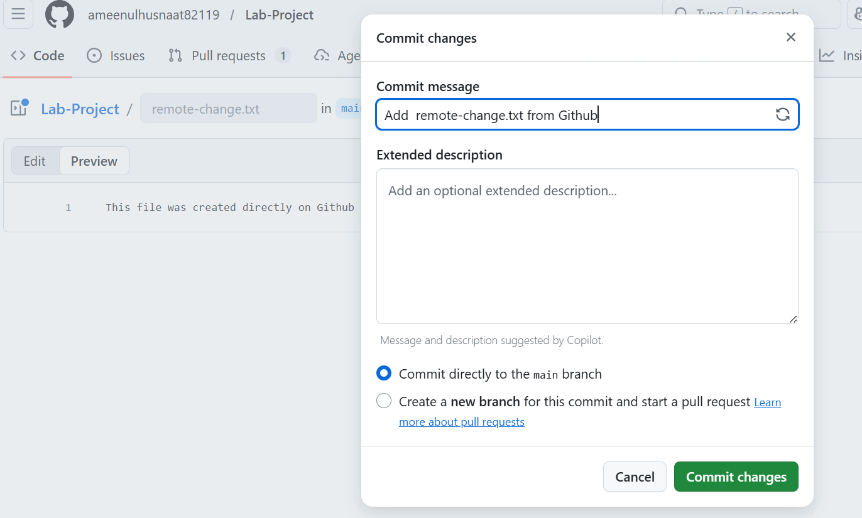

Step 2: Check Your Local Repository Before Pulling
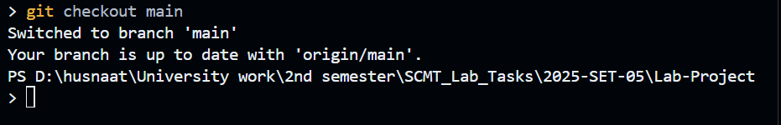

Step 3: Pull the Remote Changes
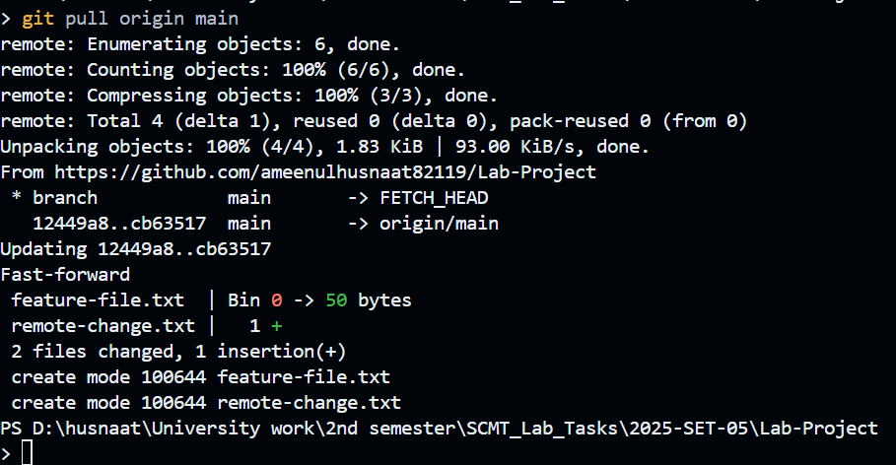

Step 4: Verify the Change Locally
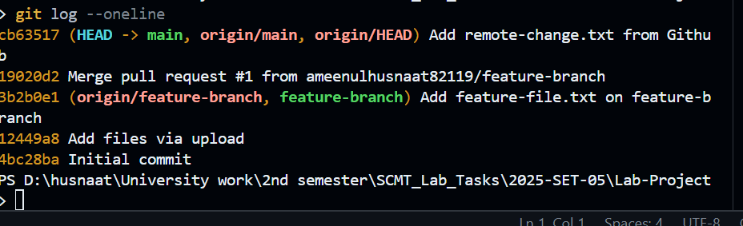

___________________ THE END _____________________

