AHMADU BELLO UNIVERSITY, ZARIA
Department of Computer Science
Object-Oriented Programming (Java)
Group Project Management System
Short Design and Implementation Report
Group Members: IBRAHIM Amiruddeen • DANIEL OTU Courage Daniel • GO'AR Ritmunu Miracle
Instructor: Aliyu Garba (algarba@abu.edu.ng)
1. DESIGN EXPLANATION
The Group Project Management System is a desktop application built with Java Swing and AWT. It helps a course instructor keep student records, organise students into project groups, assign responsibilities, and generate progress reports. All application state is held in memory with standard Java collections (ArrayList and List); there is no external database.
The design follows the Model-View-Controller (MVC) pattern so that data, presentation, and application startup remain separated.
• Model (model package): Student, Group, and Responsibility encapsulate domain data. DataStore is the single in-memory repository and also loads seed records for demonstration.
• View (view package): MainFrame hosts a JTabbedPane with StudentsGroupsPanel, TasksPanel, and ReportsPanel. StudentDialog is a modal form for creating a student.
• Controller (controller package): AppController starts the user interface on the Event Dispatch Thread through SwingUtilities.invokeLater. User actions are handled by listeners in the view classes, which update DataStore and then refresh the visible widgets.
MainFrame owns one DataStore instance and injects it into every panel. That shared store is what keeps the three tabs consistent. A tab-change listener calls refreshData() so that assigning a student to a group on the first tab immediately appears in the task combo boxes. Group.addMember() and removeMember() also write Student.groupId, enforcing the rule that a student belongs to only one group at a time.
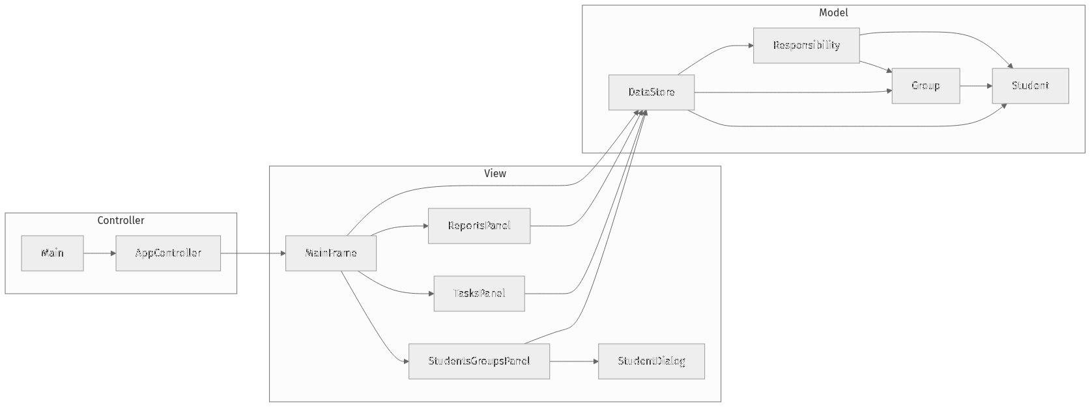
Figure 1. MVC structure and class relationships.
2. GUI COMPONENTS USED
The interface uses 14 Swing/AWT components and four layout managers (BorderLayout, GridLayout, FlowLayout, and GridBagLayout). The table below maps each component to the screen where it appears.
Component | Where it appears | Role
JFrame | MainFrame | Top-level window
JTabbedPane | MainFrame | Students & Groups, Tasks, Reports
JMenuBar / JMenu / JMenuItem | MainFrame | File → Exit and Help → About
JSplitPane | StudentsGroupsPanel | Resizable Students | Groups divider
JTable | Students & Groups, Tasks | Student records and task list
JList | StudentsGroupsPanel | Single-selection group list
JTextArea | Groups panel, Reports | Member details and formatted reports
JComboBox | TasksPanel | Group, assignee, and status selection
JDialog / JTextField | StudentDialog | Modal ID, name, and email form
JButton / JLabel / JPanel / JScrollPane | All views | Actions, labels, grouping, scrolling
Table 1. Swing/AWT components and their locations.
3. APPLICATION SCREENSHOTS
The figures below show the three primary tabs and the Add Student dialog, using the in-memory seed data (Alpha Team and two assigned tasks).
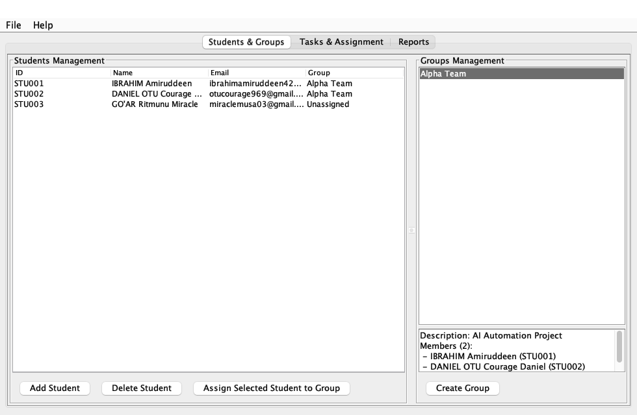 | 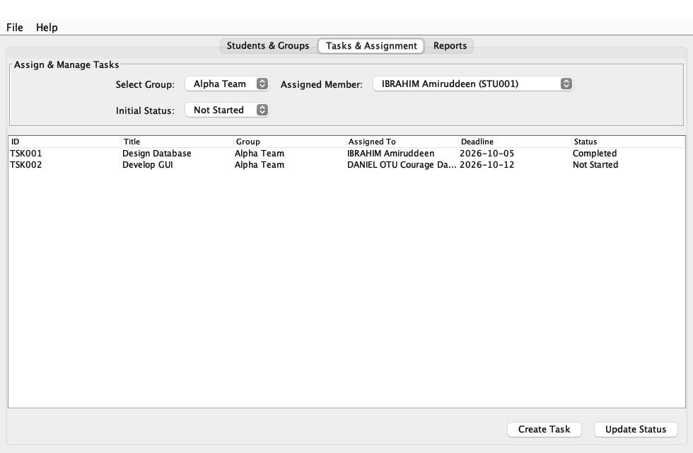
Figure 2. Students & Groups tab (left) and Tasks & Assignment tab (right).
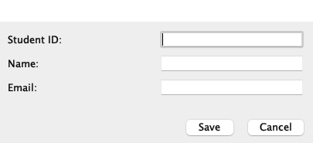 | 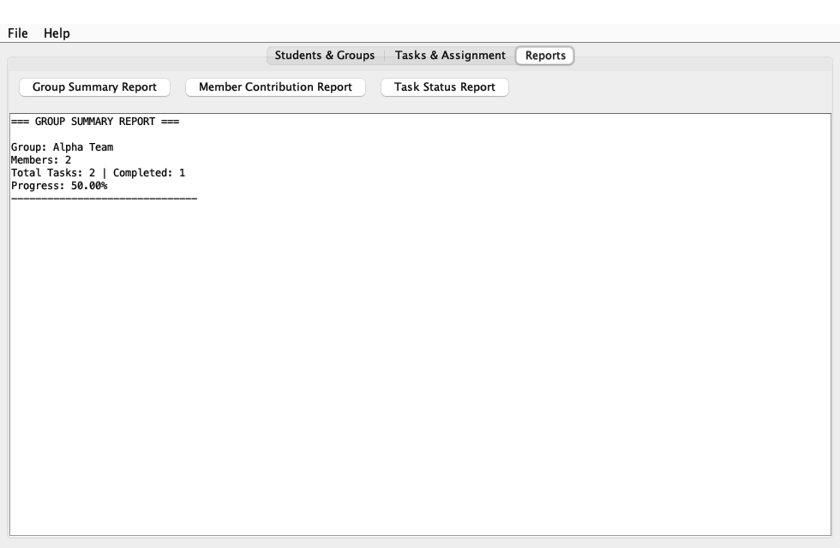
Figure 3. Add Student dialog (left) and Group Summary Report (right).
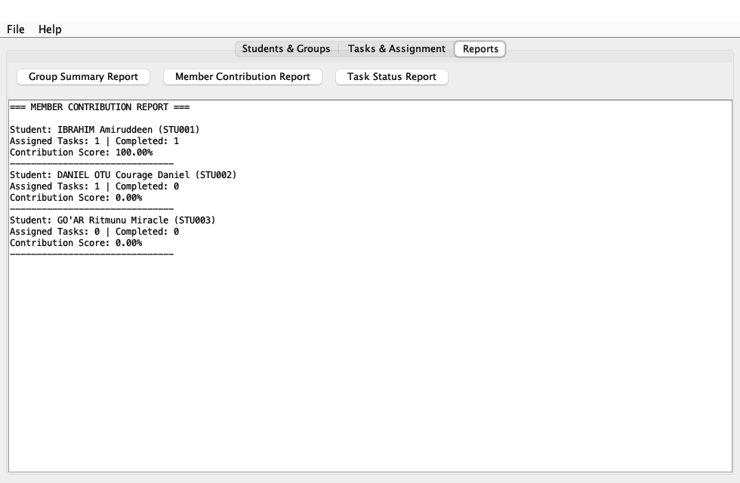 | 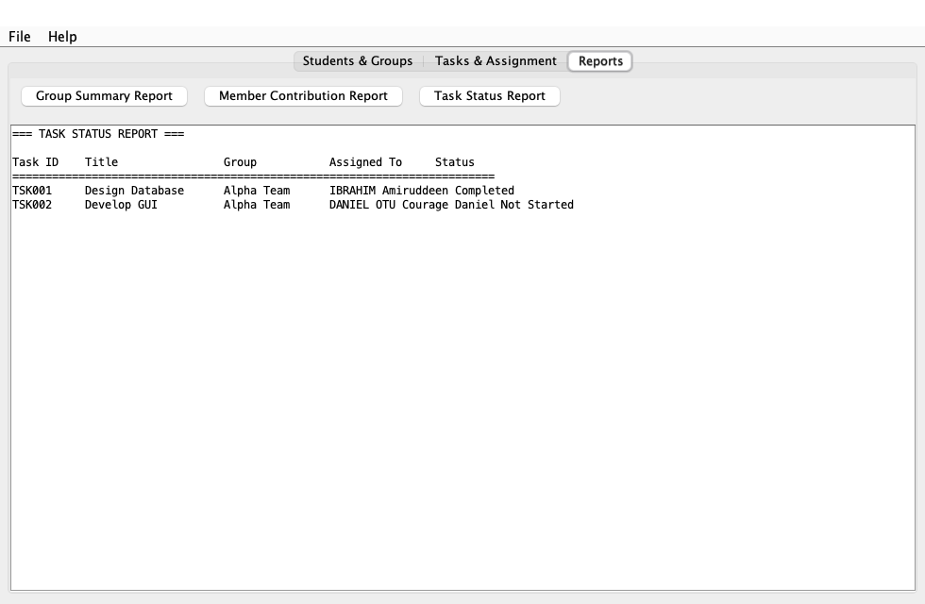
Figure 4. Member Contribution Report (left) and Task Status Report (right).
Key features visible in these screens: adding and assigning students; the one-group membership rule (GO'AR Ritmunu Miracle remains Unassigned until placed in a group); creating tasks with a group, assignee, deadline, and status; and three reports. The group summary computes completion percentage, the member report computes a contribution score per student, and the task report lists every responsibility in a monospaced table.
4. CHALLENGES AND HOW THEY WERE OVERCOME
Applying MVC in Swing. Swing listeners naturally live on components, so a strict controller class for every click would have added ceremony without much benefit. We kept models free of UI code, used AppController only for thread-safe startup, and let each panel act as a local controller over the shared DataStore.
One student, one group. A naive add-to-group operation left students in multiple groups. Before assigning, the panel now removes the student from every existing group. Group.addMember() and removeMember() keep Student.groupId aligned with membership.
Keeping three tabs in sync. Because all screens share one DataStore, stale combo boxes were possible after an assignment. MainFrame registers a JTabbedPane change listener that refreshes the Students and Tasks panels whenever the user switches tabs.
Packed data-entry layouts. The task form needed labels and combo boxes aligned in two rows. GridBagLayout handled that form, while JSplitPane separated student and group management without forcing a fixed width.
Readable reports without a charting library. Progress and contribution values are calculated from streams over the responsibility list and printed in a non-editable, monospaced JTextArea. This met the reporting requirement without extra dependencies.
Overall, the MVC split, a single DataStore, and tab-level refresh were enough to keep the interface consistent while remaining a compact academic Swing application.

