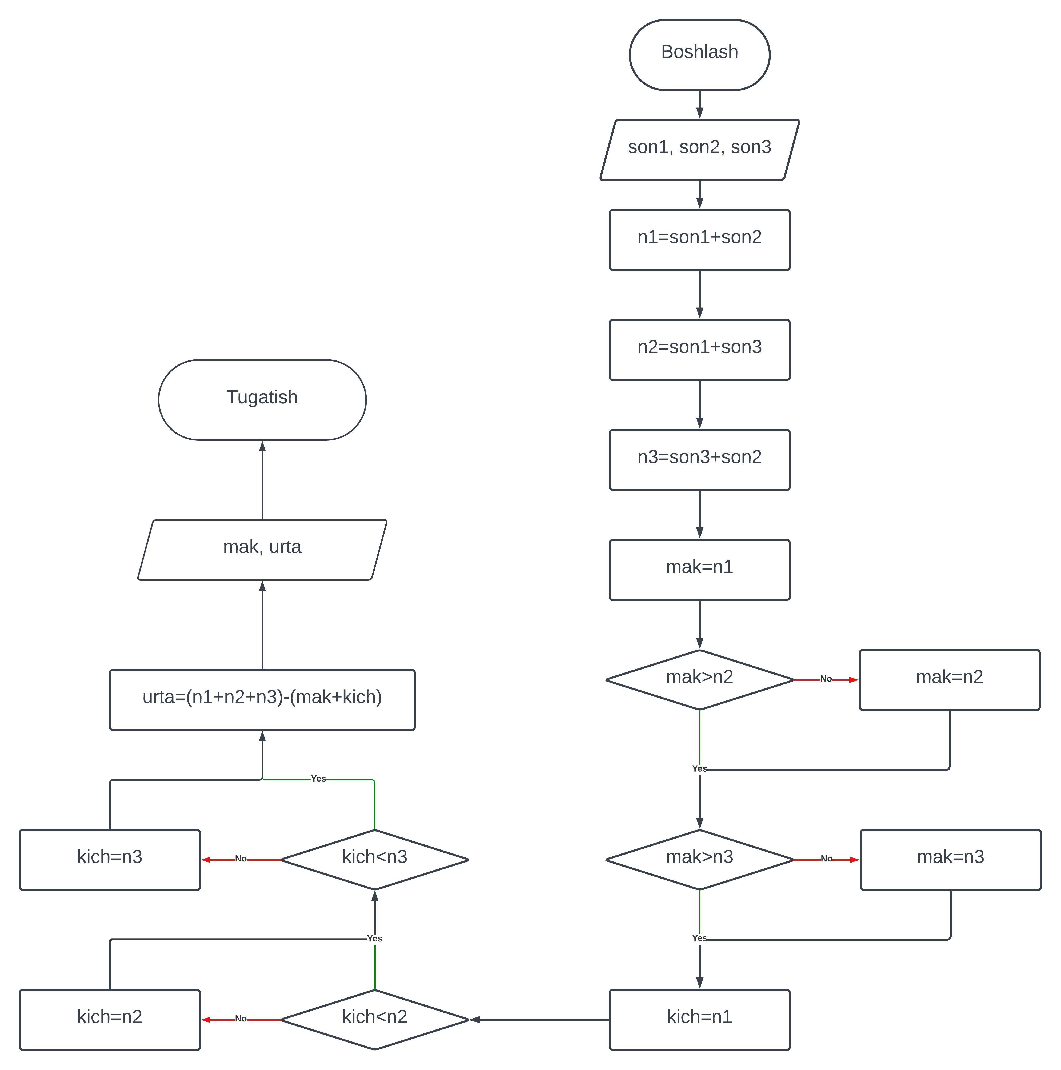

#include <iostream>

using namespace std;

int main()

{

cout << "Bu dastur, siz kiritgan uchta sonning ikkitasini qo'shish orqali hosil bo'lgan eng katta ikkita sonni konsolga chiqaradi.\n";

float son1, son2, son3, n1, n2, n3, mak, kich, urta;

cout << "1-sonni kiriting:_"; cin >> son1;

cout << "2-sonni kiriting:_"; cin >> son2;

cout << "3-sonni kiriting:_"; cin >> son3;

n1 = son1+son2;

n2 = son1+son3;

n3 = son3+son2;

mak = n1;

if (mak<n2) {mak=n2;}

if (mak<n3) {mak=n3;}

kich = n1;

if (kich>n2) {mak=n2;}

if (kich>n3) {mak=n3;}

urta = (n1+n2+n3)-(mak+kich);

cout << "Natija: " << mak << " va " << urta;

cout << endl;

return 0;

}