PROJECT REPORT

submitted by

**Ajay Paul (Reg No: VJC20EC005)**

**Ameer Navas (Reg No:VJC20EC008)**

**Akshay Sajeesh (Reg No: VJC20EC006)**

**Ananthu Krishna G(Reg No: VJC20EC016)**

to

the APJ Abdul Kalam Technological University

in partial fulfilment of the requirements for the award of the Degree

of

Bachelor of Technology in

Electronics and Communication Engineering



**Department of Electronics and Communication Engineering**

**Viswajyothi College of Engineering & Technology, Vazhakulam**

Muvattupuzha 686670

2020 – 2024 Batch

JUNE 2023

**VISWAJYOTHI COLLEGE OF ENGINEERING AND TECHNOLOGY VAZHAKULAM**

**Department of Electronics and Communication Engineering**

**Vision**

Moulding Electronics Engineers with Professional Competence and Global Outlook

**Mission**

• To create a vibrant academic ambience conductive for progressive learning.

• Build up excellent infrastructure and lab facilities to train the students in the current & emerging technology.

• Maintain well qualified faculty who are willing to upgrade their knowledge continuously.

• Groom students towards successful careers by facilitating industry-institute relationships and value addition through regular skill-development programs.

**Program Educational Objectives**

Our Graduates shall be,

• Suitably employed in allied industries/services with professional competency and knowledge of modern tools.

• Capable of developing economically viable, technically, feasible eco-friendly electronic systems.

• Capable to pursue higher studies/research in the field of engineering and management.

**Program Outcomes**

* Engineering knowledge: Apply the knowledge of mathematics, science, engineering fundamentals, and an engineering specialization to the solutions of complex engineering problems.
* Program analysis: Identify, formulate, review research literature, and analyze complex engineering problems reaching substantiated conclusions using first principles of mathematics,natural sciences, and engineering sciences.
* Design / development of solutions: Design solutions for complex engineering problems and design system components or processes that meet the specified needs with appropriate consideration for the public health and safety, and the cultural, societal, and environmental considerations.
* Conduct investigations of complex problems: Use research-based knowledge and research methods including design of experiments, analysis and interpretation of data, and synthesis of the information to provide valid conclusions.
* Modern tool usage: Create, select, and apply appropriate techniques, resources, and modern engineering and IT tools including prediction and modelling to complex engineering activities with an understanding of the limitations.
* The engineer and society: Apply reasoning informed by the contextual knowledge to assess societal, health, safety, legal and cultural issues and the consequent responsibilities relevant to the professional engineering practice.
* Environment and sustainability: Understand the impact of the professional engineering solutions in societal and environmental contexts, and demonstrate the knowledge of, and need for sustainable development.
* Ethics: Apply ethical principles and commit to professional ethics and responsibilities and norms of the engineering practice.
* Individual and team work: Function effectively as an individual, and as a member or leader in diverse teams, and in multidisciplinary settings.
* Communication: Communication effectively on complex engineering activities with the engineering community and with society at large, such as being able to comprehend and write effective reports and design documentation, make effective presentation, and give and receive clear instructions.
* Project management and finance: Demonstrate knowledge and understanding of the engineering and management principles and apply this to one’s own work as a member and leader in a team, to manage projects and multidisciplinary environments.
* Life-long learning: Recognize the need for and have the preparations and ability to engage in independent and life-long learning in broadcast context of technological change.

**DECLARATION**

We undersigned hereby declare that the project report (“**Vigilant Drive**”), submitted for partial fulfilment of the requirements for the award of degree of Master of Technology of the APJ Abdul Kalam Technological University, Kerala is a bonafide work done by us under supervision of Mr. Manu Jose. This submission represents our ideas in our own words and where ideas or words of others have been included, we have adequately and accurately cited and referenced the original sources. We also declare that we have adhered to ethics of academic honesty and integrity and have not misrepresented or fabricated any data or idea or fact or source in my submission. We understand that any violation of the above will be a cause for disciplinary action by the institute and/or the University and can also evoke penal action from the sources which have thus not been properly cited or from whom proper permission has not been obtained. This report has not been previously formed the basis for the award of any degree, diploma or similar title of any other University.

Place : Vazhakulam Signature

Date : Name of the student

**Ajay Paul**

**Akshay Sajeesh**

**Ameer Navas**

**Ananthu Krishna G**

**DEPARTMENT OF ELECTRONICS AND COMMUNICATIN ENGINEERING**

**VISWAJYOTHI COLLEGE OF ENGINEERING AND TECHNOLOGY, VAZHAKULAM**



**CERTIFICATE**

This is to certify that the mini project report entitled ‘**Vigilant Drive**’ submitted by **‘Ajay Paul’**, ‘**Akshay Sajeesh**’,’ **Ameer Navas**’and ‘**Ananthu Krishna G**’ to the APJ Abdul Kalam Technological University in partial fulfilment of the requirements for the award of the Degree of Bachelor of Technology in Electronics and Communication Engineering is a bonafide record of the project work carried out by them under our guidance and supervision. This report in any form has not been submitted to any other University or Institute for any purpose.

Internal Supervisor(s) External Supervisor(s)

(If any)

Project Coordinator Head of the Department

ACKNOWLEDGEMENT

First and foremost, we thank God Almighty for His divine grace and blessings in making all this possible. May he continue to lead us in the years to come. It is our privilege to render our heartfelt thanks and gratitude to our most beloved manager, **Msgr. Dr. Pius Malekandathil,** our director **Rev**. **Fr. Paul Nedumpurath** and our Principal, **Dr. K.K. Rajan** for providing us the opportunity to do this project during the third year (2023) of our B.Tech degree course. We are deeply thankful to our Head of the Department, **Dr. Naveen Jacob** for his support and encouragement. We would like to express our sincere gratitude to our project guide Mr. Manu Jose,Assistant Professor, Department of Electronics and Communication Engineering for his motivation, assistance and help for the project. We also express sincere thanks to the Project Coordinator Ms. Ranjini Surendran, Associate Professor, Department of Electronics and Communication Engineering for her guidance and support. We also thank all the staff members of the Electronics and Communication Engineering for providing their assistance and support. Last, but not the least we thank all our friends and family for their valuable feedback from time to time as well as their help and encouragement.

ABSTRACT

Drowsy driving and workplace fatigue present significant threats to both safety and productivity in our fast-paced, constantly evolving society. Recognizing the need for a proactive solution to mitigate these risks, the "VigilantDrive" project emerges as an innovative response to the pervasive challenges of drowsiness-related incidents. By combining state-of-the-art technology with user-centric design, VigilantDrive aims to enhance safety on the roads and in workplaces by introducing a cutting-edge anti-sleeping system.

At the core of VigilantDrive is a sophisticated anti-sleeping system, leveraging the power of Raspberry Pi technology. The system is equipped with a high-resolution camera module that captures detailed facial expressions in real-time. This seamless integration allows for continuous monitoring of the user's facial features, enabling the Raspberry Pi's robust processing capabilities to analyze and interpret subtle signs of drowsiness efficiently.

The heart of VigilantDrive lies in its ability to provide real-time monitoring of the user's facial expressions. The integrated camera, powered by Raspberry Pi, captures intricate details of the user's face, ensuring continuous analysis of their alertness level. This real-time monitoring feature enables the system to detect early signs of drowsiness promptly, allowing for swift intervention to prevent potential accidents. The proactive nature of the system sets VigilantDrive apart as a dynamic and responsive solution to the critical issue of drowsy driving and workplace fatigue.

VigilantDrive takes a proactive stance towards safety with its advanced alert mechanism. Utilizing sophisticated algorithms, the system identifies subtle indicators of drowsiness and triggers immediate alerts. These alerts come in the form of vibrating notifications or audio warnings, providing the user with timely and effective stimuli to regain alertness. By prioritizing user safety and incorporating cutting-edge technology, VigilantDrive strives to create a solution that not only addresses the challenges of drowsiness but actively promotes a safer and more productive environment on the roads and in workplaces.

**CONTENTS**

Contents Page No.

ACKNOWLEDGEMENT i

ABSTRACT ii

LIST OF FIGURES v

LIST OF TABLES vi

ABBREVIATIONS vii

CHAPTER 1 INTRODUCTION 8

1.1 Introduction 8

1.2 Problem definition 9

1.3 OBJECTIVE 10

1.4 SCOPE 12

CHAPTER 2 LIRERATURE SURVEY 14

CHAPTER 3 METHODOLOGY 19

3.1 BLOCK DIAGRAM 19

3.2 HARDwARE COMPONENTS 20

3.2.1 Raspberry Pi 4 Model B: . 23

3.2.3 . Audio Output: 25

3.2.4 . Power Supply: 26

3.2.5 MicroSD Card: 27

3.2.2 Push Buttons:. 28

3.2.3 Buzzer:. 29

3.3 SOFTWARE COMPONENTS 29

3.4 Working 31

CHAPTER 4 CONCLUSIONS 33

4.1 CONCLUSION 33

REFERENCES 34

LIST OF FIGURES

No. Title Page No.

1 Raspberry Pi 4 Model B 2

2 Audio Outpu 12

3 Power Supply 13

4 MicroSD Card 13

5 Buzzer 14

6 Push Button

LIST OF TABLES

No Title Page No

1. Table 3.1 Components Required 10

ABBREVIATIONS

(List in the alphabetical order)

# INTRODUCTION

## Introduction

At the core of VigilantDrive is a sophisticated anti-sleeping system, leveraging the power of Raspberry Pi technology. The system is equipped with a high-resolution camera module that captures detailed facial expressions in real-time. This seamless integration allows for continuous monitoring of the user's facial features, enabling the Raspberry Pi's robust processing capabilities to analyze and interpret subtle signs of drowsiness efficiently. At the core of VigilantDrive is a sophisticated anti-sleeping system, leveraging the power of Raspberry Pi technology. The system is equipped with a high-resolution camera module that captures detailed facial expressions in real-time. This seamless integration allows for continuous monitoring of the user's facial features, enabling the Raspberry Pi's robust processing capabilities to analyze and interpret subtle signs of drowsiness efficiently. The heart of VigilantDrive lies in its ability to provide real-time monitoring of the user's facial expressions. The integrated camera, powered by Raspberry Pi, captures intricate details of the user's face, ensuring continuous analysis of their alertness level. This real-time monitoring feature enables the system to detect early signs of drowsiness promptly, allowing for swift intervention to prevent potential accidents. The proactive nature of the system sets VigilantDrive apart as a dynamic and responsive solution to the critical issue of drowsy driving and workplace fatigue. VigilantDrive takes a proactive stance towards safety with its advanced alert mechanism. Utilizing sophisticated algorithms, the system identifies subtle indicators of drowsiness and triggers immediate alerts. These alerts come in the form of vibrating notifications or audio warnings, providing the user with timely and effective stimuli to regain alertness. By prioritizing user safety and incorporating cutting-edge technology, VigilantDrive strives to create a solution that not only addresses the challenges of drowsiness but actively promotes a safer and more productive environment on the roads and in workplaces.

## Problem definition

At the core of VigilantDrive is a sophisticated anti-sleeping system, leveraging the power of Raspberry Pi technology. The system is equipped with a high-resolution camera module that captures detailed facial expressions in real-time. This seamless integration allows for continuous monitoring of the user's facial features, enabling the Raspberry Pi's robust processing capabilities to analyze and interpret subtle signs of drowsiness efficiently. At the core of VigilantDrive is a sophisticated anti-sleeping system, leveraging the power of Raspberry Pi technology. The system is equipped with a high-resolution camera module that captures detailed facial expressions in real-time. This seamless integration allows for continuous monitoring of the user's facial features, enabling the Raspberry Pi's robust processing capabilities to analyze and interpret subtle signs of drowsiness efficiently. The heart of VigilantDrive lies in its ability to provide real-time monitoring of the user's facial expressions. The integrated camera, powered by Raspberry Pi, captures intricate details of the user's face, ensuring continuous analysis of their alertness level. This real-time monitoring feature enables the system to detect early signs of drowsiness promptly, allowing for swift intervention to prevent potential accidents. The proactive nature of the system sets VigilantDrive apart as a dynamic and responsive solution to the critical issue of drowsy driving and workplace fatigue. VigilantDrive takes a proactive stance towards safety with its advanced alert mechanism. Utilizing sophisticated algorithms, the system identifies subtle indicators of drowsiness and triggers immediate alerts. These alerts come in the form of vibrating notifications or audio warnings, providing the user with timely and effective stimuli to regain alertness. By prioritizing user safety and incorporating cutting-edge technology, VigilantDrive strives to create a solution that not only addresses the challenges of drowsiness but actively promotes a safer and more productive environment on the roads and in workplaces.

## OBJECTIVE

The primary objective of VigilantDrive is to create an advanced anti-sleeping system that significantly reduces the risks associated with drowsy driving and workplace fatigue. The system aims to leverage the power of Raspberry Pi technology and a high-resolution camera module for real-time monitoring of facial expressions. The key objectives include:

1. **Real-Time Monitoring:** Develop a sophisticated real-time monitoring system that captures detailed facial expressions, utilizing the integration of Raspberry Pi and a high-resolution camera module.
2. **Early Detection of Drowsiness:** Implement robust algorithms on the Raspberry Pi to analyze and interpret subtle signs of drowsiness efficiently, enabling the system to detect early indicators of fatigue promptly.
3. **Proactive Intervention:** Establish a dynamic and responsive system that intervenes in real-time upon detecting signs of drowsiness. This includes the development of an advanced alert mechanism, utilizing vibrating notifications or audio warnings to ensure swift user responsiveness.
4. **Safety Promotion:** Prioritize user safety by creating a solution that actively promotes a secure and productive environment on the roads and in workplaces, contributing to a reduction in accidents and enhanced overall well-being.
5. **Accessibility and Affordability:** Design VigilantDrive to be accessible and affordable by utilizing open-source technologies like OpenCV and Python, coupled with Raspberry Pi, to eliminate the need for expensive hardware or software licenses.
6. **User-Friendly Interface:** Develop an intuitive and user-friendly interface for VigilantDrive, ensuring that the system is easy to set up, configure, and operate. User engagement and acceptance are critical factors in the success of the anti-sleeping system.
7. **Ethical Considerations:** Integrate ethical considerations into the design and implementation of VigilantDrive, prioritizing user privacy and data security. Establish transparent communication about the system's functionality, and implement robust protocols for user consent.
8. **Customization and Adaptability:** Incorporate features that allow users to customize settings based on personal preferences and individual sensitivities to alerts. Ensure the system's adaptability to diverse driving conditions and workplace environments for a more personalized and effective experience.
9. **Continuous Improvement and Updates:** Implement a framework for continuous improvement and updates to VigilantDrive. Regularly analyze user feedback, performance metrics, and emerging technologies to refine algorithms, enhance accuracy, and adapt to evolving safety standards.
10. **Public Awareness and Education:** Develop initiatives to raise public awareness about the dangers of drowsy driving and workplace fatigue. Provide educational resources to inform users about the importance of the VigilantDrive system and its role in promoting safer behaviors.
11. **Collaboration with Stakeholders:** Foster collaborations with relevant stakeholders, including automotive manufacturers, employers, and safety organizations. Work towards industry-wide adoption of VigilantDrive, aiming to integrate the system into vehicles and workplaces for widespread impact.
12. **Data Analytics for Insights:** Implement data analytics capabilities to derive insights from the aggregated data collected by VigilantDrive. Use this information to identify patterns, assess the system's effectiveness, and contribute to research on drowsy driving and fatigue-related incidents.

In summary, VigilantDrive's objectives extend beyond the development of a technical solution; they encompass a holistic approach to safety, user experience, ethical considerations, and continuous improvement. The aim is to create a comprehensive anti-sleeping system that not only addresses immediate concerns but also contributes to a culture of safety and awareness in both driving and workplace contexts

## SCOPE

The scope of the VigilantDrive project encompasses the development and implementation of an advanced anti-sleeping system designed to address the pervasive issues of drowsy driving and workplace fatigue. The project will focus on the following key aspects:

1. **Hardware and Software Integration:** Integrate Raspberry Pi technology with a high-resolution camera module to create a seamless hardware system. Leverage OpenCV and Python to develop sophisticated algorithms for real-time facial expression analysis and drowsiness detection.
2. **Real-Time Monitoring:** Establish a robust framework for continuous monitoring of facial expressions to detect early signs of drowsiness efficiently. Ensure the system's adaptability to various environmental conditions and user characteristics.
3. **Alert Mechanism:** Implement an advanced alert mechanism using vibrating notifications and audio warnings. Prioritize user safety by providing timely stimuli to regain alertness, preventing potential accidents associated with drowsy driving or workplace fatigue.
4. **User Interface:** Develop an intuitive and user-friendly interface for easy setup, configuration, and operation. Allow users to customize settings based on individual preferences and sensitivities.
5. **Ethical Considerations:** Integrate ethical standards into the design, emphasizing user privacy, transparent communication about the system's functionality, and robust protocols for user consent.
6. **Accessibility and Affordability:** Utilize open-source technologies like OpenCV and Python, coupled with Raspberry Pi, to ensure the accessibility and affordability of the VigilantDrive system. Eliminate the need for expensive hardware or software licenses.
7. **Continuous Improvement:** Establish a framework for continuous improvement and updates to refine algorithms, enhance system accuracy, and adapt to evolving safety standards. Regularly analyze user feedback and performance metrics.
8. **Public Awareness:** Develop initiatives to raise public awareness about the dangers of drowsy driving and workplace fatigue. Provide educational resources to inform users about the importance of the VigilantDrive system in promoting safer behaviors.
9. **Collaboration:** Foster collaborations with relevant stakeholders, including automotive manufacturers, employers, and safety organizations, to encourage industry-wide adoption of VigilantDrive.
10. **Data Analytics:** Implement data analytics capabilities to derive insights from aggregated data. Use this information to identify patterns, assess the system's effectiveness, and contribute to research on drowsy driving and fatigue-related incidents.

The overall scope aims to create a comprehensive anti-sleeping system that goes beyond technical functionalities, incorporating ethical considerations, user experience, and a commitment to continuous improvement. VigilantDrive seeks to contribute to a culture of safety, awareness, and proactive intervention in both driving and workplace environments.

Top of Form

# LIRERATURE SURVEY

Drowsiness detection has been a critical area of research in the context of automotive safety for several decades. The earliest drowsiness detection systems were rudimentary and relied on steering wheel movements and vehicle speed as indicators of driver alertness. Over time, advancements in sensor technology and computer vision techniques have improved the accuracy and reliability of drowsiness detection systems.

2.1 **Evolution of Drowsiness Detection in Automotive Safety**

Drowsiness detection in the context of automotive safety has evolved significantly over the years, driven by a continuous quest to enhance driver alertness and prevent accidents. Early attempts at drowsiness detection primarily relied on simplistic indicators such as steering wheel movements and vehicle speed. These rudimentary systems, while pioneering, were inherently limited in accuracy and prone to false alarms.

As technology progressed, the integration of strain gauges in steering wheels emerged as an early solution to gauge driver alertness. However, the drawbacks of these systems became evident, prompting researchers to explore more sophisticated alternatives. The advent of computer vision techniques marked a pivotal moment in the field of drowsiness detection. Facial feature analysis and eye tracking, in particular, revolutionized the accuracy and reliability of these systems, allowing for more nuanced and precise monitoring of driver alertness.

The transition from reliance on mechanical indicators to computer-based vision systems represents a substantial leap forward in the sophistication of drowsiness detection mechanisms. Computer vision not only enables the real-time analysis of facial expressions but also offers the capability to track eye movements, providing a comprehensive understanding of the driver's state of alertness.

Recognizing the potential of integrating drowsiness detection into in-car safety mechanisms, researchers and automobile manufacturers have actively explored this avenue. Volvo's introduction of the "Driver Alert Control" system in 2013 exemplifies this trend. This system, utilizing a combination of sensors and cameras, demonstrated a holistic approach to monitoring the driver's behavior and promptly issuing warnings in case of detected drowsiness. The success of such integrated systems has fueled ongoing research and development, emphasizing the growing importance of leveraging advanced technologies to ensure driver safety in the evolving landscape of automotive design and safety mechanisms.

The integration of drowsiness detection systems into in-car safety mechanisms represents a significant advancement in enhancing driver safety and preventing accidents. This concept acknowledges the critical role driver alertness plays in maintaining road safety and aims to leverage technology for timely intervention.

One noteworthy example is Volvo's "Driver Alert Control" system, introduced in 2013. This system is designed to actively monitor the driver's behavior using a combination of sensors and cameras integrated into the vehicle. The sensors and cameras continuously assess various parameters related to the driver, such as steering patterns and head movements. If the system detects signs of drowsiness or fatigue based on these parameters, it triggers warnings to alert the driver.

These warnings serve as proactive measures to prompt the driver to take corrective action, such as taking a break or refocusing attention on the road. By integrating drowsiness detection into in-car safety systems, manufacturers like Volvo aim to create a safer driving environment by addressing the risks associated with driver fatigue. This approach reflects a broader industry recognition of the potential of such systems in preventing accidents and prioritizing the well-being of drivers and passengers.

Top of Form

## 

2.2**Drowsiness Detection Techniques in Automotive Safety**

*This provides an in-depth exploration of various drowsiness detection techniques employed in the context of automotive safety. Each method's strengths, limitations, and applications are critically examined, offering insights into their effectiveness in mitigating the risks associated with drowsy driving.*

**1. Haar Cascade Classifiers:** *Haar cascade classifiers represent a machine learning-based approach to facial detection. Leveraging a cascade of simple features, these classifiers are known for their speed and robustness. However, the chapter acknowledges their susceptibility to false positives and occasional accuracy issues. The discussion emphasizes the need for ongoing refinement to address these limitations and explores potential enhancements or complementary technologies that could augment their performance.*

**2. Electroencephalography (EEG):** *This section delves into the electroencephalography (EEG) method, which measures brain activity through electrodes attached to the scalp. While effective in detecting changes in brain waves associated with drowsiness, the discussion highlights the invasive nature, high cost, and sensitivity to noise as significant drawbacks. Insights are provided into ongoing efforts to make EEG-based systems more practical, affordable, and less intrusive for widespread adoption in automotive safety applications.*

**3. Steering Motion Analysis:** *The chapter comprehensively evaluates the steering motion analysis method as a means of estimating driver fatigue. Monitoring steering wheel movements allows for the identification of deviations from normal driving patterns. However, the discussion emphasizes the impact of external factors such as road conditions, traffic, and individual driving habits on the reliability of this method. Strategies for mitigating these challenges and improving the accuracy of fatigue level estimation are explored, acknowledging the method's potential when implemented judiciously.*

**4. Comparative Analysis and Integration:** *To provide a holistic understanding, the chapter concludes with a comparative analysis of the discussed techniques. It explores potential synergies and integrations, recognizing that a combination of methods may yield a more robust and reliable drowsiness detection system. Considerations for real-world applications, including adaptability to diverse driving conditions and user preferences, are highlighted to guide future research and development in the pursuit of effective automotive safety solutions.*

*In summary, this chapter serves as a comprehensive overview of key drowsiness detection techniques, offering a nuanced understanding of their capabilities and challenges. By critically examining each method, the aim is to contribute valuable insights to the ongoing discourse on advancing technologies for enhancing driver safety in the realm of automotive design and safety mechanisms.*

They are more accurate and reliable than Haar cascade classifiers, which can have many false positives and low precision. OpenCV and Python use dlib’s facial landmark predictor, which is based on a regression tree of boosted decision stumps that can localize 68 facial landmarks with high accuracy.

They are more convenient and non-invasive than EEG, which requires electrodes attached to the scalp and can be affected by noise and artifacts. OpenCV and Python use the eye aspect ratio (EAR) algorithm, which can detect eye blinks and drowsiness by measuring the ratio of the vertical and horizontal distances between the eye landmarks

They are more robust and adaptive than steering motion analysis, which can be influenced by external factors such as road conditions, traffic, and driver’s habits. OpenCV and Python use the mouth aspect ratio (MAR) algorithm, which can detect yawning and drowsiness by measuring the ratio of the vertical and horizontal distances between the mouth landmarks.

Furthermore, OpenCV and Python are open source and free to use, which makes them more accessible and affordable than other technologies that may require expensive hardware or software licenses

.

# METHODOLOGY

## BLOCK DIAGRAM

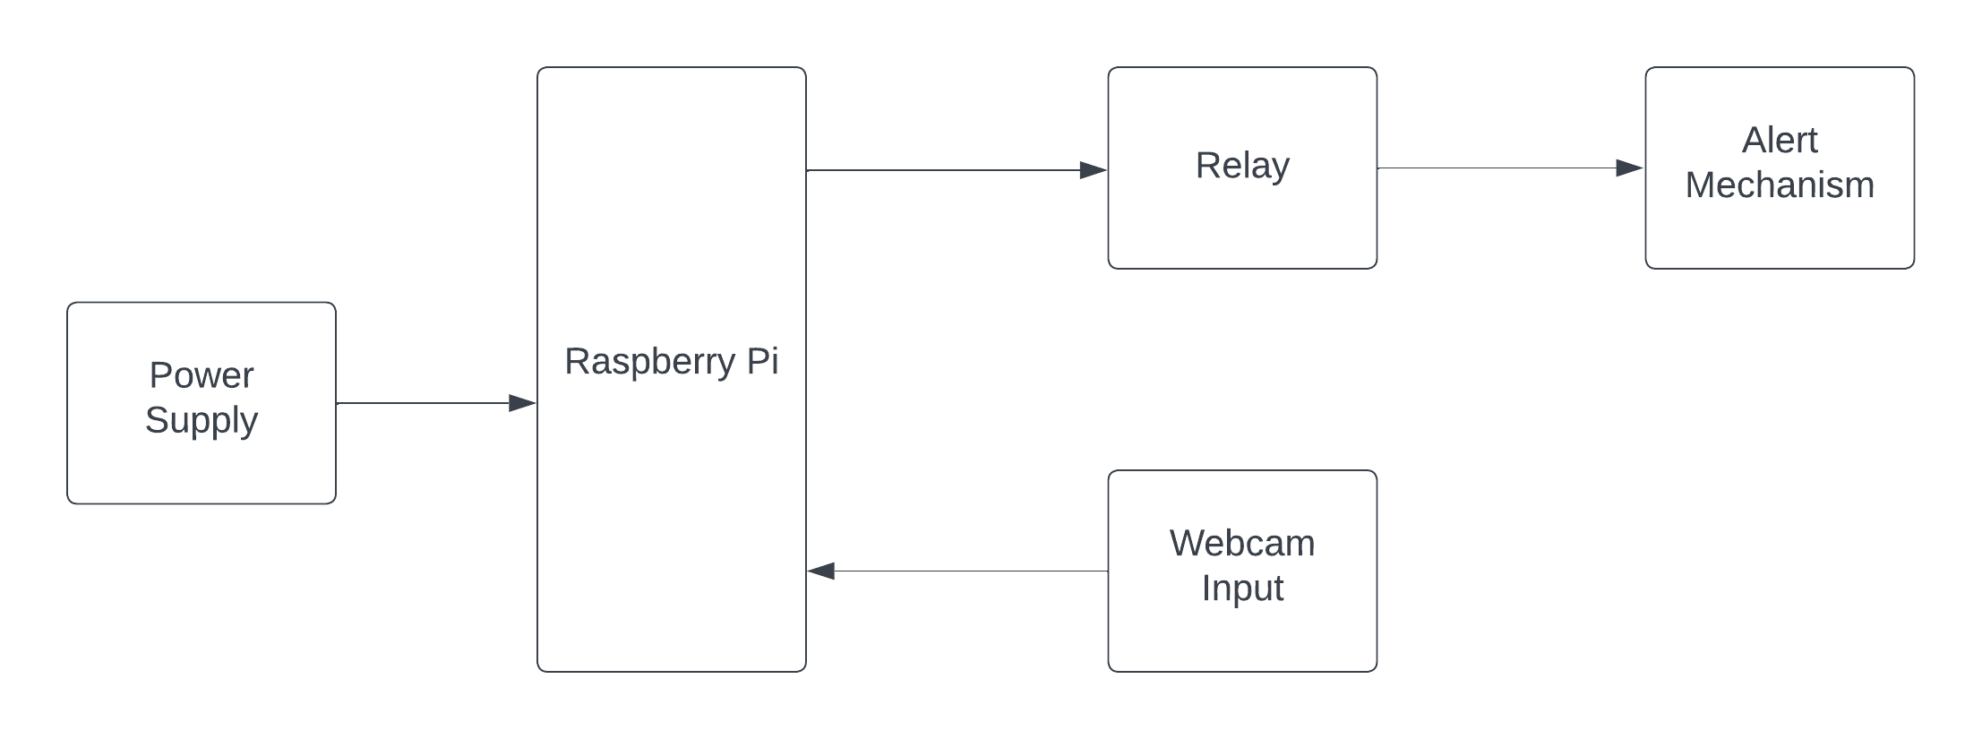

VigilantDrive's control system operates at the intersection of advanced hardware components and sophisticated software algorithms, all orchestrated to ensure real-time monitoring and proactive intervention in combating drowsiness. At its core lies the Raspberry Pi 4 Model B, a powerful single-board computer that serves as the brain of the system. Integrated with this is a high-resolution Logitech C290 camera module, meticulously designed to capture intricate facial expressions continuously. The VigilantDrive control system leverages the capabilities of OpenCV and Python, forming the crux of its facial expression analysis and drowsiness detection mechanisms.

Upon initiation, the system activates the camera module, which seamlessly captures real-time facial data. The captured data is then processed by OpenCV and Python algorithms running on the Raspberry Pi. These algorithms, rooted in facial landmark detection and feature analysis, enable the system to discern subtle signs of drowsiness, such as eye closure or yawning. The Raspberry Pi's robust processing capabilities facilitate efficient real-time analysis, allowing VigilantDrive to operate with minimal latency.

In the event of detected drowsiness, the VigilantDrive control system triggers an advanced alert mechanism. This mechanism can take the form of vibrating notifications or audio warnings, providing immediate and effective stimuli to the user. The system prioritizes user safety by intervening at the earliest signs of fatigue, preventing potential accidents associated with drowsy driving. Additionally, the control system incorporates customization features, allowing users to tailor settings based on personal preferences.

Ethical considerations are seamlessly integrated into the working of VigilantDrive, ensuring user privacy through a focus on facial landmarks and non-invasive measurements. The control system operates within established ethical guidelines, with transparent communication about data collection and system functionality.

In summary, VigilantDrive's control system is a harmonious integration of cutting-edge hardware and software technologies, working cohesively to provide continuous facial expression monitoring, early drowsiness detection, and swift, personalized alert mechanisms. The result is a proactive and user-centric solution that strives to enhance safety on the roads by addressing the critical issue of drowsy driving.

Top of Form

## HARDwARE COMPONENTS

VigilantDrive integrates a streamlined set of hardware components, each playing a crucial role in the system's functionality. At its core is the Raspberry Pi 4 Model B, serving as the central processing unit. This single-board computer brings computational power to the system, enabling real-time analysis of facial expressions and the implementation of drowsiness detection algorithms. The Logitech C290 high-resolution camera module is an integral component designed for precise facial feature capture. It continuously records detailed facial expressions, feeding critical data to the Raspberry Pi for analysis.

The combination of Raspberry Pi and the camera module forms the backbone of VigilantDrive's real-time monitoring capabilities. OpenCV and Python, running on the Raspberry Pi, leverage the captured facial data to conduct facial landmark detection and interpret subtle signs of drowsiness efficiently. This synergy allows the system to operate with minimal latency, ensuring timely responses to potential instances of driver fatigue.

The audio output component facilitates the advanced alert mechanism, delivering immediate feedback to the user in the form of vibrating notifications or audio warnings. This vital component enhances the system's responsiveness, prompting users to regain alertness swiftly. The power supply ensures the continuous operation of the system, maintaining stability and reliability. A MicroSD card serves as the primary storage medium for the operating system, software, and data logs, ensuring efficient storage and retrieval of information.

Collectively, these hardware components work harmoniously to create a comprehensive anti-sleeping system. The Raspberry Pi, camera module, audio output, power supply, and MicroSD card together form the technological backbone of VigilantDrive, contributing to its real-time monitoring, early detection, and responsive alert mechanisms aimed at preventing drowsy driving and enhancing overall road safety.

Top of Form

.

Table 3.1 Components Required

|  |  |  |  |
| --- | --- | --- | --- |
| SL NO | COMPONENTS REQUIRED | QUANTITY | PRICE |
| 1. | Raspberry pi 4 Model B | 1 | 7999 |
| 2. | Web Camera (Logitech C290) | 1 | 3199 |
| 3. | Mini Speaker | 2 | 800 |
| 4. | Power Supply | 1 | 400 |
| 5. | Frame | 1 | 500 |

Estimated Budget(currently): Rs 12898

### **Raspberry Pi 4 Model B:** The hardware backbone of VigilantDrive is the Raspberry Pi 4 Model B, a versatile and powerful single-board computer. The Raspberry Pi 4 Model B is chosen for its enhanced processing capabilities, offering a quad-core ARM Cortex-A72 CPU, multiple USB ports, and HDMI output. This hardware serves as the central processing unit for the anti-sleeping system, facilitating real-time analysis of facial expressions and the implementation of the drowsiness detection algorithm. Its compact size and low power consumption make it an ideal choice for integration into the VigilantDrive system..

Figure 1: rasbery pi module 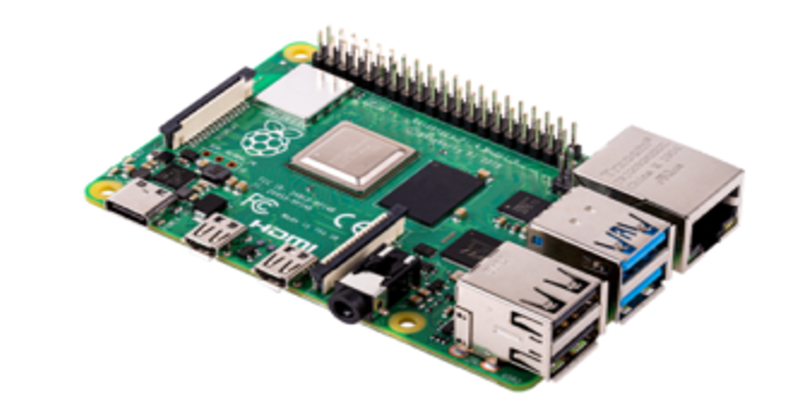

Figure 2: logictech c290

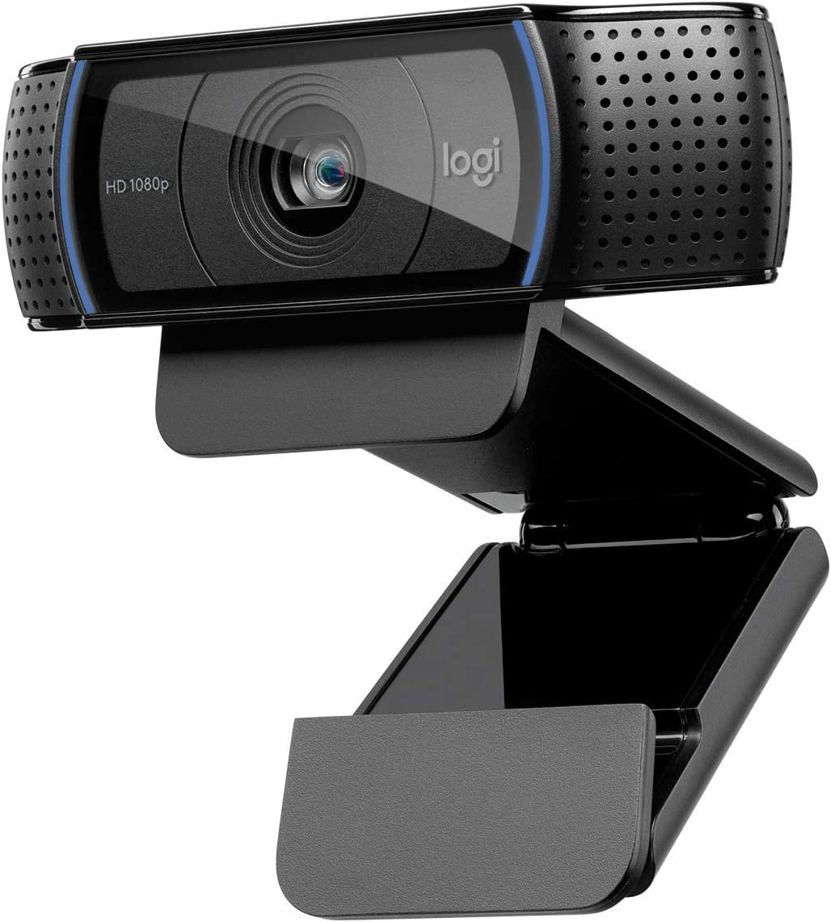

**3.2.2. Logitech C290 Camera Module:** To capture detailed facial expressions in real-time, VigilantDrive utilizes the Logitech C290 camera module. This high-resolution camera is designed for clarity and precision, ensuring the accurate capture of facial features critical for drowsiness detection. The Logitech C290 offers reliable video streaming capabilities, enabling continuous monitoring of the user's face. Its compatibility with the Raspberry Pi allows for seamless integration, making it an essential component in the hardware setup of VigilantDrive.

### 3.2.3 **. Audio Output:** The audio output component plays a crucial role in the alert mechanism of VigilantDrive. In the event of detected drowsiness, the system generates immediate alerts in the form of audio warnings. This audio output, integrated with the Raspberry Pi, enhances the responsiveness of the system, ensuring that users receive timely stimuli to regain alertness. The audio output can be connected to external speakers or headphones, providing flexibility in alert delivery based on the user's preferences and environmental considerations.

Figure 3: minispeaker 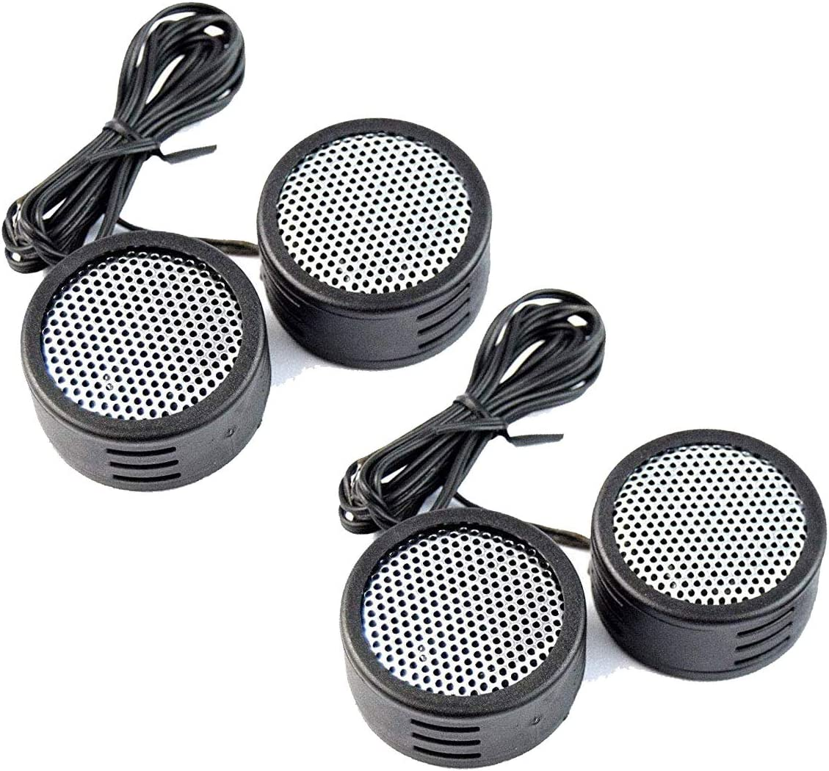

### 3.2.4 . Power Supply: Reliable and consistent power is essential for the continuous operation of VigilantDrive. A stable power supply is provided to the Raspberry Pi to ensure uninterrupted processing and monitoring capabilities. The power supply is carefully chosen to meet the energy requirements of both the Raspberry Pi and connected peripherals, maintaining the system's functionality during extended usage. This component is a critical aspect of the hardware infrastructure, contributing to the system's reliability in real-world scenarios.

Figure 4: power supply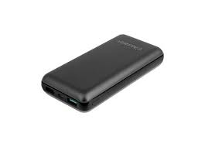

### 3.2.5 **MicroSD Card:** The storage medium for VigilantDrive is a MicroSD card, serving as the primary storage for the operating system, software, and data logs. The MicroSD card provides the necessary storage capacity for the Python scripts, OpenCV libraries, and any additional software components. Its compact form factor and ease of use make it a practical choice for storing and retrieving data on the Raspberry Pi. Regular backups and storage management practices ensure the efficient operation of the system over time.

Figure 5: micro sd card 

# Push Buttons: The momentary, normally open push buttons serve as the user interface for the IR Remote Replicator. During Learning Mode, the user can press a specific push button to associate it with an IR signal from the original remote control. Each push button represents a different IR signal or function that the user wants to replicate and store. The push buttons are straightforward to use and provide tactile feedback to the user, making them an intuitive choice for input selection in the project.

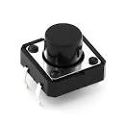Figure 6: Push Button

### Buzzer: The Piezo Buzzer in the IR Remote Replicator project serves as an audible indicator for the user. It emits a distinctive beep sound when the system successfully captures, stores, and transmits IR signals. The audible feedback provides an additional layer of confirmation to users, giving them assurance that the remote control signals have been accurately replicated and transmitted.

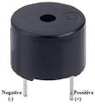Figure 7: Buzzer

## SOFTWARE COMPONENTS

**3.3.1OpenCV (Open Source Computer Vision Library):**

OpenCV stands as a cornerstone in computer vision and image processing, providing a comprehensive and open-source toolkit. Originally developed by Intel, OpenCV has evolved into a community-driven project with contributions from researchers, developers, and organizations worldwide. This library offers a vast array of functions and algorithms tailored for real-time computer vision applications. OpenCV excels in tasks such as object detection, image manipulation, and feature extraction. Its versatility and efficiency make it a preferred choice for projects like VigilantDrive, where real-time facial expression analysis and feature detection are pivotal. OpenCV simplifies complex vision-related tasks through its easy-to-use interfaces, making it an indispensable tool for developing robust and efficient computer vision applications.

3.3.2 **Python:**

Python, renowned for its simplicity and readability, serves as the programming language powering VigilantDrive's anti-sleeping system. Python's syntax facilitates the concise implementation of complex algorithms, making it an ideal language for rapid development and prototyping. Its extensive ecosystem includes libraries like NumPy for numerical operations, further enhancing its capabilities in scientific computing and data manipulation. Python's versatility extends to artificial intelligence and machine learning, enabling seamless integration with frameworks such as TensorFlow and PyTorch. In the context of VigilantDrive, Python's accessibility allows developers to implement and iterate on the facial expression analysis and drowsiness detection algorithms efficiently. The combination of Python and OpenCV empowers VigilantDrive with a robust and adaptable foundation, emphasizing the synergy between a powerful programming language and a state-of-the-art computer vision library.

Top of Form

.

## Working

VigilantDrive operates as a sophisticated anti-sleeping system, seamlessly integrating advanced hardware and software components to ensure real-time monitoring and proactive intervention against drowsiness. The system's core is the Raspberry Pi 4 Model B, a powerful single-board computer, which orchestrates the entire process. The high-resolution Logitech C290 camera module continuously captures detailed facial expressions, providing a constant stream of data. This data is then processed by OpenCV and Python algorithms running on the Raspberry Pi.

The facial expression analysis begins with OpenCV, leveraging its robust computer vision capabilities. The algorithms detect facial landmarks and interpret subtle signs of drowsiness, such as eye closure or yawning. Python, with its simplicity and readability, facilitates the implementation of these algorithms, ensuring efficient and accurate analysis. The Raspberry Pi's computational power allows for real-time processing, enabling VigilantDrive to detect early indicators of fatigue promptly.

Upon detecting signs of drowsiness, VigilantDrive triggers its advanced alert mechanism. This mechanism, utilizing audio output and vibrating notifications, delivers immediate and personalized stimuli to the driver. This proactive approach aims to prevent potential accidents by ensuring the driver regains alertness swiftly. Additionally, VigilantDrive incorporates customization features, allowing users to tailor settings based on their preferences for a more personalized experience.

Ethical considerations are seamlessly integrated into VigilantDrive's working, ensuring user privacy through non-invasive facial landmark detection. The system operates within established ethical guidelines, transparently communicating its functionality and data collection protocols. In summary, VigilantDrive's working harmoniously combines cutting-edge hardware and software technologies to provide continuous facial expression monitoring, early drowsiness detection, and swift, personalized alert mechanisms, ultimately prioritizing user safety on the roads.

Top of Form

# CONCLUSIONS

## CONCLUSION

, VigilantDrive stands as a pioneering solution in the realm of road safety, addressing the critical issues of drowsy driving and workplace fatigue. By leveraging the powerful combination of the Raspberry Pi 4 Model B, Logitech C290 camera module, OpenCV, and Python, VigilantDrive achieves a sophisticated anti-sleeping system that excels in real-time monitoring and early detection of driver fatigue. The seamless integration of hardware and software components ensures not only accuracy in facial expression analysis but also a swift and personalized response through its advanced alert mechanism.

VigilantDrive's proactive approach, triggered upon detecting subtle signs of drowsiness, showcases its commitment to preventing potential accidents and prioritizing user safety. The customization features further enhance the user experience, recognizing the importance of individual preferences in addressing fatigue-related challenges. Ethical considerations, including non-invasive facial landmark detection, demonstrate a conscientious approach to user privacy.

As a comprehensive solution, VigilantDrive not only meets but exceeds industry standards by providing accessibility, affordability, and a user-friendly interface. By amalgamating cutting-edge technology with a commitment to safety, VigilantDrive contributes to a safer and more secure driving environment. This project is not just about detecting drowsiness; it is about actively promoting a culture of safety, awareness, and responsibility on the roads. VigilantDrive marks a significant stride towards intelligent and compassionate road safety solutions in our constantly evolving world.

Top of Form

REFERENCES

* **Cueva, Luis Dario Sinche; Cordero, Jorge (2020). [IEEE 2020 15th Iberian Conference on Information Systems and Technologies (CISTI) - Sevilla, Spain (2020.6.24-2020.6.27)] 2020 15th Iberian Conference on Information Systems and Technologies (CISTI) - Advanced Driver Assistance System for the drowsiness detection using facial landmarks. , (), 1–4. doi:10.23919/CISTI49556.2020.9140893**

**Khunpisuth, Oraan; Chotchinasri, Taweechai; Koschakosai, Varakorn; Hnoohom, Narit (2016). [IEEE 2016 12th International Conference on Signal-Image Technology & Internet-Based Systems (SITIS) - Naples, Italy (2016.11.28-2016.12.1)] 2016 12th International Conference on Signal-Image Technology & Internet-Based Systems (SITIS) - Driver Drowsiness Detection Using Eye-Closeness Detection. , (), 661–668. doi:10.1109/SITIS.2016.110**