Script-Controlled ACL restrict record access based on field value

Project Overview
Milestone-3: Creation of Access Control List-READ
ACL Configuration:
- In the Application Navigator, search for System Security → Access Control (ACL).
- Elevate “Security_admin” role
- Click New to create a new ACL.
- Enter the following details
- Type: record
- Operation: read
- Name: u_institution_details
- Active: true
- Advanced: true
- In the Requires role related list, add: bb1 (custom role)
- Add Data condition as Branch is EEE
- In the Script field, add the following script
- Save the ACL form
(function () {
// Allow admin users full access
If (gs.hasRole(‘admin’)) {
Return true;
}
// Allow only EEE branch users to see EEE records
If (gs.hasRole(‘bb1’)){
Return true;
}
// Deny access for all others
Return false;
})();

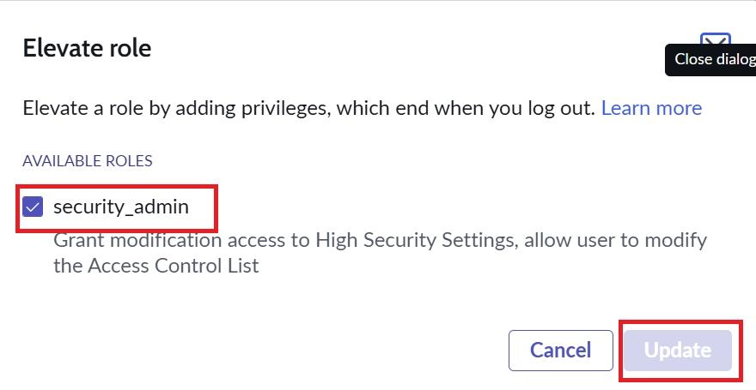

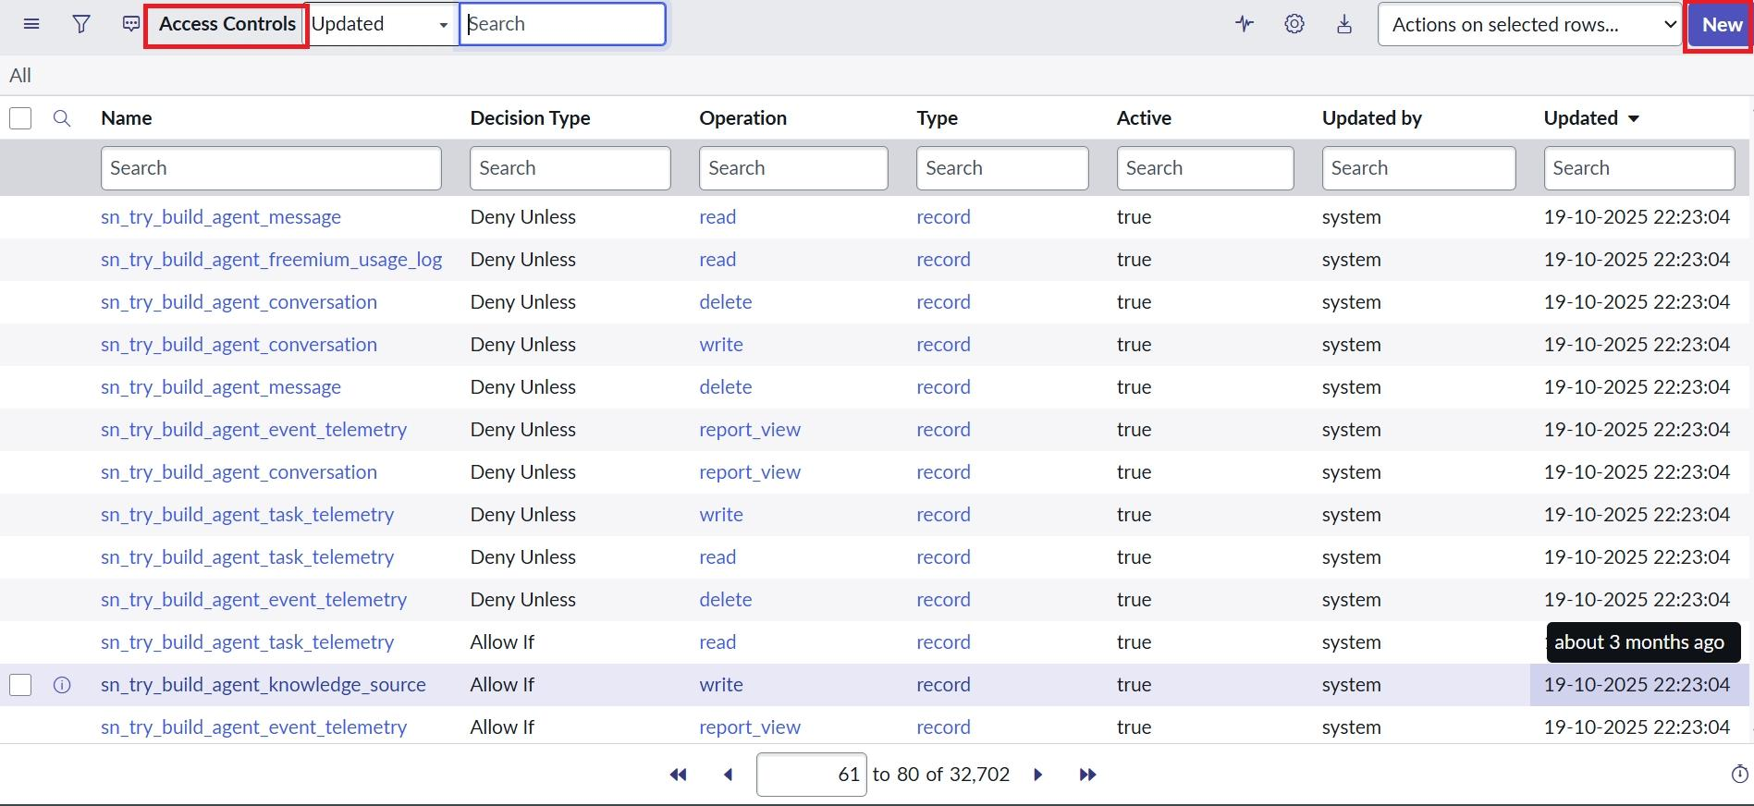

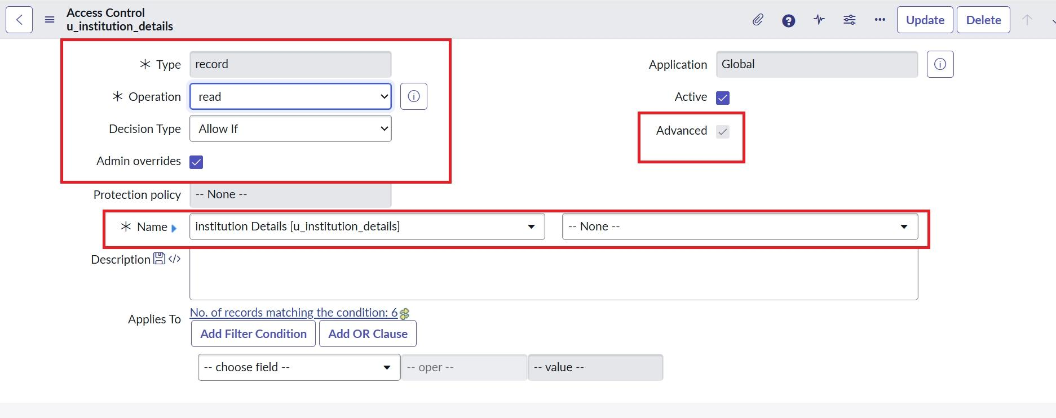

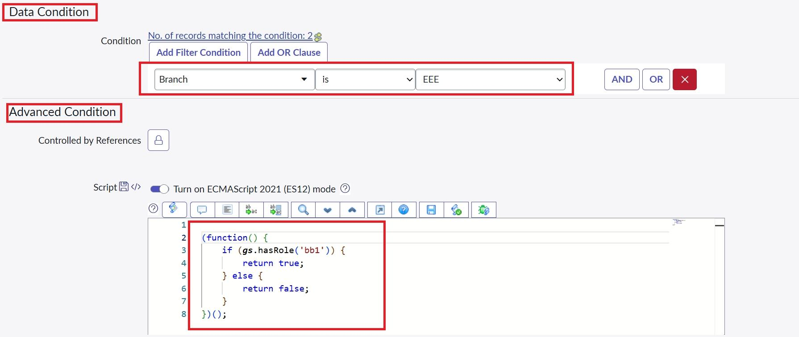

- Impersonate EEE users and open the Student Records list.
- Copy the table name u_institution_details.list/LIST and paste in the All menu.
- Impersonate Admin and open the Student Records list.

Verify : User with bb1 role can view only EEE branch records
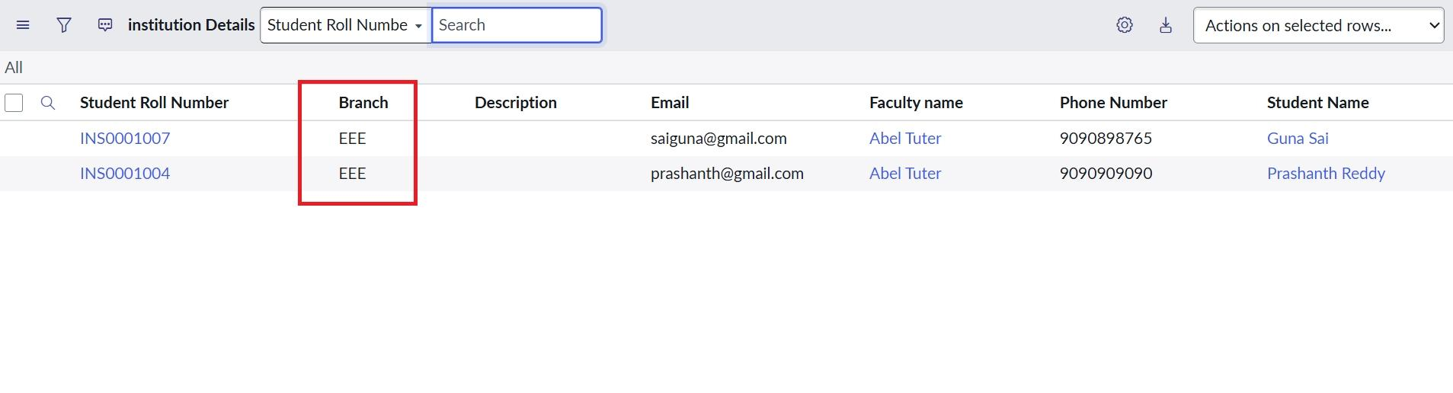

- User without the role cannot view any records
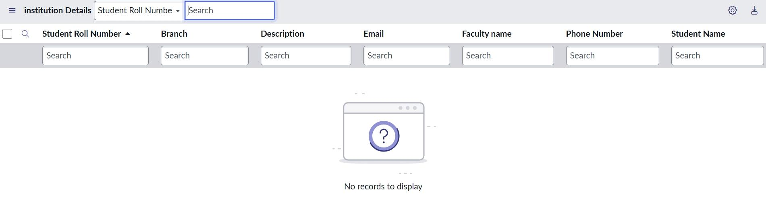

- Admin user can view all records regardless of branch
