Script-Controlled ACL restrict record access based on field value

Project Overview
Milestone-4: Creation of Access Control List-CREATE
Creation of ACL-Create:

- Click New to create a new ACL(Create)
- Enter the following details
- Type: record
- Operation: create
- Name: u_institution_details
- Active: true
- In the Requires role related list, add: bb2 (custom role)
- No need to add any Data condition
- Save the ACL Record
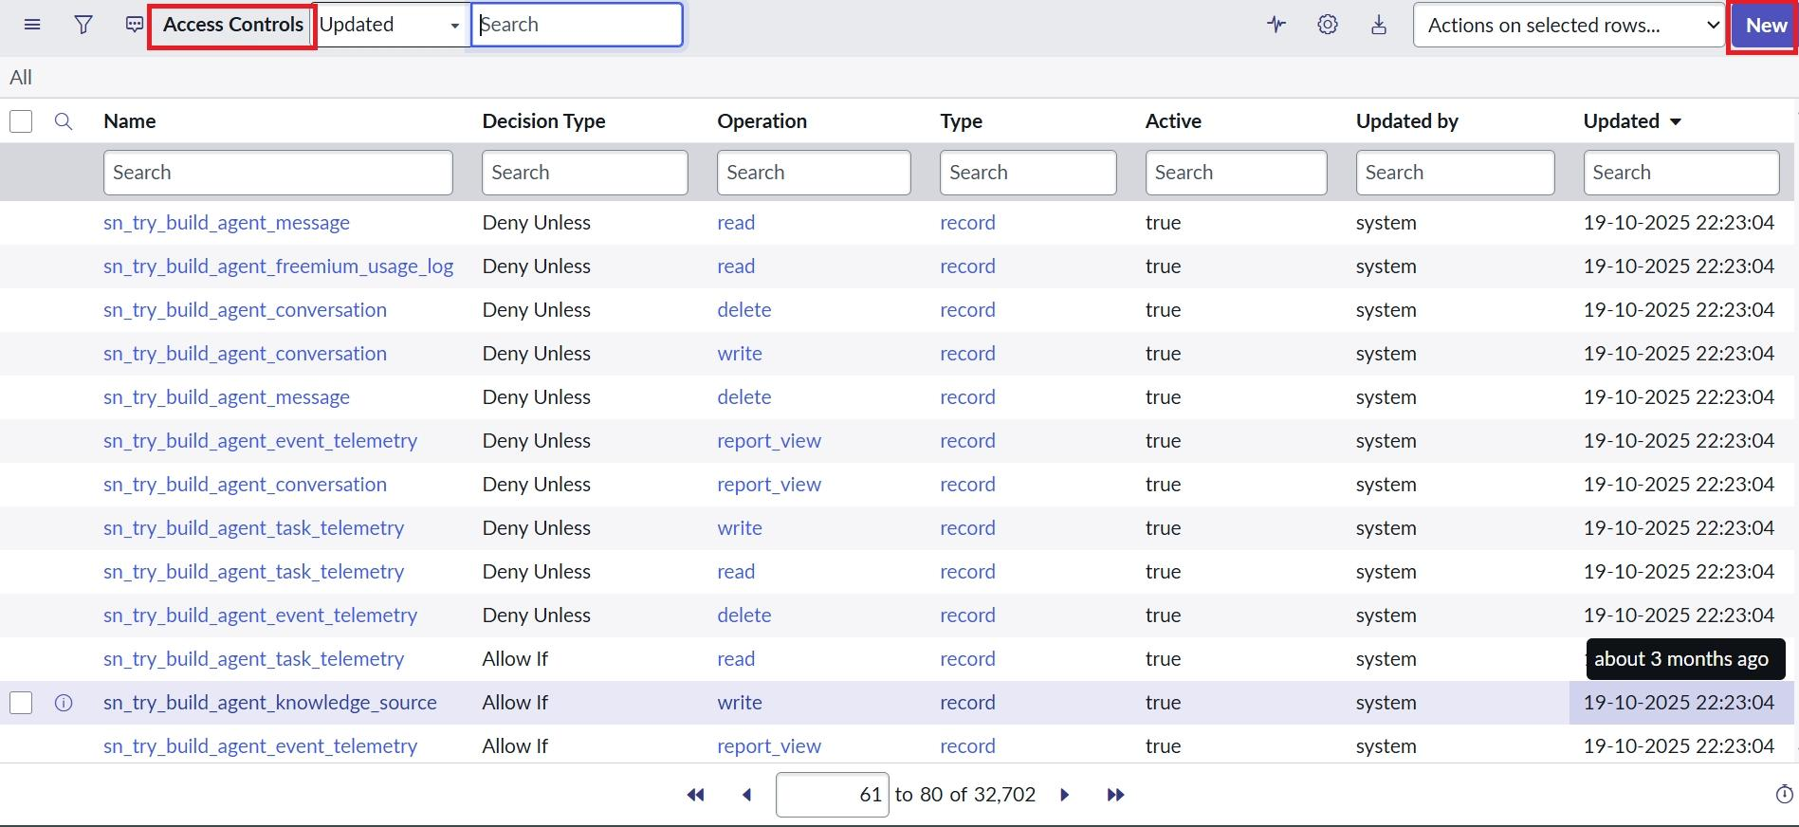

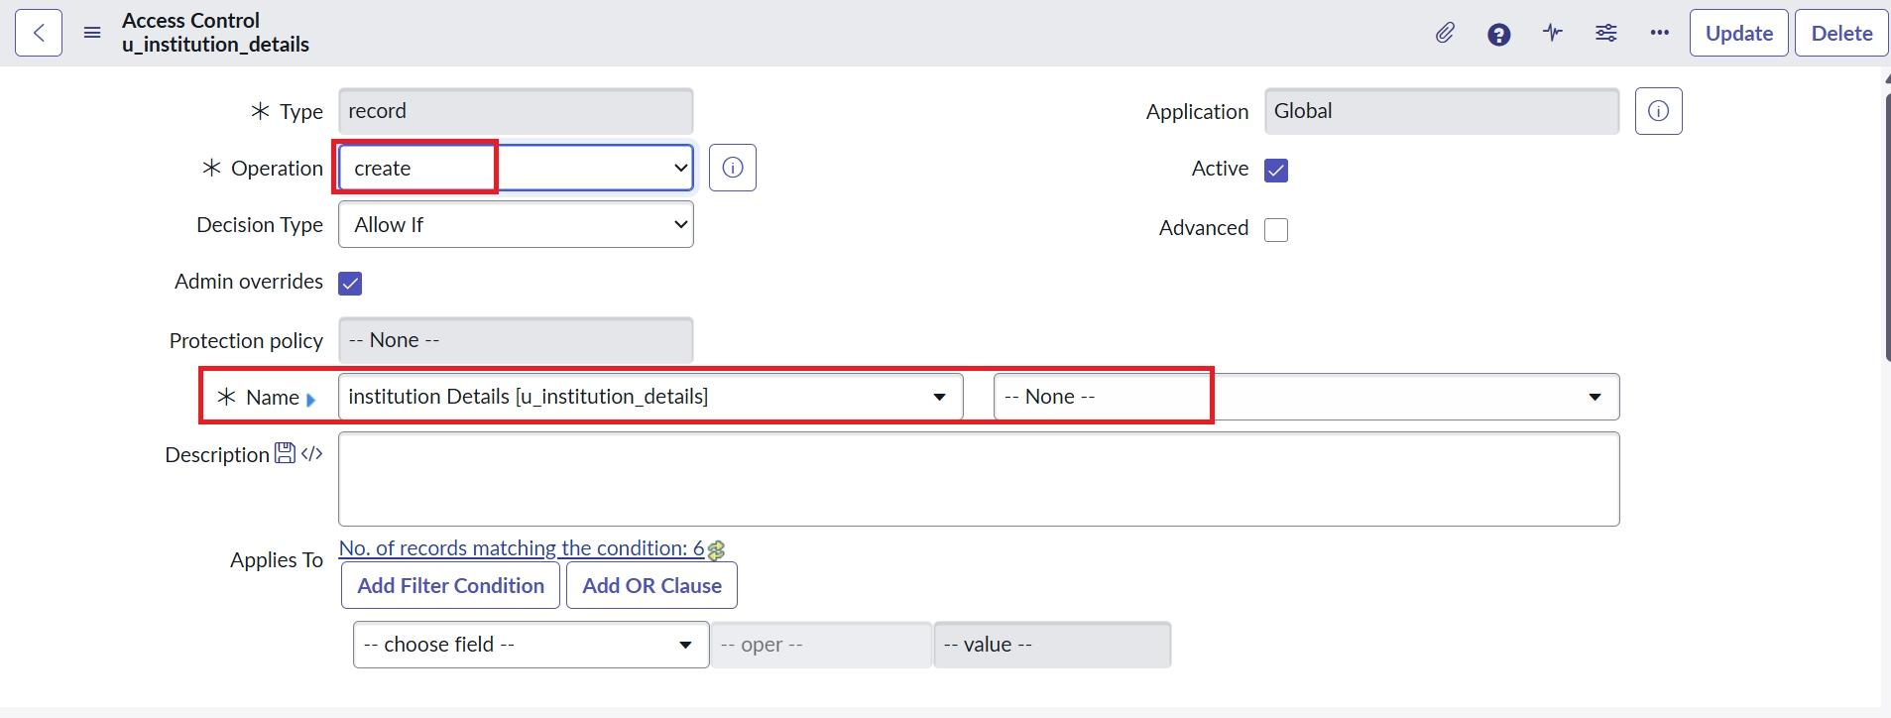

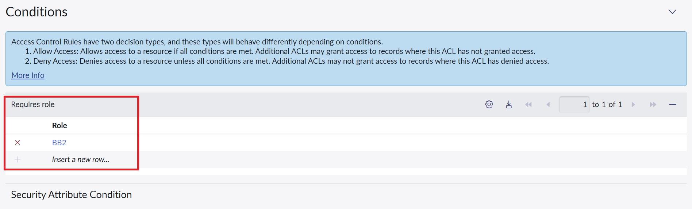

Verify :
- User with bb1 &bb2 roles can view only EEE branch records & New Button
