Script-Controlled ACL restrict record access based on field value

Project Overview

Milestone-6: Creation of Access Control List-DELETE
Creation of ACL-DELETE:

- Click New to create a new ACL(Delete)
- Enter the following details
- Type: record
- Operation: Delete
- Name: u_institution_details
- Active: true
- In the Requires role related list, add: bb4 (custom role)
- No need to add any Data condition
- Save the ACL Record
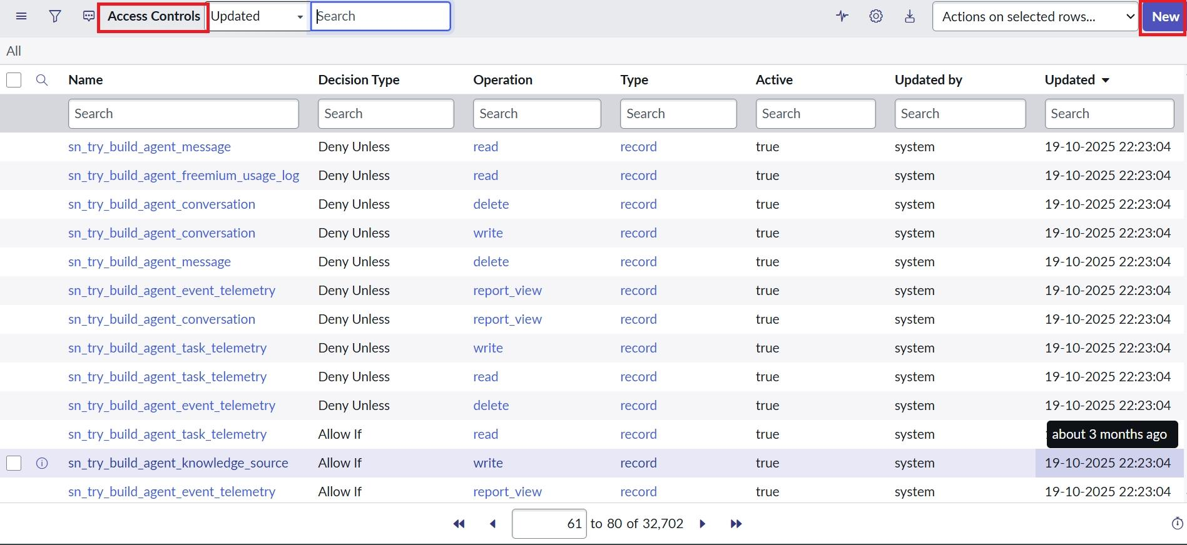

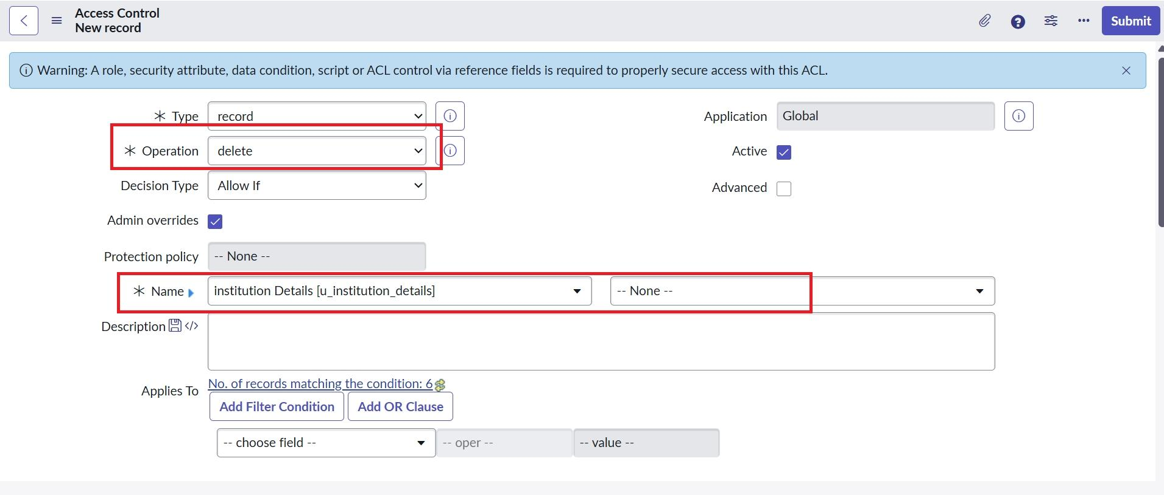

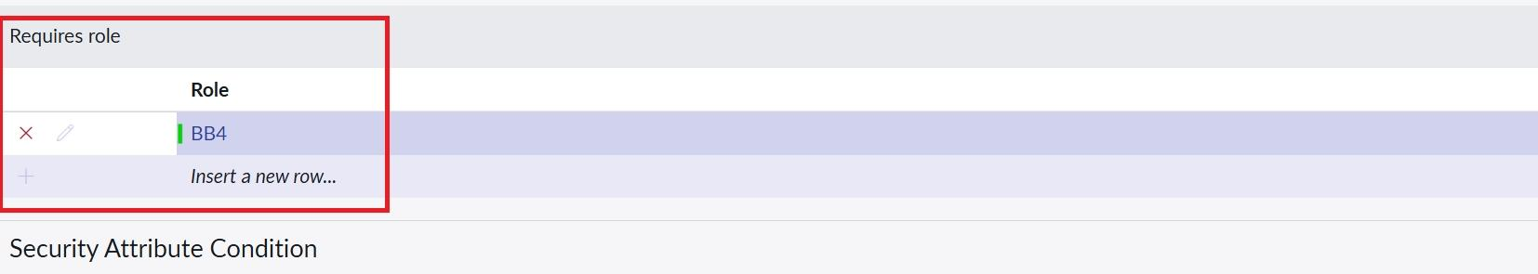

Verify :
Users with bb1 &bb2 &bb3&bb4 roles can see, create and edit along with delete the EEE branch records.
