Hospital Emergency Room Triage System
PSPJ Project

1. Introduction
In a hospital emergency room, patients arrive with different levels of urgency, and those in the most serious condition must be treated first. Sorting patients in this way is known as triage. The Hospital Emergency Room Triage System is a Java console application that demonstrates this idea. It registers the patients, decides their emergency level, arranges them in order of priority, and displays the treatment plan before ending with a completion message.

2. Abstract
The Hospital Emergency Room Triage System is a Java-based console application designed to help organize patients in an emergency room according to their emergency level. The system collects patient information such as name, age, temperature, and main complaint, and then decides whether the patient is Critical, Serious, or Normal. It sorts up to 20 patients by priority and displays the treatment order with the assigned doctor, estimated waiting time, and bed availability, followed by a summary of the emergency room. Built using core Java features, the project demonstrates variables, data types, methods, operators, conditional statements, arrays, loops, switch statements, sorting, exception handling, and console input/output. It provides a simple digital approach for demonstrating the basic idea of patient priority management in an emergency room.

3. Advantages
- Multiple Patient Management: Stores and processes the records of up to 20 patients using arrays.
- Priority Identification: Classifies patients as Critical, Serious, or Normal using the complaint, age, and temperature.
- Quick Decision Support: Shows the treatment order, assigned doctor, estimated waiting time, and bed availability.
- Easy to Understand: Uses core Java concepts with a simple console flow, making it suitable for beginners.

4. Algorithm
1. Start the program.
2. Create a Scanner object and the arrays to store the name, age, temperature, complaint, and emergency level of each patient.
3. Read the number of patients, rejecting wrong input using try-catch.
4. Using a for loop, read the name, age, temperature, and main complaint of every patient.
5. Find the emergency level from the complaint using a switch statement. Raise the level to Critical if the temperature is 104 F or above, or to Serious if the patient is younger than 5 or aged 65 and above and the level is Normal.
6. Sort the patients by emergency level using bubble sort, so that Critical patients come first.
7. For each patient in the sorted order, display the details, fever status, assigned doctor, estimated waiting time, bed availability, and treatment message.
8. Count the patients by emergency level, find the average temperature, the highest temperature, and the oldest patient, and show an alert if critical patients are present.
9. Display the message "TRIAGE COMPLETED. THANK YOU. PROGRAM ENDED."
10. End the program.

5. Java Code
import java.util.Scanner;

class HospitalTriageSystem {

// Constants and lookup arrays (index 1 = Critical, 2 = Serious, 3 = Normal)
static final int MAX = 20, CRITICAL = 1, SERIOUS = 2, NORMAL = 3;
static final String[] LEVEL_NAMES = {"", "Critical", "Serious", "Normal"};
static final String[] DOCTORS = {"", "Emergency Specialist", "Senior Doctor",
"General Physician"};
static final String[] MESSAGES = {"", "Patient needs immediate treatment.",
"Patient needs urgent treatment.",
"Patient can wait for normal treatment."};
static final String[] COMPLAINTS = {"Chest pain", "Difficulty in breathing",
"Severe bleeding", "Broken bone", "High fever", "Minor cut or injury",
"General checkup"};
static final int[] BEDS = {0, 1, 2, 3}; // beds available for each level

// Arrays to store the patient records
static String[] names = new String[MAX], complaints = new String[MAX];
static int[] ages = new int[MAX], levels = new int[MAX];
static double[] temps = new double[MAX];
static Scanner sc = new Scanner(System.in);

// Read a number in a range; try-catch handles wrong input
static double readNumber(String msg, double min, double max) {
while (true) {
System.out.print(msg);
try {
double value = Double.parseDouble(sc.nextLine().trim());
if (value >= min && value <= max) { return value; }
System.out.println("Enter a value from " + (int) min
+ " to " + (int) max);
} catch (NumberFormatException e) {
System.out.println("Invalid input. Please enter a number.");
}
}
}

// Decide the emergency level from the complaint number
static int levelFromComplaint(int choice) {
switch (choice) {
case 1: case 2: case 3: return CRITICAL;
case 4: case 5: return SERIOUS;
default: return NORMAL;
}
}

// Raise the level for a very high fever, small children and elderly patients
static int adjustLevel(int level, int age, double temp) {
if (temp >= 104.0) { return CRITICAL; }
else if ((age < 5 || age >= 65) && level == NORMAL) { return SERIOUS; }
else { return level; }
}

static String feverStatus(double temp) {
if (temp < 97.0) { return "Low temperature"; }
else if (temp <= 99.5) { return "Normal temperature"; }
else if (temp <= 102.0) { return "Fever"; }
else { return "High fever"; }
}

// Time needed to treat one patient of the given level
static int treatmentMinutes(int level) {
switch (level) {
case CRITICAL: return 30;
case SERIOUS: return 20;
default: return 10;
}
}

static void registerPatient(int i) {
System.out.print("Enter patient name: ");
names[i] = sc.nextLine().trim();
if (names[i].isEmpty()) { names[i] = "Patient " + (i + 1); }
ages[i] = (int) readNumber("Enter age (0-120): ", 0, 120);
temps[i] = readNumber("Enter temperature in F (90-110): ", 90, 110);
for (int k = 0; k < COMPLAINTS.length; k++) {
System.out.println((k + 1) + ". " + COMPLAINTS[k]);
}
int choice = (int) readNumber("Select main complaint (1-7): ", 1, 7);
complaints[i] = COMPLAINTS[choice - 1];
levels[i] = adjustLevel(levelFromComplaint(choice), ages[i], temps[i]);
System.out.println("Emergency Status: " + LEVEL_NAMES[levels[i]]);
}

// Bubble sort on an index array: Critical patients come first
static int[] sortByPriority(int n) {
int[] order = new int[n];
for (int i = 0; i < n; i++) { order[i] = i; }
for (int i = 0; i < n - 1; i++) {
for (int j = 0; j < n - 1 - i; j++) {
if (levels[order[j]] > levels[order[j + 1]]) {
int temp = order[j];
order[j] = order[j + 1];
order[j + 1] = temp;
}
}
}
return order;
}

static void showTreatmentList(int[] order, int n) {
int[] bedsUsed = new int[4];
int waitMinutes = 0;
System.out.println("\n===== TREATMENT ORDER (MOST URGENT FIRST) =====");
for (int k = 0; k < n; k++) {
int p = order[k];
int level = levels[p];
System.out.println("\nPriority " + (k + 1) + " : " + names[p]
+ " (Age " + ages[p] + ")");
System.out.println("Complaint : " + complaints[p]);
System.out.println("Temperature : " + temps[p] + " F ("
+ feverStatus(temps[p]) + ")");
System.out.println("Emergency Level : " + LEVEL_NAMES[level]);
System.out.println("Assigned Doctor : " + DOCTORS[level]);
System.out.println("Estimated Wait : " + waitMinutes + " minutes");
if (bedsUsed[level] < BEDS[level]) {
bedsUsed[level]++;
System.out.println("Bed : Bed allotted");
} else {
System.out.println("Bed : No free bed, please wait");
}
System.out.println(MESSAGES[level]);
waitMinutes += treatmentMinutes(level);
}
}

static void showSummary(int n) {
int[] levelCount = new int[4];
int oldest = 0, hottest = 0;
double total = 0;
for (int i = 0; i < n; i++) {
levelCount[levels[i]]++;
total += temps[i];
if (ages[i] > ages[oldest]) { oldest = i; }
if (temps[i] > temps[hottest]) { hottest = i; }
}
System.out.println("\n===== EMERGENCY ROOM SUMMARY =====");
System.out.println("Total patients : " + n);
System.out.println("Critical patients : " + levelCount[CRITICAL]);
System.out.println("Serious patients : " + levelCount[SERIOUS]);
System.out.println("Normal patients : " + levelCount[NORMAL]);
System.out.printf("Average temperature : %.1f F%n", total / n);
System.out.println("Highest temperature : " + names[hottest]
+ " (" + temps[hottest] + " F)");
System.out.println("Oldest patient : " + names[oldest]
+ " (" + ages[oldest] + " years)");
if (levelCount[CRITICAL] > 0) {
System.out.println("ALERT: Critical patients need immediate attention!");
}
}

public static void main(String[] args) {
System.out.println("===== HOSPITAL EMERGENCY ROOM TRIAGE SYSTEM =====");
int n = (int) readNumber("Number of patients (1-" + MAX + "): ", 1, MAX);

for (int i = 0; i < n; i++) {
System.out.println("\n--- Patient " + (i + 1) + " of " + n + " ---");
registerPatient(i);
}

int[] order = sortByPriority(n);
showTreatmentList(order, n);
showSummary(n);

System.out.println("\n=================================================");
System.out.println(" TRIAGE COMPLETED. THANK YOU. PROGRAM ENDED.");
System.out.println("=================================================");
sc.close();
}
}

6. Output

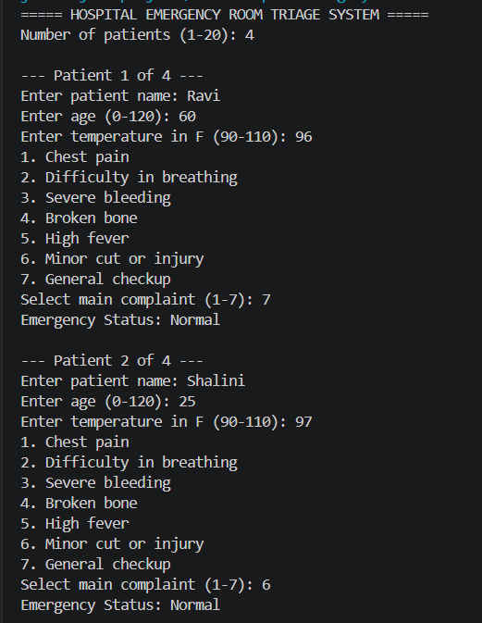
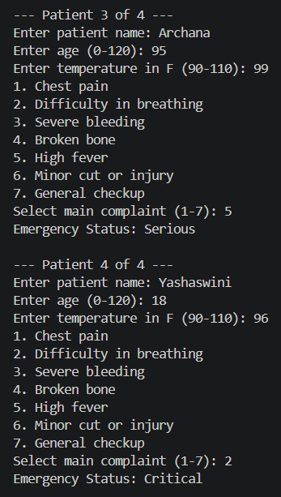
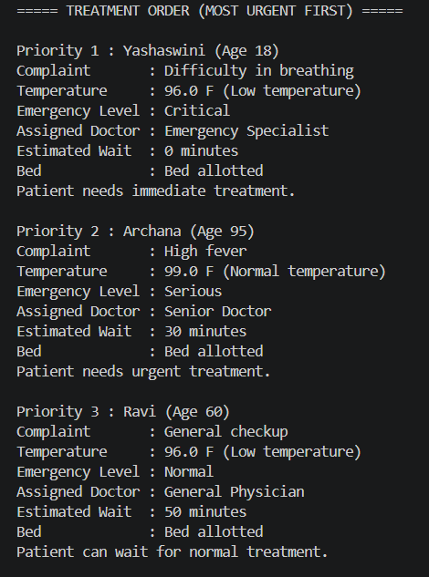
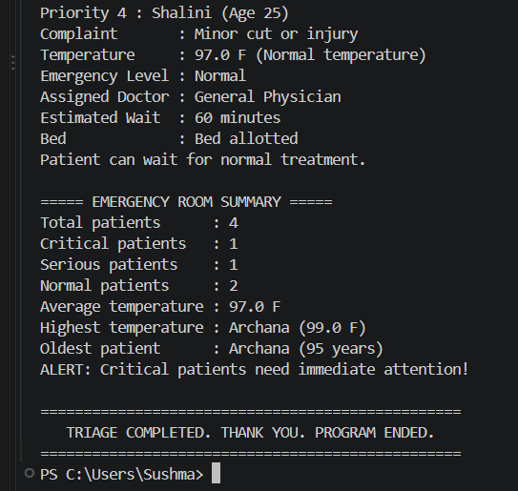

7. Conclusion
The Hospital Emergency Room Triage System demonstrates how Java can be used to create a patient priority management application. The program registers multiple patients, decides the emergency level from the complaint, age, and temperature, sorts the patients by priority, and displays a clear treatment order with the doctor, waiting time, and bed availability. The project is suitable for beginners because it combines fundamental Java concepts such as variables, arrays, loops, switch statements, methods, sorting, and exception handling in one practical application.

