**No table of contents entries found.**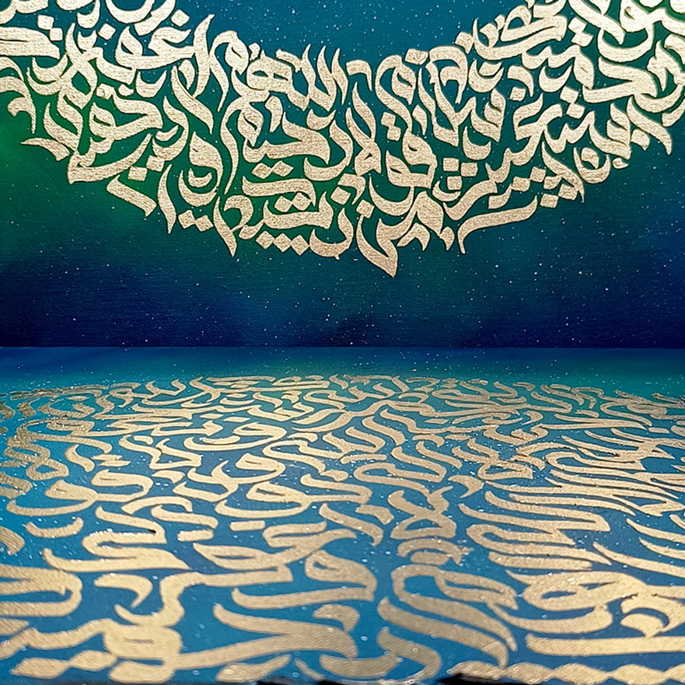

Made By Ameer Hamza

Calligraphy

## TABLE OF CONTANT

Contents

TABLE OF CONTANT 2

PROJECT TEAM 3

Introduction 4

OBJECTIVE 6

PROBLEM STATEMENT 7

CERTIFICATE 10

TASK SHEET 11

CHECK LIST 12

ER DIAGRAM 13

# PROJECT TEAM

|  |  |
| --- | --- |
| STUDENTS | STUDENTS ID |
| MUHAMMADAMEERHAMZA | Student1568598 |
| MUHAMMAD AFFAN ARIF | Student1568613 |
| FAZAL HUSSAIN | Student1577003 |

HTML5,CSS3,BOOTSTRAP

Miss Noor un Nisa

PRI2-2024-03G

JQUERY&PHP.

TECHNOLOGY:

PROJECT INSTRUCTOR:

BATCH CODE:

## Introduction

The thirst for learning, upgrading technical skills and applying the concepts in real

life environment at a fast pace is what the industry demands from IT professionals

today. However busy work schedules, far-flung locations, unavailability of convenient

time-slots pose as major barriers when it comes to applying the concepts into

realism. And hence the need to look out for alternative means of implementation in

the form of laddered approach.

The above truly pose as constraints especially for our students too! With their busy

schedules, it is indeed difficult for our students to keep up with the genuine and

constant need for integrated application which can be seen live especially so in the

field of IT education where technology can change on the spur of a moment. Well,

technology does come to our rescue at such times!!

Keeping the above in mind and in tune with our constant endeavor to use

Technology in our training model, we at Aptech have thought of revolutionizing the

way our students learn and implement the concepts using tools themselves by

providing a live and synchronous eProject learning environment!

So what is this eProject?

eProject is a step-by-step learning environment that closely simulates the classroom

and Lab based learning environment into actual implementation. It is a project

implementation at your fingertips!! An electronic, live juncture on the machine that

allows you to

o Practice step by step i.e. laddered approach.

o Build a larger more robust application.

o Usage of certain utilities in applications designed by user.

o Single program to unified code leading to a complete application.

o Learn implementation of concepts in a phased manner.

o Enhance skills and add value.

o Work on real life projects.

o Give a real-life scenario and help to create applications more complicated and

useful.

o Mentoring through email support.

The students at the center are expected to complete this eProject and send complete

project along with the documentation to eProjects Team

Looking forward to a positive response from your end!!

### OBJECTIVE

The Objective of this program is to give a sample project to work on real life

projects. These applications help you build a larger more robust application.

The objective is not to teach you HTML/JavaScript/Dreamweaver/HTML5 but to

provide you with a real-life scenario and help you create basic applications using the

tools.

You can revise the chapters before you start with the project.

This project is meant for students who have completed the module of HTML5. These

programs should be done in the Lab sessions with assistance of the faculty if

required.

It is very essential that a student has a clear understanding of the subject. Students

should go through the project and solve the assignments as per requirements given.

Kindly get back to eProjects Team in case of any doubts regarding the application or

its objectives.

### PROBLEM STATEMENT

Stylish Strokes is a website designed to provide an easy and interactive way to learn

calligraphy. The website will offer comprehensive information about the art of

calligraphy, its history, and various styles. It will also include resources and tools for

users to practice and improve their calligraphy skills.

You are supposed to create a Single-Page-Application and responsive Website with

the below mentioned requirement specifications.

The website should work well in all leading browsers including Chrome, IE, Firefox

etc.

Requirement Specification:

The portal will be designed as a Single-Page-Application and responsive Website with

a set of pages and menus that represent choice of activities to be performed. The

pages, menus, and other visual elements must be designed in a visually appealing

manner with attractive fonts, colors, and animations. All of these should also be laid

out in a responsive manner.

The Web site is to be created based on the following requirements.

Home Page:

Describe keywords and highlight calligraphy designs.

Define all navigation links clearly.

Site Structure:

1. About Calligraphy:

Brief information about calligraphy, including its origins.

Detailed descriptions of various calligraphy styles (Western, Arabic,

Oriental).

2. Learning Resources:

Categories of calligraphy styles with subcategories for different skill

levels (e.g., easy for kids, complex for elders).

Examples of calligraphy styles and lettering sub-styles.

Descriptions of letters and fonts used in calligraphy.

3. Interactive Features:

Gallery section showcasing different calligraphy works.

Feedback form for user inputs and suggestions.

4. Contact Us:

Display contact details and location using Geolocation API (e.g.,

Google Maps or any other).

5. About Us:

Information about the team behind Stylish Strokes and the mission of

the website.

Design and Usability:

Well-designed menu with necessary sub-menu options.

Uniform color combination throughout the website.

Smooth navigation across all pages.

Additional Features:

Links to popular calligraphy tools and software.

Options to download practice sheets and templates.

Over and above this, the portal should implement the following functionalities:

• Display a continuous scrolling ticker at the bottom of the page with current

date, time, and location (hint: Use geolocation features of HTML5).

• Display a visitor count at the top right corner of the page beside a logo

image.

• The menu options should change color on hover and also after clicking.

• Fade in and fade out options can be used for the menus.

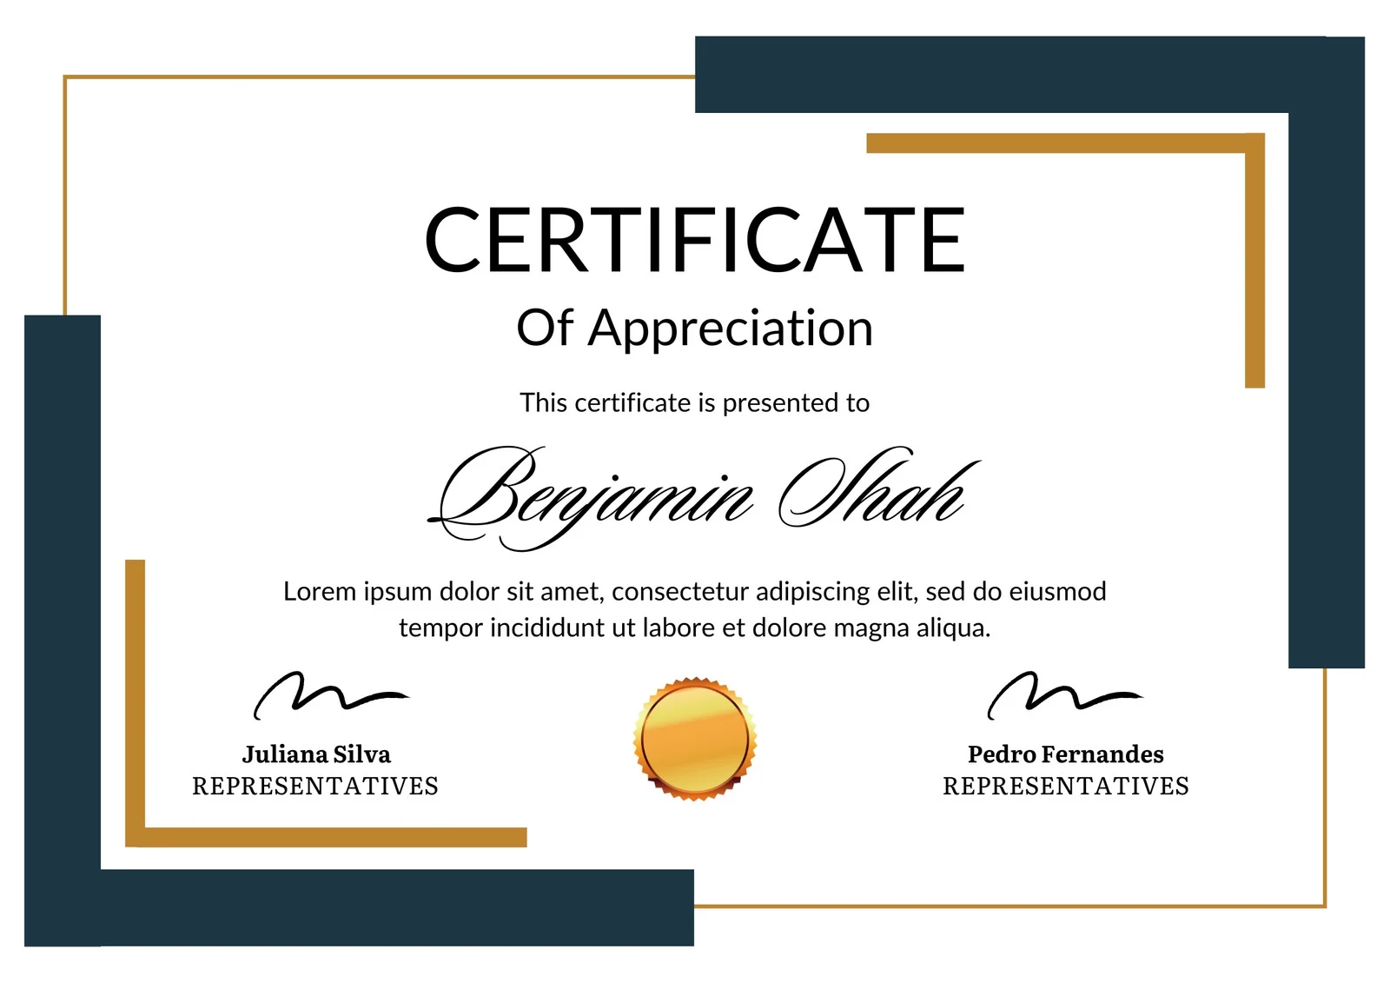

# CERTIFICATE

### TASK SHEET

|  |  |  |  |
| --- | --- | --- | --- |
| S_NO | TASK | NAME | STATUS |
| 1 | HOME | AFFAN ARIF | COMPLETED |
| 2 | ABOUT US | AMEER HAMZA | COMPLETED |
| 3 | LEARNING RESOURCES | AFFAN ARIF | COMPLETED |
| 4 | INTERACTIVE FEATURES | AFFAN ARIF | COMPLETED |
| 5 | CONTACT US | AFFAN ARIF | COMPLETED |
| 6 | DOCUMENTATION | AMEER HAMZA | COMPLETED |

# CHECK LIST

|  |  |  |  |
| --- | --- | --- | --- |
| 1 | ALL PAGE ARE LINKED TOGHETHER | YES | NO |
| 2 | BROWSER CAPABILITY | YES |  |
| 3 | DECENT AND SIMPLE COLOR THEME | YES |  |
| 4 | ALL PAGES OPEN PROPERLY | YES |  |
| 5 | IMAGES AND LOGIN IN PAGES | YES |  |
| 6 | PROJECT ZIP FILE | YES |  |

|  |  |
| --- | --- |
| Student Name | Page they have made |
| Affan Arif | Home, Interactive features, Learning resource, contact us |
| Hamza | About us |
| Fazal | Did nothing |

Website Designed By

Interactive Features:

**Our vision and our teams introduction**

**Various type of Calligraphy and their brief history**

**Contact form and location**

**Different Courses and Information**

CONTACT US

Learning Resources:

ABOUT US

HOME

# ER DIAGRAM