PS D:\SyedMurtazaSaeed\EPROJECT1-2409D-NOV> git status

On branch main

nothing to commit, working tree clean

PS D:\SyedMurtazaSaeed\EPROJECT1-2409D-NOV>

nothing to commit, working tree clean

g --global user.email

murtazasaeed@aptechgdn.net

PS D:\SyedMurtazaSaeed\EPROJECT1-2409D-NOV> git config --global user.mail sms2000n@gmail.com

g --global user.mail sms2000n@gmail.com

PS D:\SyedMurtazaSaeed\EPROJECT1-2409D-NOV> git config --global user.mail

sms2000n@gmail.com

PS D:\SyedMurtazaSaeed\EPROJECT1-2409D-NOV> git branch -a

\* main

PS D:\SyedMurtazaSaeed\EPROJECT1-2409D-NOV> git branch -a

\* main

<<<<<<<<<<< we create a cfiletext in our folder------------ then run below these command>>>>>>

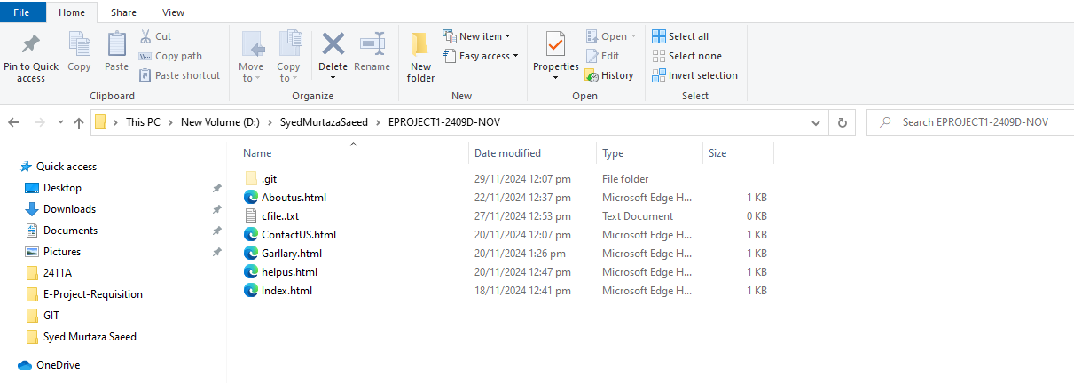

PS D:\SyedMurtazaSaeed\EPROJECT1-2409D-NOV> git add .

PS D:\SyedMurtazaSaeed\EPROJECT1-2409D-NOV> git commit -m "cfiletextfilebackup"

[main 7ca232c] cfiletextfilebackup

Committer: Murtazasaeed <Murtaza.imran@dcaptech.org>

Your name and email address were configured automatically based

on your username and hostname. Please check that they are accurate.

You can suppress this message by setting them explicitly:

git config --global user.name "Your Name"

After doing this, you may fix the identity used for this commit with:

git commit --amend --reset-author

create mode 100644 cfile..txt

PS D:\SyedMurtazaSaeed\EPROJECT1-2409D-NOV> git branch -a

\* main

<<<<<<<<< here we create a cfiles (This is branch) name >>>>>>>>>>

PS D:\SyedMurtazaSaeed\EPROJECT1-2409D-NOV> git branch cfiles

This command showed all branch we have two branchs

PS D:\SyedMurtazaSaeed\EPROJECT1-2409D-NOV> git branch - a

cfiles

\* main

<<<<< leave main branch and go to Cfiles(branch)>>>>>>

PS D:\SyedMurtazaSaeed\EPROJECT1-2409D-NOV> git checkout cfiles

Switched to branch 'cfiles'

PS D:\SyedMurtazaSaeed\EPROJECT1-2409D-NOV>

(go to Eproject1-2409d-nov> R.click>git bash here

Murtaza.imran@FACULTY03 MINGW64 /d/SyedMurtazaSaeed/EPROJECT1-2409D-NOV (cfiles)

$ touch password.txt

Now see password ‘s file is created in your folder EPROJECT1-2409D-NOV

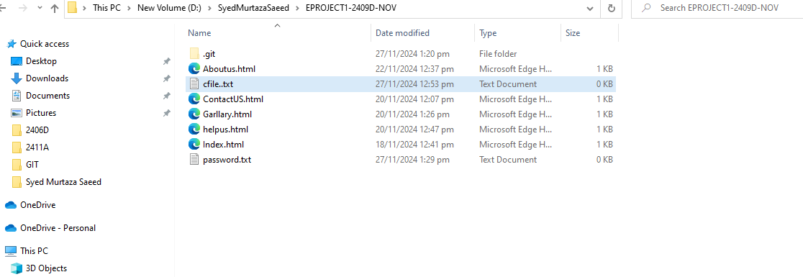

Now add password.txt file in your git

Murtaza.imran@FACULTY03 MINGW64 /d/SyedMurtazaSaeed/EPROJECT1-2409D-NOV (cfiles)

$ git add .

<<<<Now Saved (commit passwordtxtf file in cfile branch)>>>>>>

Murtaza.imran@FACULTY03 MINGW64 /d/SyedMurtazaSaeed/EPROJECT1-2409D-NOV (cfiles)

$ git commit -m "saved passwordfile in cfile branch"

1 file changed, 0 insertions(+), 0 deletions(-)

<<<< Now switched to main branch>>>>

Murtaza.imran@FACULTY03 MINGW64 /d/SyedMurtazaSaeed/EPROJECT1-2409D-NOV (cfiles)

$ git checkout main

Switched to branch 'main'

<<<<Hare ( in main branch not showed passwordfile) file >>>>>

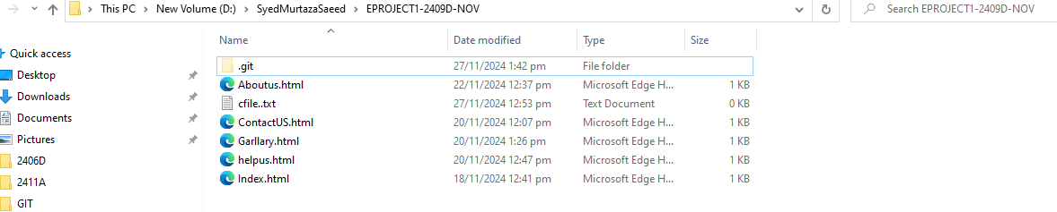

<<<<<<<<<<<< now we can also creted second branch (SecondBranch) then we will be merging both

Main and second Branch>>>>>>>>>>>>>>>>>>>>>>>>>>>>>>>>>>>>>>>>>>>>>>>>>>>

$ Git branch SecondBranch

< Then go to SecondBranch>>>>>>>>>>

$ git checkout SecondBranch

Switched to branch 'SecondBranch'

<<<<<< now created a file with the help of touch command>>>>>>>>>>>>>>

$ touch newAbout29-11-2024.html

<<<<<<<<<<<<<<<<<<<<<now switch main branch>>>>>>>>>>>>

Git checkout master

<<<<<<then add and commit newAbout29-11-2024.html file>>>>>>>>

$ git commit -m "saved newAbout29-nov-2024file"

<<<<<<<< now marching both branch= main and secondbranch )

$ git merge Secondbranch

Already up to date.

<<<<< now switch main branch>>>>>>>>>>>>>>>>

$ git checkout main

Switched to branch 'main' here not showed newAbout29-11-2024.html.

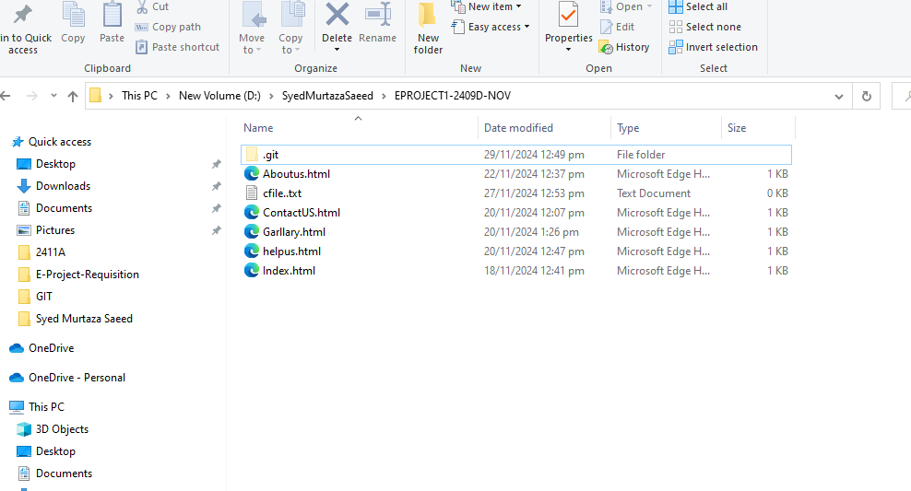

<< now again merch both main and SecondBranch”>>>>>>>>>>>

$ git merge SecondBranch

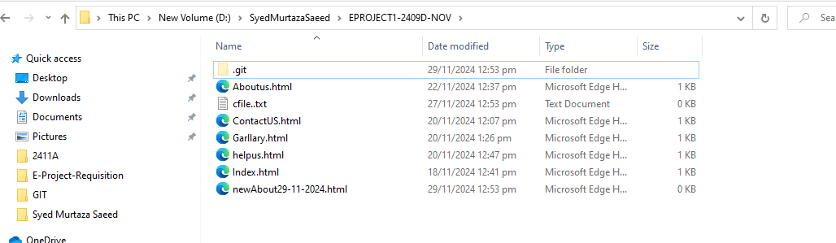

Stop 15 :33 lecture video:

To see all branch :

$ git branch -a

SecondBranch

cfiles

\* main

================= puch >>>>>>>>>>>

Git push -o origin main

Then git hub branch refresh:

We can create our branch

Then push

$ Git push -o origin my createdbranch